**Assignment 2_1**

**Task 1-** Check whether the directory /user/acadgild/Hadoop exists or not,if doesn’t then create it.

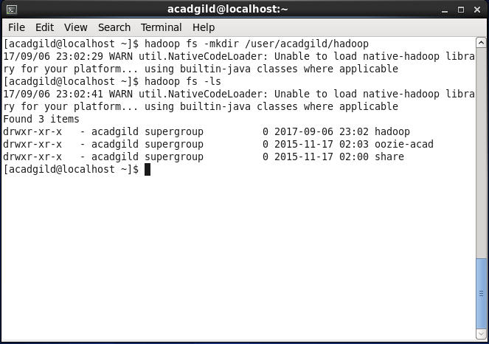

**Task 2-** Create a file in the directory named word-count.txt, whatever we write on the screen should be appended to the file.

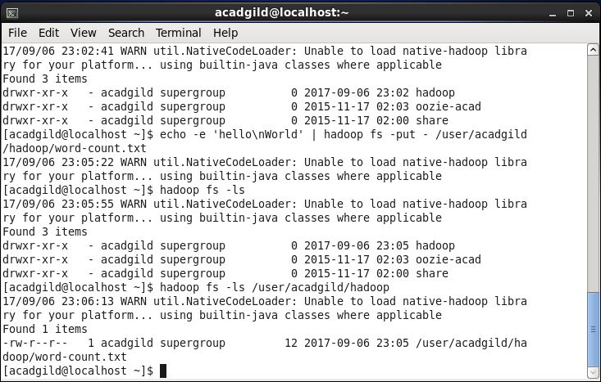

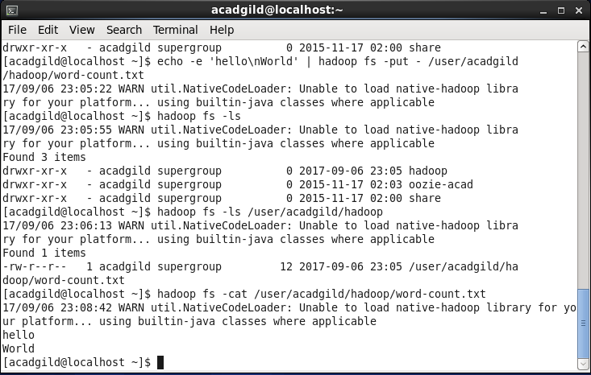

The echo and put commands were used to create a file in hdfs and append whatever was passed in the single quotes to the file. The contents of the file was displayed using the cat command as shown above. The tail command can also be used to display the contents of the file.