**Assignment2_2**

**Task 3-** Create a file max-temp.txt in local FS. Put some 10-15 records of date and temperature example:

dd-mm-yyyy,temperature

Example:

10-01-1990,10

10-02-1991,20

Move this file to HDFS at /user/acadgild/hadoop.

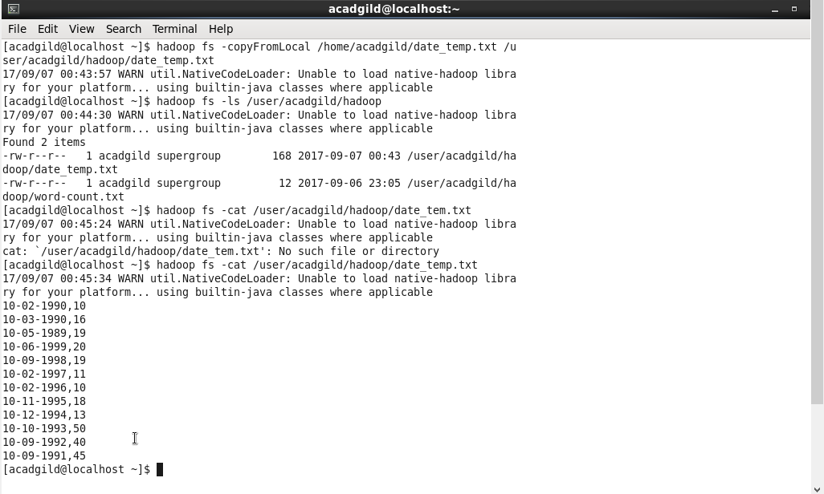

**Task 4** - Change the permission of the file /user/acadgild/hadoop/max-temp.txt, such that

only the owner and the group members have full control over the file.

Others do not have any control over it.

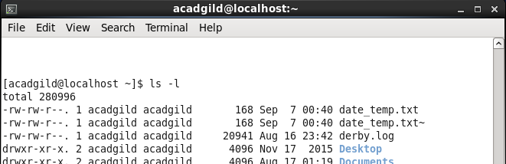

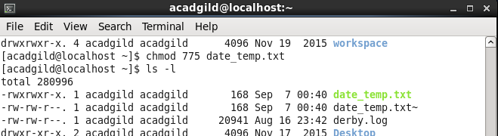

The permissions of the file are changed using the chmod command.

Syntax- Command: Owner: Group: World: Path

Example : chmod 775 date_temp.txt

4=read(r)

2=write(w)

1=execute(x)