**Assignment 1_1**

**Problem Statement:**

1. **Say True or False for the below statements:**

• Prescriptive Analytics used to predict the future outcomes?

* **False**

Reason- Prescriptive analytics provides recommendations, helps in forming business strategies whereas predictive analytics is used to predict future outcomes from the historical data.

• Base R packages installed automatically?

* **True**

Reason- An R package is an **extension of R** containing data sets and specific functions to solve specific questions. R comes with standard or base packages, which contain the basic functions and data sets as well as standard statistical and graphical functions that allow R to work. You can also install packages specific to your tasks from repositories such as CRAN and GITHUB using install.package(“package name”) function.

1. **What is Recycling of elements in a vector?**

Vector arithmetics are done member vise.

Suppose we add two vectors u and v

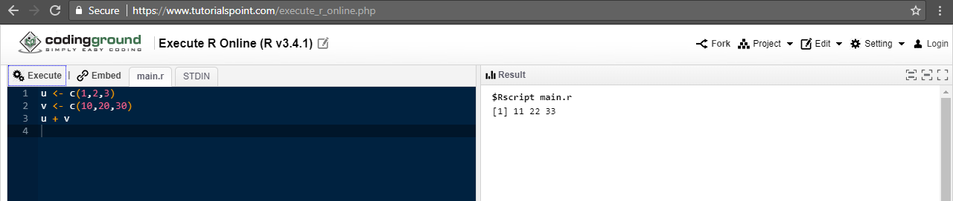

Recycling Rule

If two vectors are of unequal length, the shorter one will be recycled in order to match the longer vector. For example, the following vectors u and v have different lengths, and their sum is computed by recycling values of the shorter vector u.

1. **Give an example of recycling of elements.**

