**Assignment1_2**

**Problem Statement:**

1. **What should be the output of the following Script?**

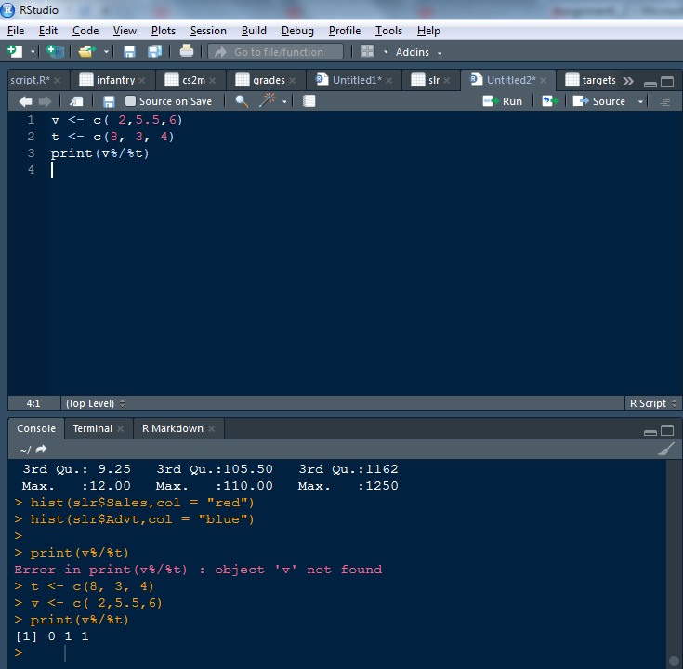

1. **You have 25 excel files with names as xx_1.xlsx, xx_2.xlsx,........xx_25.xlsx in a dir.Write a program to extract the contents of each excel sheet and make it one df.**

With list.files you can create a list of all the filenames in your working directory. Next you can use lapply to loop over that list and read each file with the read_excel function from the readxl package:

library(readxl)

file.list <- list.files(pattern='*.xlsx')

df.list <- lapply(file.list, read_excel)

If you also want to include the files in subdirectories, use:

file.list <- list.files(pattern='*.xlsx', recursive = TRUE)

Supposing the columns are the same for each file, you can bind them together in one dataframe with bind_rows from dplyr:

library(dplyr)

df <- bind_rows(df.list, .id = "id")

or with rbindlist from data.table:

library(data.table)

df <- rbindlist(df.list, idcol = "id")

Both have the option to add a id column for identifying the separate datasets.

1. **If the above 25 files were csv files, what would be your script to read?**

The above method can also be used with other file reading functions like read.csv or read.table. Just replace read_excel with the appropriate file reading function and make sure you use the correct pattern in list.files.

You can also create your own function as follows:

multmerge = function(mypath){  
filenames=list.files(path=mypath, full.names=TRUE)  
datalist = lapply(filenames, function(x){read.csv(file=x,header=T)})  
Reduce(function(x,y) {merge(x,y)}, datalist)

mymergeddata = multmerge(“C://R//mergeme”)

make sure to put all the files in the same directory before running the codes.