**Assignment11.1**

**Problem Statement:**

**1. Use the given link and locate the bank marketing dataset.**

**Perform the below operations:**

**a. Create a visual for representing missing values in the dataset.**

**b. Show a distribution of clients based on a Job.**

**c. Check whether is there any relation between Job and Marital Status?**

**d. Check whether is there any association between Job and Education?**

**a)**

**The dataset is as follows:**

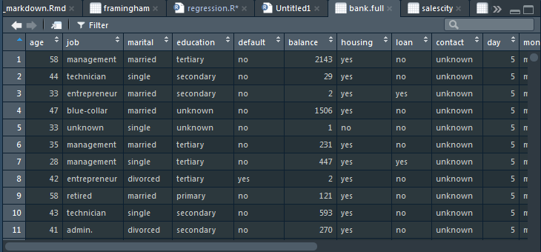

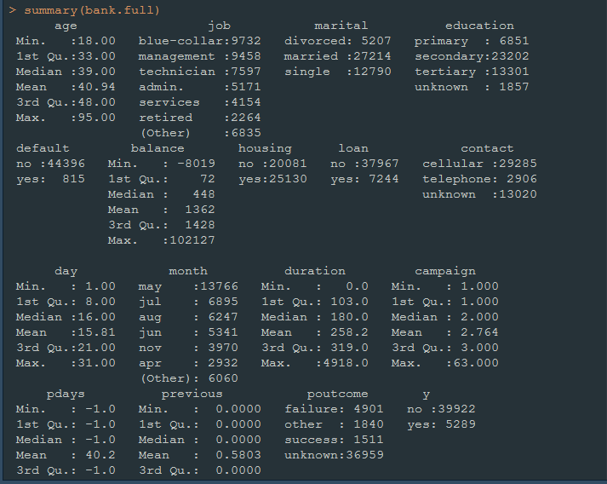

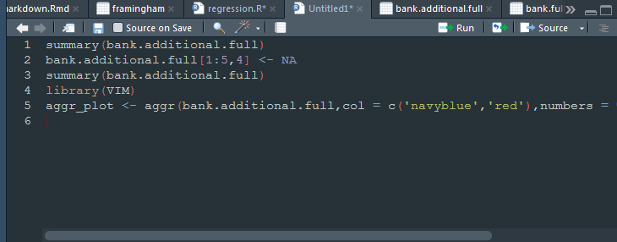

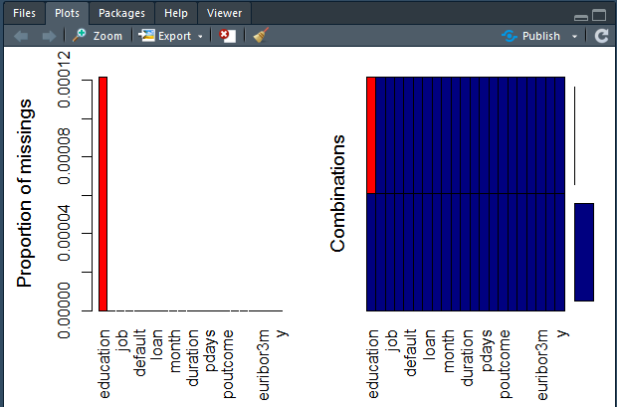

**b)**



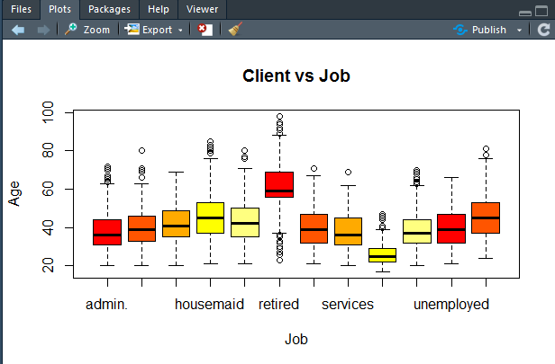

**c)**

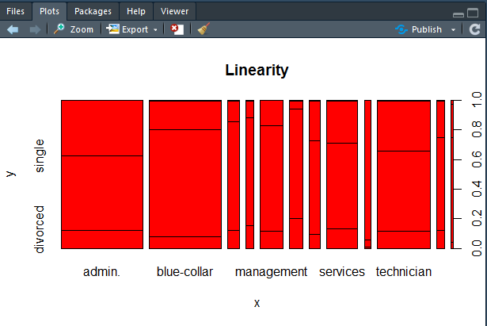

**d)**

