**Assignment11.2**

**Problem Statement:**

**1. Use the given link below and locate the bank marketing dataset.**

**Perform the below operations:**

**a. Is there any association between Job and default?**

**b. Is there any significant difference in duration of last call between people having housing loan or not?**

**c. Is there any association between consumer price index and consumer?**

**d. Is the employment variation rate consistent across job types?**

**e. Is the employment variation rate same across education?**

**f. Which group is more confident?**

**a)**

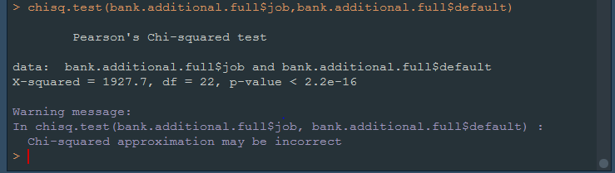

**b)**

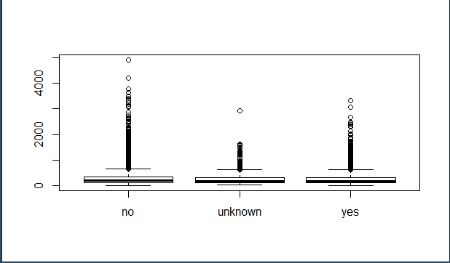

**c)**

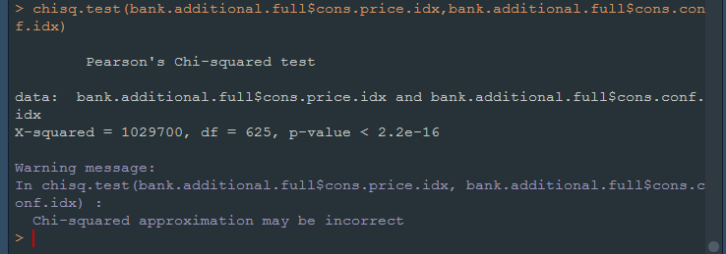

**d)**



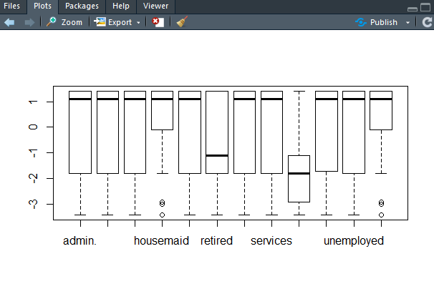

**e)**



