**Assignment3.2**

**Problem Statement:**

1. **Define matrix mymat by replicating the sequence 1:5 for 4 times and transforming into a matrix, sum over rows and columns.**

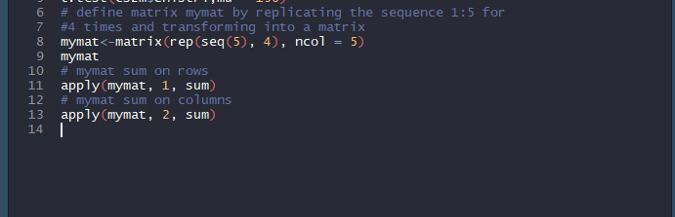

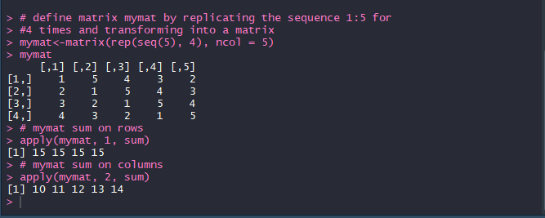

apply() function, instructs R to call a user-specified function on each of the rows or each of the columns of a matrix.

This is the general form of apply for matrices:

**apply(m,dimcode,f,fargs)**

where the arguments are as follows:

1. m is the matrix.
2. dimcode is the dimension, equal to 1 if the function applies to rows or 2 for columns.
3. f is the function to be applied.
4. fargs is an optional set of arguments to be supplied to f.