**Assignment4.3**

Problem Statement:

1. States = rownames(US Arrests)

Get states names with ‘w’.

Get states names with ‘W’.

The USArrests dataframe is as follows:

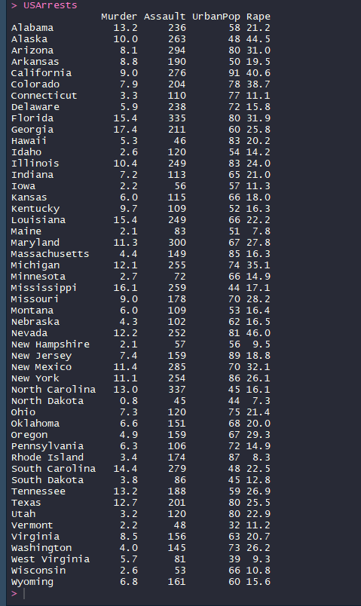

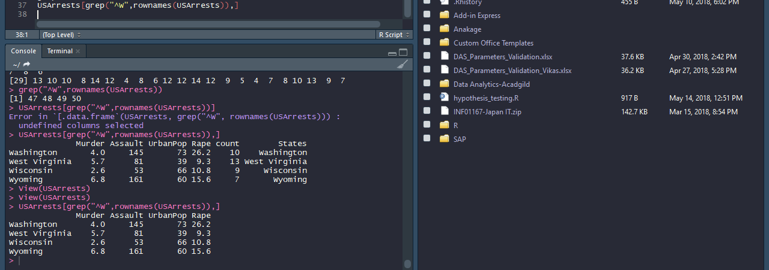

2. Prepare a Histogram of the number of characters in each US state.

