**Assignment5.1**

**Problem Statement**:

1. How many vowels are there in the names of USA States?

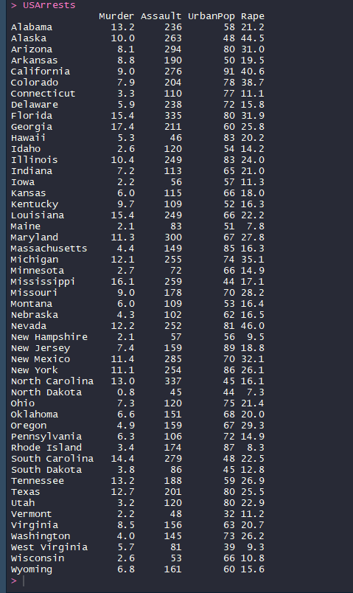

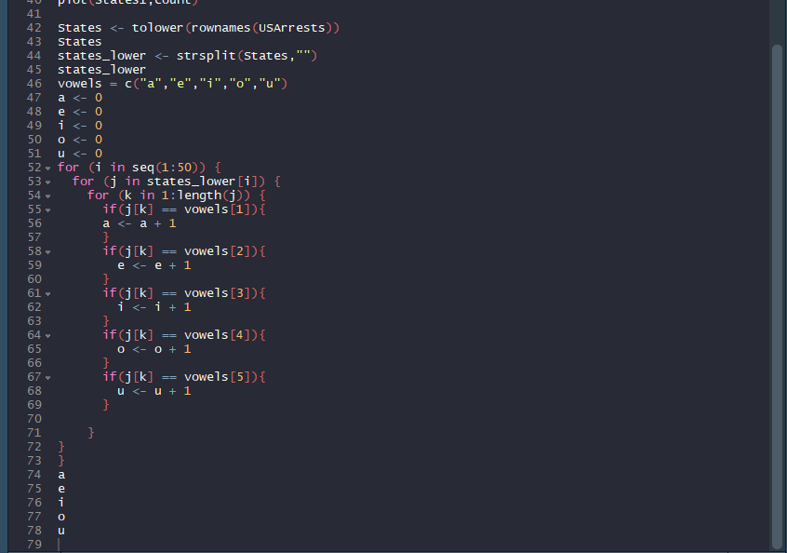

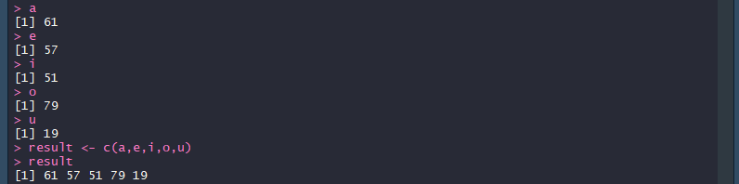

1. Visualize the vowels distribution.

