**Assignment7.2**

**Problem Statement:**

1. Write a program to create barplots for all the categorical columns in mtcars.

boxplot(mtcars$cyl,mtcars$vs,mtcars$am,mtcars$gear,mtcars$carb,main = "multiple boxplot",at = c(1,2,3,4,5),names = c("cyl","vs","am","gear","carb"),col = heat.colors(5),horizontal = FALSE,notch = TRUE)

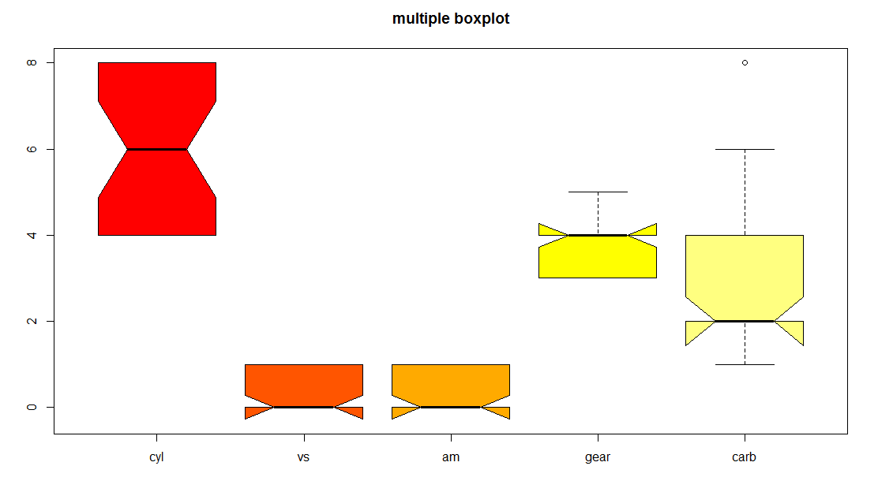

1. Create a scatterplot matrix by gear types in mtcars dataset.

library(car)

scatterplotMatrix(~cyl+mpg+disp+hp+drat+wt+qsec+vs+am+carb|gear,data = mtcars,main = "scatterplot wrt gear")

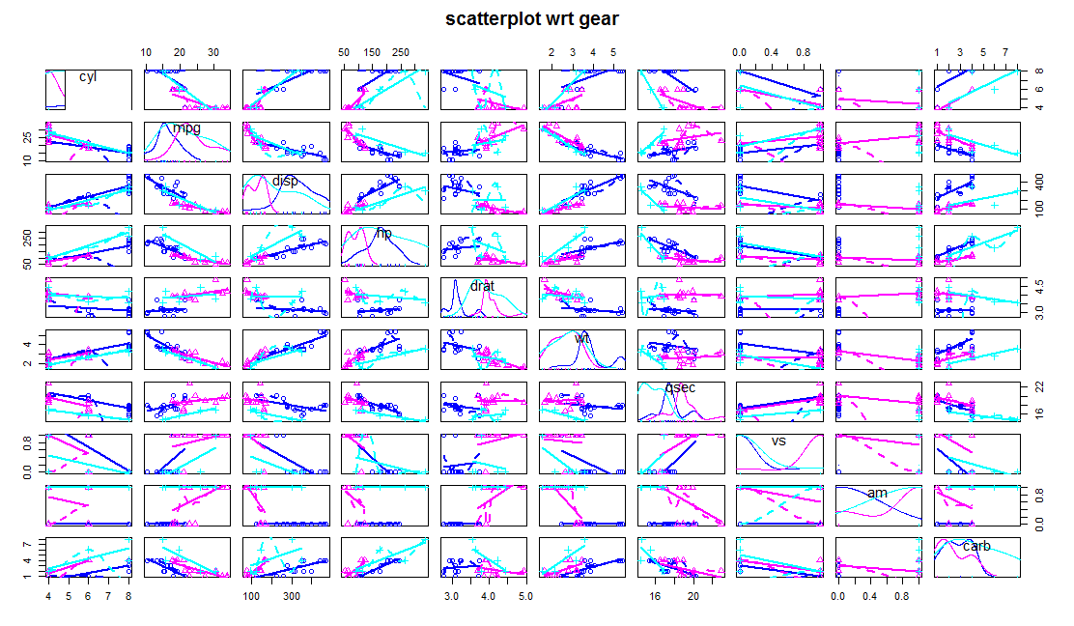

1. Write a program to create a plot density by class variable.

Library(ggplot2)

ggplot(data = mtcars)+ geom_area(mapping = aes(x = hp,y = wt,color = gear,group = gear,fill = gear,size = gear))

