**Assignment8.1**

**Problem Statement:**

1. Use the package RcmdrPlugin.IPSUR.

data(RcmdrTestDrive)

and perform the below operations:

1. Calculate the average salary by gender and smoking status.

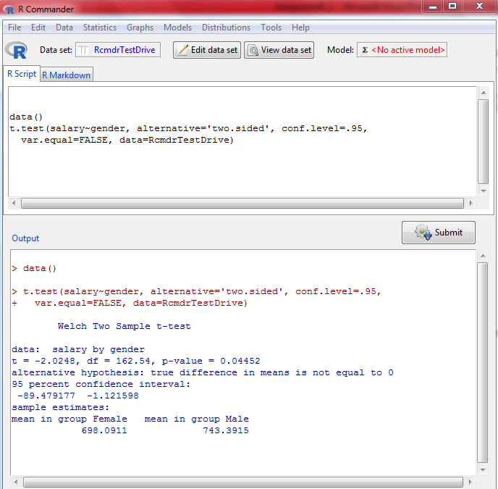

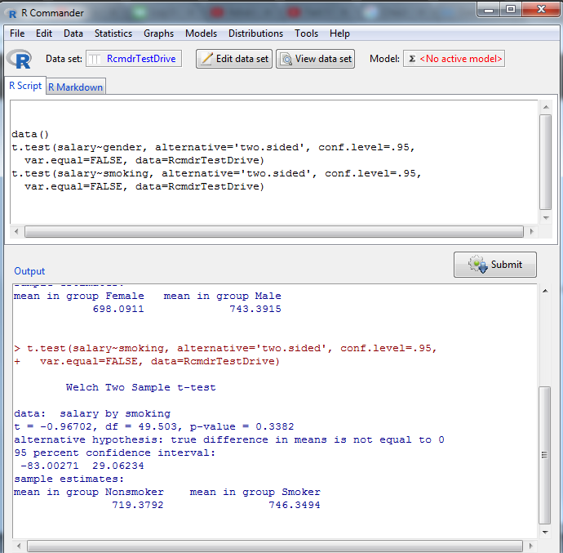

1. Which gender has the highest mean salary?

Males have the highest mean salary of 743.3915

1. Report the highest mean salary.

746.3494

1. Compare the spreads for the genders by calculating the standard deviation of salary by gender.

