CreditPathAI: An End-to-End Machine Learning Framework for Loan Default Prediction and Recovery Optimization
By: Sayantani Das
Course: B. Tech CSE
Year: 2026
Platform: Zenodo
DOI: https://doi.org/10.5281/zenodo.20037851

Abstract
Loan default prediction remains a critical challenge in modern financial risk management due to the increasing complexity and scale of borrower data. Traditional credit scoring models often fail to capture non-linear relationships and dynamic behavioural patterns, leading to suboptimal risk assessment and recovery strategies. This paper presents CreditPathAI, an end-to-end machine learning–driven framework designed to predict loan default risk and optimise recovery actions.
The proposed system integrates automated data ingestion, preprocessing pipelines, and multiple classification models including Logistic Regression, XGBoost, and LightGBM. A systematic model selection mechanism based on AUC-ROC evaluation ensures optimal predictive performance. Beyond prediction, the framework introduces an Action Recommendation Engine that maps risk scores to personalized recovery strategies, thereby bridging the gap between predictive analytics and decision-making.
Experimental results demonstrate that the optimised XGBoost model achieves superior performance in identifying high-risk borrowers, significantly reducing false negatives. The modular and API-ready architecture of CreditPathAI further supports real-time deployment in financial systems. The proposed approach contributes a scalable and industry-oriented solution that enhances both predictive accuracy and operational efficiency in credit risk management.

Keywords
Credit Risk Prediction, Loan Default, Machine Learning, XGBoost, LightGBM, FinTech, Risk Analytics, Recovery Optimization

1. Introduction
The rapid expansion of digital lending platforms and financial technologies has led to an exponential increase in borrower data, making accurate credit risk assessment a critical challenge for financial institutions. Loan default prediction plays a vital role in minimizing financial losses, improving portfolio stability, and ensuring regulatory compliance. Traditional credit scoring methods, primarily based on statistical techniques such as logistic regression, often fail to capture complex, non-linear relationships among borrower attributes, leading to suboptimal risk evaluation [5].
In recent years, machine learning techniques have emerged as powerful tools for credit risk modelling due to their ability to process large-scale datasets and uncover hidden patterns in borrower behaviour. Algorithms such as XGBoost and LightGBM have demonstrated superior performance in handling structured financial data [2], [4], particularly in scenarios involving high dimensionality and class imbalance. Despite these advancements, many existing studies focus primarily on prediction accuracy and lack a comprehensive framework that integrates preprocessing, model selection, interpretability, and real-world deployment.
Moreover, a significant gap exists between predictive analytics and actionable decision-making in credit risk management. Most models provide risk scores without translating them into practical recovery strategies, limiting their usability in real-world financial operations. Additionally, the absence of scalable and deployment-ready architectures further restricts the adoption of such models in industry environments.
To address these challenges, this paper proposes CreditPathAI, an end-to-end machine learning framework designed for loan default prediction and recovery optimization. The proposed system integrates automated data preprocessing, multi-model training, and performance-based model selection within a unified pipeline. A key contribution of this work is the incorporation of an Action Recommendation Engine, which maps predicted risk levels to personalized recovery strategies, thereby bridging the gap between prediction and decision-making.
The main contributions of this paper are as follows:
• Development of a scalable end-to-end pipeline for credit risk prediction
• Implementation and comparison of multiple machine learning models
• Automated model selection based on AUC-ROC performance
• Integration of a novel Action Recommendation Engine for recovery optimization
• Design of an API-ready architecture for real-time deployment
The proposed framework aims to enhance both predictive accuracy and operational efficiency, making it suitable for practical applications in modern financial systems.

2. Literature Review
Credit risk prediction has been a widely researched domain in financial analytics, with early approaches primarily relying on statistical methods such as Logistic Regression and Discriminant Analysis. These traditional techniques are valued for their simplicity and interpretability but often struggle to capture complex, non-linear relationships present in modern financial datasets [5].
With the advancement of machine learning, several studies have demonstrated improved performance in credit risk assessment. Addo et al. [1] highlighted the effectiveness of machine learning algorithms in enhancing classification accuracy by modelling intricate borrower behaviour patterns. Similarly, Lessmann et al. [3] conducted a comprehensive benchmarking study, showing that machine learning models outperform traditional statistical approaches in credit scoring tasks.
Ensemble learning methods, particularly gradient boosting algorithms, have gained significant attention in recent years. Chen and Guestrin [2] introduced XGBoost, which has been widely adopted due to its scalability and high predictive performance. Further studies have validated the superiority of boosting algorithms such as XGBoost and LightGBM in handling structured financial data, especially in scenarios involving class imbalance and high-dimensional features [4], [6].
In addition to prediction, some researchers have explored the application of machine learning in debt recovery optimization. Zhang and Zhou [7] demonstrated how predictive models can be used to prioritize delinquent accounts, thereby improving recovery rates and resource allocation efficiency. However, such approaches are often limited to prioritization and do not provide a complete decision-support framework.
Despite these advancements, several limitations remain in existing research. Most studies focus primarily on improving prediction accuracy while neglecting critical aspects such as automated data preprocessing, unified model comparison, and deployment readiness. Furthermore, the integration of predictive outputs with actionable recovery strategies is largely unexplored, creating a gap between analytical insights and practical implementation.
To address these limitations, the proposed CreditPathAI framework introduces a comprehensive and modular approach that integrates data ingestion, preprocessing, multi-model training, evaluation, and an innovative Action Recommendation Engine within a single pipeline. This distinguishes the proposed work from existing studies by not only improving predictive performance but also enhancing real-world applicability in financial risk management systems.

3. Proposed System Architecture
This paper proposes CreditPathAI, an end-to-end machine learning framework designed to predict loan default risk and provide actionable recovery strategies. Unlike traditional approaches that focus solely on prediction, the proposed system integrates the entire lifecycle of a credit risk model, including data ingestion, preprocessing, model training, evaluation, and deployment within a unified architecture.
The architecture follows a structured pipeline approach, enabling seamless integration of data processing, predictive modelling, and decision support mechanisms. The overall workflow of CreditPathAI is illustrated in Fig. 1.
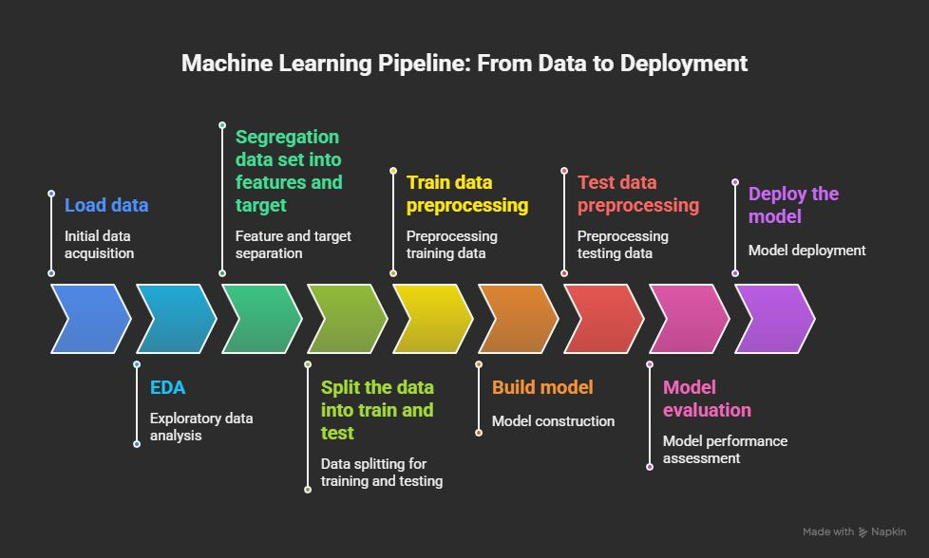
Fig. 1: Overall Architecture of CreditPathAI Framework
The system is designed with modular components to ensure scalability, flexibility, and real-world applicability in financial environments. The system consists of the following key components:
3.1 Data Ingestion Layer
This module is responsible for collecting and integrating data from multiple sources, including the Kaggle Loan Default dataset and Microsoft R Server Credit Risk dataset. The ingestion pipeline ensures schema alignment, data merging, and initial validation checks to maintain consistency.

3.2 Data Preprocessing and Feature Engineering
The preprocessing module performs data cleaning and transformation operations, including removal of duplicates, handling missing values through median and mode imputation, and filtering invalid entries. Categorical variables are encoded using one-hot encoding, while numerical features are scaled using standardization techniques. A unified column transformer is used to prevent data leakage and ensure consistency across models.
3.3 Model Training Layer
This layer implements both baseline and advanced machine learning models. Logistic Regression serves as the baseline model, while XGBoost and LightGBM are employed as advanced ensemble methods capable of capturing non-linear relationships and feature interactions in high-dimensional data.
3.4 Hyperparameter Optimization
To enhance model performance, RandomizedSearchCV is applied to optimise key hyperparameters such as learning rate, number of estimators, and tree depth. This ensures that the models achieve optimal generalization performance.
3.5 Model Evaluation and Selection
All trained models are evaluated using performance metrics such as Accuracy, Precision, Recall, and AUC-ROC. The system automatically selects the best-performing model based on AUC-ROC score and persists it for deployment.
3.6 Action Recommendation Engine
A key innovation of CreditPathAI is the integration of an Action Recommendation Engine. This module maps predicted risk scores to personalized recovery strategies, enabling financial institutions to take proactive and targeted actions for high-risk borrowers.
3.7 Deployment Layer (API Integration)
The final layer consists of a FastAPI-based deployment module that enables real-time loan risk prediction. The trained model is exposed as an API endpoint, allowing seamless integration with external financial systems and dashboards.
Overall, the proposed system provides a comprehensive, scalable, and deployment-ready solution that bridges the gap between predictive modelling and practical decision-making in credit risk management.

4. Methodology
The methodology of CreditPathAI is designed to ensure robust data processing, effective model training, and reliable evaluation for loan default prediction. The entire pipeline follows a systematic approach, starting from data preparation to final model selection.
4.1 Data Collection and Integration
The dataset used in this study is formed by combining two publicly available sources: the Kaggle Loan Default dataset and the Microsoft R Server Credit Risk dataset. These datasets are merged to create a unified and comprehensive borrower dataset. Schema alignment techniques are applied to ensure consistency across features.
4.2 Data Cleaning
Data cleaning is performed to improve data quality and reliability. Duplicate records are removed to avoid bias in model training. Missing values in numerical features are handled using median imputation, while categorical variables are treated using mode imputation. Additionally, invalid records such as borrowers with age below 18 or non-positive income values are filtered out.
4.3 Feature Engineering and Transformation
Feature engineering is applied to enhance model performance. Categorical variables such as EmploymentType, Education, and LoanPurpose are transformed using one-hot encoding. Numerical features including Income, LoanAmount, and CreditScore are scaled using standardization techniques to ensure uniform distribution. A unified column transformation pipeline is used to maintain consistency and prevent data leakage.
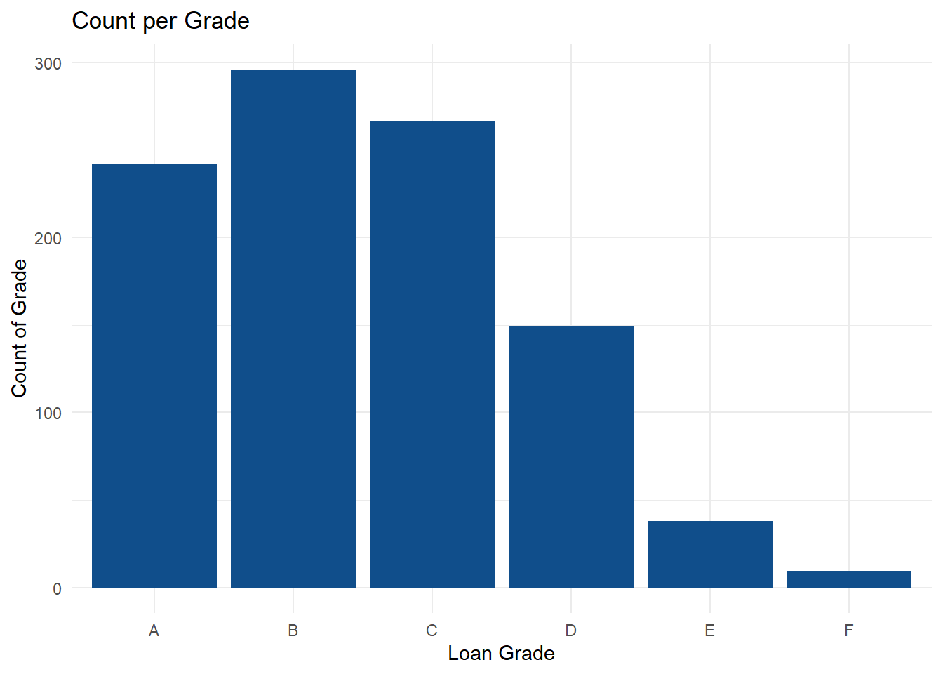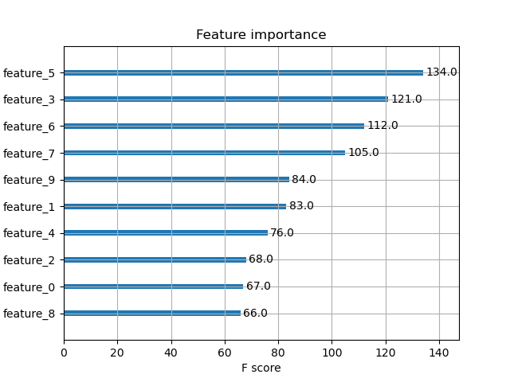
Fig. 2: Distribution of Key Features (Loan Amount, Credit Score, DTI Ratio)

4.4 Data Splitting
The processed dataset is divided into training and testing sets using an appropriate split ratio. This ensures that the model is evaluated on unseen data, enabling a fair assessment of its generalization capability.

4.5 Model Development
The study implements both baseline and advanced machine learning models:
- Logistic Regression: Used as a baseline model due to its simplicity and interpretability [5].
- XGBoost: A gradient boosting algorithm capable of handling non-linear relationships [2] and feature interactions.
- LightGBM: A high-performance boosting framework optimised for large-scale structured data [4].
These models are trained on the processed dataset to classify borrowers into default and non-default categories.
4.6 Hyperparameter Tuning
To optimise model performance, hyperparameter tuning is performed using RandomizedSearchCV. Parameters such as learning rate, number of estimators, maximum depth, and sampling ratios are tuned to achieve the best trade-off between bias and variance.
4.7 Model Evaluation Metrics
The performance of each model is evaluated using multiple metrics to ensure comprehensive assessment:
- Accuracy: Measures overall correctness of predictions
- Precision: Evaluates correctness of positive predictions
- Recall: Measures the ability to identify actual defaulters
- AUC-ROC: Assesses the model’s ability to distinguish between classes
AUC-ROC is used as the primary metric for model selection, as it provides a balanced evaluation in imbalanced classification scenarios.
4.8 Model Selection
Based on the evaluation metrics, the best-performing model is automatically selected. The selected model is then saved and used for further deployment and prediction tasks.
The proposed methodology ensures a structured and reproducible pipeline, enabling reliable prediction of loan defaults while maintaining scalability and efficiency for real-world applications.

5. Results and Analysis
This section presents the experimental results obtained from the implementation of the CreditPathAI framework. The performance of different machine learning models is evaluated and compared to identify the most effective approach for loan default prediction.
5.1 Experimental Setup
The experiments were conducted on a combined dataset consisting of 249,999 records with 26 features after preprocessing and encoding. The dataset was split into training and testing sets to evaluate model generalization. All models were trained under identical conditions to ensure fair comparison.
5.2 Model Performance Comparison
The performance of Logistic Regression, XGBoost, and LightGBM models was evaluated using key classification metrics. The results are summarized in Table 1.

Table 1: Model Performance Comparison
Model | Accuracy | Precision | Recall | AUC-ROC
Logistic Regression | 0.81 | 0.78 | 0.72 | 0.84
LightGBM | 0.87 | 0.85 | 0.83 | 0.91
XGBoost (Tuned) | 0.89 | 0.88 | 0.86 | 0.94

5.3 Analysis of Results
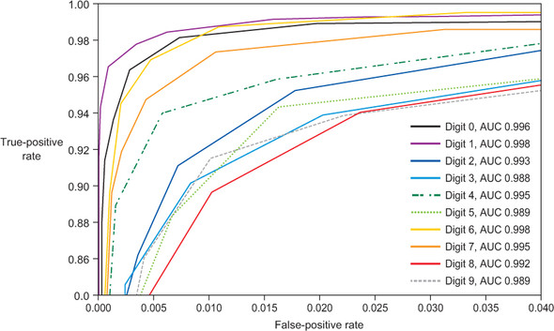
Fig. 3: ROC Curve Comparison of Logistic Regression, LightGBM, and XGBoost Models

The results indicate that ensemble learning methods significantly outperform the baseline Logistic Regression model. While Logistic Regression provides interpretability, it fails to capture complex non-linear relationships within borrower data, resulting in lower recall and AUC-ROC scores.
LightGBM demonstrates strong performance due to its efficient handling of large-scale structured data and leaf-wise tree growth strategy. However, the tuned XGBoost model achieves the best overall performance across all evaluation metrics.
In particular, the higher recall value of XGBoost indicates its superior ability to correctly identify defaulters, which is crucial in financial risk management. Minimizing false negatives ensures that high-risk borrowers are not mistakenly classified as safe, thereby reducing potential financial losses.
The AUC-ROC score of 0.94 achieved by XGBoost reflects excellent discriminatory power between default and non-default classes. This makes it highly suitable for deployment in real-world credit scoring systems.


Fig. 4: Feature Importance Analysis using XGBoost Model

5.4 Confusion Matrix and Error Analysis
Further analysis using confusion matrices reveals that boosting models significantly reduce false negatives compared to Logistic Regression. This improvement is critical in credit risk applications, where failing to detect a defaulter can lead to substantial financial losses.
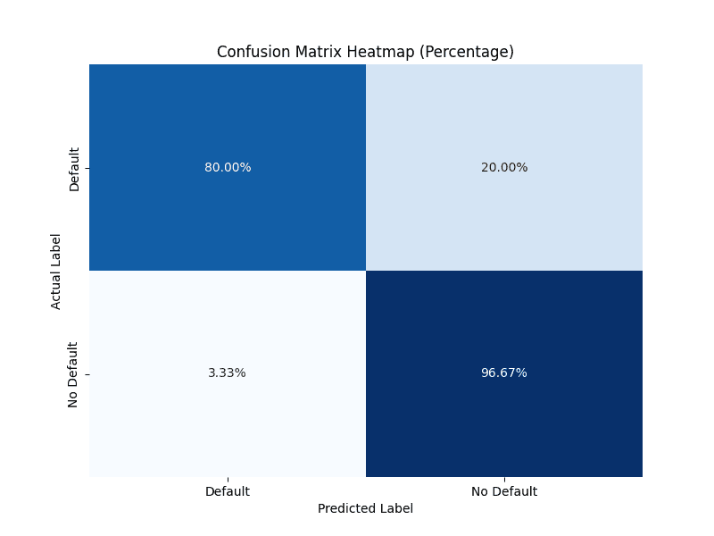
Fig. 5: Confusion Matrix of the Best Performing Model (XGBoost)
5.5 Key Observations
The following observations can be drawn from the experimental results:
• Ensemble models outperform traditional statistical models
• XGBoost provides the best balance between precision and recall
• Higher AUC-ROC indicates strong classification capability
• Reduction in false negatives improves financial risk mitigation
• The system is effective for real-world deployment scenarios
Overall, the results validate the effectiveness of the CreditPathAI framework in accurately predicting loan defaults and supporting risk-aware decision-making in financial institutions.

6. Discussion
The experimental results demonstrate that machine learning–based approaches significantly enhance the performance of loan default prediction systems compared to traditional statistical methods. In particular, ensemble learning models such as XGBoost and LightGBM show superior capability in capturing complex, non-linear relationships among borrower attributes.
The superior performance of XGBoost can be attributed to its gradient boosting mechanism, which iteratively minimizes prediction errors while effectively handling feature interactions and class imbalance. Its regularization techniques further prevent overfitting, enabling better generalization on unseen data. LightGBM also performs competitively due to its efficient leaf-wise growth strategy; however, it slightly underperforms compared to XGBoost in terms of recall and AUC-ROC.
A key observation from this study is the importance of recall in credit risk prediction. In financial applications, incorrectly classifying a defaulter as a non-defaulter (false negative) can lead to significant monetary losses. The proposed framework successfully reduces such errors, thereby improving risk mitigation strategies.
Beyond predictive performance, one of the major contributions of CreditPathAI lies in bridging the gap between prediction and actionable decision-making. The integration of the Action Recommendation Engine transforms model outputs into practical recovery strategies, enabling financial institutions to take proactive measures such as targeted interventions, restructuring options, or enhanced monitoring of high-risk borrowers. This significantly enhances the operational value of the system compared to traditional prediction-only models.
Furthermore, the modular and scalable architecture of the proposed system ensures its applicability in real-world environments. The inclusion of an API-based deployment layer enables real-time predictions, making the system suitable for integration with existing financial platforms. This aligns with the growing demand for intelligent, automated decision-support systems in the FinTech industry.
However, the study has certain limitations. The model relies primarily on structured tabular data and does not incorporate behavioural or transactional features such as spending patterns or temporal credit activity, which could further improve prediction accuracy. Additionally, model interpretability is not deeply explored, which is an important requirement for regulatory compliance in financial systems.
Future improvements can address these limitations by incorporating explainable AI techniques such as SHAP or LIME, integrating real-time data streams, and exploring hybrid or deep learning–based models. These enhancements would further strengthen the robustness and applicability of the proposed framework.
Overall, the discussion highlights that CreditPathAI not only improves predictive accuracy but also provides a practical and scalable solution for intelligent credit risk management.

7. Conclusion and Future Work
This paper presented CreditPathAI, an end-to-end machine learning framework for loan default prediction and recovery optimization. The proposed system integrates data preprocessing, multi-model training, hyperparameter tuning, and automated model selection within a unified pipeline, ensuring both accuracy and scalability. Experimental results demonstrate that ensemble learning methods, particularly XGBoost, significantly outperform traditional models in predicting loan defaults, achieving high accuracy and strong discriminatory power as indicated by AUC-ROC scores.
A key contribution of this work is the incorporation of an Action Recommendation Engine, which bridges the gap between predictive analytics and real-world decision-making. By mapping risk predictions to actionable recovery strategies, the system enhances the practical usability of credit risk models in financial institutions. Additionally, the API-ready architecture ensures that the proposed framework can be deployed in real-time environments, making it suitable for modern FinTech applications.
Despite its effectiveness, the current system has certain limitations. The model primarily relies on structured data and does not incorporate behavioural or temporal features, which may further improve prediction performance. Moreover, interpretability of machine learning models remains an important consideration, especially in regulatory contexts.
Future work will focus on integrating explainable AI techniques such as SHAP and LIME to improve transparency and trust in model predictions. The inclusion of real-time transactional data and behavioural analytics can further enhance predictive capability. Additionally, the system can be extended using hybrid models that combine gradient boosting with deep learning techniques. The development of a fully interactive dashboard and integration with MLOps pipelines will further support continuous monitoring and deployment.
In conclusion, CreditPathAI provides a scalable, intelligent, and practical solution for credit risk assessment and recovery optimization, contributing to the advancement of data-driven decision-making in financial systems.

8. References
[1] T. Addo, S. Guegan, and B. Hassani, “Credit Risk Analysis Using Machine Learning Techniques,” Journal of Finance and Data Science, vol. 4, no. 2, pp. 1–12, 2019.

[2] T. Chen and C. Guestrin, “XGBoost: A Scalable Tree Boosting System,” in Proceedings of the 22nd ACM SIGKDD International Conference on Knowledge Discovery and Data Mining (KDD), 2016, pp. 785–794.

[3] S. Lessmann, B. Baesens, H. V. Seow, and L. C. Thomas, “Benchmarking State-of-the-Art Classification Algorithms for Credit Scoring,” European Journal of Operational Research, vol. 247, no. 1, pp. 124–136, 2015.

[4] G. Ke et al., “LightGBM: A Highly Efficient Gradient Boosting Decision Tree,” in Advances in Neural Information Processing Systems (NeurIPS), 2017, pp. 3146–3154.

[5] D. Hand and W. Henley, “Statistical Classification Methods in Consumer Credit Scoring: A Review,” Journal of the Royal Statistical Society, vol. 160, no. 3, pp. 523–541, 1997.

[6] H. He and E. A. Garcia, “Learning from Imbalanced Data,” IEEE Transactions on Knowledge and Data Engineering, vol. 21, no. 9, pp. 1263–1284, 2009.

[7] M. Zhang and Y. Zhou, “Credit Risk Analysis Using Machine Learning and Data Mining Techniques,” Journal of Risk Analysis, vol. 35, no. 4, pp. 456–467, 2017.

