Step 1: Create Apple ID: <https://appleid.apple.com/account>

Step 2: Enroll: <https://developer.apple.com/programs/enroll/>

According to Apple, what we need before enrolling is:

### Enrolling as an Individual

If you are an individual or sole proprietor/single person business, get started by signing in with your Apple ID with [two-factor authentication](https://support.apple.com/en-us/HT204915) turned on. You’ll need to provide basic personal information, including your legal name and address.

### Enrolling as an Organization

If you’re enrolling your organization, you’ll need an Apple ID with [two-factor authentication](https://support.apple.com/en-us/HT204915) turned on, as well as the following to get started:

#### A D-U-N-S® Number

Your organization must have a D-U-N-S Number so that we can verify your organization’s identity and legal entity status. These unique nine-digit numbers are assigned by Dun & Bradstreet and are widely used as standard business identifiers. You can check to see if your organization already has a D-U-N-S Number and request one if necessary. They are free in most jurisdictions. [Learn more](https://developer.apple.com/support/D-U-N-S/)

#### Legal Entity Status

Your organization must be a legal entity so that it can enter into contracts with Apple. We do not accept DBAs, fictitious businesses, trade names, or branches.

#### Legal Binding Authority

As the person enrolling your organization in the Apple Developer Program, you must have the legal authority to bind your organization to legal agreements. You must be the organization’s owner/founder, executive team member, senior project lead, or an employee with legal authority granted to you by a senior employee.

#### A Website

Your organization’s website must be publicly available and the domain name must be associated with your organization.

[**Start Your Enrollment**](https://developer.apple.com/enroll/)

**Before You Begin**

* Creating a Google Play Developer account requires that you have a traditional Google account available. Make sure you have created a Google account ([https://accounts.google.com/SignUp)](https://accounts.google.com/SignUp).

## How to Set-up Your Google Play Developer Account and Google Wallet Merchant Account

### 1. Go to the Google Play Developer Console <https://play.google.com/apps/publish/signup/> and sign up for an account.

[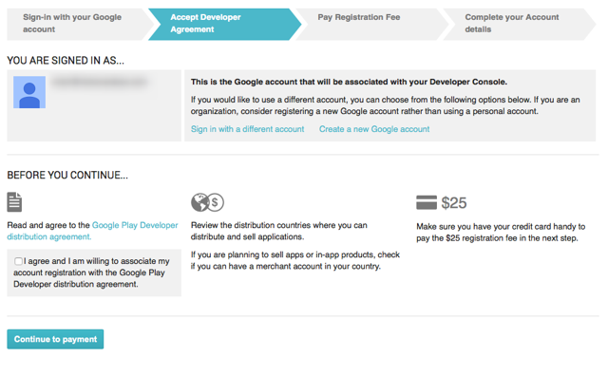](https://s3.amazonaws.com/screensteps_live/images/magplus/171042/1/rendered/03802578-a19a-4279-9129-c57fd17d2800.png)

### 2. Read and agree to the Google Play Developer distribution agreement.

[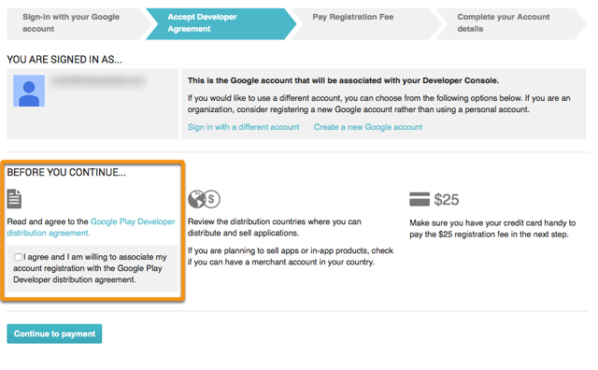](https://s3.amazonaws.com/screensteps_live/images/magplus/171042/1/rendered/7b4c387e-d7d1-4df0-943b-f13cc4365e70.png)

### 3. Pay the registration fee for your account.[Pay the registration fee for your account.](https://s3.amazonaws.com/screensteps_live/images/magplus/171042/1/rendered/76a0cbfc-7ebb-4a93-9500-29801e394558.png)

### 4. Fill out your Google Play Developer Profile.

[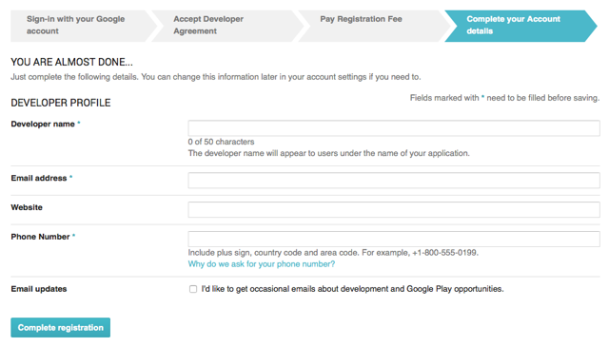](https://s3.amazonaws.com/screensteps_live/images/magplus/171042/1/rendered/019ddc0b-cbc3-43f3-8067-45160ca0ea14.png)

### 5. (Optional) If you plan to create paid apps or in-app purchases for products, set-up a Merchant Account.

This will prompt you to create a Google Wallet Merchant account. Follow the presented steps to complete your enrollment. You will be directed back to the Developer Console when your account is approved.

[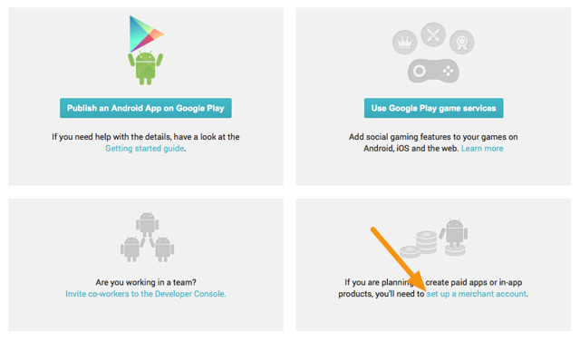](https://s3.amazonaws.com/screensteps_live/images/magplus/171042/1/rendered/39baf615-2ad9-4700-a41d-2901585c004a.png)

### 6. Go to Settings (Label 1) > Merchant Account to access a link to go back to your Merchant Account (Label 2).

[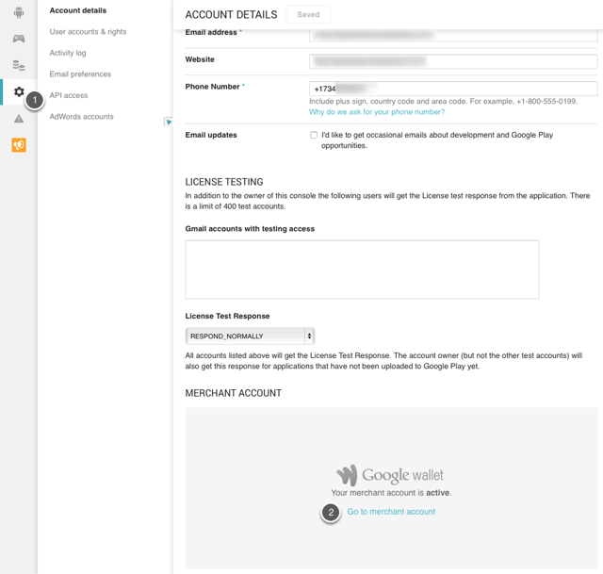](https://s3.amazonaws.com/screensteps_live/images/magplus/171042/1/rendered/96e830b4-7067-4981-936d-103e0820ef86.png)

### 7. In the Wallet Merchant Center, go to Settings (Label 1) > Sales Tax (Label 2) and fill out the appropriate details.

**Important Information**

* It is vital to set-up the proper sales tax for the geographic regions where you will sell your app. You can learn more about sales tax settings by [reading the Google Help article on charging sales tax](https://support.google.com/payments/answer/3092806).
* For more information on tax rates and value-added tax (VAT), [read the Google Help article on this subject](https://support.google.com/googleplay/android-developer/answer/138000?hl=en&topic=15867&ctx=topic).

[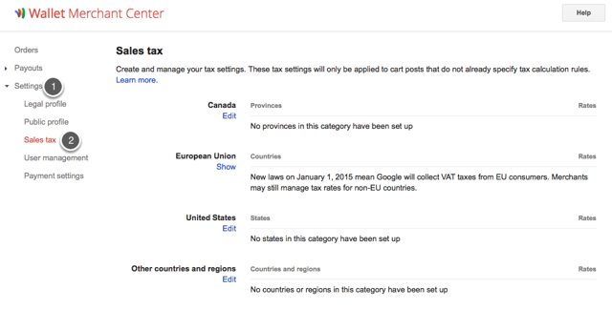](https://s3.amazonaws.com/screensteps_live/images/magplus/171042/1/rendered/62a1cb29-cf3c-497e-b053-b801da17da05.png)

## App Creation: Next Steps

Once you've set-up and configured your account, you can create a Google Play app and find your Google Play License Key. This key is tied to your branded Mag+ Android app and is entered in the Mag+ Publish portal prior to building your app.