

*Total Virtual Event & Social Media App*

**Phase 1 Release 2**

**Live P2P Events & Hologram**

After event types and categories are selected as in Release 1, P2P events are paramount as requested by users. Hologram can be used on P2P If the invited and Invitation is accepted, other guests can attend online on a P2P basis as well. Sample, Zoom or MS Team.

In addition to eMail Account SignUp Validation, Notification and Text should be sent to subscribers’ Phones.

**P2P Event Mode (Top Priority)**

* All guests connect on P2P to the event and those who are using hologram are connected the same way but those on Hologram are pushed to eSprayMe Event Engineers - eEE Hologram WorkArea for eEE to push to the Holographic Materials at the event location. Those on hologram will be located in 2 places - the general guest area and eEE work area for hologram push
* Once an Invite is sent, Click and Join using eMail address or Phone number. System can ask you to setup your profile later if you are new and have not signed up
* All Live invited guests(phone contacts, email, etc.) whether Accepted or not Accepted invitation, are notified by phone calls/notification and email as the event starts and they see the event info and other gateway info before joining the event. Should be made very simple to JOIN events Live with phone number/email and password. There must be daily(twice) notification 2 weeks before event starts
* ***If event link is sent to you or you’re on my phone contact, click on the link, sign-in/sign-up, subscription payment gateway, give donation(optional) but if concert - pay ticket, if hologram-(optional) - pay hologram if hologram , go straight to Live event. You can decide to spray or hologram after entering event***
* All Live P2P guests can spray Live after donation in different currencies
* Moderator/celebrant is able to pause audio and/or video for Guests
* All participants Accepted to event are able to
  + pause video and /or audio, talk, chat, and comment
* They are Muted by default. Can be Muted or suspended from the event by the celebrant/eEE
* Users must be able to comment on the main page, write what’s on their minds to the Home Page or their walls and share with others or the public with or without events.
* Post or Publish Photos/Videos to the main page.
* Able to interact outside and inside events or without events on the Home page

**Cover Charge P2P Event**

* This is also an option to select.
* Attendees purchase tickets and makes payments via Paypal , all on eSprayMe app
* Organizer/Celebrant receives notification of ticket buyers and email list of attendants
* Attendees are able to see event performer with ticket
* Performer/Celebrant appears Online Live for people to attend. Copy Pushed to Hologram at the same time at event location by eEEE if that option is selected by celebrant/coordinator/performer

**Mode Of Hologram (Top Priority)**

Mode of Hologram Usage is one or both of the following:

* ***Hologram Live (Top Priority)***
  + If Hologram Live is chosen, P2P video communication/Visual is required for eEE to push the remote person to the event stage at the event location via Hologram.
* ***Hologram Pre-Recorded:*** 
  + If Event Pre-recorded, then eEE pushes the pre-recorded video of the remote person to Holographic equipment at the event location
* If Hologram Pre-recorded, then eEE pushes the current Spraying/Dancing video to Hologram. ***Payment Gateway is Required***
* If Hologram Live, P2P video is required. ***Payment Gateway is Required***
* Hologram Special/Performing Guests - Attend Event Through Hologram
  + These are setup by celebrants or coordinators of the event. Celebrants/Coordinator pays a fee for the performing special guests for entrance into eSprayMe to perform.
* Event Performers on Hologram:
  + Musician
  + Stand Up Comedian
  + MC
  + DJ
  + Speech Giver
  + Eulogist
  + Lecturer
* Organizer or Celebrant adds event Type

**Event Engineers**

* eSprayMe Event Engineers– eEE page to be added for registered engineers as in Workers in Release 1 (uncompleted for Release 1)
* All guests connect on P2P to the event and those who are using hologram are connected the same way but they also show up at eEE Hologram WorkArea for eEE to push to the Holographic Materials at the event location. The engineers are set up by eSpray Admin and can be selected by celebrant/event coordinator from a drop-down using GPS, name search or eEE ID search if known. The nearest eEE to that event location is displayed for celebrant/event coordinator to select for the event Holographic work
* Guests can spray Live or through Hologram with Name, location, Amount Sprayed showing on screen in respective currency. Currency should be animated.
* Guest should be able to spray guest Live in the same event
* The celebrant, the guest or the event coordinator pays for Hologram on behalf of the invited guest appearing on Hologram.

**2. Payment Gateway**

* + Live Event like Concert which can be on Hologram requires Cover Charge/Tickets
    - Organizer or event owner sets up the event and indicates ticket price.
    - Attendees purchase tickets and makes payments via Paypal , all on eSprayMe app
    - Organizer/Celebrant receives notification of ticket buyers and email list of attendants
    - Watched Online or be present at the event location where Holographic materials are manned by eEE
    - Guests:
      * Concert Performer
      * Bands
      * Stand Up Comedy
      * Stage Shows
      * Musician
      * Stand Up Musician
      * MC
      * DJ
      * Games - Sports of any kind
      * Olympics
      * etc

**Timing & Fees/Duration to Perform via Hologram is Setup By Admin**

* 15 Minutes attracts a fee
* 30 minutes attracts a fee
* 1 hour upto 24 hours. Each hour attracts a fee setup in Admin

**Payment gateway**

* All contributions, fees and X% of contributions are made to eSprayMe through Paypal
  + Live guests spraying event celebrant Live on P2P
    - eSprayMe takes X% sprayed and remit balance to event celebrant
  + Concert or Gate Fee/Cover Charge event on P2P:
    - eSprayMe takes X% of fee and remit balance to event owner
  + Hologram event coordinator, celebrant or guest appearing through Hologram P2P
    - Usage is paid to eSprayme directly based on duration above

| **Description** | **Partner Commission?** | **Amount/%** |
| --- | --- | --- |
| eSprayMe Subscription | No | Admin Setup |
| P2P Event - Live - Spray | Yes | Admin Setup |
| Event - Pre-Recorded Spray | Yes | Admin Setup |
| Hologram Relocation/Rental Per day | No (only eEE as eSprayMe contractor) | Admin Setup |
| P2P Event with Cover Charge/Tickets. | No | Admin Setup |
| P2P Live - Hologram - 15 minutes | Yes | Admin Setup |
| P2P Live - Hologram - 30 minutes | Yes | Admin Setup |
| P2P Live - Hologram - Per Hour | Yes | Admin Setup |
| Adverts - Homepage - Prints | No. ( In-House Marketing Staff) | Admin Setup |
| Adverts - Homepage - video | No. ( In-House Marketing Staff) | Admin Setup |
| Adverts - Prints - During Virtual P2P Live Event | No. ( In-House Marketing Staff | Admin Setup |
| Adverts - Video - During Virtual P2P Live Event (max of 1 Minute) | No. ( In-House Marketing Staff | Admin Setup |

***Methods & Descriptions***

| **Description** | **Remarks** | **Amount/%** |
| --- | --- | --- |
| eSprayMe Subscription | Leave Gray | Admin Setup |
| P2P Event - Live - Spray : | Celebrants indicate one of the listed payment methods to receive money sprayed. Guests pay commission thru paypal before paying a celebrant through selected payment methods above. | Admin Setup |
| Event - Pre-Recorded Spray | Celebrants indicate one of the listed payment methods to receive money sprayed. Guests pay commission thru paypal before paying a celebrant through selected payment methods above. | Admin Setup |
| Holographic MATERIALS Relocation/Rental Per day - 2 types   * Holo- Mesh * Holo-Glass * Projector - default $0.00 * Laptop - default $0.00 * Backdrop Frames - default $0.00 | Pay by PayPal via debit or credit card only | Admin Setup |
| P2P Event with Cover Charge/Tickets. | Pay by PayPal via debit or credit card only | Admin Setup |
| Envelope Money Gift offered to celebrant outside the app | eSprayMe Commission Paid via PayPal | Admin Setup |
| GiftBox to Celebrant | eSprayMe Commission Paid via PayPal. Not %Commission but a fixed amount | Admin Setup |
| P2P Live - Hologram - 15 minutes | Pay by PayPal via debit or credit card only | Admin Setup |
| P2P Live - Hologram - 30 minutes | Pay by PayPal via debit or credit card only | Admin Setup |
| P2P Live - Hologram - Per Hour | Pay by PayPal via debit or credit card only | Admin Setup |
| Adverts - Homepage - Prints | Pay by PayPal via debit or credit card only | Admin Setup |
| Adverts - Homepage - video | Pay by PayPal via debit or credit card only | Admin Setup |
| Adverts - Prints - During Virtual P2P Live Event | Pay by PayPal via debit or credit card only | Admin Setup |
| Adverts - Video - During Virtual P2P Live Event (max of 1 Minute) | Pay by PayPal via debit or credit card only | Admin Setup |

**Support Workers**

* To be completed as already in Phase 1 Release 1.
* Celebrants/ Coordinator should be able to select and assign workers based on GPS of events and workers
* They pay workers directly

**The Flow**

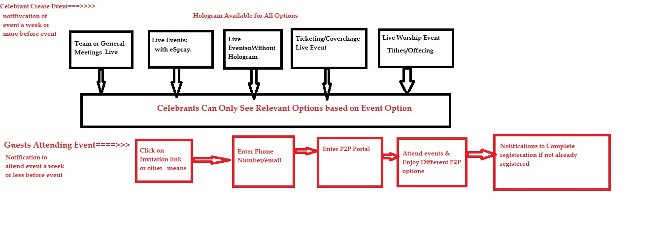

**P2P Event**

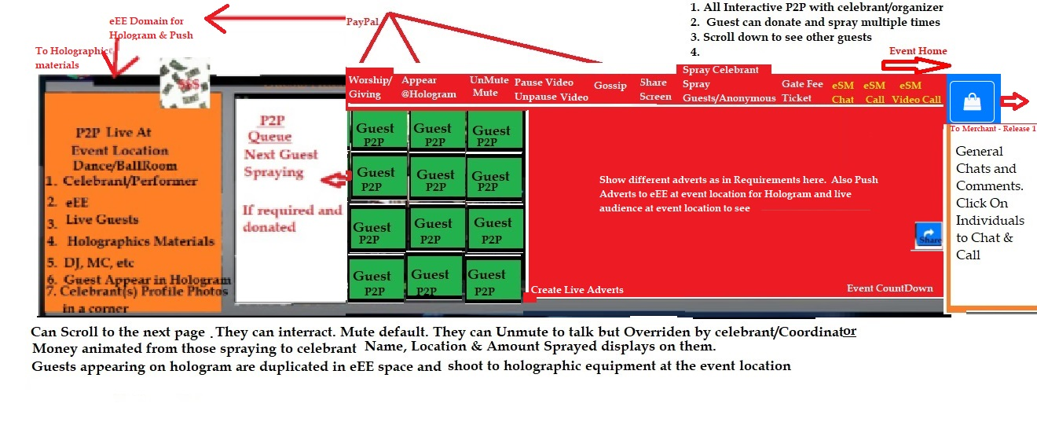

**Summary**

Release 2 in Phase 1 includes Hologram which enables event participants, host, guests, etc to appear at the event location from any part of the world. Note that Hologram is optional for the following:

* Team or General Meetings. Host or Guest speaker can come to meeting location via hologram
* Worship Center Live with Tithes & Offerings. Worship Leaders are able to preach from anywhere and appear on the altar to the congregation
* Concert/Shows/Band/Others with Cover Charge & Ticketgateway
* A Social Event with Money Spraying will be Live. Guests can spray the celebrant, guests can spray guests, Throw money to the audience, etc and money in your bank account

**Others:**

* eSM Chat - For Text Chats
* eSM Call - For Audio Calls
* eSM Videos - For Video Chats
* Go Live - example, XYZ is Live now - for monolog or events
* Post Your Thoughts - Stories with Videos/Photos
* Add photos, videos, etc. to your status/
* Adverts during Live event

Users are able to Like, Comment, View, and Monetize videos etc. You will be able to share contents and events with Friends, Selected People or Public

**Modification of the existing eSprayMe Phase 1 Release 1**

Add the below items to the original phase 1 release 1: eSM Chat, eSM Call, eSM Videos. Use respective icons for thewith eSM blue prints on the Icons. People should be able to invite friends to join eSprayMe from their phones, email and other social media.

Video and print ads are also allowed in the general home page and individual’s profiles.

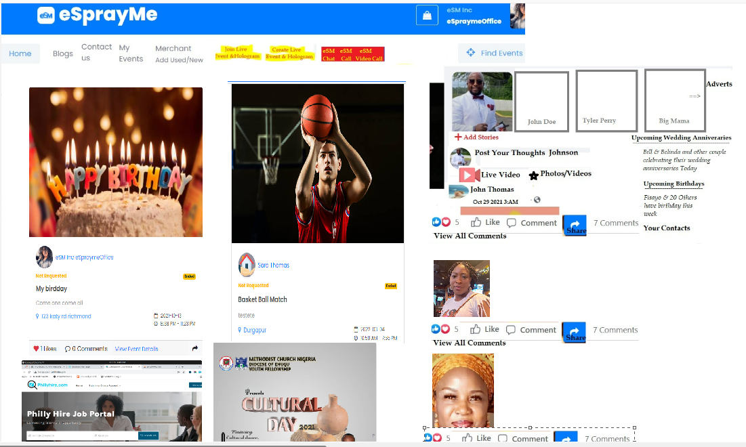

Event workers Module to be completed below:

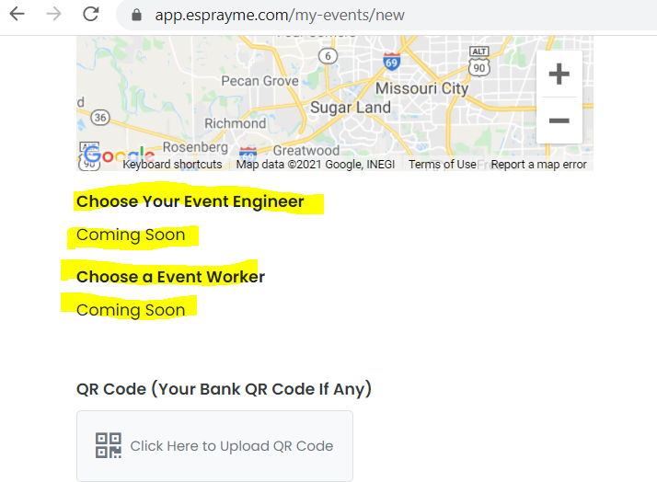

Make the following correction:

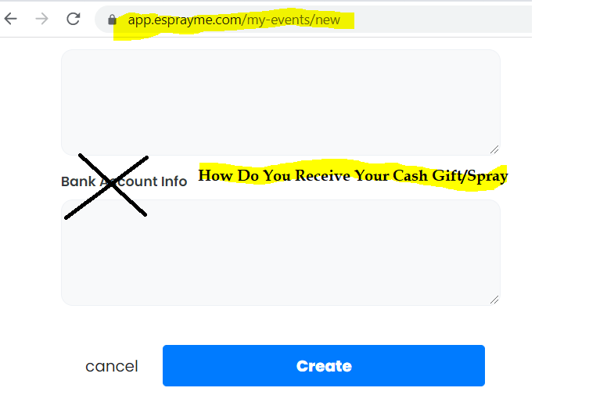

**Summary2**

Team or General Meetings. Host or Guest speaker is able to attend and appear at meeting location via hologram

eSprayMe Social Events with giving & spraying money and gift items

Worship Center Live Worship and Giving of Tithes & Offerings.

Worship Leaders are able to preach from anywhere and appear on the altar to the congregation via Hologram Live

Concert/Shows/Band/Others with Cover Charge & Ticket gateway

A Social Event with Money Spraying will be Live. Guests can spray the celebrant,

guests can spray guests, Throw money to the audience, etc and money in your bank account

Others.

Pre-recorded guest spraying & celebrant dance video events. Saves Time & Money for busy celebrants & guests.

Hologram - state-of-the-arts Technology that enables event participants, host, guests, etc to appear at any event location from any part of the world for all types of Meetings, social events, and others.

eSM Chat - For Text Chats

eSM Call - For Audio Calls

eSM Videos - For Video Chats

Go Live - example, XYZ is Live now - for monologue or events

Post Your Thoughts - Stories with Videos/Photos

Add photos, videos, etc. to your status

Adverts during Live event

Users are able to Like, Comment, View, and Monetize videos etc. You will be able to share contents and events with Friends, Selected People or Public

Buy & Sell New & Used items and services free at no cost.