***Step-by-step guide to add Product Stripe ID and assign course***

1. **Create product stripe ID:**
2. Login using your stripe credential:

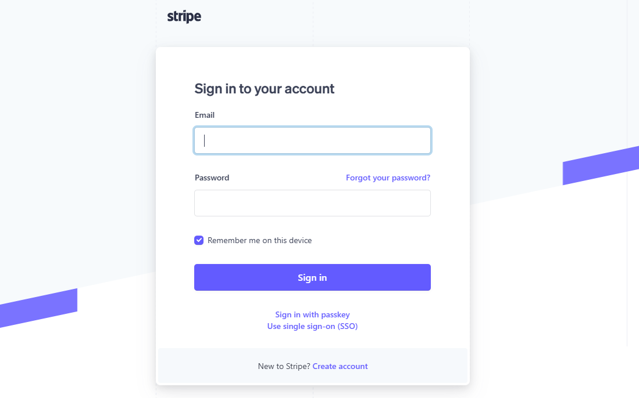

1. Click on “**Product catalog**” then “**Create product**”.

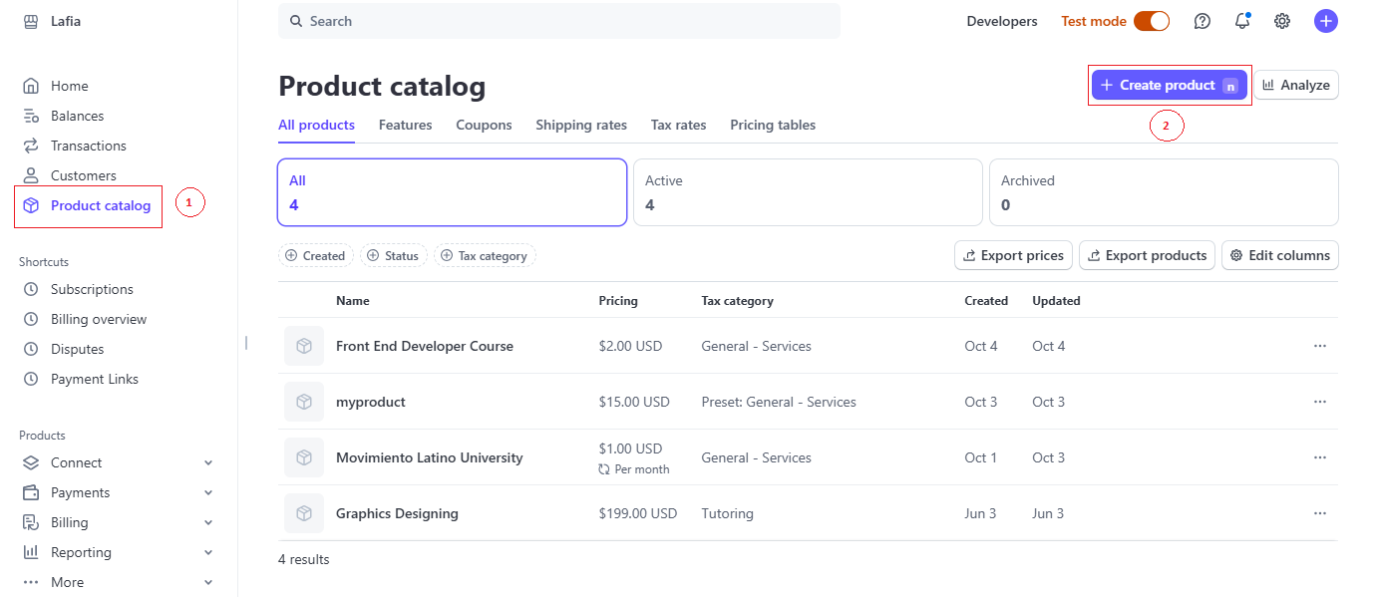

1. Once you click on the “Create product” button. You will get a popup. Fill the necessary details as per your requirement and click on “Add product”.

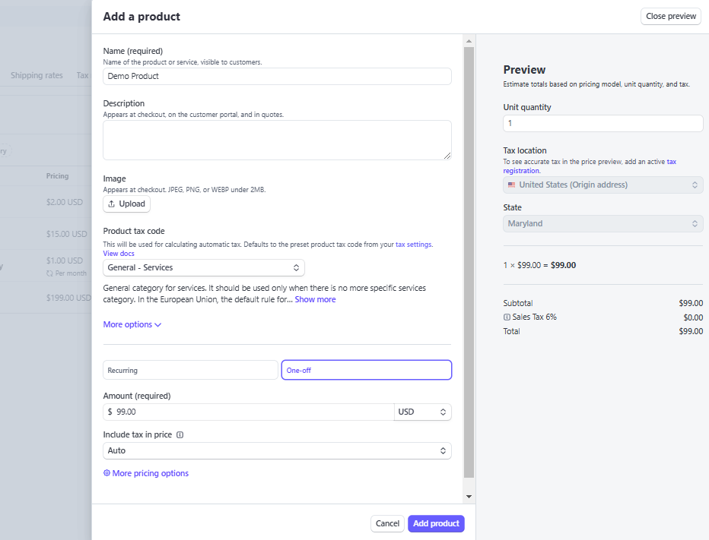

1. 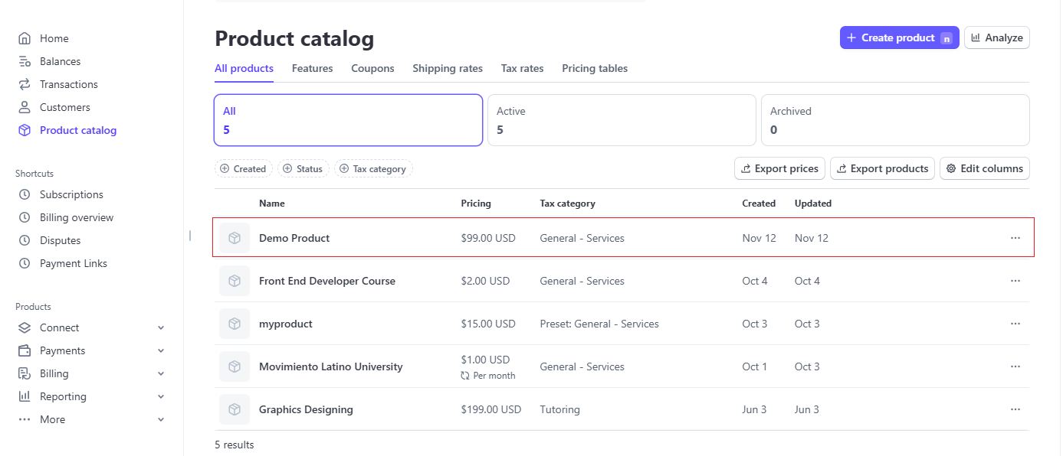Newly created product will be listed in the “Product catalog” Section. Once click on the record you will get the product ID (Please see the screenshot below). You can use the product ID, while adding course.

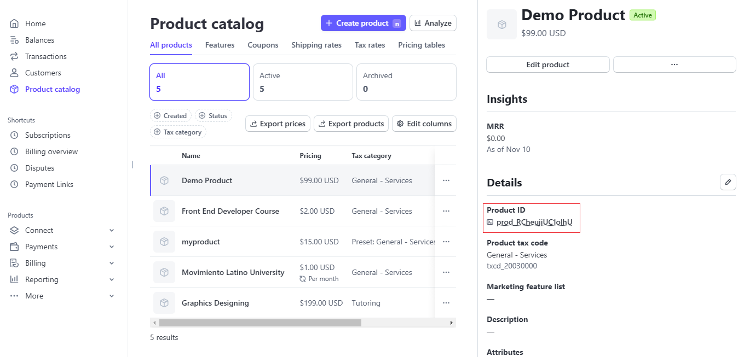

*Note: Remember that course price and Stripe product amount needs to be same. Always Check the environment while creating any product catalog. Please find attach screenshot below.*

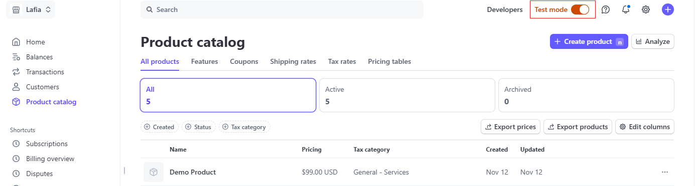

1. **Assign Course to the instructor:**
2. 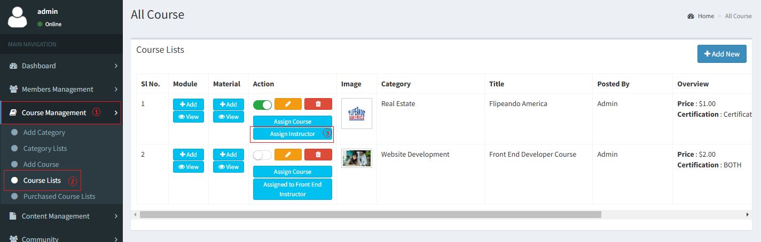Only admin can assign any unassigned course to any instructor.
3. Once click on the assign course admin will get a pop-up, which contain instructors list. Admin need to choose an instructor from the list and then click on “Assign” to assign instructor for that particular course.

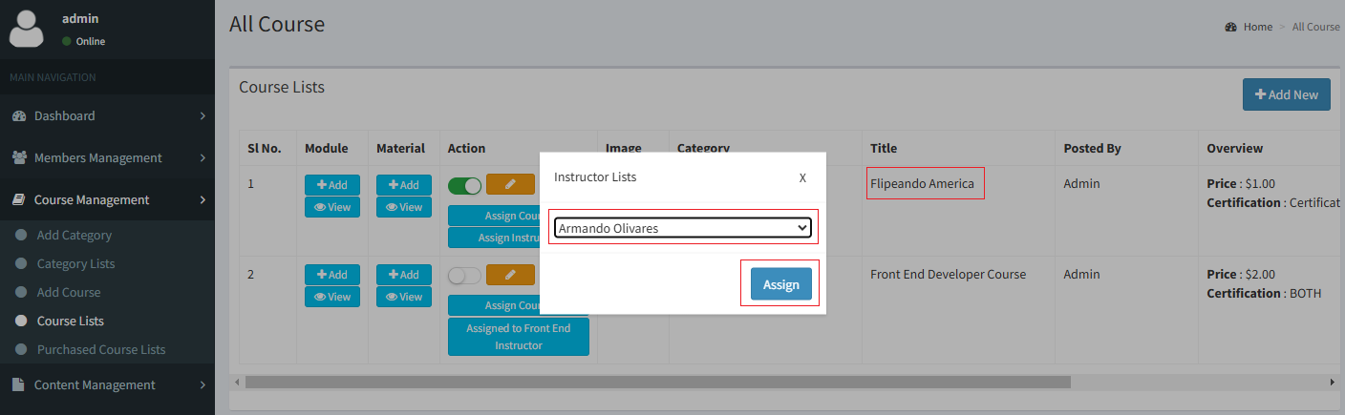

1. Once that instructor login using a valid credential that assigned course will be listed in the course list section.

