Documentation of Employee
- Employee Sign-Up:
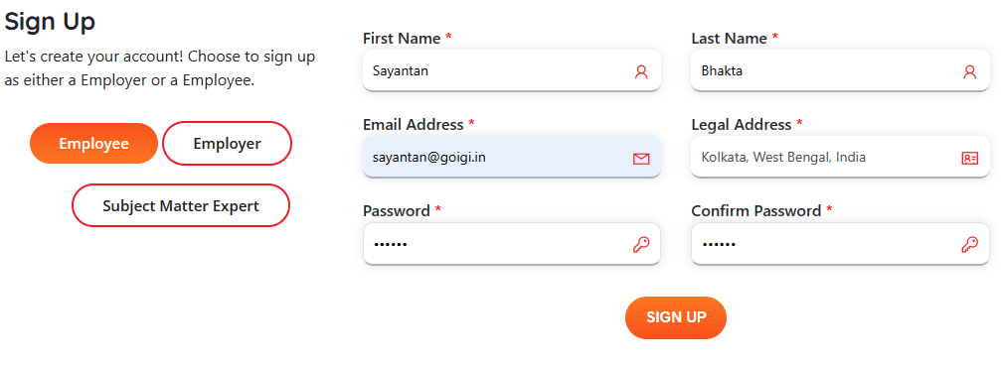
- Email Notification:
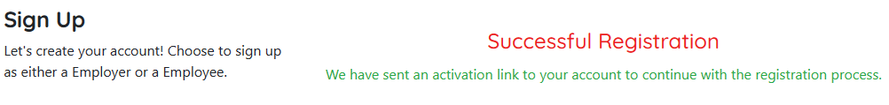
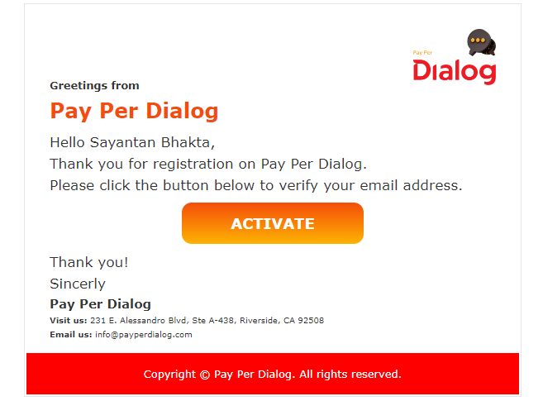
User can only login after clicking on the “Activate” button.
- Login as an Employee:
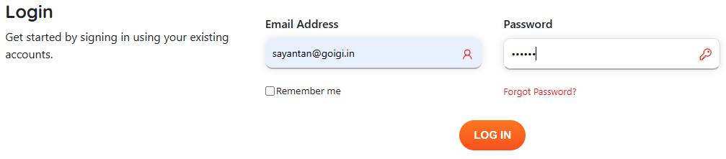
- Profile Page after login:
After login using the valid credential, user will redirect to their profile page, it will show a pop-up to accept the user agreement. After accept it will reload the profile page.

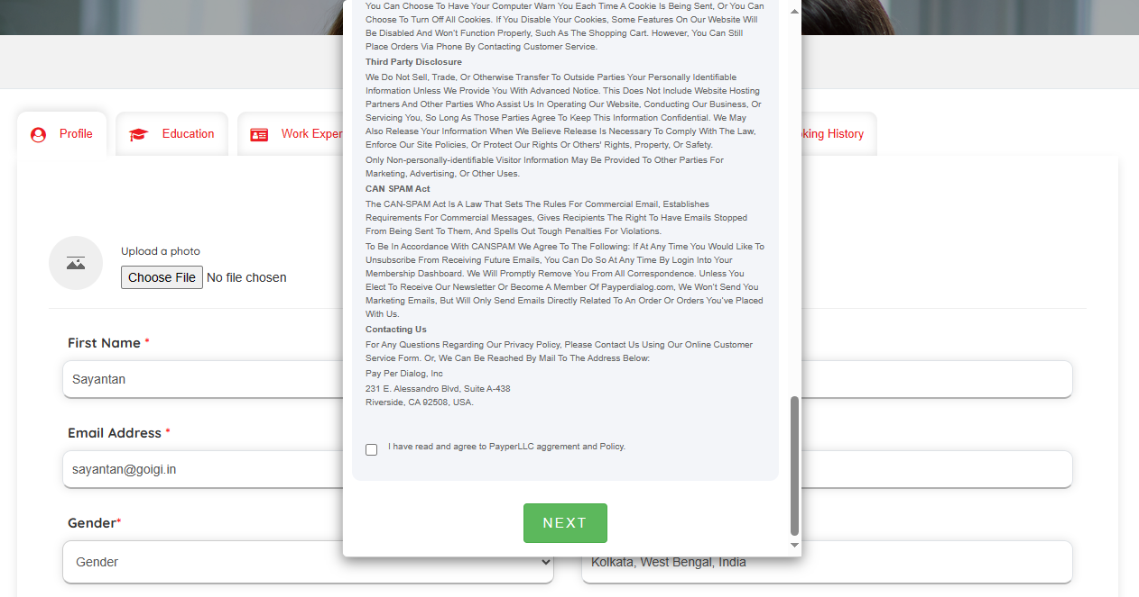
- Employee need to fill the required fields before accessing the other tab. Employee can add “Education”, “Work experience”, “My Jobs”, “Message”, “Availability”, and “Booking History”.

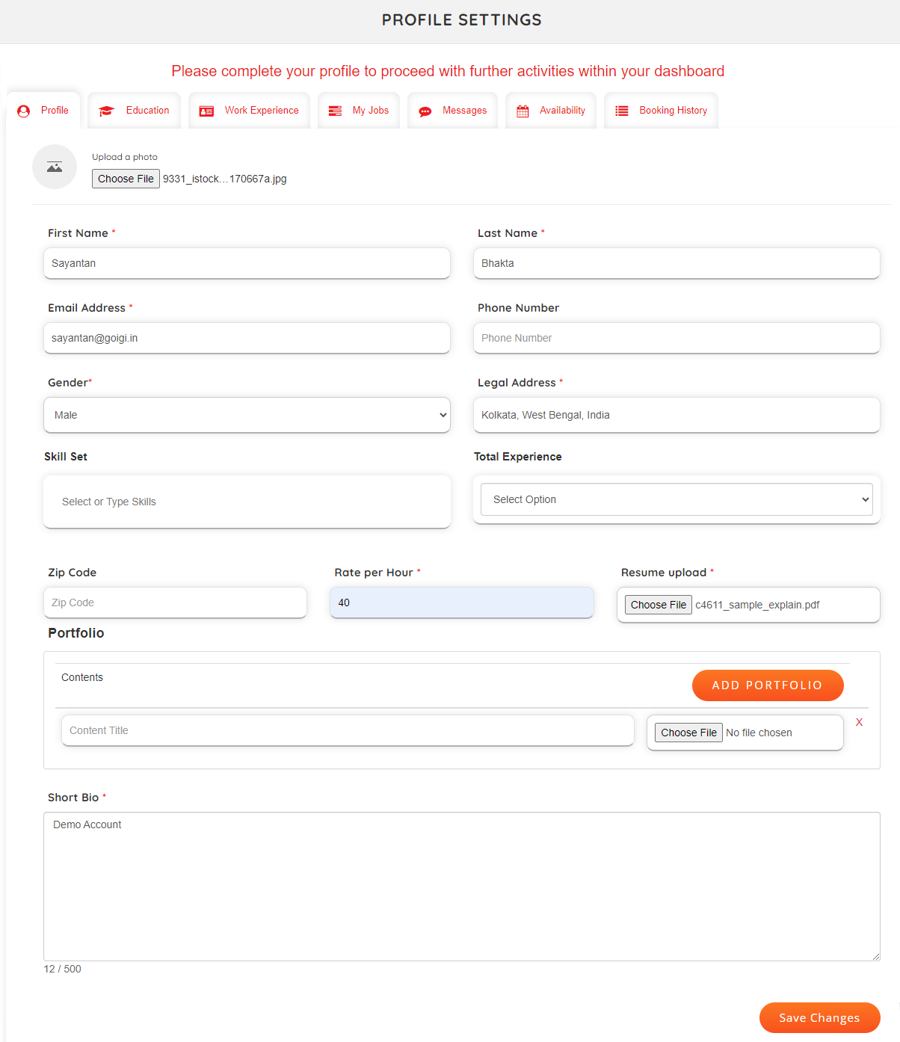

- Employee Education:
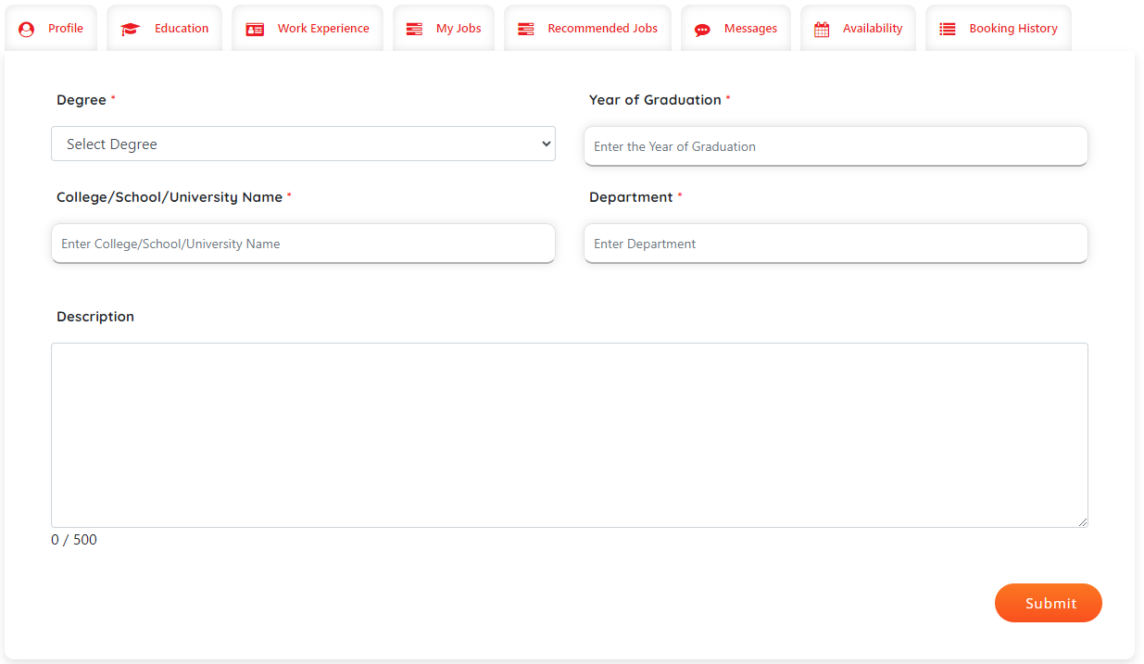
Education Details will show in employee details page.
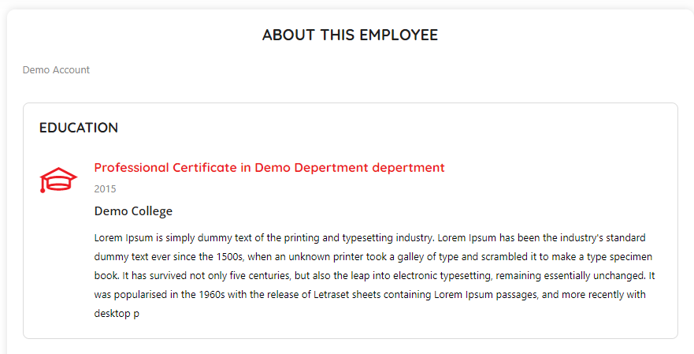
- Work Experience:
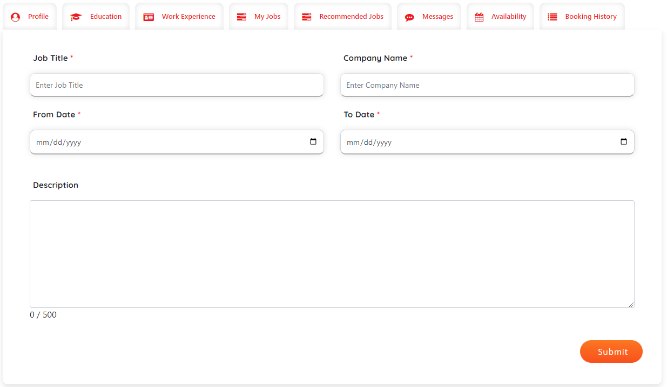
Work Experience details will show in employee details page.
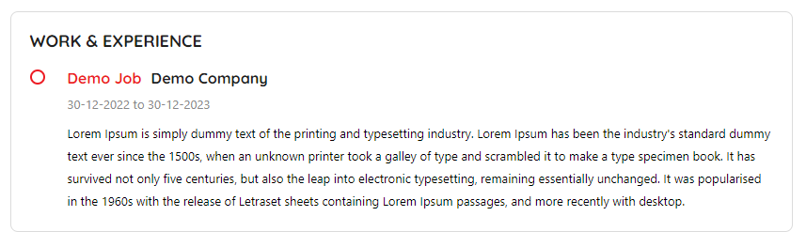
- My Jobs for employee:
In my jobs “Apply for jobs” button will be there, if there is no job bid by employee.
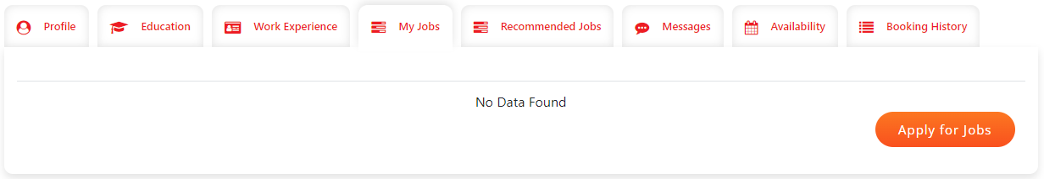
Click on the “Apply for jobs”, employee will be redirecting to the Job listing page.
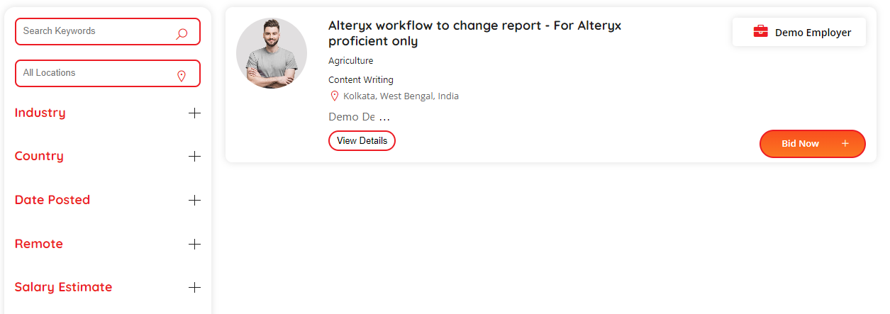
- Bid Now:
Click on “Bid Now” will redirect user to Job details page, where employee can bid job based on their preference.
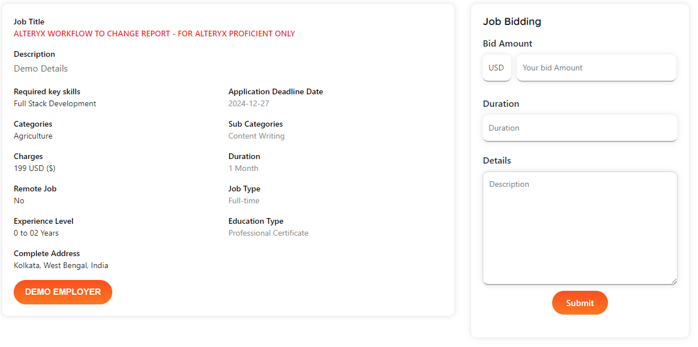
Without updating the profile data employee cannot be able to bid job. Job bid option will be disabled for those.
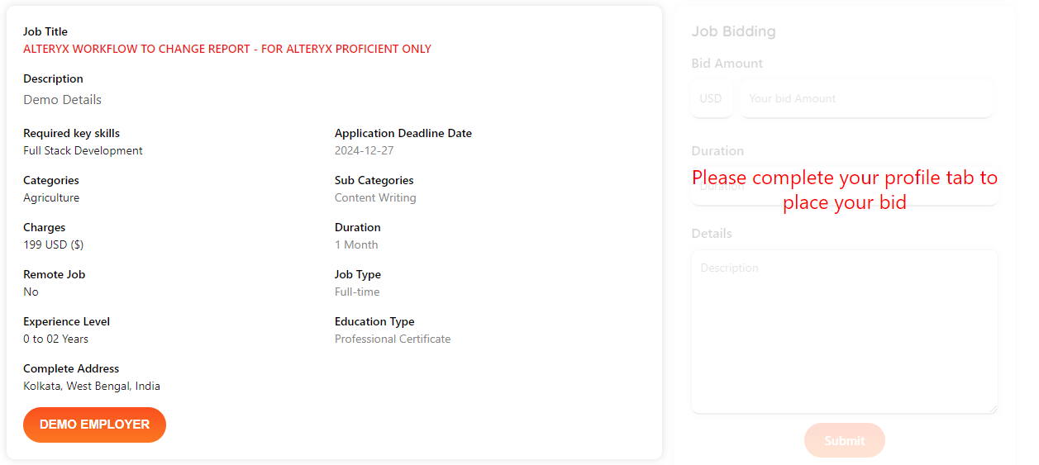
- After job bid the listing will show in the My job profile. By default, it will show as pending.
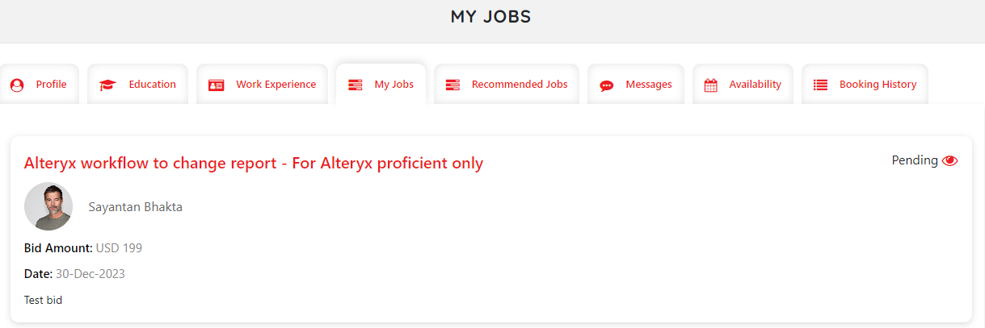
Once the status became “Selected” that particular employer and employee cam communicate through “Message” tab.
- Availability:
Once user click on the calender date, one pop-up will appear, where employee can set availability for each date.
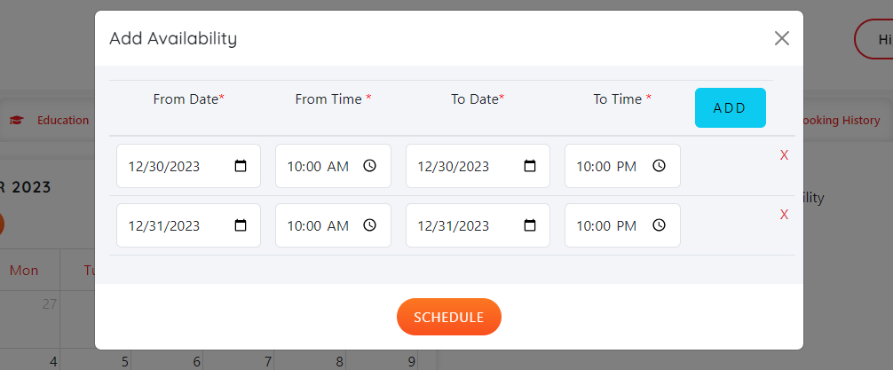
After adding the data the listing page will be
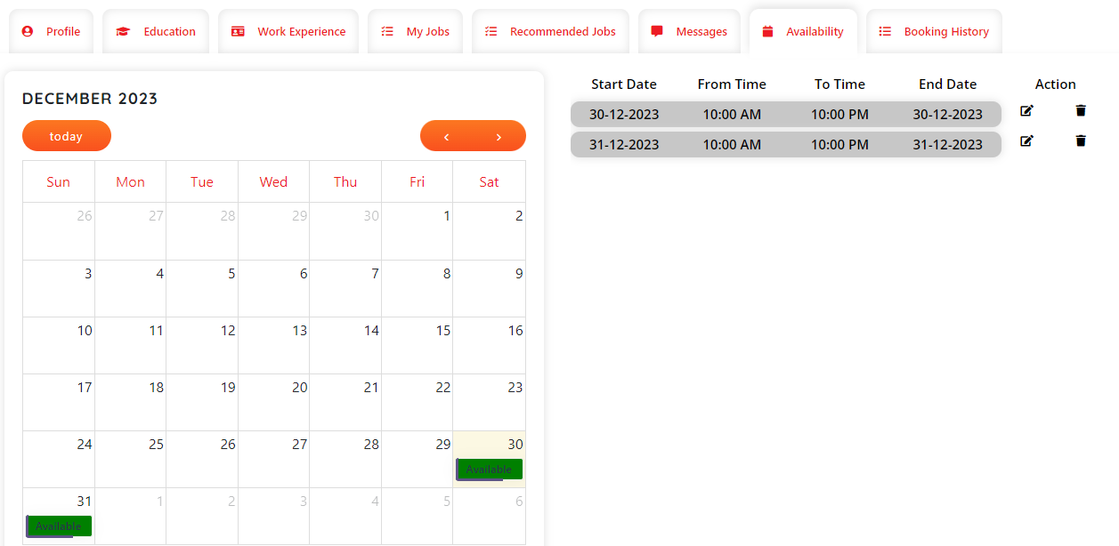
User can edit/update, and delete the availability. If any employer books any slot for a particular date, employee will not update or delete that availability data.
- Booking Details:
Once any employer books any slot from employee details page, the booking data will show in this tab.
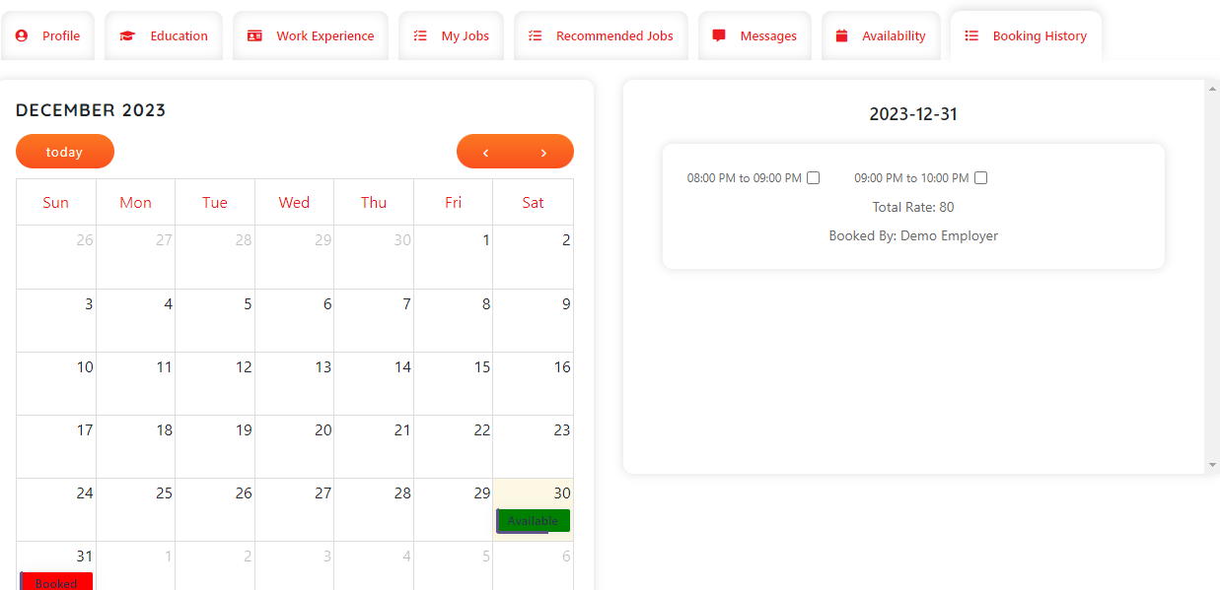
- Recommended Job: Employee can search job based on their skill sets.

