Feedback
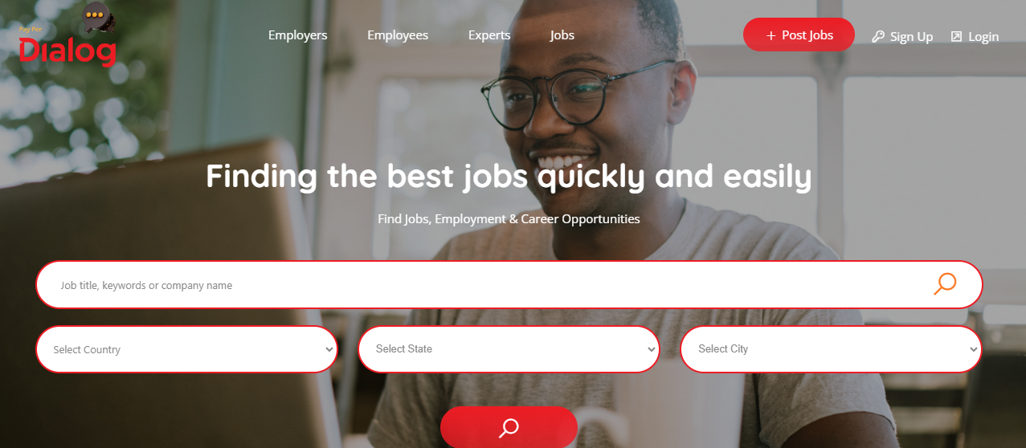

We can change the “employees” to “Job Seekers”
When I click the Employee – it shows me a list of employees. That is incorrect if I am a job seeker myself. It should take me to a portal where I have information about my resume, my skills etc, the jobs I applied to and the interviews scheduled for me.
When I click on Employers – it shows me a list of employers. It should ideally take me to an employer portal – with jobs I posted, candidates who applied, the money I spent etc.
--

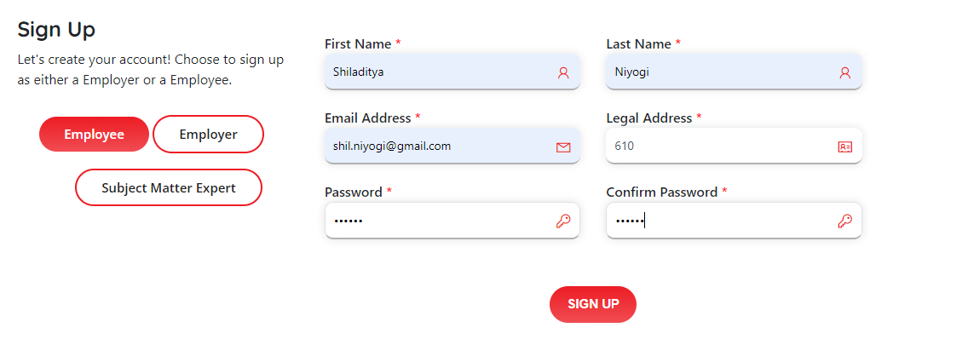
As I sign up, can we have some rules for the password (e.g. alphanumeric and special keys)
--
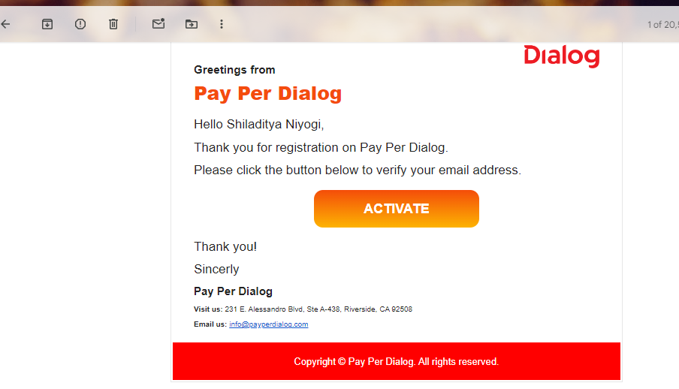
Looks good – may have to change the verbiage later
--
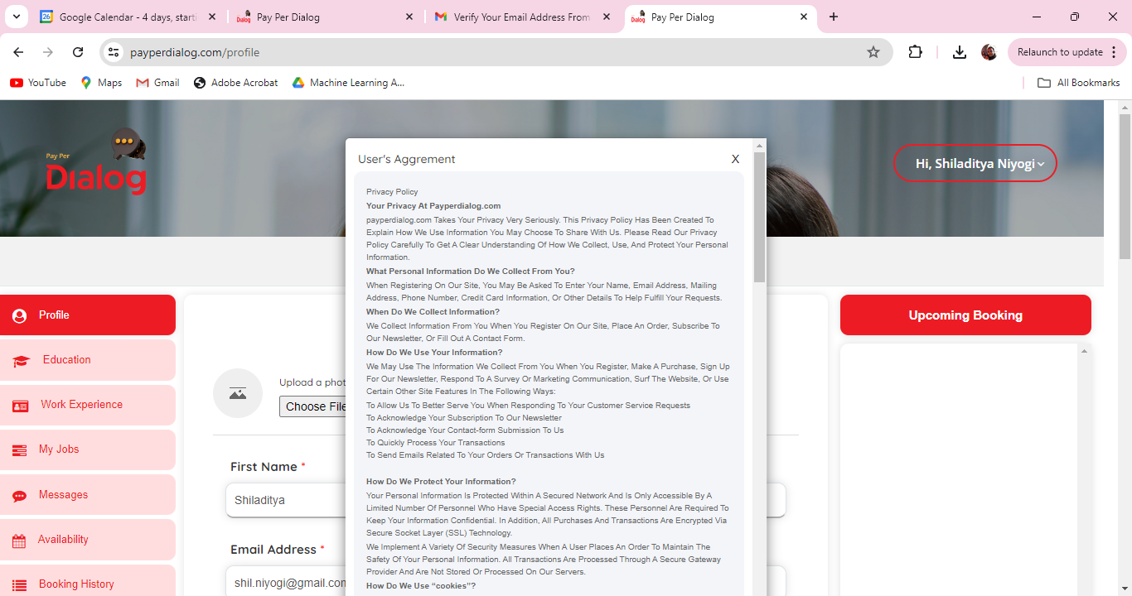
Will have to change the User’s agreement verbiage

