- Program to write the first 10 numbers.
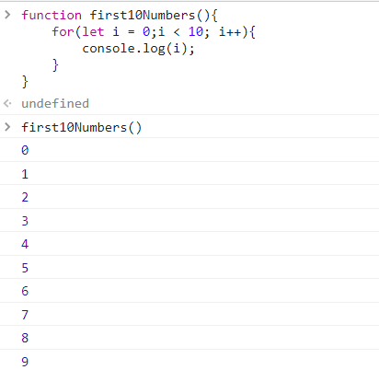

2.Program to calculate the sum of first 10 numbers.
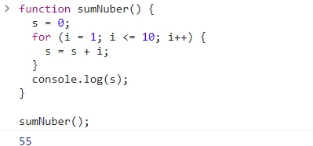

3.Make the loop stop when I is 5. 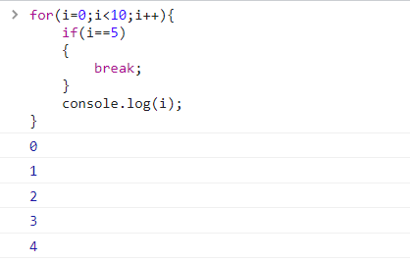
4. Write a programto print day of week name using switch case.

4. Write a programto print day of week name using switch case.

