**SPE 89341: Implications of Coupling Fractional Flow and Geochemistry for CO2 Injection in Aquifers: Noh, Lake, and Bryant**

This paper gives the mathematical formalism of combined geochemical reactions and multiphase flow. If the local-equilibrium assumption applies, the theory leads to a graphical solution, from which it is easy to see when and under what conditions mineralization will occur. The theory also illustrates the modes of CO2 trapping.

Assumptions:

1. Dry injected CO2
2. Semi-miscible displacement, since there is substantial dissolution of CO2 in brine
3. Incompressible fluid

Shock Velocity: Gas Displacing Brine

Without dissolution of gas in water, the gas-saturation profile for gas displacing water is given by:

$$x_{D}=\frac{x}{L}=\frac{Q}{∅AL}\frac{df_{g}}{dS_{g}}=t_{D}\frac{df_{g}}{dS_{g}}$$

Initially, the reservoir is brine saturated, and the injected CO2 displaces the brine (drainage). The paper proposes the formation of three separate zones: single phase dry CO2, two-phase dissolution zone, and a pure brine zone. The shock front for the two-phase/brine interface moves with a velocity given by $x_{D|S{}_{g1}}$ and the shock between dry gas/two-phase zones moves at ${ x}_{D|S{}_{g2}}$. This is shown in the figure below.

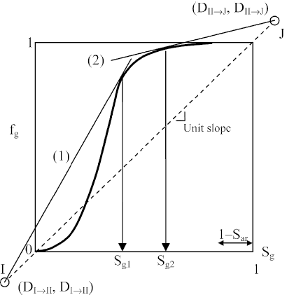

The points on the graph are given by:

$$I=\frac{C_{i,a}}{C_{i,a}-C_{i,g}},\frac{C_{i,a}}{C_{i,a}-C_{i,g}}$$

$$J=\frac{C_{i,g}^{J}-C_{i,a}}{C_{i,g}-C_{i,a}},\frac{C_{i,g}^{J}-C_{i,a}}{C_{i,g}-C_{i,a}}$$

Velocity of fast shock, xD|Sg1=slope of line (1)

Velocity of slow shock, xD|Sg2=slope of line (2)

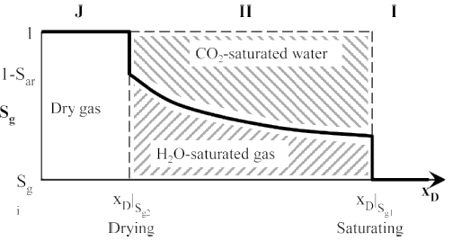

Injection of a single-phase, single-component CO2 gas into an aquifer (Figure 2): The profile consists of one mixed wave that contains two shocks (between Regions II and I and between Regions J and II). The spreading portion of the mixed wave is Region II. Region II contains wet CO2; the gaseous phase is saturated with respect to water. Similarly, the aqueous phase is saturated with CO2. The specific velocity (normalized by a macroscopic velocity) of the downstream shock is given by:

Figure 2

Figure 1

$$v{}_{ΔC}={\left(f_{g}^{-}-D\right)}/{\left(S_{g}^{-}-D\right)}, D=\frac{C_{CO_{2},a}^{II}}{C_{CO_{2},a}^{II}-C_{CO_{2},g}^{II}}$$

Where *fg*  is evaluated at Sg1 from Figure 1.

The velocity of the upstream shock is given by:

$$v{}_{ΔC}=\frac{f_{g}^{+}-D_{2}}{S_{g}^{+}-D_{2}}, D_{2}=\frac{C_{CO_{2},g}^{J}-C_{CO_{2},a}^{II}}{C_{CO_{2},g}^{II}-C_{CO_{2},a}^{II}}$$

In the region between the shocks, the velocity is given by:

$$v_{C}=\frac{df_{g}}{dS_{g}}=\frac{df_{a}}{dS_{a}}$$