TITLE OF THE PROJECT: OPEN SOURCE PULSE OXIMETER

NAME: SAYANTH PV (1NH18EE067)

R SUPRAJA (1NH18EE737)

R PUNEETH(1NH18EE736)

GUIDED BY: Ms. KARTHIKA

**Abstract**

COVID-19 is a disease caused by the SARS-CoV-2 virus that primarily attacks a person's respiratory system. Some milder symptoms can include fever, aches, and chills, but it can also lead to more serious conditions such as pneumonia. A person who has pneumonia or even slight shortness of breath might not know when to go to a hospital, especially as they start to get even more overwhelmed. This is why we created this open source pulse oximeter, which can assist in getting people the help they need and get accurate information about their current condition.

The device was made using basic electronic components available in the market as per the circuit and pin diagrams. The Arduino is programmed in C++ language to perform the functions. The output of the device was verified by placing the finger tip of the person on the oximeter sensor and the LCD displayed the reading of saturated oxygen rate.

**Index**

1. Introduction
2. Theory
3. Components
4. Components Description
5. Table
6. Working of Project
7. Circuit Diagram
8. Hardware picture
9. Conclusion
10. Applications
11. Appendices
12. Bibliography

**INTRODUCTION:**

The main aim of the project is to develop an open source pulse oximeter. A pulse oximeter is a device used to measure the level of oxygen saturation the blood of a human being.

As we are aware of the present global pandemic the SARS –CoV-2 or better known as COVID-19 has been creating huge chaos across the world. COVID-19 has symptoms like fever, cold and breathing difficulties.

Mainly focusing on breathing difficulty using this device we can find out the intake of Oxygen(O2) into the blood of human beings using this device. A person who has pneumonia or even slight shortness of breath might not know when to go to a hospital, especially when they start getting even more vulnerable.

So we have planned to design this device so that people get to know exactly how bad or good their situation is by monitoring the intake of Oxygen level in their blood.

The core device used in this project is Arduino.cc. We have used programming languages such as C, C++ to code the Arduino.

The hardware of the projects also consists of an integrated IC MAX30102 which is a pulse and heartrate sensor and also an DFR Gravity 12C OLED-2864 Display.

The device mainly works using the heartrate sensor. When small beams of light pass through the blood in the finger it measures the amount of Oxygen in the blood. This process requires no manual attention.

**THEORY:**

Pulse oximetry is a painless test that measures the level of oxygen in your blood. It can rapidly detect even small changes in how efficiently the blood is being carried not only to our heart but also to our legs and arms.

The pulse oximeter is a small device that is usually placed on the tip of our finger and it is usually used in a critical core like emergency rooms or hospitals.

The working of the device is very simple. When the oximeter is placed on the finger like a clamp. Small beams of light pass through the blood in the finger and this measures the amount of oxygen. It does this by measuring the changes of the absorption of light in the oxygenated or deoxygenated blood.

The pulse oximeter will therefore be able to tell you your oxygen saturation levels along with your heart rate.

89% of your blood should consist of Oxygen (minimum level). An Oxygen saturation level of 95% is considered to be healthy, whereas an Oxygen level below 92% is considered to be hypoxic in nature.

One of the greatest advantages of a pulse oximeter is that the device is really small and durable. Pulse oximeter reading is fairly accurate. If the reading is 85% your blood level could be anywhere between 81% to 87% as per certain errors which are unavoidable.

Errors mainly occur due to movement, rise in temperature, or even nail polish or paint when placed on the finger of the individual.

The device will be really helpful for people with conditions like:

* COPD
* Asthma
* Pneumonia
* Lung cancer
* Anemia
* Heart attack or heart failure

**COMPONENTS:**

The components required for this project are simple and readily available in the market

The components required are:

1. Arduino UNO
2. MAX30100 Pulse Oximeter
3. LCD Display
4. Connecting wires
5. Breadboard

**LCD DISPLAY UNIT:**

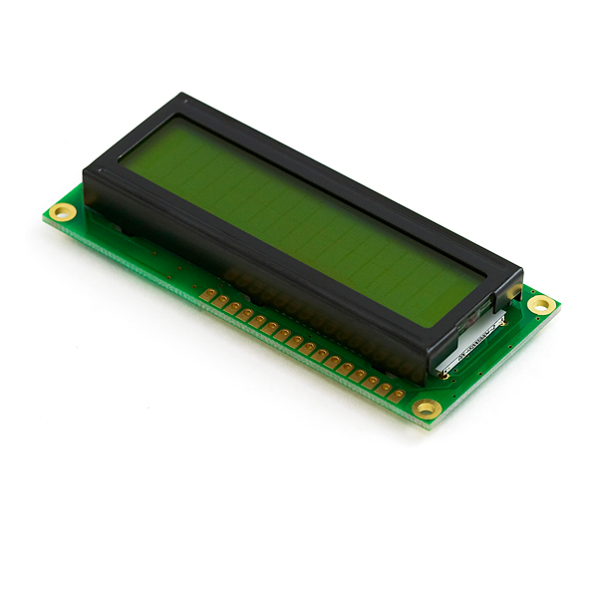

**ARDUINO UNO:**

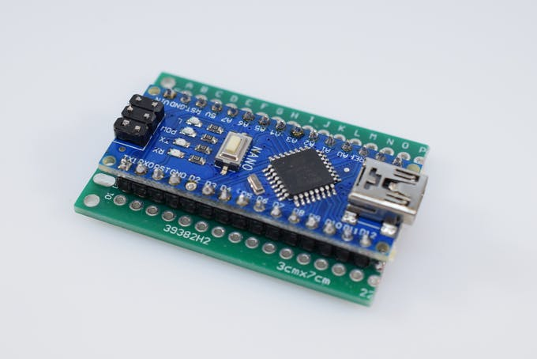

**MAX30100:**

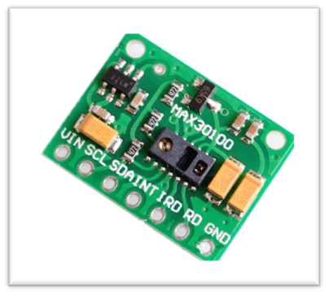

**COMPONENTS DISCRIPTION:**

The core component of this project is the Arduino. This component is programmed using C and C++ programming languages and is connected to the MAX30100 Pulse oximeter sensor as shown below.

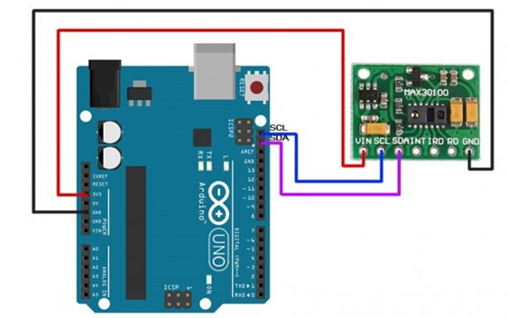

Connections are made as per instructed, Vin of MAX30100 to 5V or 3.3V pin, GND to GND and so on.

After this is done we need to interface the LCD display with the circuitry. Another program is typed and the LCD is set to display the level of oxygen in your blood.

The MAX30100 an integrated pulse oximetry and heart rate sensor uses two LEDs, a photodetector and a low noise analog signal processing to detect pulse oximetry and heart rate signals.

As shown below the MAX30100 emits light that passes through our finger and measures the level of concentration of O2 in our blood. This reading is then picked up by the Arduino which reads the data as per the code and further sends the information to display on the LED.



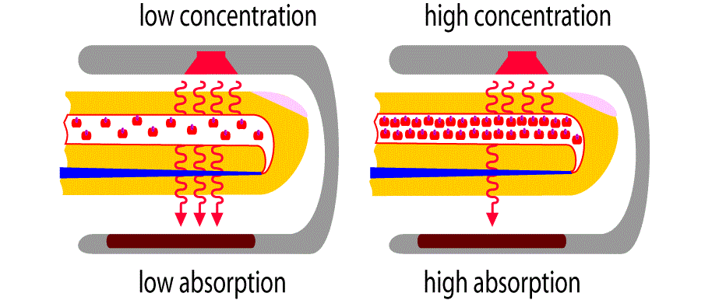Lower the concentration of O2 lower will be the absorption of light and higher the concentration of O2 in blood higher will be the absorption of light by the blood as shown in the figure below.

**BLOCK DIAGRAM:**

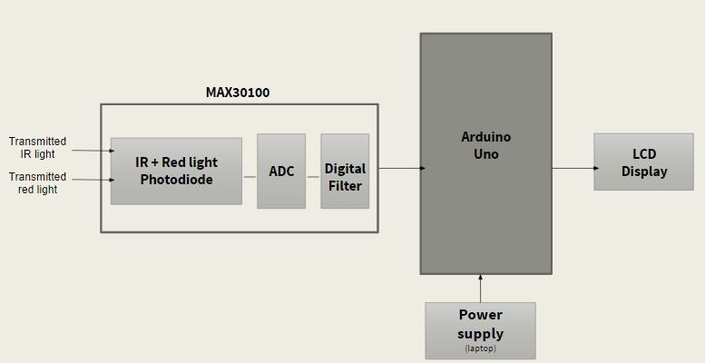

**Block Diagram Explanation:**

IR and red light emitted by the photo diode is in the form of analog signal. This analog signal is converted into digital signal by using ADC. For further improvement in the signal quality we provide it to a digital filter. This process basically takes place in the MAX30100 chip.

The data of the amount of IR light and red light absorbed is further provided to the Arduino UNO. The Arduino calculates the amount of oxygenated and deoxygenated blood as per the code.

The result is displayed on the LCD screen.

The power supply block basically provides the input voltage.

**PIN DIAGRAM AND CONNECTIONS OF EXTERNAL PINS:**

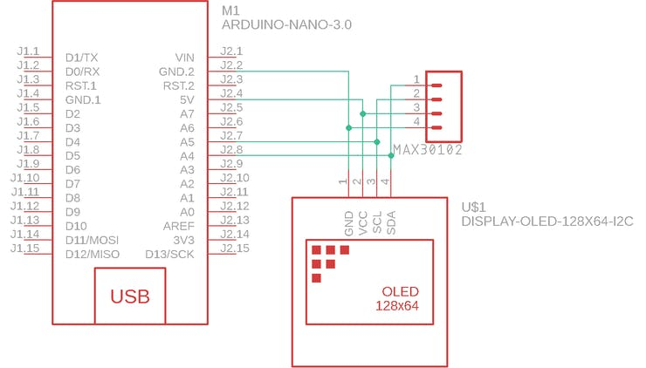

**THE CODE FOR ARDUINO UNO IS:**

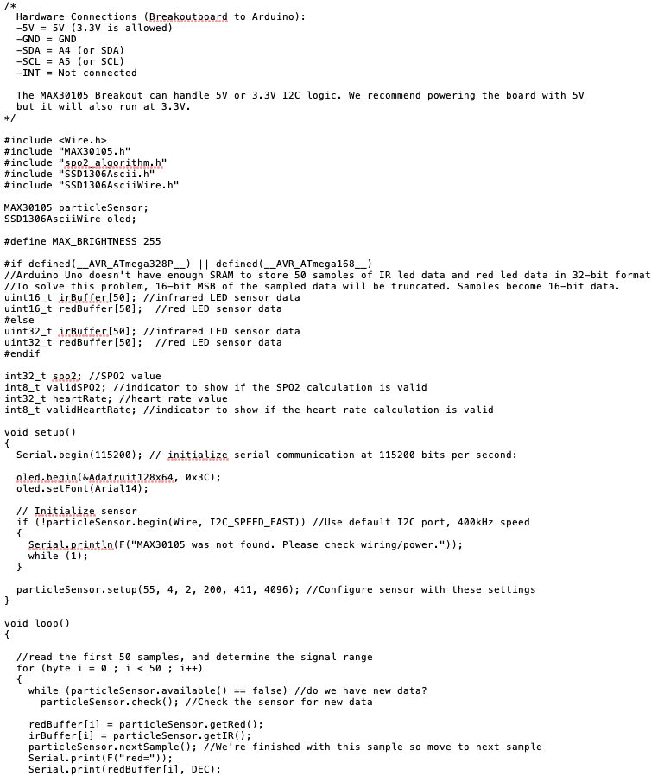

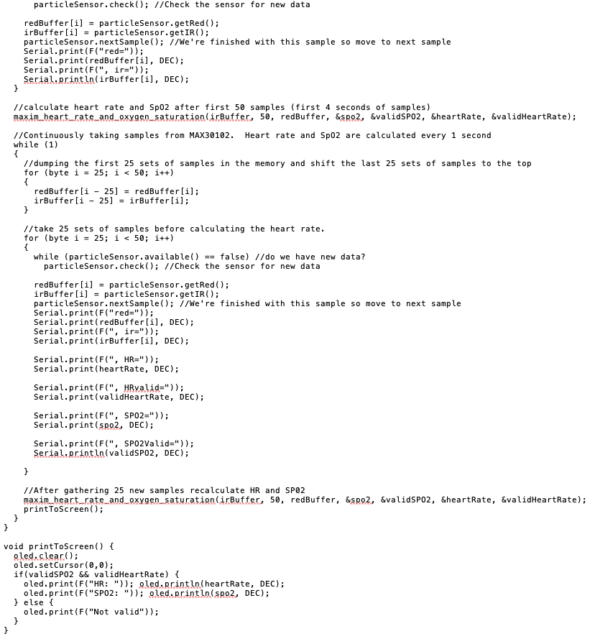

**AFTER EXECUTION OF CODE:**

OUTPUT

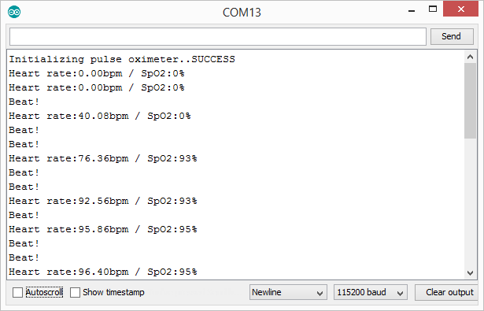

**WORKING:**

Oxygen enters the lungs and later on is passed on into blood. The blood passes on oxygen to the various organs in our body. The central way oxygen is passed on in our blood is by strategies for hemoglobin. During a heartbeat oximetry examining, a little support like contraption is put on a finger, ear ligament, or toe.

Minimal light emanations experience the blood in the finger, assessing the proportion of oxygen. It does this by assessing changes in light maintenance in oxygenated or deoxygenated blood.

**MAX30100 PULSE OXIMETER WORKING**

[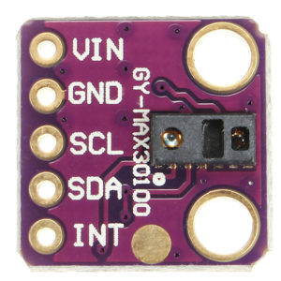](https://www.how2electronics.com/wp-content/uploads/2019/06/MAX30100.jpg)

The sensor is a fused heartbeat oximetry and beat screen sensor course of action. It combines two LED's, a photo identifier, improved optics, and low-uproar straightforward sign taking care of to perceive heartbeat and heartbeat signals. It works from 1.8V and 3.3V power supplies and can be closed down through programming with irrelevant hold current, permitting the power deftly to remain related reliably.

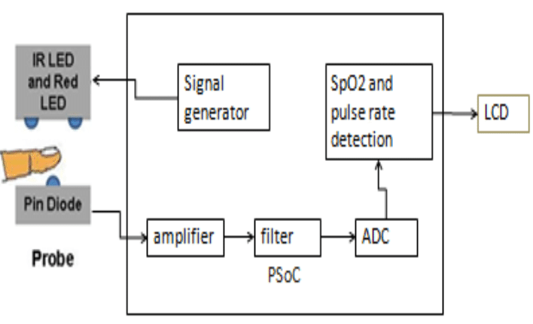

**WORKING OF MAX30100 PULSE OXIMETER**

The contraption has two LEDs, one creating red light, another radiating infrared light. For beat rate, only the infrared light is required. Both the red light and infrared light is used to measure oxygen levels in the blood.

Exactly when the heart siphons blood, there is a development in oxygenated blood as a result of having more blood. As the heart loosens up, the volume of oxygenated blood similarly reduces. By knowing the time between the extension and lessening of oxygenated blood, the beat rate is settled.

It turns out, oxygenated blood ingests progressively infrared light and passes continuously red light while deoxygenated blood absorbs red light and passes progressively infrared light. This is the essential limit of the MAX30100: it examines the maintenance levels for both light sources and set aside them in a pad that can be scrutinized through I2C.

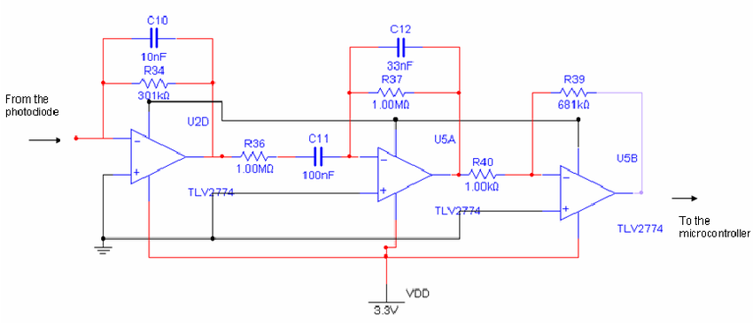**CIRCUIT DIAGRAM:**

Fig.12 Circuit Diagram

NOTE: HERE INSTEAD OF CONNECTING THE OUTPUT TO A MICRO CONTROLLER WE HAVE USED AN ARDUINO UNO.

**INTERFACING WITH LCD:**

Interface the Vin pin of MAX30100 to Arduino 5V or 3.3V pin, GND to GND. Associate the I2C Pin, SCL and SDA of MAX30100 to A5 and A4 of Arduino. So also interface the LCD pin 1, 5, 16 to GND of Arduino and 2, 15 to 5V VCC. Thus associate LCD pin 4, 6, 11, 12, 13, 14 to Arduino pin 13, 12, 11, 10, 9, 8. Utilize 10K Potentiometer at pin 3 of LCD to change the differentiation of LCD.

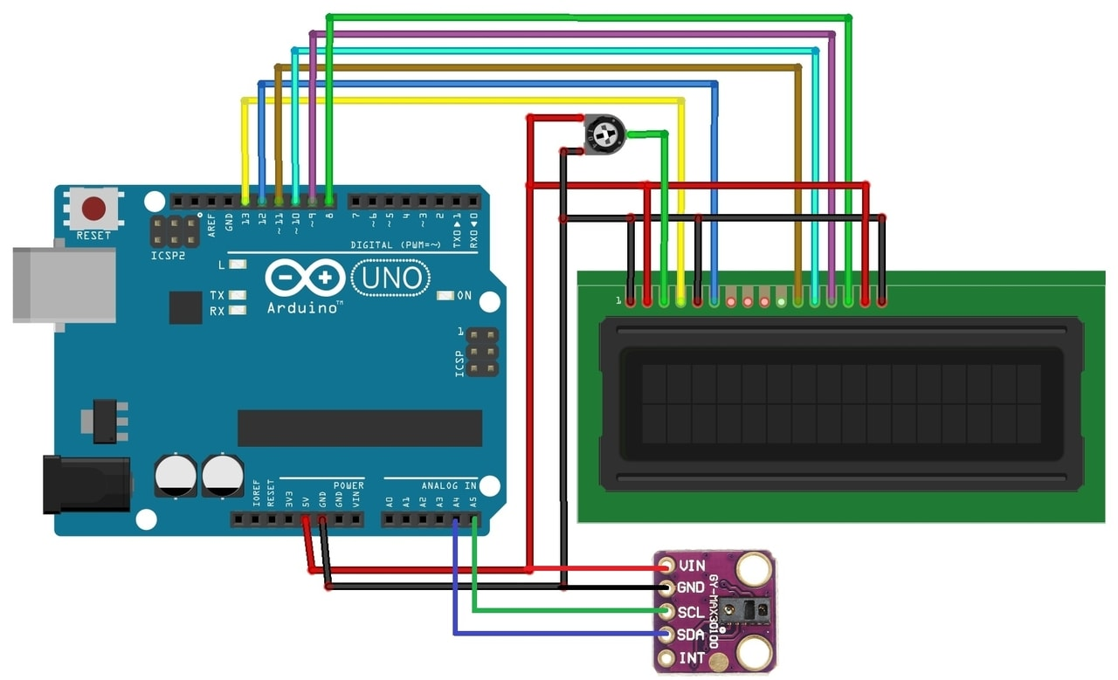

Fig.13 LCD Interfacing

**CONCLUSION:**

The project has been effectively finished by having set up an easy to use and condition cordial framework which can be actualized utilizing basic, ease electronic parts.

The open source pulse oximeter with minimal effort parts make it a perfect bit of innovation for the normal man.

COVID-19 is a sickness brought about by the SARS-CoV-2 infection that basically affects an individual's respiratory framework. Some milder manifestations can incorporate fever, aches, and chills. In some cases, it may lead to pneumonia.

An individual who has pneumonia may not even realize when to see a doctor. This is why an open source pulse oximeter was made to aid people and get the information about their breathing condition.

This is a medical equipment used to display the rate of saturated oxygen in our blood. When this rate drops below the normal rate, it’s a cause for concern. The normal rate of saturated oxygen is in the range of 95%-100%. When the rate falls below the normal range this device signals us when we are in trouble even before we realize it.

In the wake of rising corona cases there is a growing concern for the shortage of medical equipment. This open source can work as an alternative to the medically approved pulse oximeters for the people who can’t get access to them.

**APPLICATIONS**:

A pulse oximeter is used in the field of medicine to evaluate arterial blood oxygenation for various patient groups with suspected cardiopulmonary issue or in normal individuals during intense workout or vigorous exercise or introduction to low partial pressure of oxygen. By and large, the instruments perform well and sensible readings for oxygen saturation are acquired.

Pulse oximetry is likely one of the most noteworthy advances in respiratory monitoring. This level of exactness, combined with the ease of functioning of most instruments, has led to extensive utilization of pulse oximetry for monitoring patients in the ICU.

**APPENDICES**

* **OXYGEN SATURATION**

Oxygen saturation is the degree to which hemoglobin is saturated with oxygen. Hemoglobin is a component of the blood that combines with oxygen to carry it through the circulatory system in the human body to the various orangs, tissues and cells.

The normal rate of oxygen saturation is typically between 95% to 100%. Any level below this is often considered risky and requires oxygen supplementation and treatment for the lung condition.

Oxygen saturation depends upon:

1. The availability of oxygen.
2. Exchange of gases within the Lungs.
3. Haemoglobin concentration in RBCs.
4. The affinity haemoglobin has for oxygen.

* **PULSE**

Pulse is the rhythmic dilation of an artery developed by the opening and closing of the aortic valve in the heart. This rhythmic dilation can be felt by firmly placing fingertip pressure to the skin at sites where the arteries travel near the skin’s surface. The places where pulse can be felt include the carotid artery of the neck, the brachial artery inside the elbow, and the radial artery in the wrist.