kubernetes project
Kubernetes-Based MongoDB–Mongo Express Deployment | Kubernetes, Docker, MongoDB, Persistent Volume Claim (PVC), Mongo Express, YAML, ConfigMap, Secrets
September 2025 – October 2025
• Containerized and deployed a two-tier web application on Kubernetes using declarative YAML manifest files.
• Configured Kubernetes Services (ClusterIP, NodePort) for seamless internal and external communication between microservices.
• Implemented ConfigMaps and Secrets to securely manage environment variables and credentials, enhancing deployment security and consistency.
• Implemented a PersistentVolumeClaim (PVC) for MongoDB to ensure data persistence and durability across pod restarts, improving reliability and fault tolerance.
• Deployed the complete application stack on a Minikube cluster using kubectl commands for testing and validation.
• Verified end-to-end connectivity via Mongo Express UI, performing CRUD operations on MongoDB to ensure stable and consistent data flow within the cluster.

Browser Request Flow through the K8s components
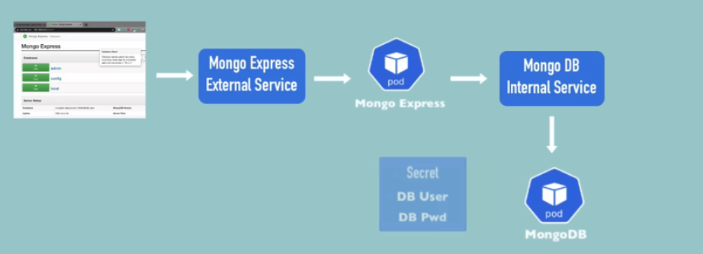

Secret for Mongodb and Mongo Express
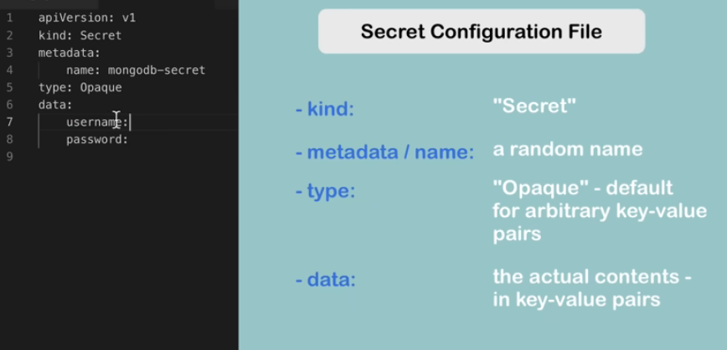
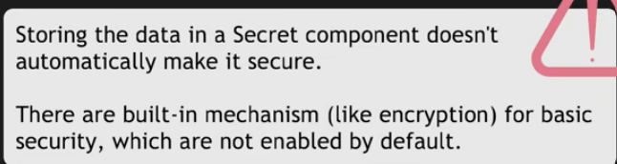
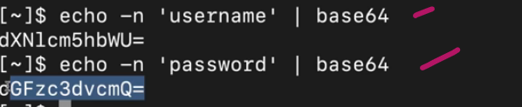
I used admin and admin123 as username and password
But for mongo express to open 1st time username and password is – admin and pass

Configmap for Mongo Express
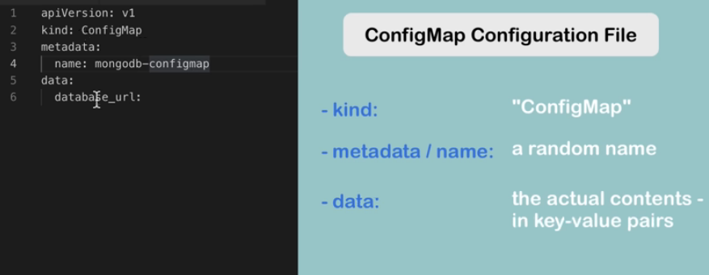
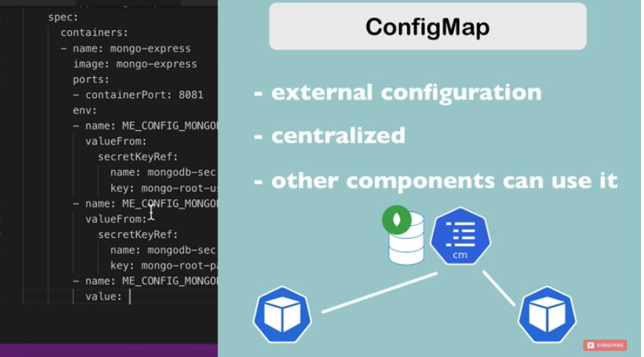

Mongo Express External Service
