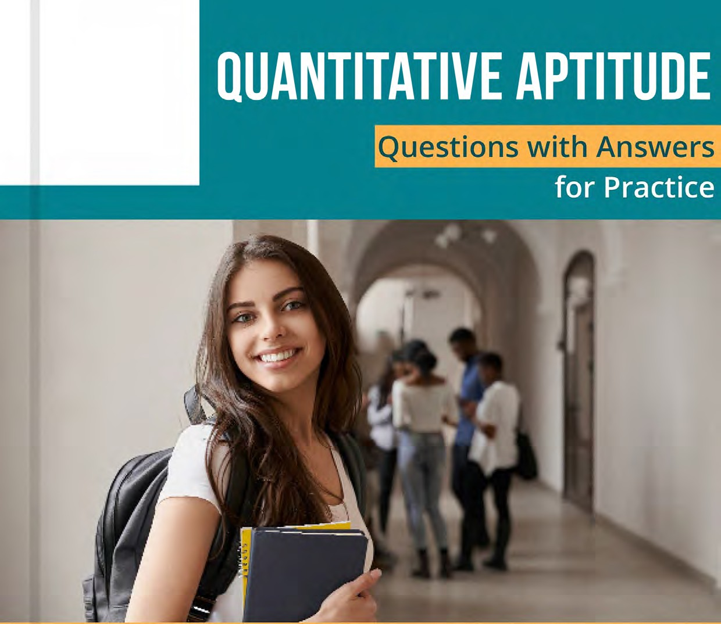Disclaimer :
This content is sourced from past years’ CAT exam papers

Quantitative Aptitude Questions with Answers for Practice

Go through the set of Quantitative Aptitude questions from official CAT question papers of previous years. There are a total of 34 questions that you should aim to solve in 60 minutes to maintain speed of the actual CAT exam. Also find, correct answers at the end of the questions set.
Quantitative Aptitude
Q 1: Anil buys 12 toys and labels each with the same selling price. He sells 8 toys initially at 20% discount on the labeled price. Then he sells the remaining 4 toys at an additional 25% discount on the discounted price. Thus, he gets a total of Rs 2112, and makes a 10% profit. With no discounts, his percentage of profit would have been?
Ans:
A: 1.50
B: 2.55

C: 3.60
D: 4.54
Q 2: In a car race, car A beats car B by 45 km, car B beats car C by 50 km and (in km) over which the race has been conducted is:
Ans:
A: 475
B: 500
C: 450
D: 550
Q 3: Students in a college have to choose at least two subjects from chemistry, mathematics and physics. The number of students choosing all three subjects is 18, choosing mathematics as one of their subjects is 23 and choosing physics as one of their subjects is 25. The smallest possible number of students who could choose chemistry as one of their subjects is:
Ans:
A: 1.21
B: 2.19
C: 3.20
D: 4.22

Q 4: In how many ways can a pair of integers (x , a) be chosen such that x2 − 2 | x | + | a - 2 | = 0 ? Ans:
A: 1.5
B: 2.4
C: 3.7
D: 4.6
Q 5: The number of integers that satisfy the equality (x² – 5x+ 7)^{x+1}= 1 is: Ans:
A: 3
B: 5
C: 4

D: 2
Q 6: How many 4-digit numbers, each greater than 1000 and each having all four digits distinct, are there with 7 coming before 3?
Answer Type: Non-MCQ
Q 7: In a group of 10 students, the mean of the lowest 9 scores is 42 while the mean of the highest 9 scores is 47. For the entire group of 10 students, the maximum possible mean exceeds the minimum possible mean by:
Ans:
A: 1.5
B: 2.4
C: 3.6
D: 4.3
Q 8: For the same principal amount, the compound interest for two years at 5% per annum exceeds the simple interest for three years at 3% per annum by Rs 1125. Then the principal amount in rupees is
Answer Type: Non-MCQ

Q 9: Two circular tracks T1 and T2 of radii 100 m and 20 m, respectively touch at a point A. Starting from A at the same time, Ram and Rahim are walking on track T1 and track T2 at speeds 15 km/hr and 5 km/hr respectively. The number of full rounds that Ram will make before he meets Rahim again for the first time is:
Ans:
A: 1.2
B: 2.4
C: 3.5
D: 4.3
Q 10: Aron bought some pencils and sharpeners. Spending the same amount of money as Aron, Aditya bought twice as many pencils and 10 less sharpeners. If the cost of one sharpener is ₹ 2 more than the cost of a pencil, then the minimum possible number of pencils bought by Aron and Aditya together is:
Ans:

A: 1.30
B: 2.33
C: 3.27
D: 4.36
Q 11: Arun’s present age in years is 40% of Barun’s. In another few years, Arun’s age will be half of Barun’s. By what percentage will Barun’s age increase during this period?
Answer Type: Non-MCQ
Q 12: A person can complete a job in 120 days. He works along on Day 1. On Day 2, he is joined by another person who also can complete the job in exactly 120 days. On Day 3, they are joined by another person of equal efficiency. Like this, everyday a new person with the same efficiency joins the work. How many days required to complete the job?
Answer Type: Non-MCQ
Q 13: If a seller gives a discount of 15% on retail price, she still makes a profit of 2%. Which of the following ensures that she makes a profit of 20%?
Ans:
A: Give a discount of 5% on retail price. B: Give a discount of 2% on retail price. C: Increase in retail price by 2%.
D: Sell at retail price.

Q 14: Suppose C1, C2, C3, C4 and C5 are five companies. The profits made by C1, C2 and C3 are in the ratio 9:10:8 while the profits made by C2, C4 and C5 are in the ratio 18:19:20. If C5 has made a profit of Rs 19 crore more than C1, then the total profit (in Rs) made by all five companies is:
Ans:
A: 438 crore
B: 435 crore
C: 348 crore
D: 345 crore
Q 15: The number of girls appearing for an admission test is twice the number of boys. If 30% of the girls and 45% of the boys get admission, the percentage of candidates who do not get admission is:
Ans:
A: 35

B: 50
C: 60
D: 65
Q 16: A stall sells popcorn and chips in packets of three sizes: large, super and jumbo. The numbers of large, super and jumbo packets in stock are in the ratio 7:17:16 for popcorn and 6:15:14 for chips. If the total number of popcorn packets in its stock is the same as that of chips packets, then the numbers of jumbo popcorn packets and jumbo chips packets are in the ratio:
Ans:
A: 1:1
B: 8:7
C: 4:3
D: 6:5
Q 17: In a market, the price of medium quality mangoes is half that of good mangoes. A shopkeeper buys 80 kg mangoes and 40 kg medium quality mangoes from the market and then sells all these at a common price which is 10% less than the price at which he bought the good ones. His overall profit is:
Ans:
A: 6%
B: 8%
C: 10%
D: 12%

Q 18: If Fatima sells 60 identical toys at 40% discount on printed price, then she makes 20% profit. Ten of these toys are destroyed in fire. While selling the rest, how much discount should be given on the printed price so that she can make the same amount of profit?
Ans:
A: 30%
B: 25%
C: 24%
D: 28%
Q 19: If a and b are integers of opposite signs such that (a+b)²: b²= 9:1 and (a-1)²: (b-1)²= 4:1 then the ratio a²:b² is:
Ans:

A: 9:4
B: 81:4
C: 1:4
D: 25:4
Q 20: A class consists of 20 boys and 30 girls. In the mid-semester examination, the average score of the girls was 5 higher than that of the boys. In the final exam, however, the average score of the girls dropped by 3 while the average score of the entire class increased by 2. The increase in average score of the boys is:
Ans:
A: 9.5
B: 10
C: 4.5
D: 6
Q 21: On selling a pen at 5% loss and a book at 15% gain, Karim gains Rs 7. If he sells the pen at 5% gain and the book at 10% gain, he gains Rs 13. What is the cost price of the book in Rupees?
Ans:
A: 1.85
B: 2.80
C: 3.95

D: 4.100
Q 22: In a circle of radius 11 cm, CD is a diameter and AB is a chord of length 20.5 cm. If AB and CD intersect at a point E inside the circle and CE has length 7 cm, then the difference of the lengths of BE and AE in cm, is:
Ans:
A: 1.5
B: 3.5
C: 0.5
D: 2.5
Q 23: For any positive integer n, let f(n)= n(n+1) if n is even, and f(n)= n +3 if n is odd. If m is positive integer such that 8f(m+1)- f(m)=2, then m equals?
Answer Type: Non-MCQ

Q 24: A chemist mixes two liquids 1 and 2. One litre of liquid weighs 1 kg and one litre of liquid weighs 800 gm. If half litre of the mixture weighs 480 gm, then the percentage of liquid 1 in the mixture, in terms of volumn, us:
Ans:
A: 1.80
B: 2.85
C: 3.75
D: 4.70
Q 25: If (5.55) ^{x}= (0.555)^{y} = 1000, then the value of 1/x -1/y is:
Ans:
A: 1/3 B: 2.1
C: 3.3 D: 4.2/3
Q 26: With rectangular axes of coordinates, the number of paths from (1,1) to (8, 10) via (4, 6), where each step from any point (x, y) is either (x, y+1) or to (x+1, y), is:
Answer Type: Non-MCQ

Q 27: A person invested a total amount of Rs 15 lakh. A part of it was invested in a fixed deposit earning 6% annual interest, and the remaining amount was invested in two other deposits in the ratio 2 : 1, earning annual interest at the rates of 4% and 3%, respectively. If the total annual interest income is Rs 76000 then the amount (in Rs lakh) invested in the fixed deposit was?
Answer Type: Non-MCQ
Q 28: Corners are cut off from an equilateral triangle T to produce a regular hexagon H. Then, the ratio area of H to the area of T is:
Ans:
A: 1:4:5
B: 2:5:6
C: 3:3:4
D: 4:2:3

Q 29: Let S be the set of all points (x, y) in the x-y plane such that | x | + | y | ≤ 2 and | x | ≥ 1. Then, the area, in square units, of the region represented by S equals.
Answer Type: Non-MCQ
Q 30: The income of Amala is 20% more than that of Bimala and 20% less than that of Kamala. If Kamala's income goes down by 4% and Bimala's goes up by 10%, then the percentage by which Kamala's income would exceed Bimala's is nearest to:
Ans:
A: 1.32
B: 2.29
C: 3.31
D: 4.28
Q 31: The number of the real roots of the equation 2cos (x ( x + 1 ) ) = 2 x + 2-x is:
Ans:
A: 1.0
B: 2.1
C: 3.2
D: Infinity
Q 32: AB is a diameter of a circle of radius 5 cm. Let P and Q be two points on the circle so that the length of PB is 6 cm, and the length of AP is twice that of AQ. Then the length, in cm, of QB is nearest to:

Ans:
A: 1.9.3
B: 2.8.5
C: 3.9.1
D: 4.7.8
Q 33: At their usual efficiency levels, A and B together finish a task in 12 days. If A had worked half as efficiently as she usually does, and B had worked thrice as efficiently as he usually does, the task would have been completed in 9 days. How many days would A take to finish the task if she works alone at her usual efficiency?
Ans:
A: 1.24
B: 2.12

C: 3.36
D: 4.18
Q 34: Meena scores 40% in an examination and after review, even though her score is increased by 50%, she fails by 35 marks. If her post-review score is increased by 20%, she will have 7 marks more than the passing score. The percentage score needed for passing the examination is:
Ans:
A: 1.60
B: 2.75
C: 3.70
D: 4.80

Answer Key:



