**Question 1:**

The summary statistics and plots were created in the accompanying html RMarkdown file, please check it out.

**Question 2:**

The likelihood function is

To obtain the loglikelihood function, we perform log transformation to both sides:

**Question 3:**

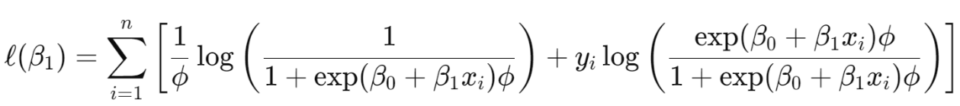To obtain the estimating equation for the β1 parameter, we differentiate the right side of the loglikelihood function with respect to β1. We get the following equation:

Differentiate both terms and get the following result:

Set the result to zero, we get the estimating equation:

**Question 4:**

Detailed information of how the plot is created is in the accompanying html RMarkdown file.

**Question 6:**

"The R code calculates the value of the estimating equation after substituting our estimated β​1-estimate​. The result is -0.017, which is very close to zero. This small value indicates that the gradient of the log-likelihood function at β​1-estimate is nearly zero, confirming that β​1-estimate is indeed the maximum likelihood estimate, as expected.