Comparison of Chest Radiography, Clinical, and Late Fusion Models for Predicting In-Hospital Mortality in Patients With COVID-19
Saya Nakamura
Abstract
Background
Early identification of patients at high risk of in-hospital mortality may support risk stratification and clinical decision-making in COVID-19. Clinical information and chest radiographs (CXRs) may contain distinct prognostic information; however, the incremental value of adding CXR-derived information to clinical information remains unclear. This study compared the predictive performance of a CXR-only model, clinical-only models, and a Late Fusion model integrating both modalities for in-hospital mortality.
Methods
We conducted a single-center retrospective study using the Stony Brook University COVID-19 Positive Cases (COVID-19-NY-SBU) dataset. Among 1,384 patients in the publicly available dataset, the prediction time point (T0) was defined as visit_start_datetime. A total of 1,277 patients with an eligible frontal CXR obtained from 2 days before T0 through the T0 calendar date were included in the final analysis and assigned to fixed Training, Validation, and Test sets comprising 1,021, 128, and 128 patients, respectively. ResNet18 was used for the CXR model, whereas Logistic Regression (LR), XGBoost, and a Multilayer Perceptron (MLP) were used as clinical models. A Late Fusion model was constructed by combining the predicted probabilities from Clinical LR and CXR ResNet18 using weights determined in the Validation set. In the final Test set, performance was evaluated using ROC-AUC, PR-AUC, Brier score, and expected calibration error (ECE), and ROC-AUCs were compared using paired DeLong tests with Holm correction for multiple comparisons.
Results
Among the 1,277 patients in the final analysis cohort, 169 (13.2%) died during hospitalization. The Test set included 17 deaths among 128 patients. ROC-AUCs were 0.907 for CXR ResNet18, 0.941 for Clinical LR, 0.936 for XGBoost, 0.880 for MLP, and 0.944 for Late Fusion. Although Late Fusion had the highest point estimate of ROC-AUC, the difference from Clinical LR was 0.003 and was not statistically significant after Holm correction. Clinical LR achieved a PR-AUC of 0.800, a Brier score of 0.057, and an ECE of 0.041, all of which were better than those of Late Fusion. In modality-level permutation importance analysis, permutation of the Clinical probability resulted in a mean ROC-AUC decrease of 0.169, compared with 0.045 after permutation of the CXR probability, indicating that Late Fusion relied predominantly on clinical information.
Conclusions
For predicting in-hospital mortality in patients with COVID-19, Logistic Regression using clinical information alone demonstrated high discrimination and good calibration. Although the CXR-only model also contained prognostic information, the incremental performance gained by adding CXR information through Late Fusion was limited and did not provide a statistically significant improvement over Clinical LR. CXR may provide complementary prognostic information; however, external validation is required to establish its additional clinical utility.

1. Introduction
Coronavirus disease 2019 (COVID-19) has a wide spectrum of clinical courses, ranging from asymptomatic or mild disease to severe respiratory failure, multiorgan dysfunction, and death. Identifying patients at high risk of clinical deterioration or death at admission or during the early period around admission is important for patient monitoring, decisions regarding respiratory support and intensive care, and appropriate allocation of healthcare resources.
A variety of clinical factors, including age, comorbidities, respiratory status, inflammatory response, coagulation abnormalities, and renal dysfunction, have been associated with mortality in patients with COVID-19 [1,2]. Accordingly, numerous models for predicting severe disease and mortality have been developed using clinical information such as patient characteristics, vital signs, and laboratory measurements.
Chest radiography (CXR), meanwhile, is widely available in clinical practice and can depict the distribution and extent of pulmonary abnormalities associated with COVID-19. Deep learning may enable automatic extraction of imaging features that are difficult to quantify manually and may capture information related to disease severity and prognosis [3,4]. Whereas clinical information reflects age, comorbidities, overall physiologic status, inflammation, and organ function, CXR primarily reflects imaging features of pulmonary disease; therefore, the two modalities may contain complementary prognostic information.
Previous studies have reported that multimodal prediction models combining CXR and clinical information may achieve better predictive performance than models using a single modality alone [4–7]. However, imaging and clinical data differ in dimensionality, distribution, noise characteristics, and their relationships with the prediction target; therefore, simply combining the two does not necessarily improve predictive performance. When evaluating multimodal models, it is also important to compare the fusion model with each unimodal model and to assess the extent to which the fusion model depends on each modality.
The Stony Brook University COVID-19 Positive Cases (COVID-19-NY-SBU) dataset is a de-identified real-world dataset containing radiologic images and clinical information from patients with COVID-19 and is publicly available through The Cancer Imaging Archive (TCIA) [8,9]. In this study, we used the same patient cohort and fixed Training, Validation, and Test split to compare a CXR-only model, three clinical models, and a Late Fusion model that integrated the predicted probabilities from the CXR and clinical models at the decision level.
The aim of this study was to predict in-hospital mortality in patients with COVID-19 using CXR and clinical information obtained around the time of admission, to compare the predictive performance of CXR-only, clinical-only, and Late Fusion models, and to evaluate whether adding CXR-derived predictive information to clinical information provides incremental predictive value beyond the clinical-only model.

2. Methods
2.1 Study design and data source
This was a single-center retrospective study aimed at developing and internally evaluating models for predicting in-hospital mortality in patients with COVID-19. We used COVID-19-NY-SBU [8], a de-identified dataset collected at Stony Brook University and made publicly available through TCIA. The dataset contains chest imaging and clinical information from patients with COVID-19. The candidate population comprised 1,384 patients in the publicly available dataset, and chest radiographs, clinical information, and in-hospital outcomes were used. The primary outcome was in-hospital mortality. This study was reported in accordance with the TRIPOD+AI reporting guideline for clinical prediction model studies [10].
2.2 Eligibility and cohort definition
The prediction time point (T0) was defined as visit_start_datetime in the patient data. Information determined after T0, including post-admission treatment, interventions after clinical deterioration, and in-hospital outcome, was not used as a predictor.
Candidate CXRs were identified as follows. First, images with a DICOM modality of CR or DX were extracted, and candidate chest examinations were identified using Study Description. Series Description was then used to restrict images to frontal AP or PA views. CENTRAL LINE examinations performed primarily for central venous catheter position confirmation and TRAUMA examinations were excluded. In contrast, CODE T, INFANT, and OVER PENETRATED examinations were not excluded solely on the basis of their names and were retained or excluded according to their eligibility as frontal chest radiographs.
For each patient, we identified the acquisition date closest to T0 among eligible frontal CXRs obtained on or before the T0 calendar date. Of the 1,309 patients with an eligible CXR on or before the T0 calendar date, 1,277 (97.6%) had their nearest acquisition date within the interval from 2 days before T0 through the T0 calendar date. Based on this empirical distribution, the final CXR inclusion window was defined as T0−2 days through the T0 calendar date. For patients without an eligible CXR on or before the T0 calendar date, a radiograph obtained on a calendar date after T0 was not substituted.
When multiple acquisition dates were available within the inclusion window, the date closest to T0 was selected. If multiple Series were present on the selected date, AcquisitionTime in the DICOM header was reviewed for all Series from that date, and the Series with the earliest acquisition time was selected as the primary criterion for within-day ordering. Only when multiple Series shared the same earliest AcquisitionTime was the Series with the smallest SeriesNumber selected as a reproducible tie-breaker to uniquely identify the representative CXR. SeriesNumber was not treated as an indicator of acquisition time and was not used for any other purpose. Using these criteria, one representative CXR was selected per patient, yielding a final analysis cohort of 1,277 patients (Figure 1).
Because the patient data did not contain the exact admission time, it was not possible to determine strictly whether a CXR obtained on the T0 calendar date was acquired before or after the actual admission time. AcquisitionTime was used only to determine the order of images acquired on the same date and was not used to classify radiographs as pre- or post-admission.
2.3 Data linkage and data splitting
Chest radiograph data and clinical data were linked at the patient level using the common patient identifier, Subject ID. For each patient, one representative CXR, the corresponding clinical information, and the in-hospital outcome were treated as a single record, and the patient was the unit of analysis.
The 1,277 patients in the final analysis cohort were assigned to fixed Training, Validation, and Test sets after stratification by outcome to preserve the proportion of in-hospital deaths. The sets contained 1,021, 128, and 128 patients, respectively, with 135, 17, and 17 in-hospital deaths. The same patient split was used for the CXR model, clinical models, and Late Fusion model.
The Training set was used for model training and estimation of preprocessing parameters derived from Training data. The Validation set was used to select hyperparameters, model checkpoints, classification thresholds, and Late Fusion weights. The Test set was used only for final performance evaluation after all such choices had been completed.
2.4 Clinical variables and preprocessing
Candidate clinical predictors were selected primarily from variables considered clinically relevant to in-hospital mortality in patients with COVID-19 and reported to be associated with prognosis in previous studies [1,2] or established risk scores [11]. Candidate variables were assessed for availability at T0, missingness, potential information leakage, redundancy among variables, and clinical plausibility. Given that the Training set contained 135 in-hospital deaths among 1,021 patients, approximately 13–14 raw clinical variables were targeted as a practical upper range to avoid using an excessive number of predictors.
We audited 131 variables in the patient dataset. For routine laboratory and clinical variables, a missingness rate of 50% or greater in the Training set was used as a general exclusion criterion. Variables related to treatment, procedures, or outcomes occurring after T0 were also excluded from consideration to avoid information leakage. This process yielded 14 candidate variables: SpO₂, respiratory rate, lymphocyte count, eGFR, CRP, D-dimer, lactate, BUN, troponin T, age, sex, heart failure, chronic kidney disease, and coronary artery disease. The rationale for selecting the 14 candidate clinical variables is summarized in Supplementary Table S2.
For continuous variables, distributions were assessed using the Training set only by reviewing the mean, standard deviation, median, interquartile range, minimum, maximum, and skewness, together with the Shapiro–Wilk test. All nine candidate continuous variables showed either departure from a normal distribution or distributional asymmetry; therefore, missing values were imputed using the Training-set median. The same medians estimated in the Training set were applied to the Validation and Test sets. Neither patients nor measurements were excluded solely because they were statistical outliers, and winsorization was not performed.
Within the Training set, distributions of raw and log1p-transformed values were compared. A log1p transformation was applied to lymphocyte count, BUN, CRP, D-dimer, and lactate, whereas SpO₂, respiratory rate, eGFR, and troponin T were not log1p-transformed.
Age was categorized into 18–59, 60–74, and 75–90 years, with 18–59 years as the reference category. Female sex was used as the reference category. Sex was missing in 19 patients in the Training set, 18 of whom (94.7%) died during hospitalization, indicating a strong association between sex missingness and mortality. We therefore considered that treating missing sex as a separate category could allow the model to exploit information related to the missingness mechanism, and missing sex values were imputed with male, the mode in the Training set. For heart failure, missing values were retained as a separate Missing category, with No heart failure as the reference category.
Variable selection was performed using the Training set only. Starting from a model containing all 14 candidate variables, backward elimination was conducted using the Akaike information criterion (AIC). Categorical variables were handled at the level of the original clinical variable rather than as individual dummy variables after one-hot encoding, and continuous variables were entered using functional forms that reflected imputation and log transformation. Troponin T, BUN, coronary artery disease, chronic kidney disease, and respiratory rate were removed in that order, leaving nine raw variables: SpO₂, lymphocyte count, eGFR, CRP, D-dimer, lactate, age, sex, and heart failure. The AIC was 522.817 for the initial 14-variable model and 515.766 for the final model.
For the final six continuous variables, missing values were imputed using the Training-set median, log1p transformation was applied where indicated, and variables were standardized using the Training-set mean and standard deviation. Age, sex, and heart failure were one-hot encoded to generate six features: age 60–74 years, age 75–90 years, male sex, HFpEF, HFrEF, and heart failure missing. These were combined with the six continuous features to yield 12 input features for the final clinical models. The same 12 features were used for LR, XGBoost, and MLP.
Because the patient dataset did not retain measurement timestamps for individual laboratory values or vital signs, the exact time interval between each measurement and T0 could not be determined. This was treated as a limitation of the study design.
2.5 CXR preprocessing and modeling
For each patient, the selected representative CXR was read from DICOM format and preprocessed. Audit of the DICOM headers for all 1,277 images in the final analysis showed that Photometric Interpretation was MONOCHROME2 in all images, Rescale Slope was 1.0, and Rescale Intercept was 0.0. Window Center and Window Width were also identical across all images at 2,048 and 4,096, respectively; therefore, fixed windowing was applied and pixel values were scaled to the range 0–1.
No automatic foreground cropping was performed. Images were directly resized to 224 × 224 pixels using bilinear interpolation, without padding to preserve the original aspect ratio. The preprocessed grayscale image was replicated across three channels and normalized using the ImageNet mean (0.485, 0.456, 0.406) and standard deviation (0.229, 0.224, 0.225). Random augmentation was not applied to the Validation or Test sets.
For the CXR-only model, we used ResNet18 pretrained on ImageNet-1K [12] and replaced the final fully connected layer with a linear layer with 512 input features and one output. The backbone was not frozen; instead, all layers were updated through full fine-tuning.
Random data augmentation was applied only to the Training set. Augmentation A consisted of horizontal and vertical translations of ±2%, scaling of 0.98–1.02, brightness adjustment of 0.95–1.05, and contrast adjustment of 0.95–1.05. Augmentation B added rotation of ±5° to these transformations. Horizontal and vertical flips were not used.
Without class weighting, six configurations defined by two augmentation strategies and three initial learning rates (1 × 10⁻⁵, 3 × 10⁻⁵, and 1 × 10⁻⁴) were compared using the Training and Validation sets. After the initial comparison, the learning curves saved with random seed 42 were additionally reviewed. Augmentation B with a learning rate of 1 × 10⁻⁴ achieved the highest single-epoch Validation ROC-AUC (Figure 2A), but its best epoch occurred early at epoch 2. Thereafter, Training ROC-AUC increased rapidly (Figure 2B), whereas Validation loss increased and Validation ROC-AUC declined (Figures 2B and 2C). This learning-curve stability review was an additional assessment performed after the initial single-metric comparison. On the basis of this review, Augmentation B with an initial learning rate of 1 × 10⁻⁵ was selected as the training configuration.
Because the Training set was imbalanced, with 886 survivors and 135 in-hospital deaths, Augmentation B and an initial learning rate of 1 × 10⁻⁵ were fixed, and models with and without class weighting were compared in the Validation set. In the weighted condition, pos_weight = 886 / 135 = 6.56 was applied to BCEWithLogitsLoss. With class weighting, the Validation ROC-AUC and PR-AUC were 0.849 and 0.561, respectively, compared with 0.836 and 0.540 without class weighting; therefore, class weighting was used in the final CXR model.
The final training configuration used BCEWithLogitsLoss with pos_weight 6.56, AdamW, an initial learning rate of 1 × 10⁻⁵, weight decay of 1 × 10⁻⁴, batch size 32, a maximum of 30 epochs, and random seed 42. ReduceLROnPlateau was used as the learning-rate scheduler, monitoring Validation loss with factor 0.5, patience 3, and a minimum learning rate of 1 × 10⁻⁶. Early stopping monitored Validation ROC-AUC with patience 8 and a minimum improvement of 0.001. For the final weighted model, the checkpoint at epoch 12, which achieved the highest Validation ROC-AUC, was selected.
To visualize the basis of predictions made by the final CXR model, Grad-CAM [13] was applied. The target layer was layer4.1.conv2 of ResNet18, and the raw logit for the in-hospital mortality class was used as the target. Representative cases were selected from the true-positive, true-negative, false-positive, and false-negative groups in the Test set on the basis of predicted probabilities before any visual review of the images. Grad-CAM was interpreted as an explanatory aid indicating image regions that contributed relatively strongly to the model prediction.
2.6 Clinical modeling
LR, XGBoost, and MLP models were constructed using clinical information alone. All three models used the same 12 input features and fixed data split. Native missing-value handling in XGBoost was not used in the primary analysis.
LR [14] used an L2 penalty with the liblinear solver, a maximum of 5,000 iterations, and random state 42. Eight configurations, defined by C = 0.01, 0.1, 1, or 10 and class_weight = None or balanced, were fitted on the Training set and compared on the Validation set, with the maximum Validation ROC-AUC as the primary selection criterion. The highest Validation ROC-AUC was obtained with C = 1.0 and class_weight = None (Validation ROC-AUC 0.896131, PR-AUC 0.600921, Brier score 0.079211, ECE 0.075881), and this configuration was adopted. The configuration with C = 0.1 and class_weight = None showed somewhat more favourable values for some secondary metrics; the primary selection criterion was not revised after the results had been inspected, and the configuration with the maximum Validation ROC-AUC was retained. The Test set was not used at any point during hyperparameter selection.
XGBoost [15] was implemented as a binary logistic classifier and tuned in two stages, with Validation ROC-AUC as the selection criterion at both stages. In Stage 1, 18 configurations defined by max_depth = 2, 3, or 4, learning_rate = 0.03, 0.05, or 0.10, and min_child_weight = 1 or 5 were compared, while subsample = 0.8, colsample_bytree = 0.8, scale_pos_weight = 1.0, reg_alpha = 0, and reg_lambda = 1 were held fixed. Stage 1 selected max_depth = 3, learning_rate = 0.10, and min_child_weight = 1. In Stage 2, these three values were fixed and 16 configurations defined by subsample = 0.8 or 1.0, colsample_bytree = 0.8 or 1.0, scale_pos_weight = 1.0 or 6.56, and reg_alpha = 0 or 1 were compared. The final configuration was max_depth = 3, learning_rate = 0.10, min_child_weight = 1, subsample = 0.8, colsample_bytree = 0.8, scale_pos_weight = 1.0, reg_alpha = 0, and reg_lambda = 1, with a best iteration of 24, corresponding to 25 trees. The Validation ROC-AUC was 0.886, PR-AUC was 0.539, Brier score was 0.086, and ECE was 0.064. The Test set was not used at any point in this search.
The MLP was a feed-forward neural network [16] that took 12 input features and produced a single logit through hidden layers of 64 and 32 units. Each hidden layer used BatchNorm1d, ReLU activation, and dropout. In the initial search, 12 configurations defined by hidden-layer configurations of 64→32 or 32→16, dropout of 0.2 or 0.3, and learning rates of 1 × 10⁻⁴, 3 × 10⁻⁴, or 1 × 10⁻³ were compared on the Validation set. A subsequent stage then held the configuration identified in the initial search fixed and compared eight configurations defined by weight decay of 1 × 10⁻⁴ or 1 × 10⁻³, batch size of 32 or 64, and positive class weight of 1.0 or 6.56.
For the configuration that showed the highest Validation ROC-AUC at this point, the Validation ROC-AUC reached its maximum at epoch 2 and subsequently showed an overall decline, whereas the Training loss continued to decrease (Supplementary Figure S2A, B), raising concern for early overfitting. Determining the final model from the single-epoch maximum of Validation ROC-AUC alone could therefore have retained a configuration whose apparent advantage reflected this behaviour, and the recorded learning curves were reviewed before the final configuration was fixed. This learning-curve review was not a selection criterion specified before the initial search; it was carried out after the learning curves had been inspected.
Informed by this review, a restricted reevaluation was performed using hidden layers of 64→32, dropout of 0.2, and a learning rate of 1 × 10⁻⁴ — a configuration that had shown more stable learning behaviour — as the basis, comparing batch sizes of 32 and 64 and weight decays of 1 × 10⁻⁴ and 1 × 10⁻³. The final configuration comprised 12 input features, hidden layers of 64→32, BatchNorm1d, ReLU activation, dropout 0.2, BCEWithLogitsLoss, AdamW, learning rate 1 × 10⁻⁴, weight decay 1 × 10⁻⁴, batch size 64, and positive class weight 1.0. The maximum number of epochs was 200, and early stopping monitored Validation ROC-AUC with patience 20 and a minimum improvement of 1 × 10⁻⁴. The best checkpoint was at epoch 24, with a Validation ROC-AUC of 0.918389 and PR-AUC of 0.717544. For this final candidate, the Validation ROC-AUC increased gradually, reached its maximum at epoch 24, and remained relatively stable thereafter, without the marked decline after a very early peak that had been observed for the initially best-performing configuration (Supplementary Figure S2C, D). The Test set was not used at any point during MLP model selection.
To evaluate the extent to which the clinical models depended on individual input features, permutation importance was calculated for the final LR, XGBoost, and MLP models using the Validation set. Each feature was permuted 30 times, and importance was defined as the mean decrease in ROC-AUC relative to the unpermuted model.
2.7 Multimodal fusion
Multimodal prediction combining CXR and clinical information has been reported previously [4–7]. In this study, we used decision-level Late Fusion to integrate imaging and clinical information. The final CXR ResNet18 model was used for the imaging modality, and Clinical LR, selected primarily on the basis of Validation ROC-AUC, was used for the clinical modality. Late Fusion probability was defined as w × Clinical probability + (1 − w) × CXR probability.
Fusion weights were determined using the Validation set only. The Clinical weight was searched from 0.00 to 1.00 in increments of 0.01. The configuration with the highest ROC-AUC was selected; ties were resolved by higher PR-AUC and, if still tied, lower Brier score. This procedure selected a Clinical weight of 0.72 and a CXR weight of 0.28, yielding a Validation ROC-AUC of 0.913, PR-AUC of 0.654, and Brier score of 0.075.
To descriptively assess the extent to which the final Late Fusion model depended on each modality, modality-level permutation importance was performed on the fixed Test set. For each modality, either the Clinical probability or CXR probability was randomly permuted across patients 1,000 times, with random seed 42. Modality dependence was evaluated using the decrease in ROC-AUC at each permutation. The results of this analysis were not used to modify the model specification or retune the fusion weights.
2.8 Evaluation and statistical analysis
Final performance was evaluated on the fixed Test set of 128 patients for five models: CXR ResNet18, Clinical LR, Clinical XGBoost, Clinical MLP, and Late Fusion. Discrimination was assessed using ROC-AUC and PR-AUC. The 95% confidence interval for ROC-AUC was calculated using 10,000 stratified bootstrap resamples that preserved the proportion of in-hospital deaths and survivors, with random seed 42.
Accuracy of predicted probabilities and calibration were assessed using the Brier score [17] and ECE [18]. ECE was calculated by dividing predicted probabilities from 0 to 1 into 10 equal-width bins. Calibration curves were evaluated in the Test set and displayed using five equal-width bins in the main figure.
For threshold-dependent metrics of the CXR model, the threshold maximizing the Youden index was determined in the Validation set and then applied unchanged to the Test set.
ROC-AUCs between models were compared using paired DeLong tests [19]. Three comparisons of Late Fusion with Clinical LR, Clinical XGBoost, and Clinical MLP were treated as one comparison family and adjusted using the Holm method [20]. Separately, the two comparisons of Late Fusion with Clinical LR and with CXR ResNet18 were treated as another comparison family and adjusted using the Holm method. All tests were two-sided with a significance level of P < 0.05. A lack of statistical significance was not interpreted as evidence of equivalence.

3. Results
3.1 Participant flow and cohort
Of the 1,384 patients in the COVID-19-NY-SBU dataset, 1,277 with an eligible frontal CXR obtained from 2 days before T0 through the T0 calendar date were included in the final analysis (Figure 1). In the final cohort, 169 patients (13.2%) died during hospitalization and 1,108 (86.8%) were discharged. The Training, Validation, and Test sets contained 1,021, 128, and 128 patients, with 135, 17, and 17 deaths, respectively.
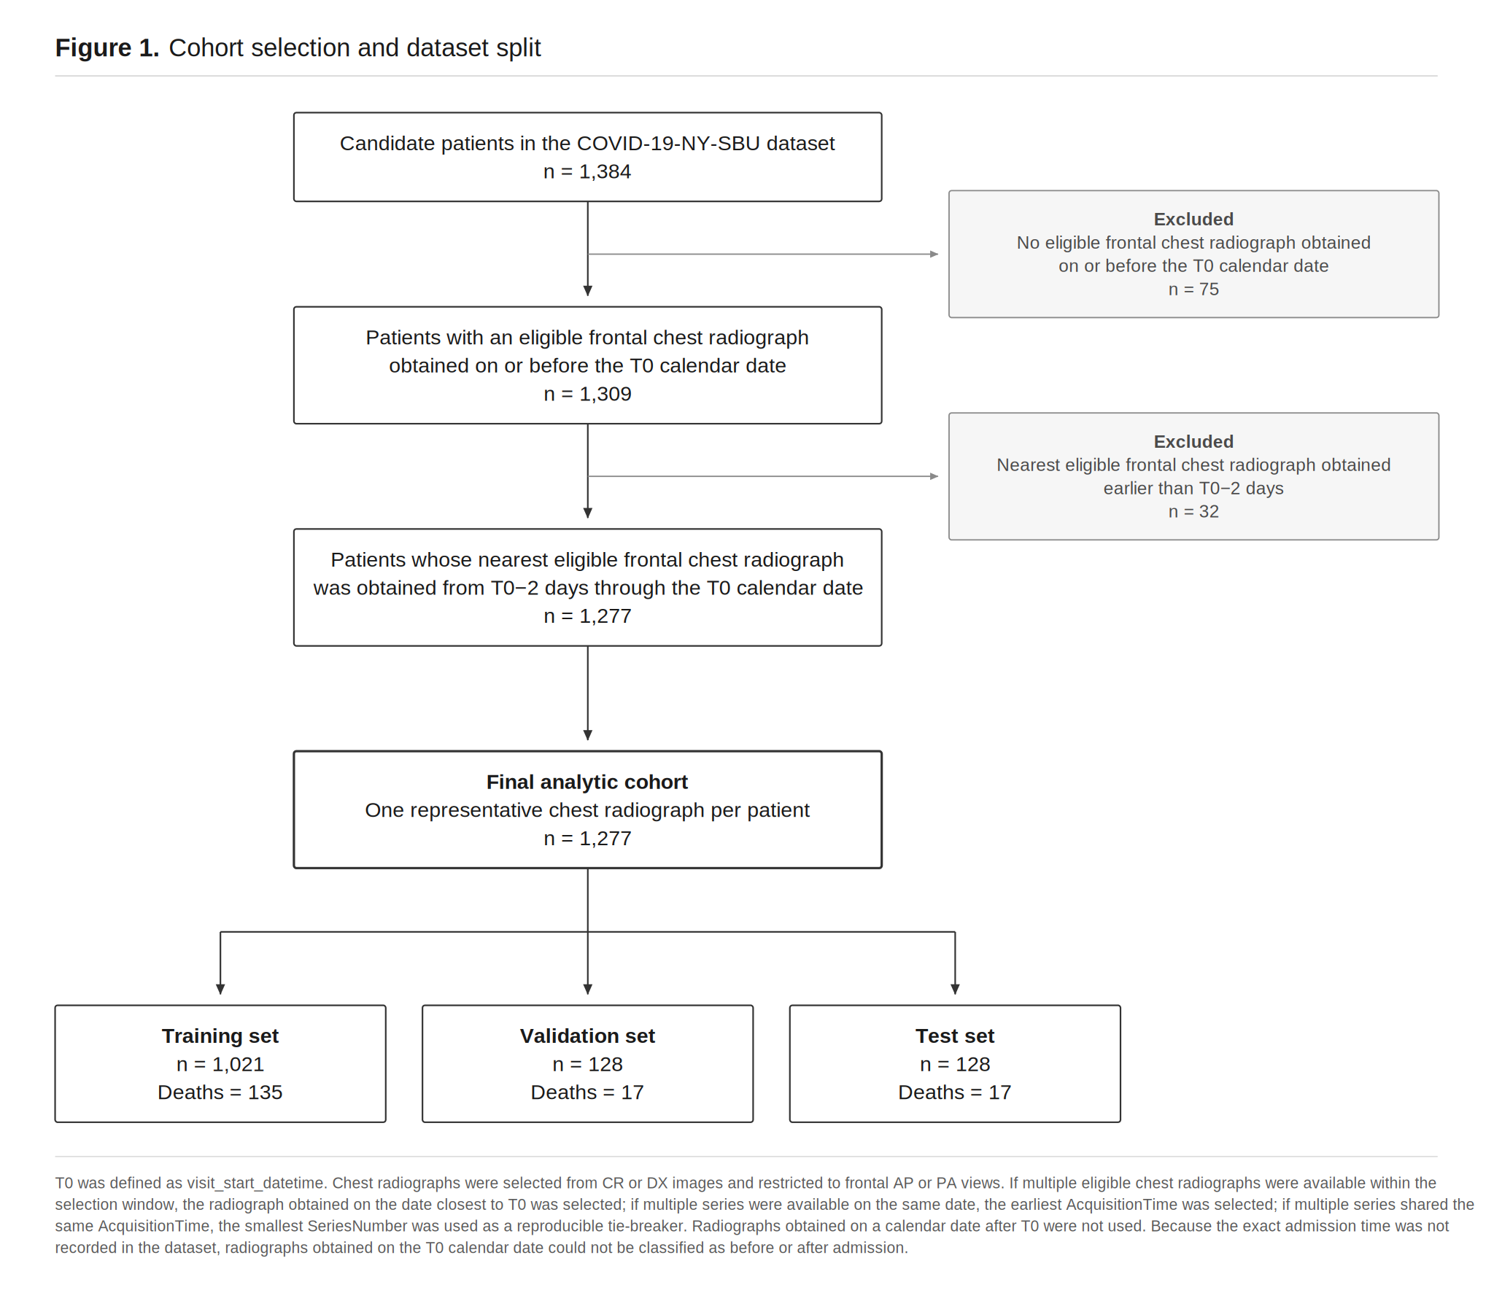
Figure 1. Participant flow and chest radiograph selection.
3.2 Baseline characteristics
Baseline characteristics of the 1,277 patients in the final analysis cohort are shown in Table 1. The nine raw variables used in the final clinical models are summarized for the overall cohort and separately for the Training, Validation, and Test sets. Continuous variables are presented as median [interquartile range], categorical variables as n (%), and the number and percentage of missing observations in the original data are reported. P values for differences in baseline characteristics across the Training, Validation, and Test sets were not calculated.
Table 1. Baseline characteristics of the final analysis cohort.
Characteristic | Overall  (N = 1,277) | Training  (N = 1,021) | Validation  (N = 128) | Test  (N = 128)
In-hospital death, n (%) | 169 (13.2%) | 135 (13.2%) | 17 (13.3%) | 17 (13.3%)
Age group, n (%)
18–59 years | 703 (55.1%) | 544 (53.3%) | 81 (63.3%) | 78 (60.9%)
60–74 years | 328 (25.7%) | 276 (27.0%) | 23 (18.0%) | 29 (22.7%)
75–90 years | 246 (19.3%) | 201 (19.7%) | 24 (18.8%) | 21 (16.4%)
Sex, n (%)
Female | 549 (43.0%) | 440 (43.1%) | 51 (39.8%) | 58 (45.3%)
Male | 699 (54.7%) | 562 (55.0%) | 70 (54.7%) | 67 (52.3%)
Missing | 29 (2.3%) | 19 (1.9%) | 7 (5.5%) | 3 (2.3%)
Heart failure, n (%)
No | 968 (75.8%) | 775 (75.9%) | 98 (76.6%) | 95 (74.2%)
HFpEF | 42 (3.3%) | 36 (3.5%) | 6 (4.7%) | 0 (0.0%)
HFrEF | 26 (2.0%) | 21 (2.1%) | 2 (1.6%) | 3 (2.3%)
Missing | 241 (18.9%) | 189 (18.5%) | 22 (17.2%) | 30 (23.4%)
SpO₂, median [IQR] | 95 [92–97] | 95 [92–97] | 95 [92–97] | 95 [92–98]
Missing, n (%) | 3 (0.2%) | 3 (0.3%) | 0 (0.0%) | 0 (0.0%)
Lymphocyte count, median [IQR] | 0.94 [0.68–1.32] | 0.94 [0.68–1.31] | 0.97 [0.72–1.41] | 0.89 [0.69–1.19]
Missing, n (%) | 375 (29.4%) | 289 (28.3%) | 42 (32.8%) | 44 (34.4%)
eGFR, median [IQR] | 88.5 [56.0–108.0] | 86.0 [57.0–107.0] | 94.0 [55.8–109.2] | 91.0 [54.5–111.0]
Missing, n (%) | 203 (15.9%) | 162 (15.9%) | 20 (15.6%) | 21 (16.4%)
CRP, median [IQR] | 8.45 [3.40–15.62] | 8.40 [3.40–15.40] | 8.25 [3.85–14.68] | 8.60 [2.90–17.15]
Missing, n (%) | 285 (22.3%) | 228 (22.3%) | 28 (21.9%) | 29 (22.7%)
D-dimer, median [IQR] | 353.0 [214.2–642.8] | 349.0 [209.0–655.0] | 363.0 [235.5–598.0] | 363.0 [242.5–631.8]
Missing, n (%) | 379 (29.7%) | 310 (30.4%) | 37 (28.9%) | 32 (25.0%)
Lactate, median [IQR] | 1.50 [1.10–2.00] | 1.50 [1.10–2.00] | 1.50 [1.10–1.92] | 1.40 [1.00–1.90]
Missing, n (%) | 304 (23.8%) | 248 (24.3%) | 28 (21.9%) | 28 (21.9%)

3.3 CXR model performance and Grad-CAM
Figure 2A shows the Validation ROC-AUC at each epoch for the initial hyperparameter comparison performed without class weighting (two augmentation strategies × three initial learning rates). For Augmentation B with learning rates of 1 × 10⁻⁴ and 1 × 10⁻⁵, Figure 2B shows the Training and Validation ROC-AUC trajectories, and Figure 2C shows the Training and Validation loss trajectories.
In the final Test set, CXR ResNet18 achieved a ROC-AUC of 0.907 (95% CI, 0.836–0.963) and a PR-AUC of 0.623 (Figure 3). The Brier score was 0.102 and the ECE was 0.152. When the threshold of 0.570, determined by the Youden index in the Validation set, was applied to the Test set, sensitivity was 70.6%, specificity 93.7%, accuracy 90.6%, and precision 63.2%; the confusion matrix comprised 104 true negatives, 7 false positives, 5 false negatives, and 12 true positives.
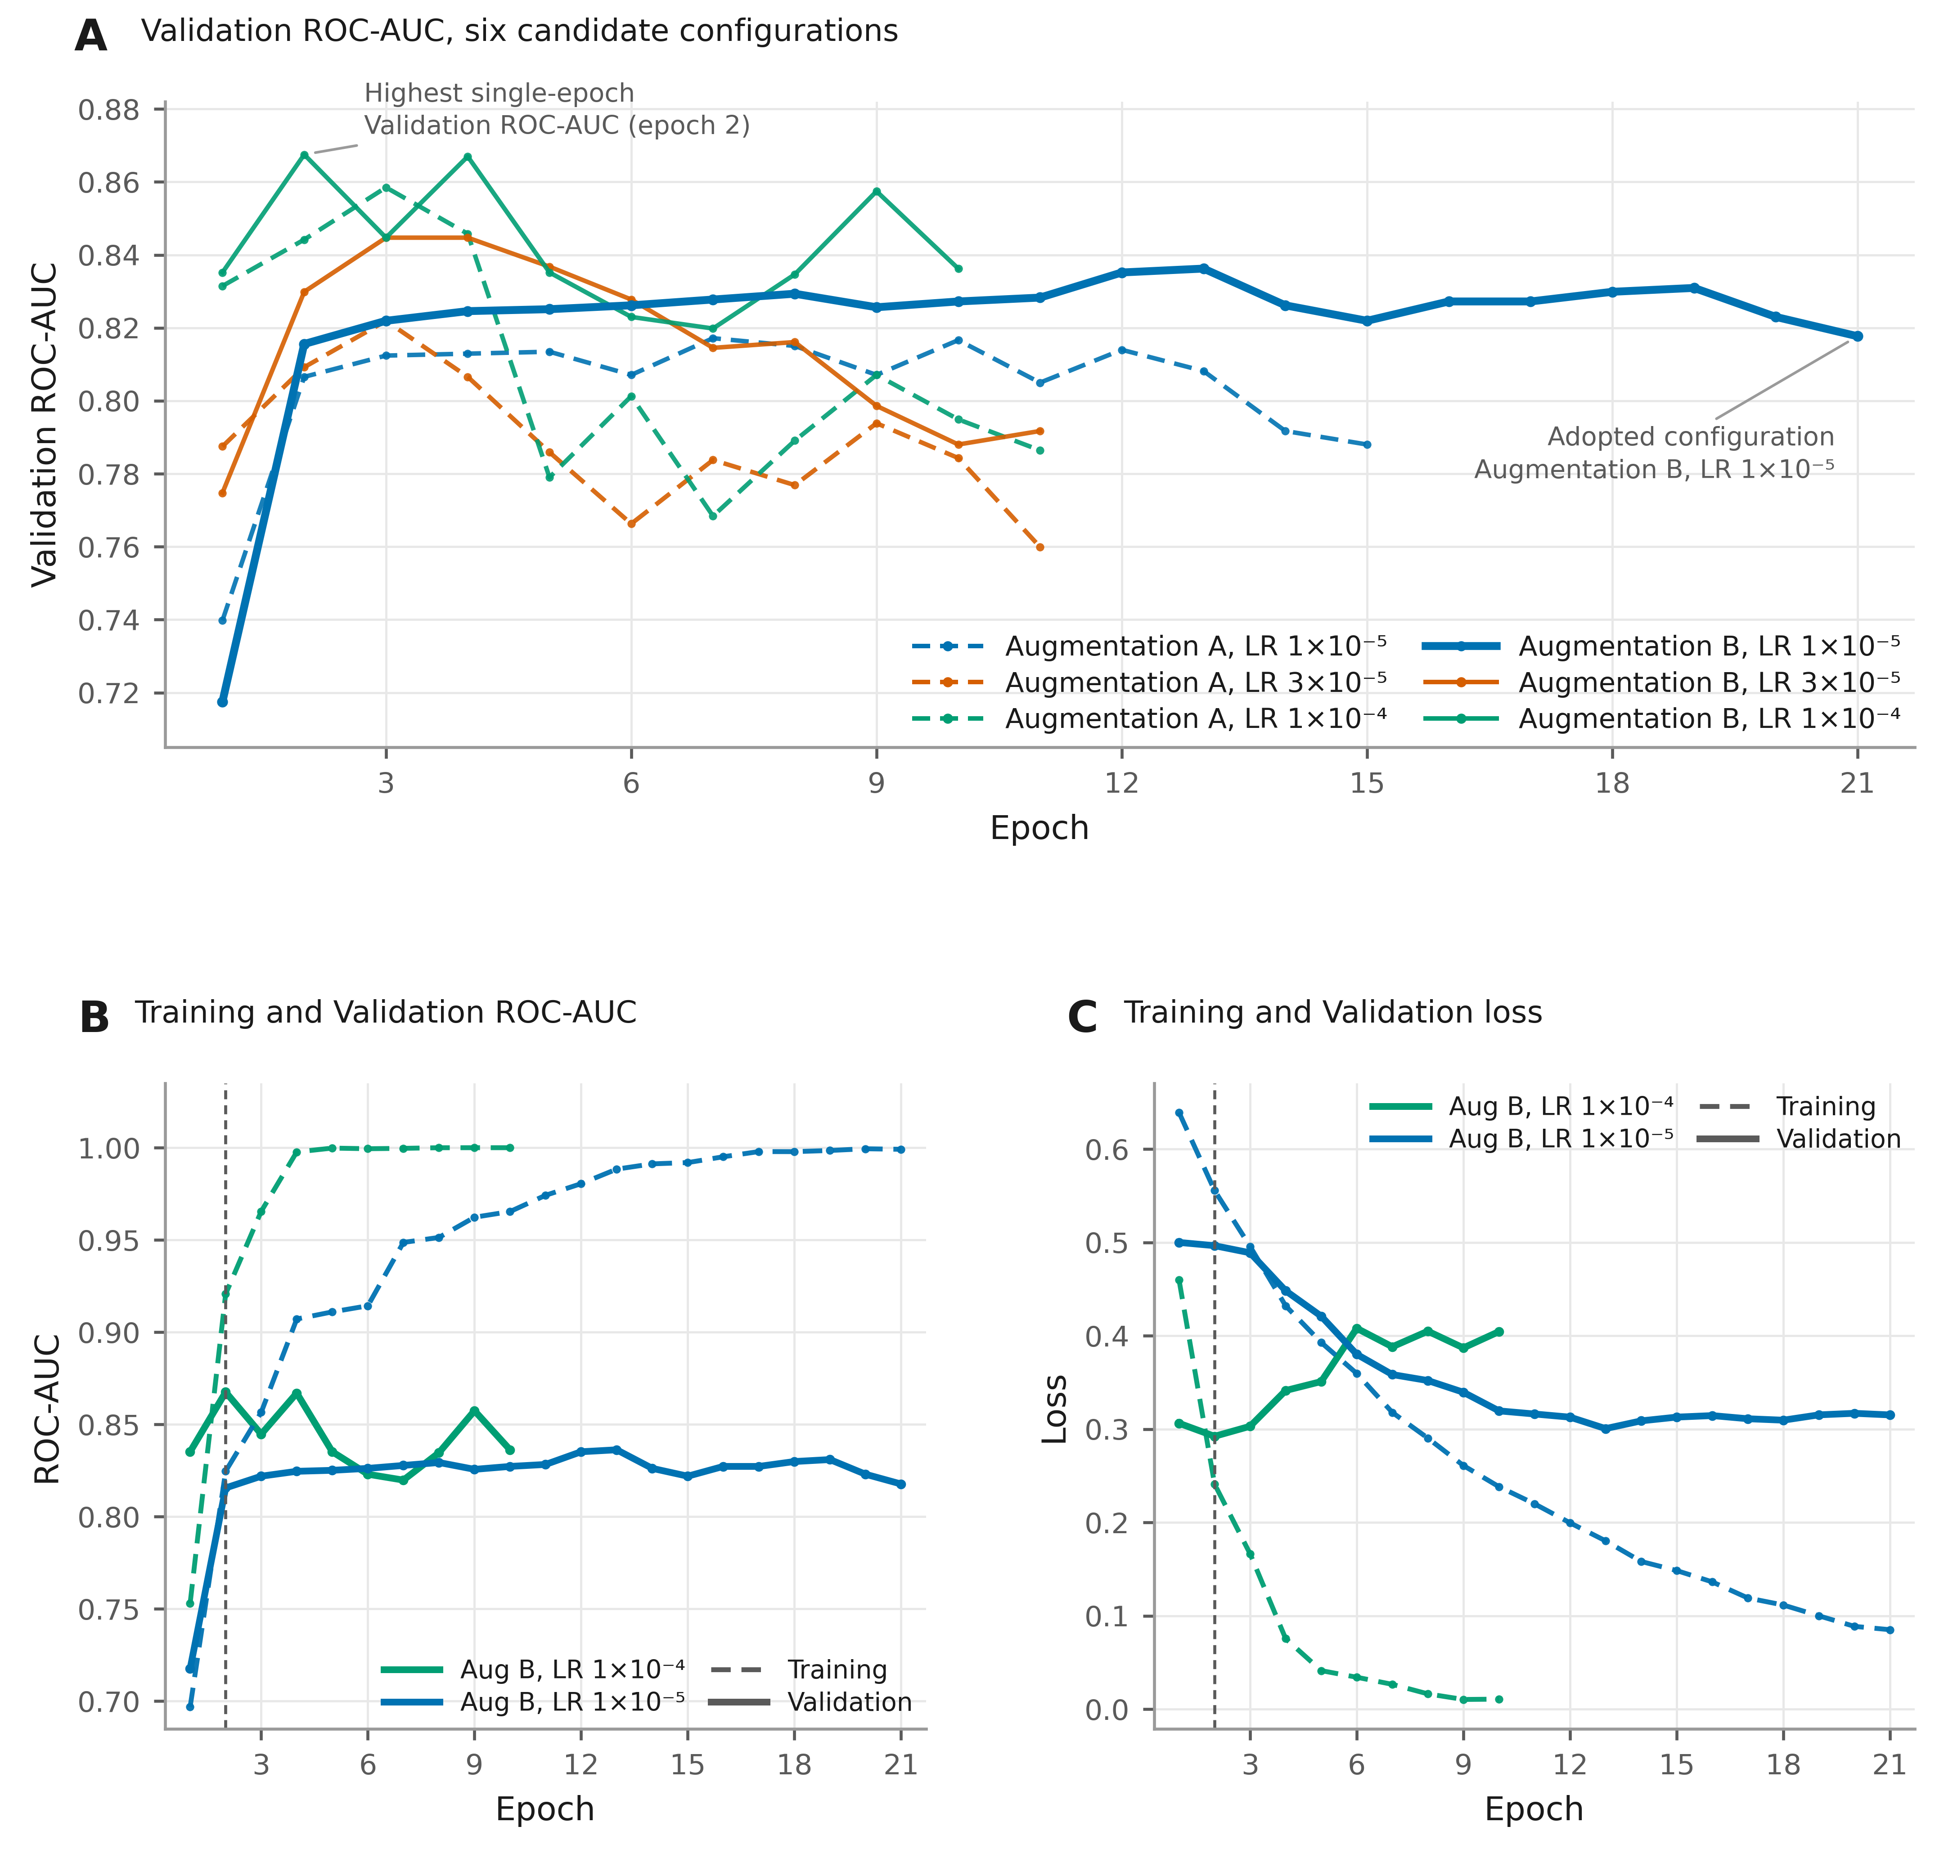
Figure 2. Selection of the CXR ResNet18 training configuration.
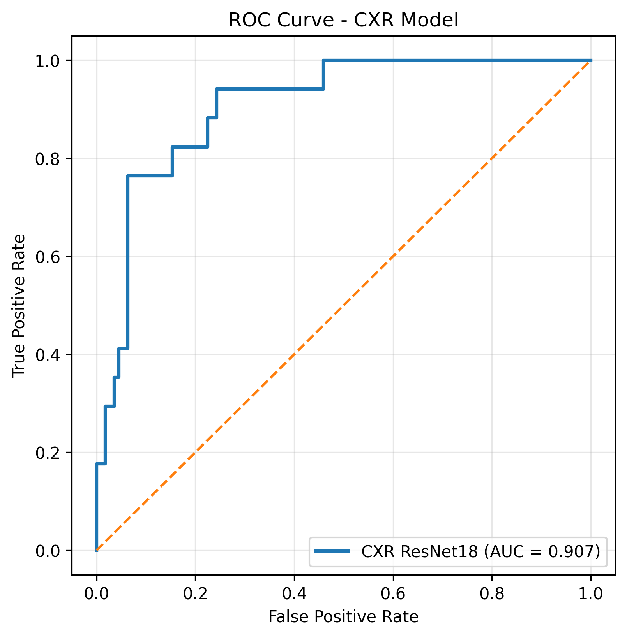
Figure 3. Receiver operating characteristic curve of the CXR ResNet18 model in the fixed test set.
In the Grad-CAM analysis, activation in true-positive cases was observed primarily within the lung fields and partially overlapped with radiographic infiltrates. In true-negative cases, clear activation for the mortality class within the lung fields was limited, and relative activation was often observed outside the lungs. In false-positive cases, prominent activation was observed within lung regions showing extensive infiltrates. In false-negative cases, activation within the lung fields was often limited, with additional activation in extrapulmonary regions such as bony structures, image margins, and medical devices (Figure 4).

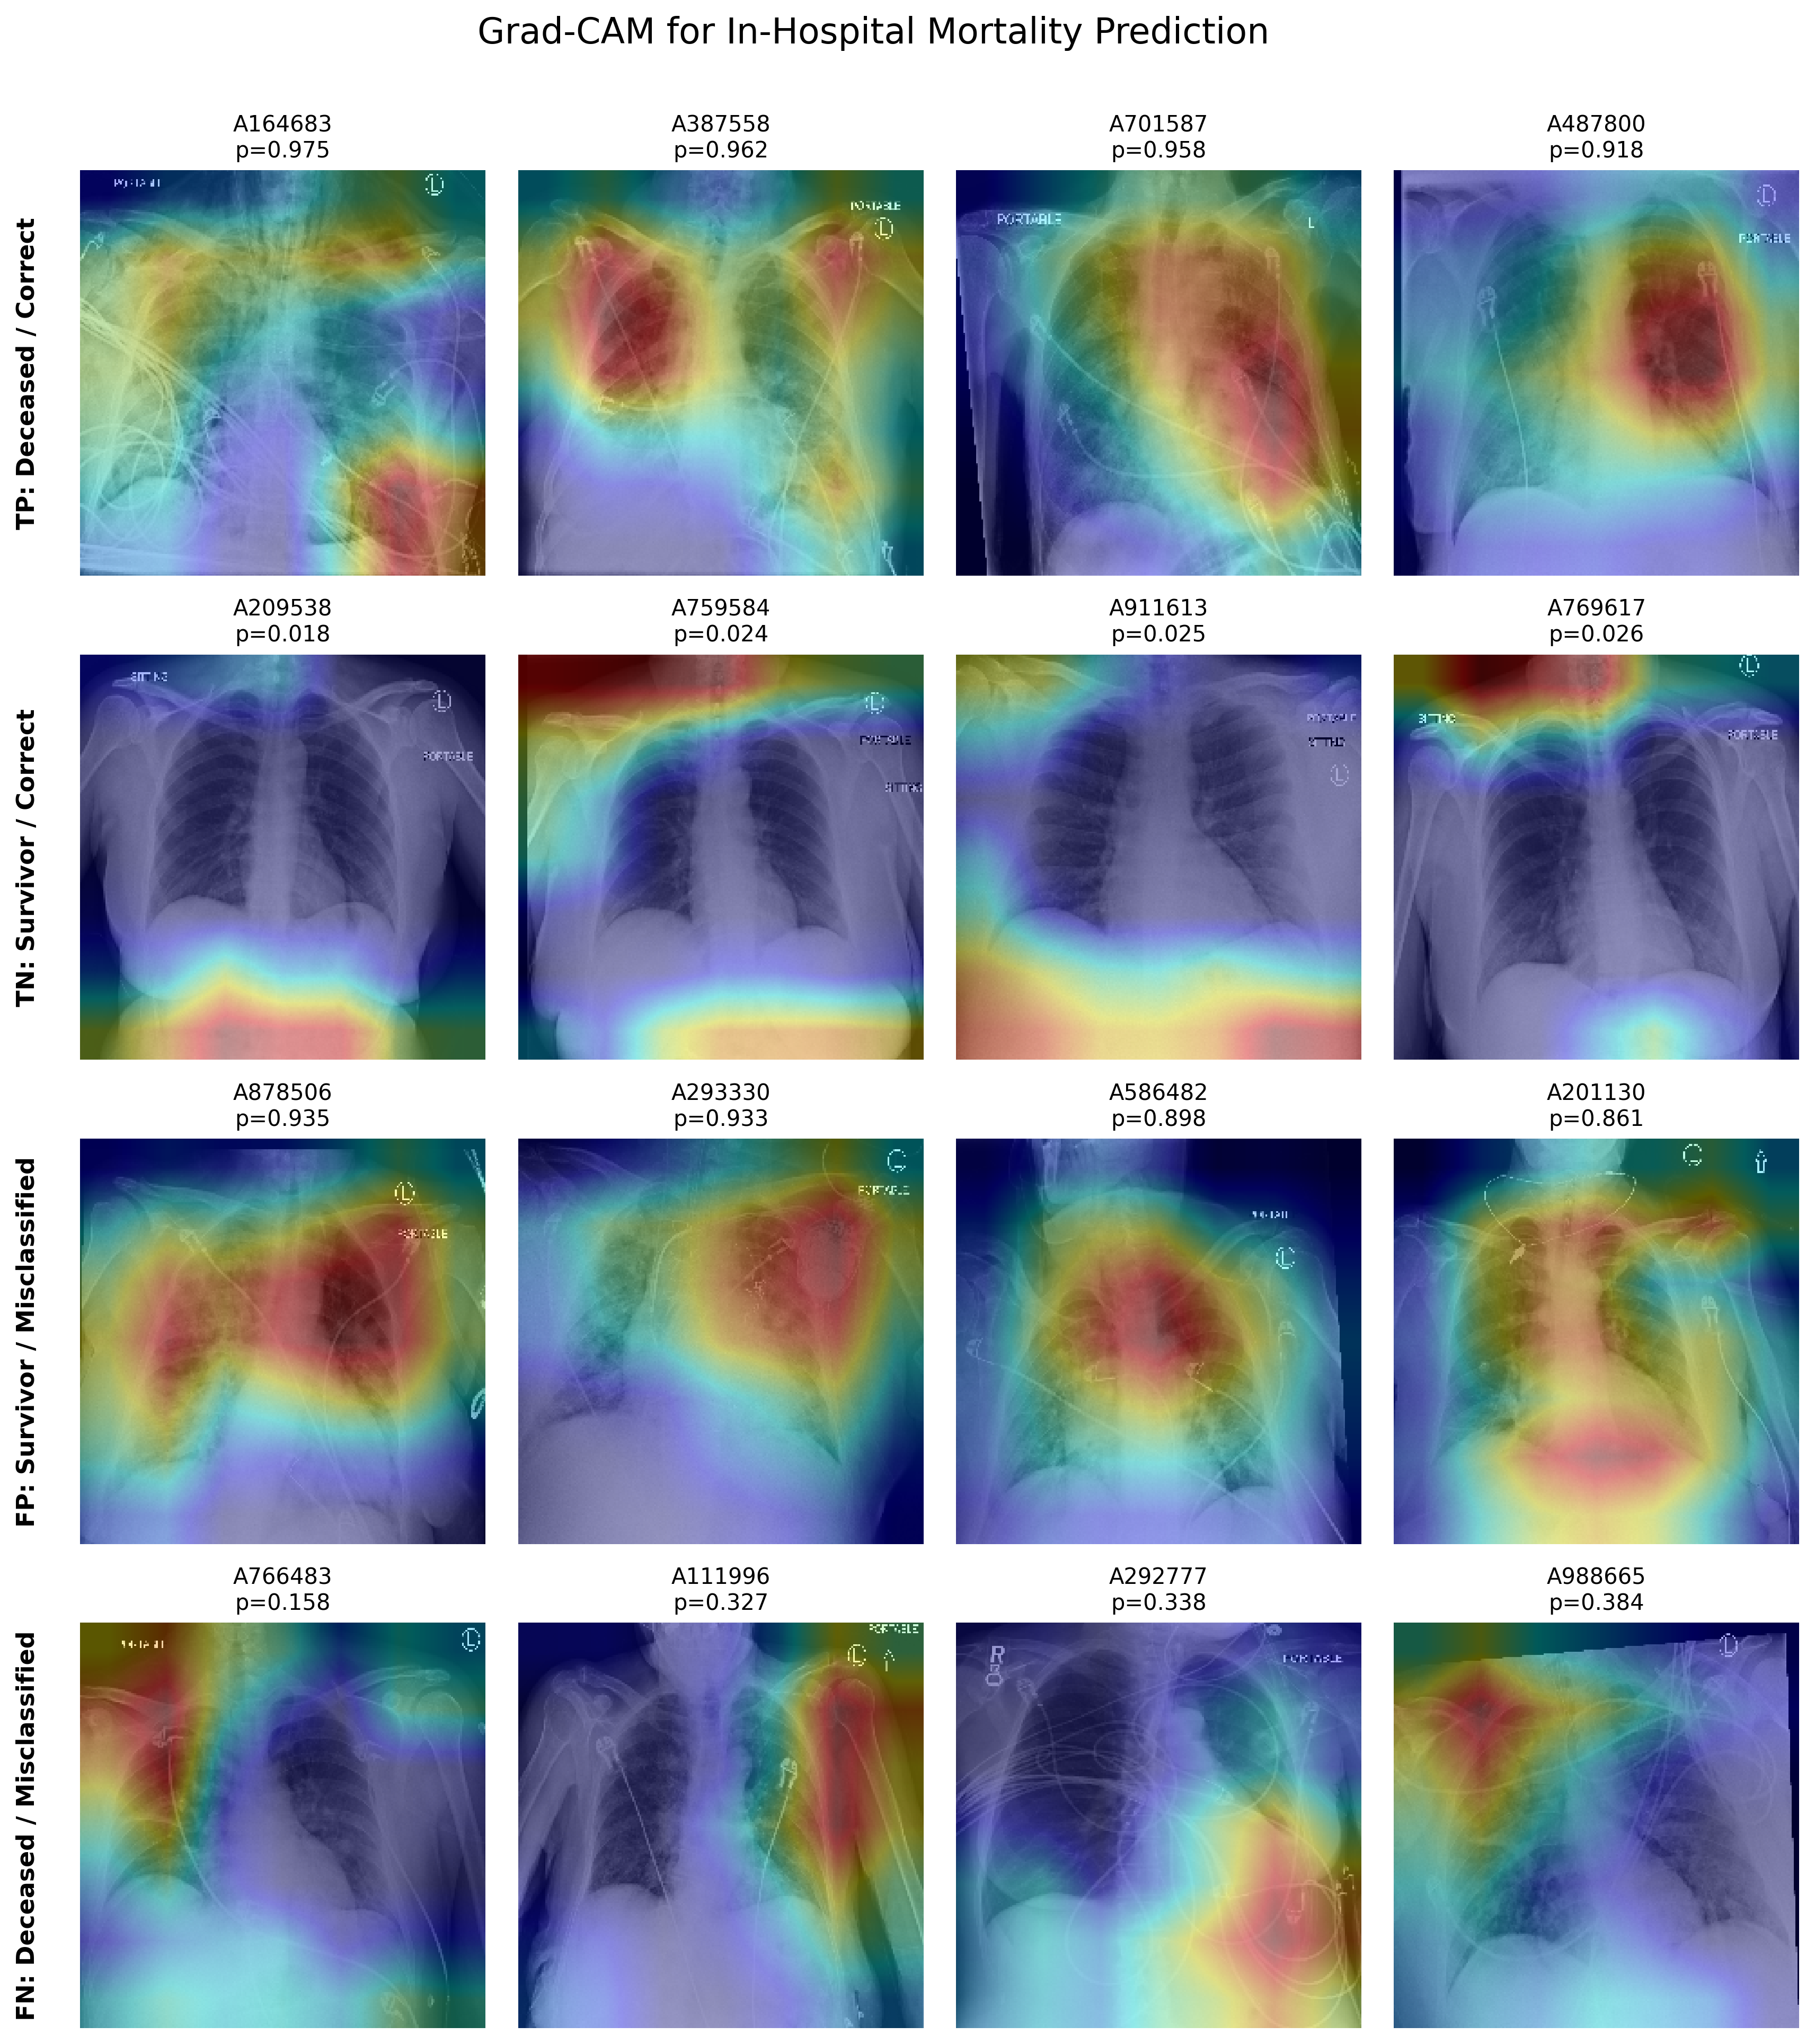
Figure 4. Gradient-weighted class activation mapping of representative CXR predictions.

3.4 Clinical model performance
In the final Test set, Clinical LR achieved a ROC-AUC of 0.941 (95% CI, 0.887–0.981), PR-AUC of 0.800, Brier score of 0.057, and ECE of 0.041. XGBoost achieved a ROC-AUC of 0.936 (95% CI, 0.876–0.979), PR-AUC of 0.718, Brier score of 0.068, and ECE of 0.090. MLP achieved a ROC-AUC of 0.880 (95% CI, 0.768–0.961), PR-AUC of 0.689, Brier score of 0.169, and ECE of 0.309. Among the three clinical models, LR had the highest point estimates of ROC-AUC and PR-AUC and the lowest Brier score and ECE (Figure 5, Table 2).
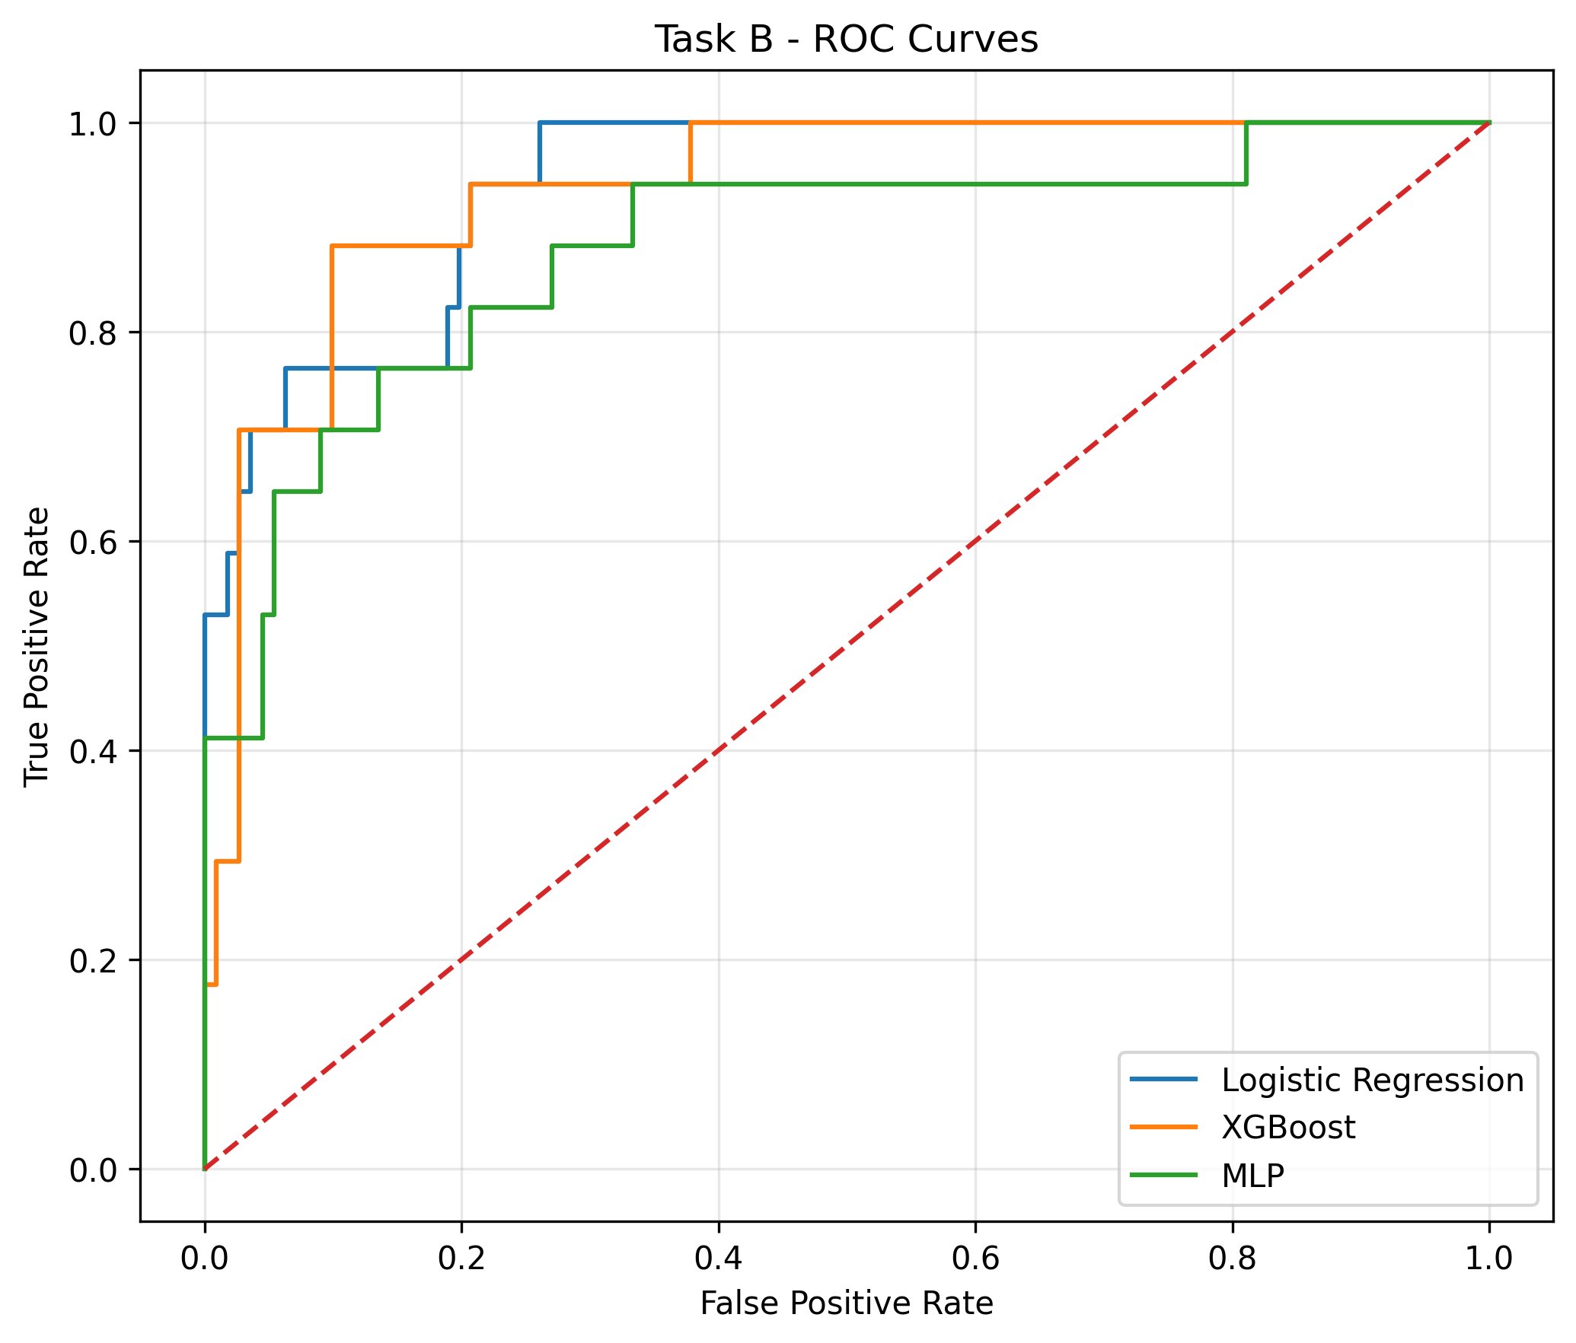
Figure 5. Receiver operating characteristic curves of the three clinical models in the fixed test set.
Permutation importance in the Validation set showed that lactate and SpO₂ consistently ranked among the most important predictors across all three clinical models. The top three features were lactate, SpO₂, and age 75–90 years for LR; lactate, SpO₂, and age 75–90 years for XGBoost; and SpO₂, lactate, and eGFR for MLP. CRP and eGFR also showed relatively high importance in multiple models (Figure 6).
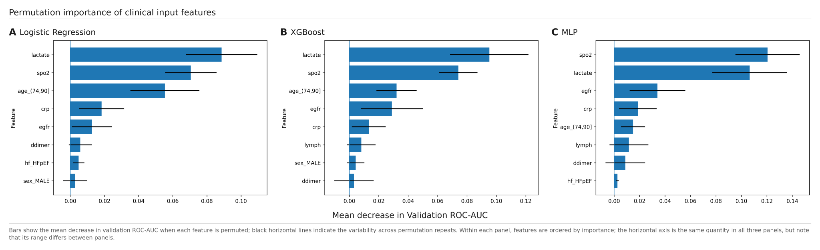
Figure 6. Permutation importance of clinical input features.

3.5 Late Fusion and all-model comparison
Late Fusion used weights of 0.72 for Clinical LR and 0.28 for CXR ResNet18. In the final Test set, Late Fusion achieved a ROC-AUC of 0.944 (95% CI, 0.884–0.985), PR-AUC of 0.797, Brier score of 0.059, and ECE of 0.065. Among the five models, Late Fusion had the highest point estimate of ROC-AUC, whereas Clinical LR showed better PR-AUC, Brier score, and ECE values (Figure 7, Table 2, Figure 8).
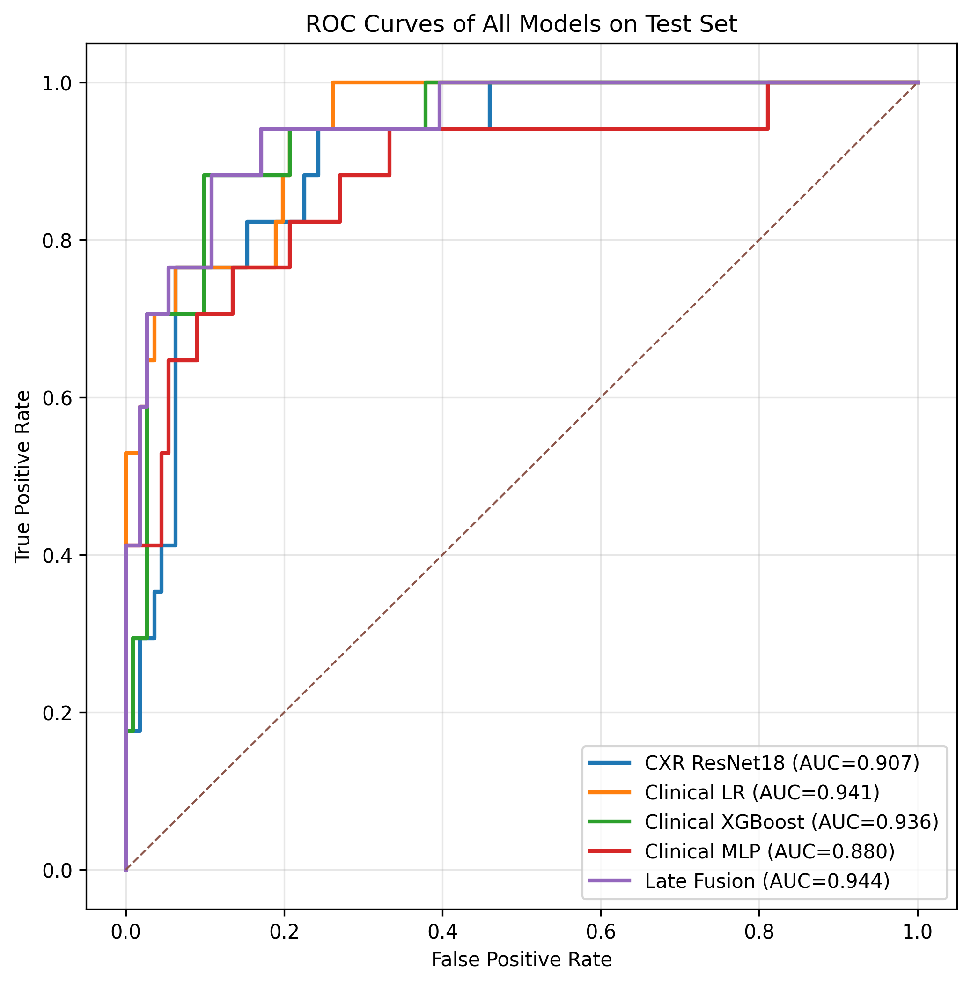
Figure 7. Receiver operating characteristic curves of the five models in the fixed test set.
Table 2. Predictive performance of the five models in the fixed test set.
Model | ROC-AUC | 95% CI | PR-AUC | Brier score | ECE
CXR ResNet18 | 0.907 | 0.836–0.963 | 0.623 | 0.102 | 0.152
Clinical Logistic Regression | 0.941 | 0.887–0.981 | 0.800 | 0.057 | 0.041
Clinical XGBoost | 0.936 | 0.876–0.979 | 0.718 | 0.068 | 0.090
Clinical MLP | 0.880 | 0.768–0.961 | 0.689 | 0.169 | 0.309
Late Fusion | 0.944 | 0.884–0.985 | 0.797 | 0.059 | 0.065

Paired DeLong comparison of ROC-AUC between Late Fusion and the three clinical models showed a ROC-AUC difference of 0.003 between Late Fusion and Clinical LR (Holm-adjusted P = 0.950) and a difference of 0.008 between Late Fusion and XGBoost (Holm-adjusted P = 0.950). The difference between Late Fusion and MLP was 0.065, with an unadjusted P = 0.021 and a Holm-adjusted P = 0.062. Thus, Late Fusion did not show a statistically significant improvement in ROC-AUC over any of the clinical models after Holm correction.
In comparisons with the component models, the ROC-AUC difference between Late Fusion and the CXR-only model was 0.037, with an unadjusted P = 0.046. When the two comparisons of Late Fusion versus Clinical LR and Late Fusion versus CXR ResNet18 were treated as one family and adjusted using the Holm method, the adjusted P value for Late Fusion versus CXR was 0.092, indicating no statistically significant difference.
Clinical LR showed the best calibration-related metrics among the five models, with a Brier score of 0.057 and ECE of 0.041, whereas Late Fusion had a Brier score of 0.059 and ECE of 0.065. Calibration curves are shown in Figure 8.
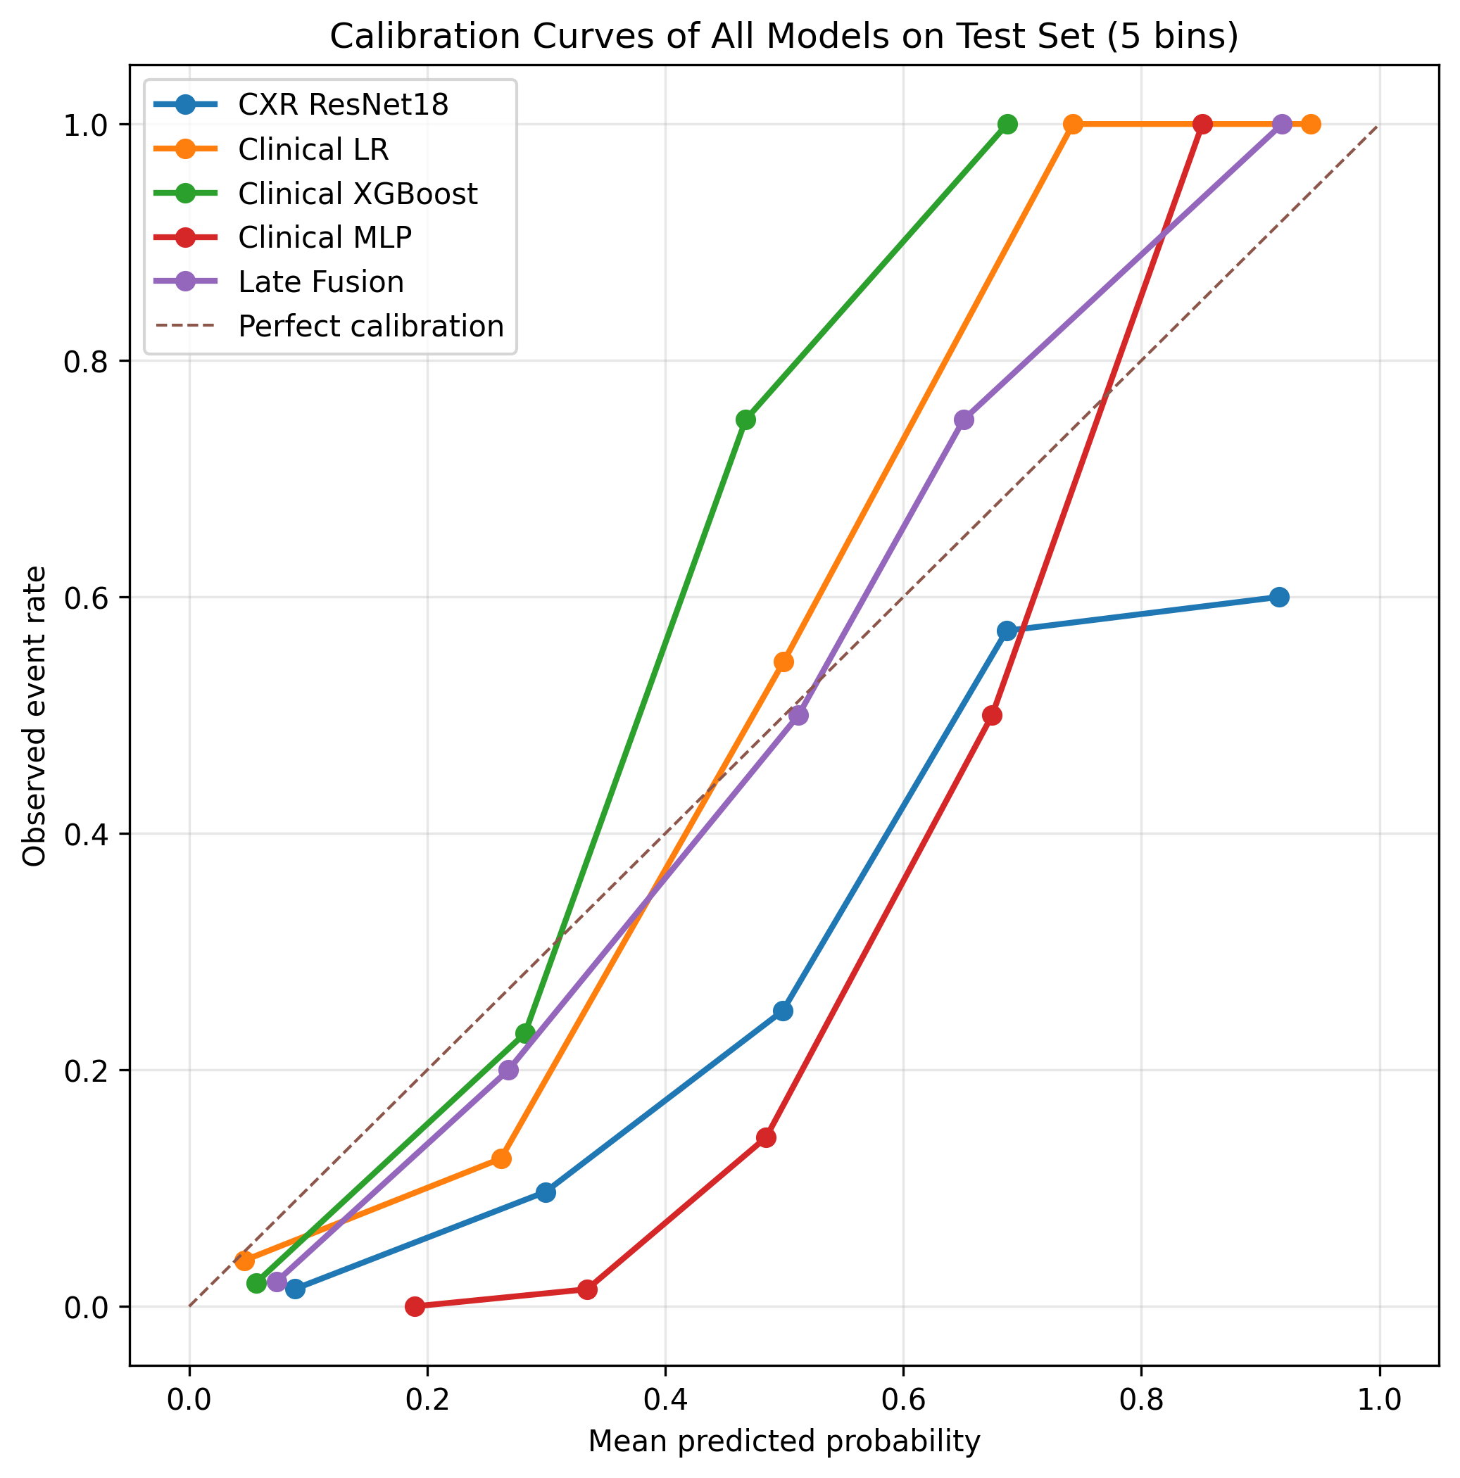
Figure 8. Calibration curves of the five models in the fixed test set.
In the modality-level permutation importance analysis, the baseline ROC-AUC of the fixed Late Fusion model was 0.944. Permuting the Clinical probability resulted in a mean ROC-AUC decrease of 0.169, whereas permuting the CXR probability resulted in a mean decrease of 0.045. These findings suggest that Late Fusion relied predominantly on clinical information while CXR provided complementary information.

4. Discussion
In this study, we compared a CXR-only model, three clinical models, and a Late Fusion model for predicting in-hospital mortality in patients with COVID-19 using chest radiographs and clinical information obtained around the time of admission. The principal finding was that LR using clinical information alone achieved high discrimination and good calibration. The CXR-only model also demonstrated good discrimination; however, the improvement obtained by adding CXR information to clinical information through Late Fusion was limited. Although Late Fusion had the highest point estimate of ROC-AUC among the five models, the difference from Clinical LR was small and was not statistically significant after Holm correction. Furthermore, modality-level permutation importance suggested that the Late Fusion predictions depended predominantly on clinical information, with CXR providing complementary information.
Among the three clinical-only models, LR had the highest point estimate of ROC-AUC and also showed the best PR-AUC, Brier score, and ECE. However, because superiority between LR and either XGBoost or MLP was not directly tested, these findings should be interpreted as comparisons of point estimates. One possible explanation is that much of the predictive information was concentrated in a relatively small number of input variables and that many relationships with mortality risk could be captured by relatively simple linear or monotonic effects. In addition, given the limited number of patients and mortality events in the Training set, the lower-parameter LR model may have been less susceptible to overfitting than more flexible nonlinear models.
Permutation importance in the Validation set showed that lactate and SpO₂ consistently had high importance across all three clinical models, while age, eGFR, and CRP also ranked highly in multiple models. These findings are consistent with clinical characteristics associated with severe COVID-19 and mortality, including tissue hypoperfusion, respiratory failure, older age, renal dysfunction, and systemic inflammation. Nevertheless, permutation importance reflects a model\'s dependence on a feature and does not represent the causal effect of that feature. Moreover, importance may be distributed among correlated variables; therefore, the ranking itself should not be overinterpreted.
The CXR-only model also demonstrated good discrimination, suggesting that chest radiographs obtained around the time of admission contain prognostic information related to in-hospital mortality. CXR primarily reflects imaging features such as the distribution and extent of pulmonary abnormalities, whereas clinical information more directly reflects systemic status, including age, oxygenation, inflammatory response, renal function, and circulatory or metabolic status. Thus, the two modalities do not represent completely identical information, and CXR may provide prognostic information from a perspective distinct from that captured by clinical data.
Indeed, Late Fusion combining Clinical LR and CXR ResNet18 achieved a ROC-AUC of 0.944 in the Test set, the highest point estimate among the five models. However, the ROC-AUC for Clinical LR alone was 0.941, corresponding to a difference of only 0.003, and the paired DeLong test did not show a statistically significant improvement. Clinical LR alone also had better PR-AUC, Brier score, and ECE values than Late Fusion. Therefore, the contribution of adding CXR in this study is more appropriately interpreted as providing limited complementary information to the clinical model rather than as a clear performance improvement over Clinical LR.
This interpretation is also consistent with the modality-level permutation importance results. Permuting the Clinical probability produced a larger decrease in ROC-AUC than permuting the CXR probability, indicating that the final prediction depended more strongly on clinical information. At the same time, ROC-AUC also decreased when the CXR probability was permuted, suggesting that CXR may have provided some complementary prognostic information. However, this analysis describes model dependence on each modality and does not directly establish the medical or causal importance of either modality.
The limited improvement from adding CXR may partly reflect the already high discrimination achieved by Clinical LR alone, leaving little room for an additional modality to improve performance. In addition, in-hospital mortality is not determined solely by the extent of pulmonary abnormalities but is influenced by multiple systemic factors, including age, comorbidities, oxygenation, hemodynamic status, inflammation, and organ dysfunction. Consequently, imaging information from a single CXR may not capture all of the prognostic information contained in the clinical data.
Previous studies have reported associations of clinical indicators such as age, oxygenation, inflammatory response, and renal function with severe COVID-19 and mortality [1,2]. Deep-learning models using CXR have also been shown to predict disease severity or prognosis [3,4]. In addition, although multimodal prediction models combining imaging and clinical information have been reported to outperform single-modality models [4–7], the magnitude of improvement varies according to the study population, clinical variables used, image selection, and fusion method. A distinguishing feature of the present study is that unimodal models and Late Fusion were compared on the same independent Test set, with modality-level permutation importance additionally used to assess the fusion model\'s dependence on each modality.
This study has several limitations. First, it was a single-center retrospective study without external validation. Model performance may therefore vary across institutions because of differences in patient characteristics, clinical practice, imaging conditions, and laboratory workflows, limiting generalizability to other centers and populations.
Second, sex information was missing for a subset of patients. In the Training set, 18 of 19 patients (94.7%) with missing sex information died during hospitalization; therefore, treating missing sex as a separate category could have allowed the model to exploit nonclinical information arising from the missingness mechanism. We therefore did not use a Missing category for sex and instead imputed missing values with male, the mode in the Training set. However, this imputation did not recover the true sex of patients with missing data, and uncertainty regarding sex information remains.
Third, the final Test set was small, comprising 128 patients with only 17 in-hospital deaths. Estimates of performance metrics, including ROC-AUC, therefore remain uncertain, and particular caution is required when interpreting calibration curves and between-model differences. Although Late Fusion had the highest point estimate of ROC-AUC, its difference from Clinical LR was small and not statistically significant; therefore, its incremental value should not be overstated.
Fourth, although visit_start_datetime was defined as T0, the exact temporal relationship between CXR acquisition and admission could not be determined for radiographs obtained on the T0 calendar date. This limits the extent to which the study can strictly reproduce a fully prospective admission-time prediction setting.
Fifth, measurement timestamps for individual laboratory values were unavailable; therefore, it could not be confirmed that all values were obtained within a fixed interval relative to T0. Consequently, some uncertainty remains regarding the temporal alignment of the clinical variables with the prediction time point.
Overall, these findings support the possibility that CXR and clinical information contain partly distinct prognostic information, while also showing that adding imaging information does not necessarily improve predictive performance. The small increase in ROC-AUC observed with Late Fusion should not be interpreted directly as an improvement in clinical utility; rather, reproducibility in external data and the impact on actual clinical decision-making require further evaluation.

5. Conclusion
In this study, we developed and compared models for predicting in-hospital mortality in patients with COVID-19 using chest radiographs and clinical information obtained around the time of admission. Clinical Logistic Regression demonstrated high discrimination and good calibration, and the CXR-only model also contained useful prognostic information. Although Late Fusion had the highest point estimate of ROC-AUC, the improvement over Clinical LR was small and not statistically significant. Modality-level permutation importance further suggested that the fusion model relied predominantly on clinical information, with CXR providing complementary information. These findings suggest that clinical information obtained around the time of admission may provide high predictive performance for in-hospital mortality in COVID-19, whereas the incremental value of multimodal prediction incorporating CXR may be limited. Future external validation is needed to confirm the model performance and the added value of CXR observed in this study.
6. Declarations
Funding
No specific external funding was received for this study.
Conflict of Interest
The author declares no conflicts of interest.
Protocol and registration
This study was not prospectively registered in a public registry.
Data and code availability
The source COVID-19-NY-SBU dataset is publicly available through The Cancer Imaging Archive (TCIA). The analysis code, trained models, and derived materials generated for this coursework project are not publicly available.

7. References
1. Tian W, Jiang W, Yao J, Nicholson CJ, Li RH, Sigurslid HH, et al. Predictors of mortality in hospitalized COVID-19 patients: a systematic review and meta-analysis. J Med Virol. 2020;92(10):1875–1883. doi:10.1002/jmv.26050.
2. Shi C, Wang L, Ye J, Gu Z, Wang S, Xia J, et al. Predictors of mortality in patients with coronavirus disease 2019: a systematic review and meta-analysis. BMC Infect Dis. 2021;21(1):663. doi:10.1186/s12879–021–06369–0.
3. Borghesi A, Zigliani A, Golemi S, Carapella N, Maculotti P, Farina D, et al. Chest X-ray severity index as a predictor of in-hospital mortality in coronavirus disease 2019: a study of 302 patients from Italy. Int J Infect Dis. 2020;96:291–293. doi:10.1016/j.ijid.2020.05.021.
4. Jiao Z, Choi JW, Halsey K, Tran TML, Hsieh B, Wang D, et al. Prognostication of patients with COVID-19 using artificial intelligence based on chest x-rays and clinical data: a retrospective study. Lancet Digit Health. 2021;3(5):e286-e294. doi:10.1016/S2589–7500(21)00039-X.
5. Wu JTY, Armengol de la Hoz MÁ, Kuo PC, Paguio JA, Yao JS, Dee EC, et al. Developing and validating multi-modal models for mortality prediction in COVID-19 patients: a multi-center retrospective study. J Digit Imaging. 2022;35(6):1514–1529. doi:10.1007/s10278–022–00674-z.
6. Lee JH, Ahn JS, Chung MJ, Jeong YJ, Kim JH, Lim JK, et al. Development and validation of a multimodal-based prognosis and intervention prediction model for COVID-19 patients in a multicenter cohort. Sensors (Basel). 2022;22(13):5007. doi:10.3390/s22135007.
7. Walston SL, Matsumoto T, Miki Y, Ueda D. Artificial intelligence-based model for COVID-19 prognosis incorporating chest radiographs and clinical data; a retrospective model development and validation study. Br J Radiol. 2022;95(1140):20220058. doi:10.1259/bjr.20220058.
8. Saltz J, Saltz M, Prasanna P, Moffitt R, Hajagos J, Bremer E, et al. Stony Brook University COVID-19 Positive Cases [dataset]. The Cancer Imaging Archive; 2021. doi:10.7937/TCIA.BBAG-2923.
9. Clark K, Vendt B, Smith K, Freymann J, Kirby J, Koppel P, et al. The Cancer Imaging Archive (TCIA): maintaining and operating a public information repository. J Digit Imaging. 2013;26(6):1045–1057. doi:10.1007/s10278–013–9622–7.
10. Collins GS, Moons KGM, Dhiman P, Riley RD, Beam AL, Van Calster B, et al. TRIPOD+AI statement: updated guidance for reporting clinical prediction models that use regression or machine learning methods. BMJ. 2024;385:e078378. doi:10.1136/bmj-2023–078378.
11. Knight SR, Ho A, Pius R, Buchan I, Carson G, Drake TM, et al. Risk stratification of patients admitted to hospital with covid-19 using the ISARIC WHO Clinical Characterisation Protocol: development and validation of the 4C Mortality Score. BMJ. 2020;370:m3339. doi:10.1136/bmj.m3339.
12. He K, Zhang X, Ren S, Sun J. Deep residual learning for image recognition. In: Proceedings of the IEEE Conference on Computer Vision and Pattern Recognition; 2016. p. 770–778. doi:10.1109/CVPR.2016.90.
13. Selvaraju RR, Cogswell M, Das A, Vedantam R, Parikh D, Batra D. Grad-CAM: visual explanations from deep networks via gradient-based localization. In: Proceedings of the IEEE International Conference on Computer Vision; 2017. p. 618–626. doi:10.1109/ICCV.2017.74.
14. Hosmer DW Jr, Lemeshow S, Sturdivant RX. Applied Logistic Regression. 3rd ed. Hoboken (NJ): John Wiley & Sons; 2013.
15. Chen T, Guestrin C. XGBoost: a scalable tree boosting system. In: Proceedings of the 22nd ACM SIGKDD International Conference on Knowledge Discovery and Data Mining; 2016. p. 785–794. doi:10.1145/2939672.2939785.
16. Rumelhart DE, Hinton GE, Williams RJ. Learning representations by back-propagating errors. Nature. 1986;323(6088):533–536. doi:10.1038/323533a0.
17. Brier GW. Verification of forecasts expressed in terms of probability. Mon Weather Rev. 1950;78(1):1–3. doi:10.1175/1520–0493(1950)078<0001:VOFEIT>2.0.CO;2.
18. Guo C, Pleiss G, Sun Y, Weinberger KQ. On calibration of modern neural networks. Proc Mach Learn Res. 2017;70:1321–1330.
19. DeLong ER, DeLong DM, Clarke-Pearson DL. Comparing the areas under two or more correlated receiver operating characteristic curves: a nonparametric approach. Biometrics. 1988;44(3):837–845. doi:10.2307/2531595.
20. Holm S. A simple sequentially rejective multiple test procedure. Scand J Stat. 1979;6(2):65–70. doi:10.2307/4615733.

8. Figure and Table Legends
Figure 1. Participant flow and chest radiograph selection. Flow diagram showing selection of the final analysis cohort from 1,384 patients in COVID-19-NY-SBU. Eligible frontal chest radiographs were identified from CR/DX studies, restricted to AP/PA views, and selected from T0−2 days through the T0 calendar date; radiographs obtained on a calendar date after T0 were not used. CENTRAL LINE and TRAUMA studies were excluded. One representative radiograph per patient was selected using the date closest to T0 and then the earliest AcquisitionTime on that date; when acquisition times were identical, the smallest SeriesNumber was used as a reproducible tie-breaker. Because the exact admission time was not recorded in the dataset, radiographs obtained on the T0 calendar date could not be classified as before or after admission. The final cohort comprised 1,277 patients.
Figure 2. Selection of the CXR ResNet18 training configuration. (A) Validation ROC-AUC at every recorded epoch for the six candidate configurations defined by two augmentation strategies and three initial learning rates (1×10^−5^, 3×10^−5^, and 1×10^−4^). Line colour denotes the initial learning rate and line style the augmentation strategy (dashed, Augmentation A; solid, Augmentation B); the configuration adopted for the final model is drawn with a thicker line. (B) Training and Validation ROC-AUC and (C) Training and Validation loss for the two configurations compared in the learning-curve stability assessment, Augmentation B with a learning rate of 1×10^−4^ and Augmentation B with a learning rate of 1×10^−5^. In (B) and (C), line colour denotes the initial learning rate and line style the dataset (dashed, Training; solid, Validation), and the vertical dashed line marks epoch 2, the best epoch of Augmentation B with a learning rate of 1×10^−4^. All models were trained with random seed 42 and without class weighting, and each curve ends at the epoch at which early stopping was triggered. Every recorded epoch is plotted without smoothing or averaging. Only the Training and Validation sets were used for this comparison; the fixed Test set was not used for hyperparameter selection or model selection.
Figure 3. Receiver operating characteristic curve of the CXR ResNet18 model in the fixed test set. The ROC curve of the final CXR ResNet18 model is shown for the 128 test patients. The diagonal line represents chance-level discrimination. The ROC-AUC and its 95% confidence interval are reported in Table 2.
Figure 4. Gradient-weighted class activation mapping of representative CXR predictions. Grad-CAM maps from the final ResNet18 model are shown for representative true-positive, true-negative, false-positive, and false-negative cases selected using stored prediction probabilities before visual inspection. The heatmaps indicate regions contributing relatively strongly to the mortality-class logit within each image. Heatmaps were normalized independently for each case; color intensity should therefore not be compared quantitatively across patients.
Figure 5. Receiver operating characteristic curves of the three clinical models in the fixed test set. ROC curves are shown for Clinical Logistic Regression, Clinical XGBoost, and Clinical MLP in the same 128 test patients. The diagonal line represents chance-level discrimination. ROC-AUC values and 95% confidence intervals are reported in Table 2.
Figure 6. Permutation importance of clinical input features. Validation-set permutation importance is shown for Clinical Logistic Regression, XGBoost, and MLP. Each feature was randomly permuted 30 times, and importance was defined as the mean decrease in ROC-AUC from the unpermuted model. Importance reflects model dependence on a feature and should not be interpreted as a causal effect.
Figure 7. Receiver operating characteristic curves of the five models in the fixed test set. ROC curves are shown for CXR ResNet18, Clinical Logistic Regression, Clinical XGBoost, Clinical MLP, and Late Fusion in the same 128 test patients. The diagonal line represents chance-level discrimination. ROC-AUC values and 95% confidence intervals are reported in Table 2.
Figure 8. Calibration curves of the five models in the fixed test set. Calibration curves are shown using five equal-width probability bins for visual presentation because the test set contained 128 patients and 17 deaths. The diagonal line indicates perfect calibration. Expected calibration error reported in Table 2 was calculated separately using 10 equal-width bins.
Table 1. Baseline characteristics of the final analysis cohort. Baseline characteristics are summarized for the overall cohort and the fixed Training, Validation, and Test sets. Continuous variables are reported as median [interquartile range], categorical variables as n (%), and missingness reflects the original data before imputation. The table includes the nine raw clinical variables retained for final clinical modeling. No P values are reported for comparisons across data splits.
Table 2. Predictive performance of the five models in the fixed test set. ROC-AUC, 95% confidence interval, PR-AUC, Brier score, and expected calibration error are reported for CXR ResNet18, Clinical Logistic Regression, Clinical XGBoost, Clinical MLP, and Late Fusion. ROC-AUC 95% confidence intervals were calculated using 10,000 stratified bootstrap resamples with random seed 42.

9. Supplementary Material
Supplementary Table S1. Chest radiograph eligibility and selection criteria.
Criterion | Definition
DICOM modality | CR or DX
Chest examination | Identified from Study Description
Projection | Frontal AP or PA based on Series Description
Time window | T0−2 days through the T0 calendar date; radiographs obtained on a calendar date after T0 were not used
Excluded study purpose | CENTRAL LINE confirmation; TRAUMA examination
Not excluded by name alone | CODE T; INFANT; OVER PENETRATED
Representative date | Date closest to T0
Same-date tie-breaker 1 | Earliest AcquisitionTime
Same-date tie-breaker 2 | Smallest SeriesNumber when AcquisitionTime was identical (reproducible tie-breaker only; SeriesNumber was not treated as acquisition order)
Images retained per patient | 1
Final cohort | 1,277 patients / 1,277 CXRs

Supplementary Table S2. Rationale for selection of the 14 candidate clinical variables.
Clinical variable | Rationale for inclusion | Supporting evidence or prognostic framework | Relationship to other candidate variables
Age | A major prognostic factor in COVID-19; the only variable in the dataset that carries age information. | Age is consistently associated with COVID-19 mortality. Included in the 4C Mortality Score. | Only available age variable; continuous age is unavailable.
Sex | A basic patient background factor that is also used in established COVID-19 mortality risk scores. | Male sex has been repeatedly associated with higher COVID-19 mortality. Included in the 4C Mortality Score. | No major redundancy.
SpO₂ | Objectively reflects respiratory status at admission. | Low admission SpO₂ is a well-established marker of respiratory severity and poor prognosis. Included in the 4C Mortality Score. | Related to respiratory rate, but represents oxygenation rather than respiratory effort.
Respiratory rate | Objectively reflects respiratory severity at admission; preferred over subjective information on dyspnoea. | Increased respiratory rate is a well-established admission severity marker. Included in the 4C Mortality Score. | Dyspnoea was not prioritized because respiratory rate is an objective measure.
Lymphocyte count | Known to be associated with severe disease and mortality in COVID-19; selected as the representative complete blood count variable. | Lymphopenia has repeatedly been associated with severe disease and mortality in COVID-19. Not included in the 4C Mortality Score. | Selected as the representative complete blood count variable; white blood cell and neutrophil counts were not prioritized.
BUN | Reflects renal function and general condition, and is used in established COVID-19 mortality scores. | Elevated urea/BUN reflects renal dysfunction and systemic illness and is associated with poor prognosis. Corresponds to the urea component of the 4C Mortality Score. | Related to eGFR and chronic kidney disease, but reflects acute admission physiology.
eGFR | Reflects renal function at admission; eGFR was prioritized over creatinine to avoid redundancy. | Reduced renal function is associated with adverse COVID-19 outcomes. Not directly included in the 4C Mortality Score. | Derived from creatinine; creatinine itself is therefore not prioritized.
Chronic kidney disease | Reflects renal risk as a background comorbidity, distinct from admission laboratory values. | Chronic kidney disease is consistently associated with increased COVID-19 mortality, and contributes to the comorbidity burden in risk scores including the 4C Mortality Score. | Represents chronic comorbidity rather than admission renal physiology.
Coronary artery disease | Background cardiovascular risk associated with severe disease and mortality in COVID-19. | Coronary artery disease and cardiovascular disease are associated with severe COVID-19 and mortality, and cardiac disease contributes to the comorbidity burden in the 4C Mortality Score. | Represents pre-existing coronary disease.
Heart failure | Reflects background cardiac risk distinct from coronary artery disease. | Pre-existing heart failure is associated with adverse COVID-19 outcomes, and chronic cardiac disease contributes to the comorbidity burden in the 4C Mortality Score. | Distinct from coronary artery disease and admission troponin, although cardiovascular overlap exists.
Troponin T | Reflects myocardial injury at admission. | Elevated cardiac troponin at admission is associated with myocardial injury and increased mortality. Not included in the 4C Mortality Score. | Represents acute myocardial injury rather than pre-existing coronary artery disease or heart failure.
CRP | A representative inflammatory marker reflecting systemic inflammation and disease severity in COVID-19. | CRP is repeatedly associated with inflammation severity and mortality in COVID-19. Included in the 4C Mortality Score. | Selected as the primary inflammatory marker; procalcitonin was not prioritized.
D-dimer | Reflects the coagulation abnormalities and thrombotic tendency associated with COVID-19. | Elevated D-dimer is consistently associated with coagulopathy, severe disease and mortality. Not included in the 4C Mortality Score. | Provides coagulation and thrombotic information distinct from CRP.
Lactate | Reflects tissue hypoperfusion and overall disease severity. | Higher lactate has been associated with poor prognosis and mortality in hospitalized COVID-19 patients. Not included in the 4C Mortality Score. | Represents tissue hypoperfusion and systemic severity; conceptually distinct from inflammatory and coagulation markers.

All 14 variables listed above were selected as provisional candidates on the basis of clinical knowledge before any statistical variable selection was performed. This table therefore describes the composition of the candidate variable set, not the final predictor set; the results of backward elimination using the Akaike information criterion are reported in Supplementary Table S3.
References to the 4C Mortality Score in this table refer to the score developed and validated by Knight et al. [11].

Supplementary Table S3. Clinical variable selection.
Item | Content
Candidate raw variables (n = 14) | SpO₂; respiratory rate; lymphocyte count; eGFR; CRP; D-dimer; lactate; BUN; troponin T; age; sex; heart failure; chronic kidney disease; coronary artery disease
Selection dataset | Training set only
Selection method | Backward elimination using AIC
Categorical handling | Grouped by original clinical variable rather than individual dummy variable
Removal order | Troponin T → BUN → coronary artery disease → chronic kidney disease → respiratory rate
Final raw variables (n = 9) | SpO₂; lymphocyte count; eGFR; CRP; D-dimer; lactate; age; sex; heart failure
Initial AIC | 522.817
Final AIC | 515.766
Final model degrees of freedom | 12
Events per model degree of freedom | Approximately 11.25

Supplementary Table S4. Clinical preprocessing and final input features.
Feature | Missing-value handling | Transformation / encoding | Reference or scaling
SpO₂ | Training-set median | None | Standardized using Training mean/SD
Lymphocyte count | Training-set median | log1p | Standardized using Training mean/SD
eGFR | Training-set median | None | Standardized using Training mean/SD
CRP | Training-set median | log1p | Standardized using Training mean/SD
D-dimer | Training-set median | log1p | Standardized using Training mean/SD
Lactate | Training-set median | log1p | Standardized using Training mean/SD
Age | Not applicable | 60–74 and 75–90 indicator variables | 18–59 years reference
Sex | Training-set mode (male) | Male indicator | Female reference
Heart failure | Missing retained as category | HFpEF, HFrEF, and missing indicators | No heart failure reference
Final feature count |  | 12 total features | Common input for LR, XGBoost, and MLP

Supplementary Table S5. Clinical model hyperparameter selection.
Model | Search / comparison | Selection procedure | Final selected condition | Validation performance
Clinical Logistic Regression | C = {0.01, 0.1, 1, 10}; class_weight = {None, balanced}; L2; liblinear; max_iter = 5,000; seed = 42 | Eight configurations compared on the Validation set; the maximum Validation ROC-AUC was the primary selection criterion. | C = 1.0; class_weight = None | ROC-AUC 0.896; PR-AUC 0.601; Brier 0.079; ECE 0.076
Clinical XGBoost | Stage 1: max_depth = {2, 3, 4}, learning_rate = {0.03, 0.05, 0.10}, min_child_weight = {1, 5}; Stage 2: subsample, colsample_bytree, scale_pos_weight, reg_alpha | Two-stage search: 18 configurations in Stage 1, then 16 configurations in Stage 2 with the Stage 1 values held fixed. | max_depth = 3; learning_rate = 0.10; min_child_weight = 1; subsample = 0.8; colsample_bytree = 0.8; scale_pos_weight = 1.0; reg_alpha = 0; reg_lambda = 1; best iteration = 24 | ROC-AUC 0.886; PR-AUC 0.539; Brier 0.086; ECE 0.064
Clinical MLP | Stage 1: hidden layers {64→32, 32→16}; dropout {0.2, 0.3}; learning rate {1×10⁻⁴, 3×10⁻⁴, 1×10⁻³}. Limited reevaluation: batch size {32, 64}; weight decay {1×10⁻⁴, 1×10⁻³} | After the initial search, learning curves of the initially best-performing configuration raised concern for early overfitting; a restricted reevaluation was therefore performed, leading to the final configuration (Methods 2.6; Supplementary Figure S2). | 12 inputs; 64→32; BatchNorm1d; ReLU; dropout 0.2; BCEWithLogitsLoss; AdamW; lr = 1×10⁻⁴; weight decay = 1×10⁻⁴; batch = 64; pos_weight = 1.0; max 200 epochs; patience = 20; min improvement = 1×10⁻⁴; best checkpoint epoch 24 | ROC-AUC 0.918; PR-AUC 0.718

Supplementary Figure S1. Raw distributions of continuous clinical variables in the Training set. Histograms show the raw observed values of SpO~2~, lymphocyte count, eGFR, CRP, D-dimer, and lactate in the Training set. Missing values were excluded from visualization. No imputation, log1p transformation, or standardization was applied for this figure because preprocessing decisions were based on the raw Training data without reference to the Validation or Test sets.
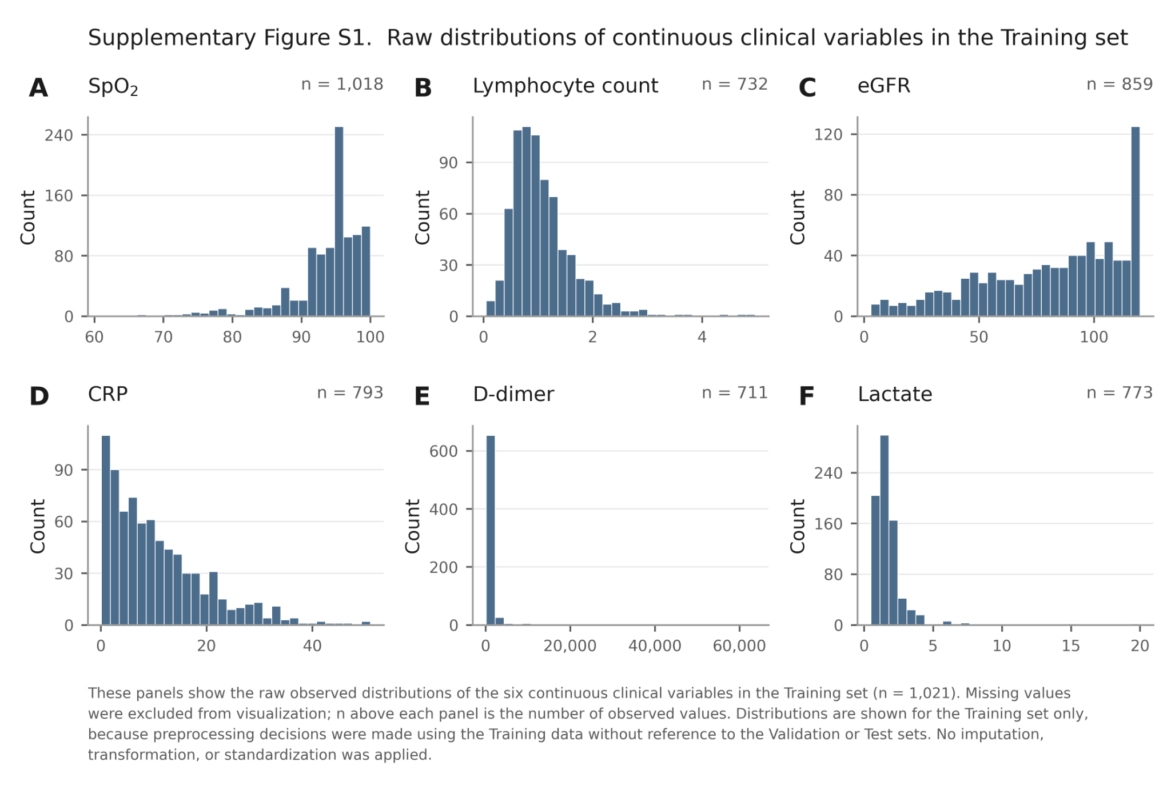

Supplementary Figure S2. Learning-curve assessment during MLP model selection. (A) Validation ROC-AUC and (B) Training loss for the initially best-performing MLP configuration. The Validation ROC-AUC reached its maximum at epoch 2 and subsequently showed an overall decline, whereas the Training loss continued to decrease, raising concern for early overfitting. (C) Validation ROC-AUC and (D) Training loss for the final candidate MLP configuration evaluated during the restricted reevaluation. For the final candidate, the Validation ROC-AUC increased gradually and reached its maximum at epoch 24, with relatively stable performance thereafter; epoch 24 was selected as the best checkpoint. All curves were recorded on the Training and Validation sets during model selection; the fixed Test set was not used.
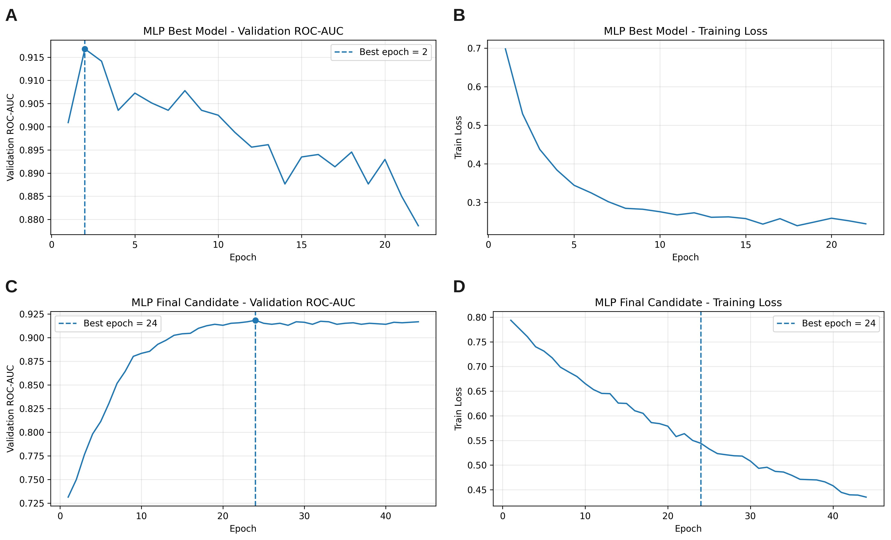

Supplementary Figure S3. Precision-recall curves of all five models in the fixed Test set. PR curves are shown for CXR ResNet18, Clinical Logistic Regression, Clinical XGBoost, Clinical MLP, and Late Fusion. The horizontal reference corresponds to the mortality prevalence in the Test set.
