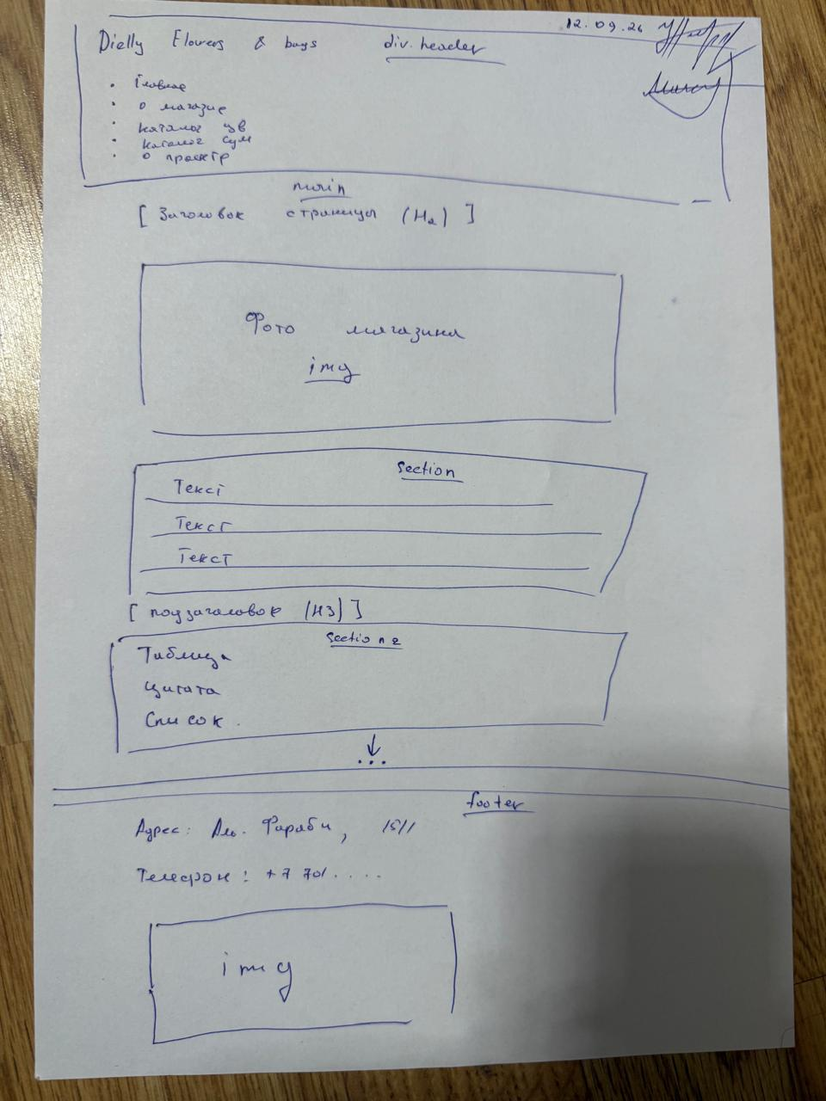
Wireframe 1: General Page Layout This is the hand-drawn wireframe for the main pages of our website (such as Home, About, and Catalogs). It shows the basic structure of the document:
- At the top, there is a <header> with the store name and navigation links.
- The <main> content area starts with an <h2> page title, followed by an <img> tag for the shop photo.
- Below the image, we planned two <section> blocks: one for the main text paragraphs, and another for additional elements like an <h3> subheader, a table, or a list.
- At the bottom, there is a <footer> containing our contact information (address at Al-Farabi 15/1 and phone number).

