Heirloom22 Requirements Report

Team C.A.L.L. (Chuan, Anqi, Luoming, Lawson)

# Background:

Many families have things they want to pass down through the generations - from photos, videos and letters to jewellery, cultural artefacts and even various knick-knacks. It's universally understood that learning about and preserving history is simultaneously an important task and a fulfilling endeavour.

In order to protect these artefacts of a family's history, the stories behind them would need to be preserved. Artefacts serve as a reminder of the people and events that happened in the past, but they do not inherently preserve that information with them; rather they are associated with that information. As a family accumulates more and more artefacts over time, however, it becomes difficult to even remember the story of each of them.

Sometimes, for items like photos, the details and story can be written on the back, but even then, these notes degrade over time. Technology has played a key role in preserving information - in archiving art and history, for example - and could be applied here.

Families could be able to archive information about artefacts not only for the benefit of their descendants, but also to later rediscover these stories that may have been forgotten. People of future generations can also experience the joy of discovery and learning about the past, given access to these recorded histories.

# Product:

The product will be a web application interface to an artefact database accessible via mobile and PC browsers.

Features:

* Users can create and store new artefacts in the database, adding relevant information, such as a textual story behind the artefact and a photo of it.
* Users can add “addendums” to artefacts for the purpose of adding to its story as time goes by.
* The application will allow users to browse the artefacts in the database, and learn more about individual artefacts they are interested in.

Other potential features:

* Artefact discovery: suggest artefacts for the user to look at.
* Related artefacts: links to related artefacts from another artefact's page – facilitating fun.

# Client Interview Notes

Included are notes taken from the various client interviews held.

## 01/08/2019 General Discussion

**Comments from Client:**

* Main use would be to help in passing it down through family and tracking its movements into the future.
  + Each owner can have “their say” on what the item means/meant to them
* Occasionally, may want to look at it sometime in the future. Explore the past and reminisce.
  + *Organic discovery? App will select artefacts or memories that you may not have looked at in a while?*

**Potential Use Cases:**

1. Passing Down an Artefact: owner of an artefact wishes to pass it down to a family member and leave a comment.
2. Artefact Discovery: owner of many artefacts opens the site to explore artefacts.

## 12/08/2019 General Discussion

**What kind of items would you want to store?**

* Chinese Vase from my father's mother
* Incense Burner – from father’s mother again
* Jade Bangle - from mother's grandma
* Photos and Videos
  + Plenty of older childhood photos
  + Photos of ancestors and relatives
* Gold Cigarette Lighter
* Cigarette Holder
* Pens from when Grandmother studied
* Father's old report book from school

**What would you want to know about your items?**

* Photo:
  + Where it was taken
  + What you were doing in life
  + What the world was like
  + Who was in it
* Items:
  + How it got to where it is
  + How it has moved down
  + How it was obtained originally
  + Any stories related to it

**How would you feel about being able to preserve this history?**

* General positivity
* Forward thinking
* Wish he had some objects that were lost, wish knew about grandfather on father's side.
  + Useful even if item is no longer in possession
* Want to know where you come from.
* Sad that history had been destroyed, covered up and hidden.
  + Mother was in China during Chairman Mao's reign. Couldn't study history - it was illegal.

Artefact recommendations -> chain of discovery

Perspectives to think about:

* Someone who wants to preserve info for future
* Someone who wants to learn about past

## 25/08/2019 General Discussion + Use Case Validation

**Use Case Validation Interview:**

* Events and people are definitely key in understanding
  + People:
    - Name
    - Description
    - Artefacts
  + Events:
    - Name
    - Date
    - Description
    - Artefacts
    - People
  + Artefacts:
    - Description
    - People involved
      * Can add description of how they're related
    - **Addendum**
      * Should addendums appear in the timeline?

Being able to search by text would be nice.

Key ideas to capture:

* Minimise the amount of effort require to create an artefact, etc.
  + everything is optional

# Models

## Goal-Based Model

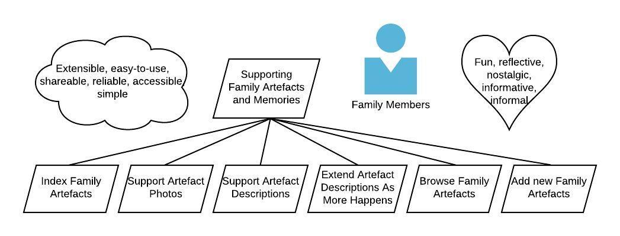

# Personas

Liam Gilbert:

* First-generation user.
* Father to Amanda

Amanda Gilbert:

* Second-generation user.
* Daughter to Liam.

**Persona – Liam Gilbert**

|  |  |
| --- | --- |
| Profile |  |
| Name | Liam Gilbert |
| Bio | Liam is 45 and married to 43 year old Sarah, with 2 children. The oldest is Sam, a 16 year old boy, and his younger sister, Amanda is 13. He works an office job with a marketing firm. On the weekends and long breaks, he likes to travel or go camping with his family. |
| Motivation | Liam's mother recently died after many years of suffering from Alzheimer's. While reflecting on his mother's life, he opened up the old shed he used to store all of his family's old possessions and found a treasure trove of family artefacts he had forgotten existed.  The experiences of rediscovering his past, reliving his memories both fond and not so fond, and even learning about his mother's early life was an enriching and cathartic experience for Liam, and helped him cope with the loss of his mother.  To his dismay, however, there were many that he and his wife could not recognise or remember the meaning behind. |
| Goals | To preserve the memories and stories behind the precious artefacts Liam had kept in his shed.  To enjoy and rediscover those memories and stories. |
| Frustration | To Liam's dismay, there were many artefacts in his shed that he and his wife could not recognise or remember the meaning behind. |

Liam wants:

* To be able to store artefacts so that their stories won’t be forgotten.
* An easy way to find information about an artefact in the system, given that he has the physical object itself on him.
* A way to enjoy rediscovering stories about items he has.

**Persona – Amanda Gilbert**

|  |  |
| --- | --- |
| Profile |  |
| Name | Amanda Gilbert |
| Bio | Amanda is 28, the daughter of 60-year old Liam Gilbert and 58-year old Sarah Gilbert. She has an older brother, Sam, who is 31. She has been working in consulting, having completed a degree in finance and economics at university. Although she no longer keeps in frequent contact with her parents, Amanda maintains a positive relationship with them by inviting them to dinners on birthdays and such.  Amanda likes to spend her free time watching movies and TV shows. |
| Motivation | Amanda is aware that her parents are growing older and will eventually pass on. She wants to make sure to preserve her memories of her parents for her future self and children to remember them by.  She also knows that Liam has been recording and maintaining information about family artefacts from his time and before, and wants to be able to learn about them.  In addition to that, she has artefacts Liam has passed on to her which have become important in her own life and wants to add to the story of those artefacts. |
| Goals | To preserve the memories and stories behind the precious artefacts Liam has passed down and add her own.  To exercise her curiosity and learn about the things Liam has kept.  To continue to build upon the stories of artefacts as they happen. |
| Frustration | It is frustrating that the efforts her predecessors put towards can very easily go to waste unless Amanda herself puts a great amount of effort towards this. However, she's not as strongly motivated as Liam was and needs an easy way to continue his work.  The modern busy lifestyle makes it hard to spend time connecting with family and exploring the history of your own family. |

# Use Cases and User Stories

See `Use Cases` in heirloom22drive.