1. What is the IP address of your computer?

**10.0.0.193**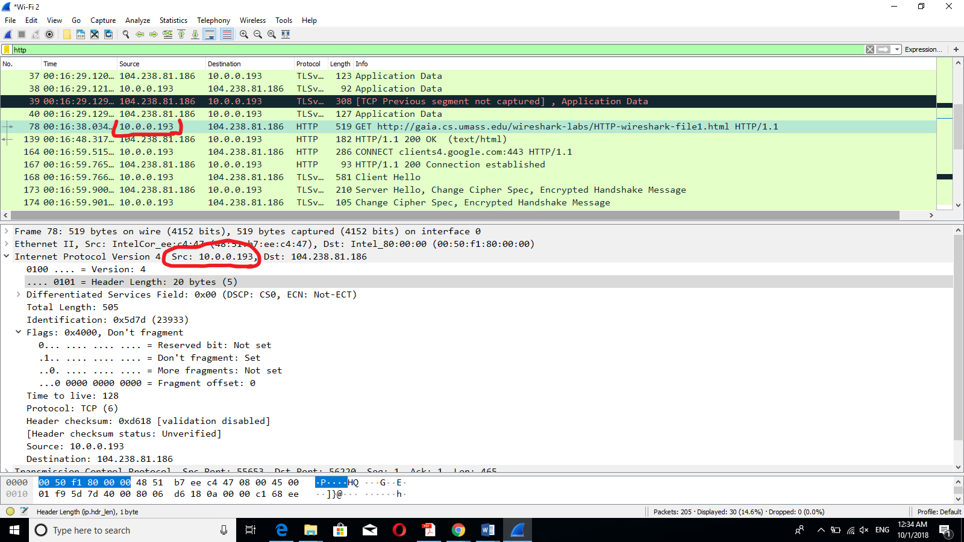

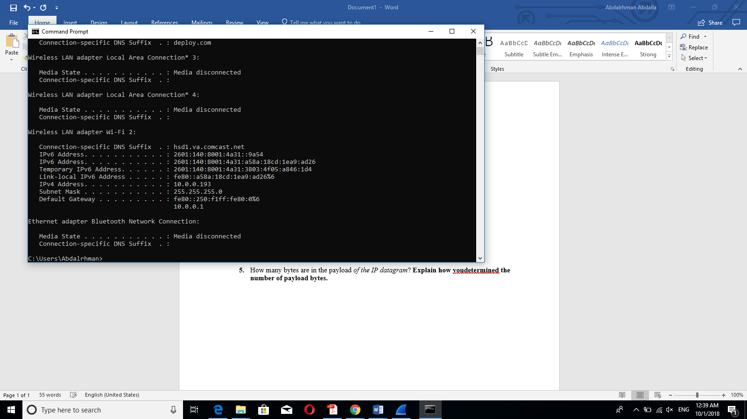

1. What is the total length of the datagram?

**505 bytes**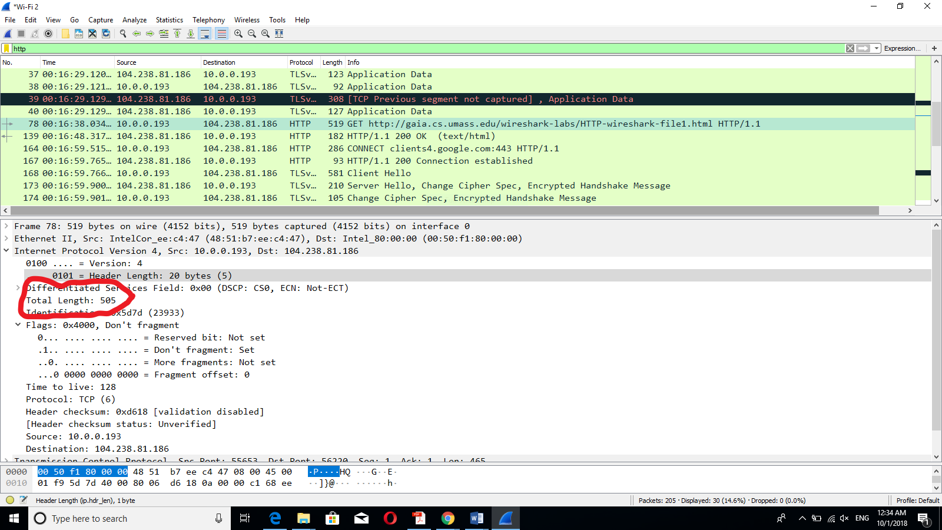

1. Has this IP datagram been fragmented?

**The IP datagram has not been fragmented, because the fragment offset :0**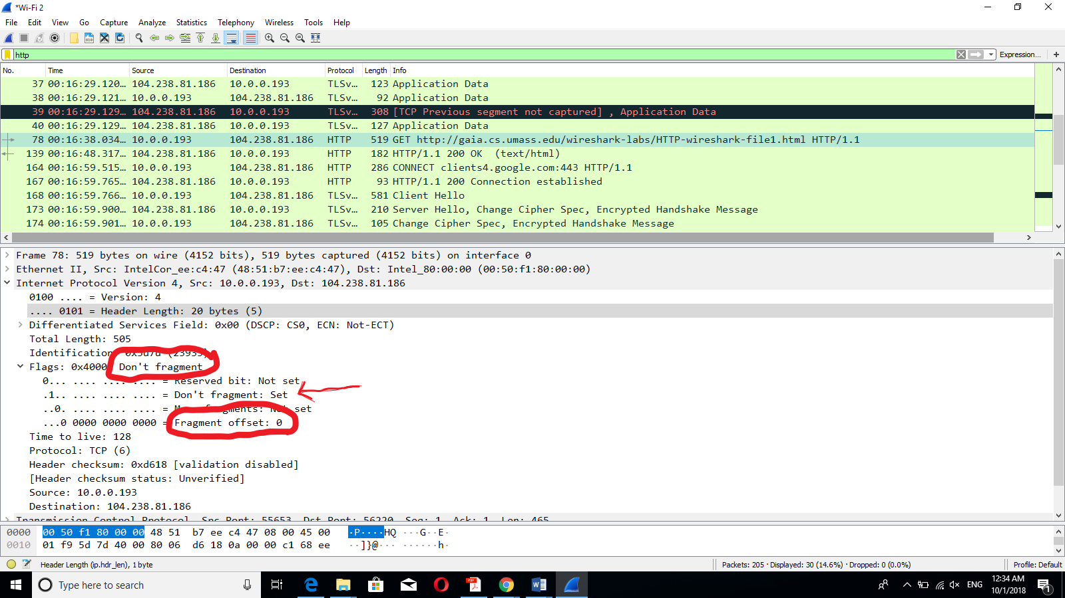

1. How many bytes are in the IP header?

**20 bytes**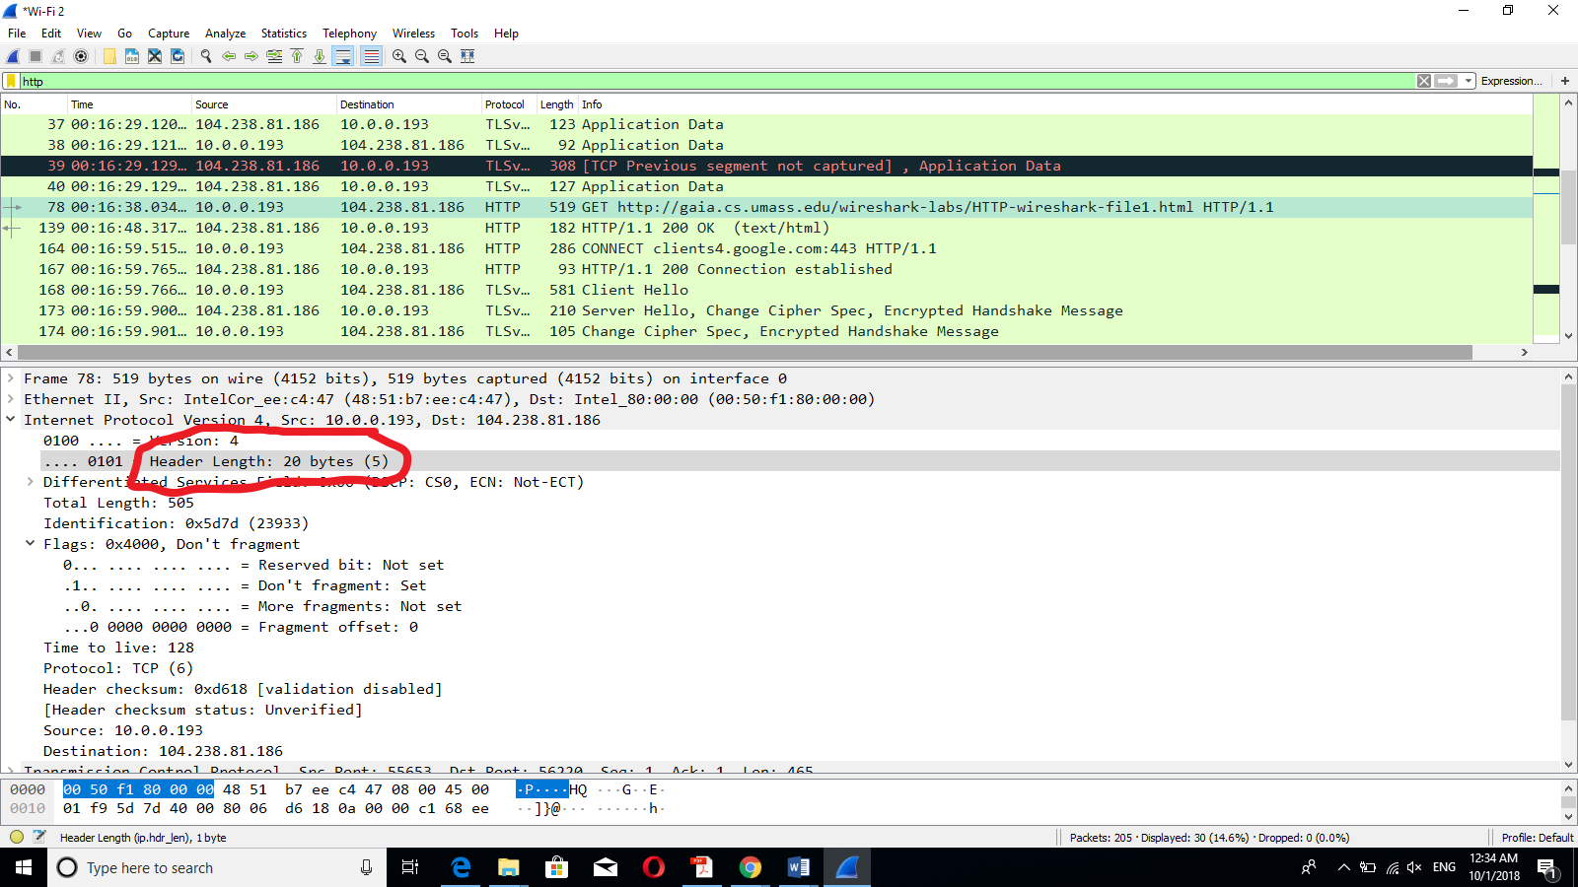

1. How many bytes are in the payload *of the IP datagram*?

**485 bytes … Total length – IP header = Payload**