**Abdalrhman Abdalla Lab6**

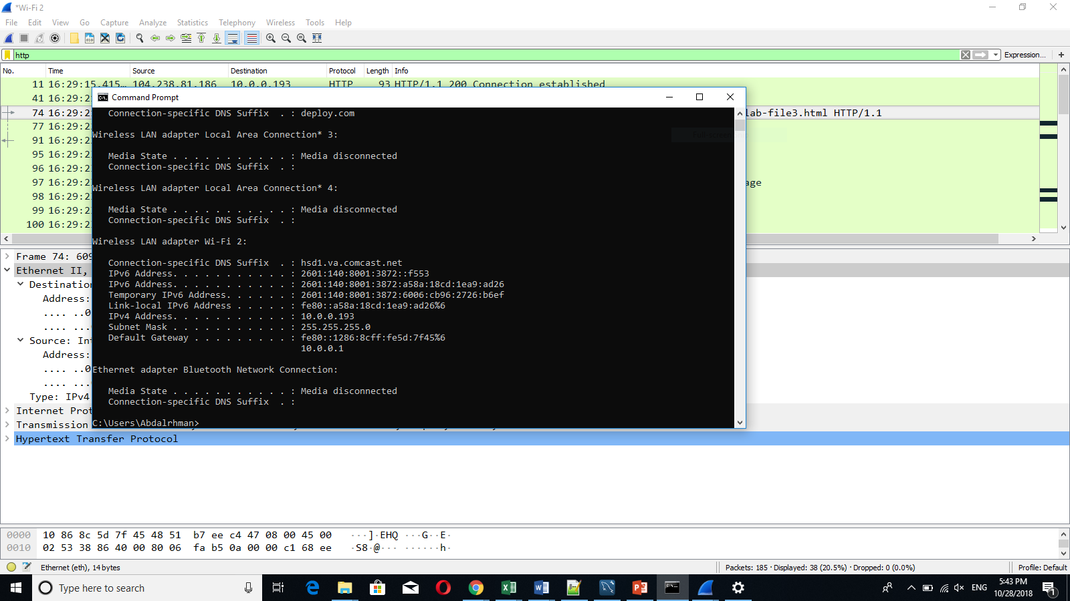

1. What is the MAC address from your computer?

48-51-B7-EE-C4-47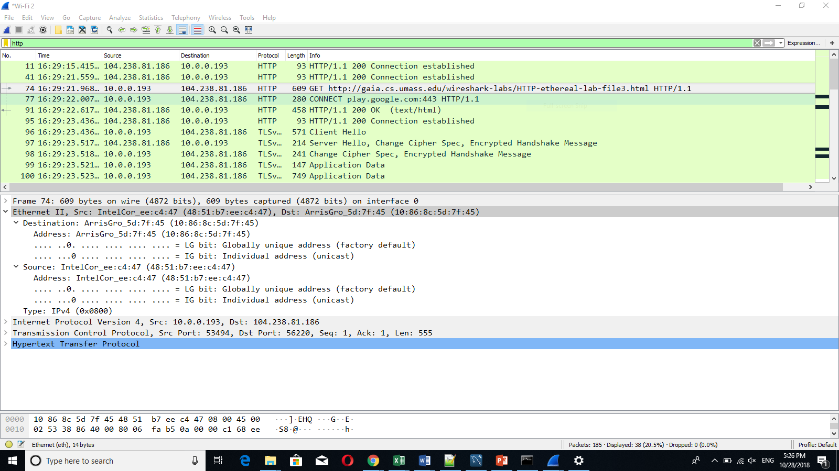

1. What is the destination MAC address?

10-86-8C-5D-7F-45



1. What device has the MAC address shown in the destination?

It Belongs to the router port that I’m using to access the internet.

1. Explain the relationship between the destination MAC address and the destination IP address.

There is no relation between them. The destination MAC address is going to be changed each time the packet goes from device port to another, The destination IP address belongs to the server that we are trying to access.

1. Using the terminal (cmd in Windows, Terminal in mac), run a command to display your full ARP list table. (Find out what the command is, and print a full screen shot of your result.)

Arp -a