**Abdalrhman Abdalla Lab 5**

1. What is your computers IP address? (This is not included in your traceroute results). Take a screenshot of your computers IP address.

**10.0.0.193**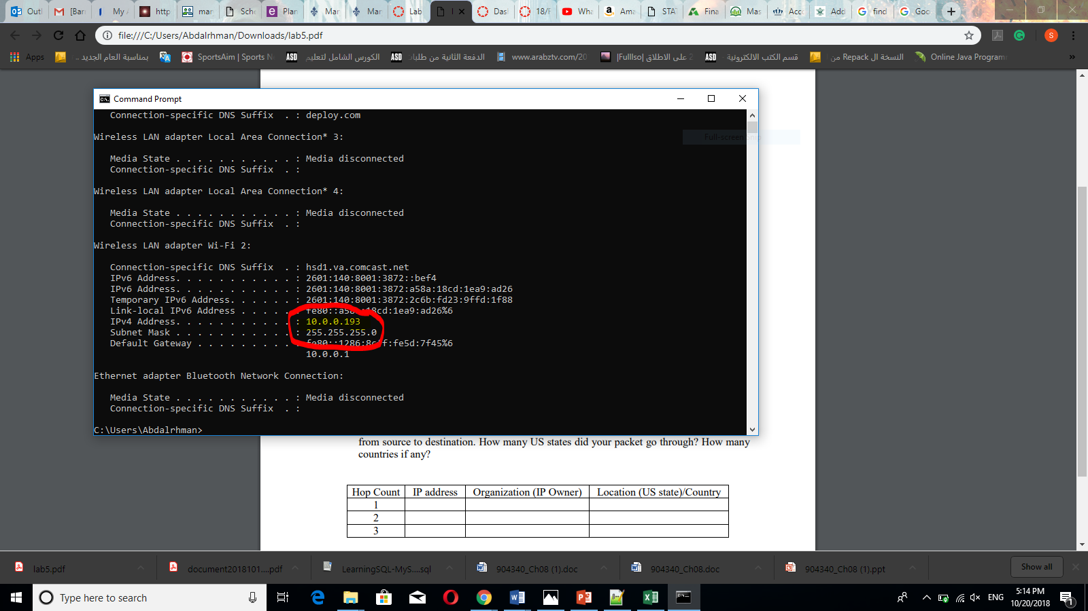

2. With reference to private/public IP addresses. What type of IP address is the first IP from your traceroute result. **Private**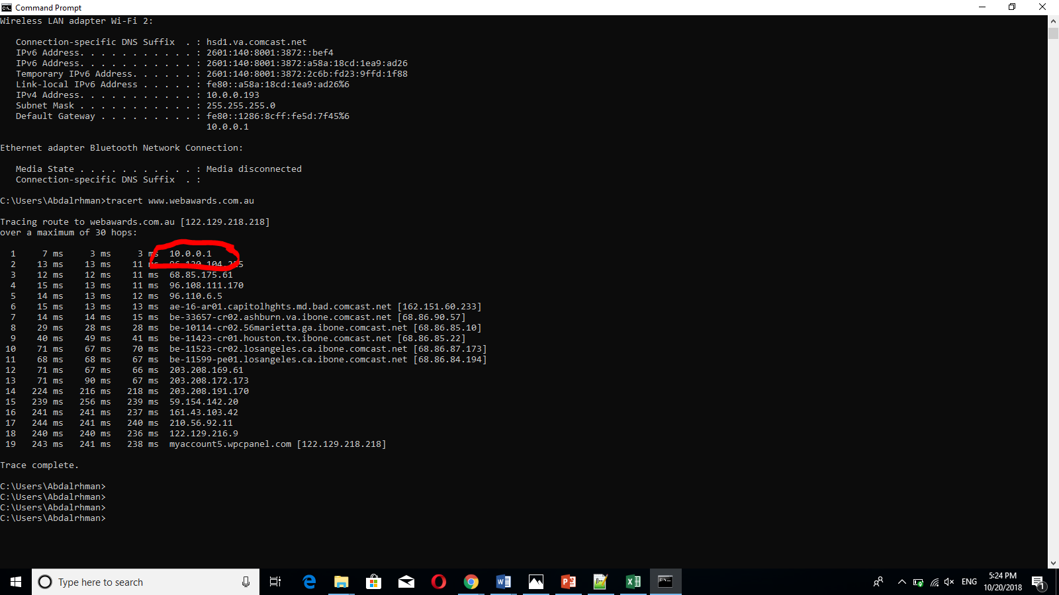

1. With reference to private/public IP addresses. What type of IP address is the second IP from your traceroute result.

**Public**

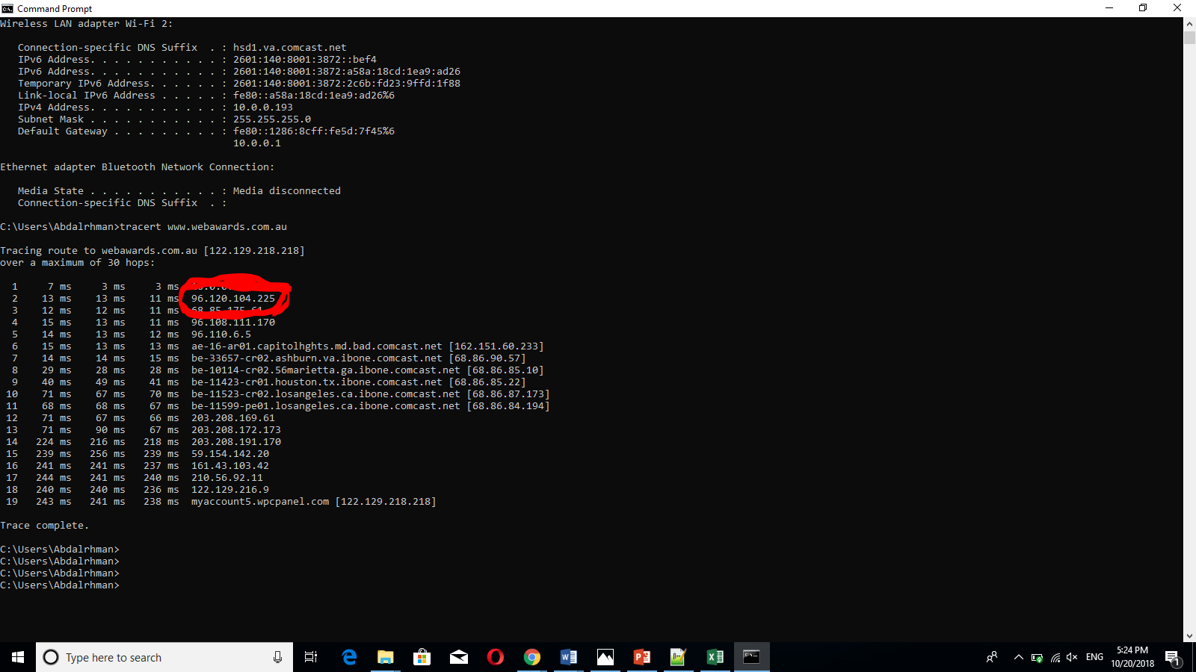

1. In a tabular format (use table example below), and in sequential order. Indicate the location of each IP address (include state for US states) and the organization that owns the IP address. (Use https://www.ultratools.com/tools/ipWhoisLookup to look up IP address whois information).

|  |  |  |  |
| --- | --- | --- | --- |
| Hop Count | IP address | Organization (IP Owner) | Location (US state)/Country |
| 1 | 10.0.0.1 | IANA | Los Angeles CA / United State |
| 2 | 96.20.104.225 | Comcast IP services L.L.C | Mt laural NJ / United State |
| 3 | 86.85.175.61 | Comcast Cable communications L.L.C | Mt laural NJ / United State |

5. In your own words, explain everything you just did, and what route did your packet took from source to destination. How many US states did your packet go through? How many countries if any?

I traced a packet from my device to [www.webawards.com.au](http://www.webawards.com.au) to see the route and it went through 2 states in the US and then through Singapore and head out to Australia