BAAO COMMUNITY COLLEGE
San Juan, Baao, Camarines Sur
College of Information Technology
BS INFORMATION SYSTEM
BSIS – 3C
CC 106 – APP DEV & EMERGING TECH
HOSPITAL MANAGEMENT SYSTEM
TECHNICAL DOCUMENTATION,
DATA DICTIONARY, AND NORMALIZATION EVIDENCE
Submitted by: Group 3
Members:
Miranda, Mark Angelo M.
Agravante, Rosella P.
Bayrante, Lyn Antoinette
Bazar, Jellian
Badiola, Ma. Hyacinth
Corporal, Say
Bulalacao, Krisna
BSIS – 3C
Submitted to:
MICHAEL BAÑARIA
CC106 Instructor

1. System Overview
The Hospital Management System database supports the storage and organization of patient records, doctor information, appointments, and billing records. Patient details are stored separately from doctor details. Appointments connect patients with doctors and record scheduling information, visit reasons, status, room assignment, notes, and emergency indicators. Billing records store the charges and payment details associated with an appointment.
This report is based on the SQL schema and sample data supplied in the pasted text. Field names, data types, and declared keys are represented from that source. Descriptive explanations are included to make the schema easier to understand.

2. Database Tables and Relationships
The supplied schema contains four main tables: patients, doctors, appointments, and billing.
Entity A | Entity B | Cardinality | Key / Link | Meaning
patients | appointments | 1 : many | patients.patient_id → appointments.patient_id | A patient can have multiple appointments; each appointment references one patient.
doctors | appointments | 1 : many | doctors.doctor_id → appointments.doctor_id | A doctor can be assigned to multiple appointments; each appointment references one doctor.
appointments | billing | 1 : 0/1 | appointments.appointment_id → billing.appointment_id (UNIQUE) | An appointment can have at most one billing record in this schema.
patients | billing | 1 : many (declared) | patients.patient_id → billing.patient_id | Each bill references a patient. This duplicates a patient link already derivable from the linked appointment.

Note: The billing table contains both appointment_id and patient_id. Since an appointment already identifies its patient, storing both can create a consistency risk if the two references do not match. This is discussed in the normalization section.

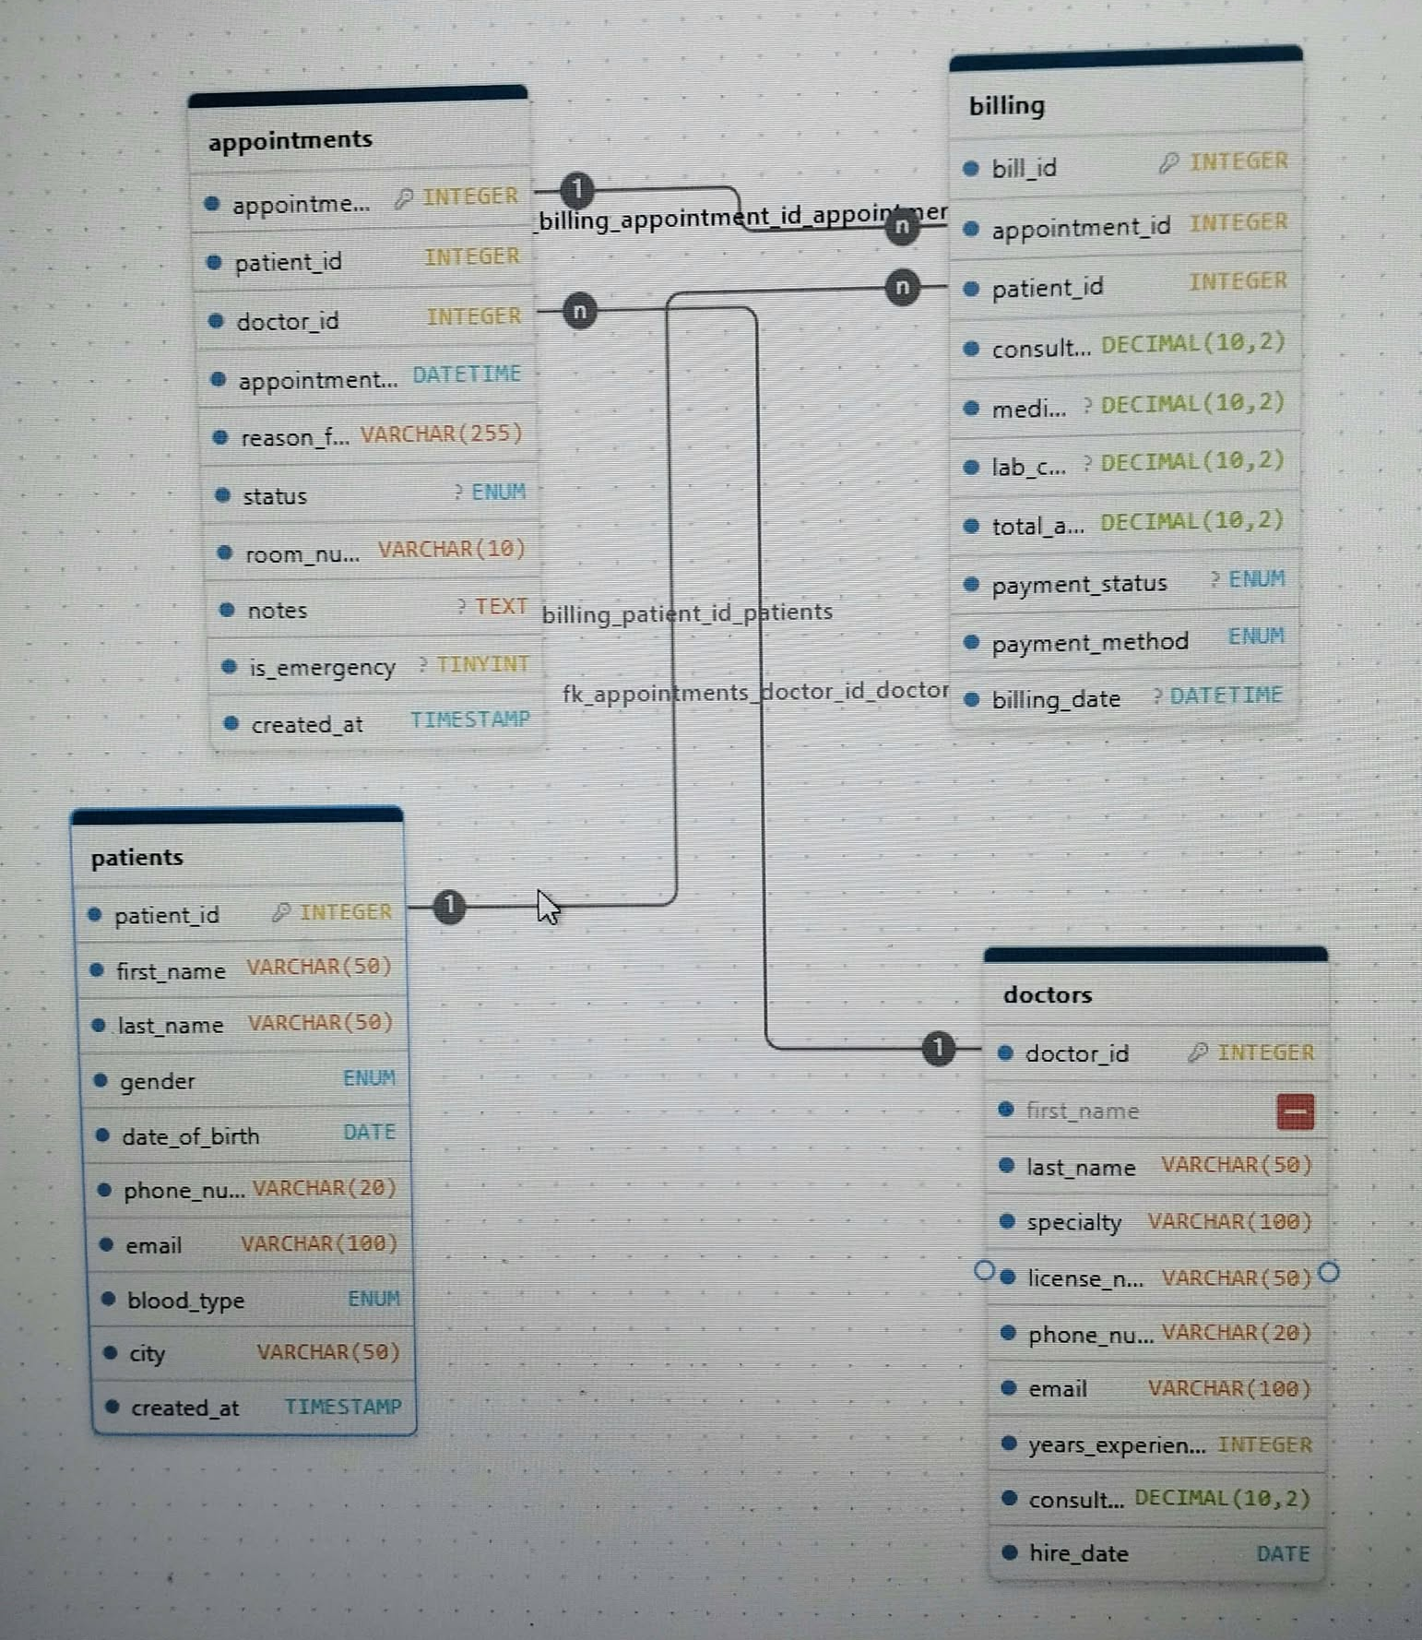

3. Data Dictionary
PK means primary key; FK means foreign key. Constraints shown here follow the supplied SQL definition.

3.1 patients
Field | Data type / constraint | Key | Description
patient_id | int NOT NULL AUTO_INCREMENT | PK | Unique patient identifier
first_name | varchar(50) NOT NULL |  | Patient's first name
last_name | varchar(50) NOT NULL |  | Patient's last name
gender | enum('Male','Female','Other') NOT NULL |  | Patient's recorded gender
date_of_birth | date NOT NULL |  | Patient's date of birth
phone_number | varchar(20) NOT NULL |  | Patient contact number
email | varchar(100) NOT NULL |  | Patient email address
blood_type | enum('A+','A-','B+','B-','AB+','AB-','O+','O-') NOT NULL |  | Patient's recorded blood type
city | varchar(50) NOT NULL |  | Patient's city
created_at | timestamp NULL DEFAULT CURRENT_TIMESTAMP |  | Record creation timestamp

3.2 doctors
Field | Data type / constraint | Key | Description
doctor_id | int NOT NULL AUTO_INCREMENT | PK | Unique doctor identifier
first_name | varchar(50) NOT NULL |  | Doctor's first name
last_name | varchar(50) NOT NULL |  | Doctor's last name
specialty | varchar(100) NOT NULL |  | Doctor's medical specialty
license_number | varchar(50) NOT NULL | UNIQUE | Unique professional license number
phone_number | varchar(20) NOT NULL |  | Doctor contact number
email | varchar(100) NOT NULL |  | Doctor email address
years_experience | int NOT NULL |  | Recorded years of experience
consultation_fee | decimal(10,2) NOT NULL |  | Doctor's consultation fee
hire_date | date NOT NULL |  | Date the doctor was hired

3.3 appointments
Field | Data type / constraint | Key | Description
appointment_id | int NOT NULL AUTO_INCREMENT | PK | Unique appointment identifier
patient_id | int NOT NULL | FK | Patient linked to the appointment
doctor_id | int NOT NULL | FK | Doctor assigned to the appointment
appointment_date | datetime NOT NULL |  | Scheduled date and time
reason_for_visit | varchar(255) NOT NULL |  | Reason for the visit
status | enum('Scheduled','Completed','Cancelled','In-Progress') DEFAULT 'Scheduled' |  | Appointment status
room_number | varchar(10) NOT NULL |  | Room assigned for the appointment
notes | text |  | Additional appointment notes
is_emergency | tinyint(1) DEFAULT '0' |  | Flag indicating whether the appointment is an emergency
created_at | timestamp NULL DEFAULT CURRENT_TIMESTAMP |  | Record creation timestamp

3.4 billing
Field | Data type / constraint | Key | Description
bill_id | int NOT NULL AUTO_INCREMENT | PK | Unique billing record identifier
appointment_id | int NOT NULL | FK, UNIQUE | Appointment linked to this bill; unique in this table
patient_id | int NOT NULL | FK | Patient linked to the bill
consultation_charge | decimal(10,2) NOT NULL |  | Consultation charge
medication_charge | decimal(10,2) DEFAULT '0.00' |  | Medication charge
lab_charge | decimal(10,2) DEFAULT '0.00' |  | Laboratory charge
total_amount | decimal(10,2) NOT NULL |  | Recorded total billed amount
payment_status | enum('Pending','Paid','Partially Paid','Refunded') DEFAULT 'Pending' |  | Billing/payment status
payment_method | enum('Cash','Credit Card','Insurance','Bank Transfer') NOT NULL |  | Recorded payment method
billing_date | datetime DEFAULT CURRENT_TIMESTAMP |  | Date and time the bill was recorded

4. Normalization Evidence (1NF, 2NF, and 3NF)

4.1 First Normal Form (1NF)
A table satisfies First Normal Form when each field contains a single, atomic value and there are no repeating groups or lists stored in one column. In the supplied schema, patient details, doctor details, appointment details, and billing details are represented as separate columns. For example, an appointment has one patient_id and one doctor_id, while charges are stored in individual fields. This structure supports 1NF, provided each stored field contains one value per row.
Example table | Atomic fields | Why it supports 1NF
patients | patient_id, first_name, last_name, phone_number, etc. | Each patient attribute is stored in its own field.
appointments | appointment_id, patient_id, doctor_id, appointment_date, status | One appointment is represented by one row; no list of appointments is stored in a field.
billing | consultation_charge, medication_charge, lab_charge, total_amount | Charge amounts are separated into individual fields.

4.2 Second Normal Form (2NF)
Second Normal Form requires the table to be in 1NF and every non-key attribute to depend on the whole candidate key, not just part of a composite key. The four tables use single-column primary keys (patient_id, doctor_id, appointment_id, and bill_id). Therefore, there is no partial dependency on a portion of a declared composite primary key in these tables. The doctors table also declares license_number as UNIQUE, which makes it an additional candidate key.
Table | Declared primary key | 2NF assessment
patients | patient_id | Single-column key; no partial-key dependency.
doctors | doctor_id | Single-column key; license_number is also unique.
appointments | appointment_id | Single-column key; appointment attributes describe that appointment.
billing | bill_id | Single-column key; billing attributes describe that billing record.

4.3 Third Normal Form (3NF)
Third Normal Form requires the table to be in 2NF and non-key attributes not to depend transitively on a key through another non-key attribute. The database separates patient information, doctor information, appointment information, and billing information into different tables. This reduces the need to repeat names and other descriptive details in appointment records.
Table | Facts kept in the table | 3NF observation
patients | Patient name, gender, date of birth, contact details, blood type, city | Patient facts are stored independently of appointment records.
doctors | Doctor name, specialty, license, contact details, experience, fee, hire date | Doctor facts are stored independently of appointments.
appointments | Patient and doctor references plus appointment-specific details | Appointment data uses foreign keys instead of repeating full patient and doctor details.
billing | Appointment and patient references, charges, status, payment method, billing date | Potential redundancy: patient_id can be obtained from appointments through appointment_id.

4.4 Normalization Note / Recommended Improvement
The schema is organized into separate entities and broadly supports 1NF and 2NF. However, the billing table has a potential 3NF/consistency issue: appointment_id identifies the appointment, and appointments.patient_id already identifies the patient for that appointment. Keeping patient_id again in billing duplicates that fact and may allow a bill to reference an appointment for one patient but a different patient_id. If the business rule is that every bill belongs to the patient attached to its appointment, consider removing billing.patient_id and obtaining the patient through appointments. If patient_id is intentionally retained for reporting or audit reasons, enforce a rule that it must match the appointment's patient.
The total_amount field may also be derivable from consultation_charge + medication_charge + lab_charge. Keeping a stored total can be useful, but the application should calculate or validate it so the total does not disagree with the individual charges. Whether total_amount should be stored depends on the system's business rules and audit requirements. These are design observations based on the supplied schema, not changes already present in the SQL.

5. Summary
The Hospital Management System database uses four related tables to organize patient, doctor, appointment, and billing information. Its atomic fields support 1NF, and its single-column primary keys avoid partial dependency issues for 2NF. The separation of entity-specific data helps support 3NF. The main item to review is the duplicated patient reference in billing, along with validation of total_amount, to improve consistency and make the 3NF design more robust.

