- 选择题

1. 在下列领域中，哪些不适合应用matlab的应用：（）
(a) 数值分析 (b) 数值和符号计算
(c) 程序验证 (d)数字信号处理

2.在matlab中完成矩阵运算A=B.*C矩阵B和C应满足（）
(a)B矩阵的列与C矩阵的行相同； (b)B矩阵与C矩阵具有相同的行和列
(b)B矩阵和C矩阵没有限制； (d)B矩阵的行与C矩阵的列相同

- If you could like an action to be executed immediately after a transition condition is found to be true, which type of action would you use?()
(a).Transition action
(b).Condition action
(c).state exit action
(d).state entry action

- 严格因果系统是指（）
(a)当前的输出只受当前的输入的影响；
(b)当前的输出受以前和当前的输入的影响；
(c)当前的输出仅受以前的输入的影响；
(d)当前的输出与输入无关。

- 反馈系统至少要有一个（）actor
(a)稳定系统的actor (b) 严格因果系统的actor
(c)时不变系统的actor (d) 无记忆系统的actor

- 编写一个函数生成n×m阶的Hilbert矩阵。所谓Hilbert矩阵, 第i行第j列的元素值为：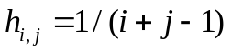
若只给出一个输入参数，则会自动生成一个方阵

- 请画出下列逻辑的Simulink模块图
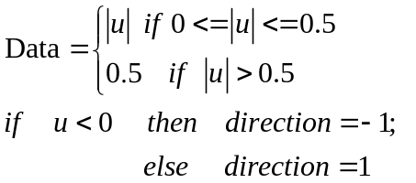
其中输入信号是正弦波，输出信号Data和direction在示波器上显示。
可能用到的模块：
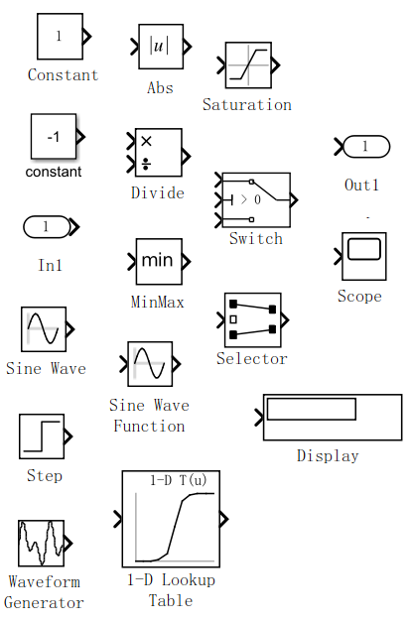

- 密码检测逻辑。在很多系统密码都是由四位数字组成的，只要用户给定的密码与预设的密码一致，则开锁。请使用Stateflow 的流程图（Flow Graph）完成密码检测逻辑的建模。要求：
    - 密码是具有四个数字的四个输入信号in1, in2, in3, in4，输出信号为out;
    - 流程图应该分别检测每个数字是否与预设的密码PRE1, PRE2, PRE3, PRE4匹配
    - 正确的密码数字为常量；
    - 若密码正确，则out为1；否则out为0。
- 证明S(x,y)(t)=x(t)-y(t)是线性系统（linear system）
- (8points) Consider a temperature thermostat. There is only one temperature threshold, and to avoid chattering the thermostat simply leaves the heat on or off for at least a fixed amount of time. In the initial state, if the temperature is less than or equal to 20 degrees Celsius, it turns the heater on, and leaves it on for at least 30 seconds. After that, if the temperature is greater than 20 degrees, it turns the heater off and leaves it off for at least 1 minute 30 seconds. It turns it on again only if the temperature is less than or equal to 20 degrees. Please design this finite state machine for this discrete system.

- Consider a bouncing ball. At time t = 0, the ball is dropped from a height y(0) = h0, where h0 is the initial height in meters. It falls freely. At some later time t1 it hits the ground with a velocity 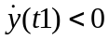 m/s (meters per second). A bump event is produced when the ball hits the ground. The collision is inelastic (meaning that kinetic energy is lost), and the ball bounces back up with velocity 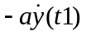, where a is constant with 0 < a < 1. The ball will then rise to a certain height and fall back to the ground repeatedly. Construct a model for the hybrid system and calculate the time of the first hitting the ground of the ball.
- 中央控制门锁的控制逻辑，这种门锁的基本逻辑很简单，实现车门和报警器相互关联，实现锁闭车门和报警两种功能。它的基本逻辑为：
    - 按下锁车键之后，锁闭车门并使报警器进入临界状态，使各个报警器传感器进入工作状态；
    - 按下开锁键之后，解除报警器状态并打开车锁；
    - 在报警器进入临界状态时，任意报警器传感器相应的动作，例如打开车门，车窗、车辆受到撞击等均可触发报警；
请将这种逻辑通过stateflow中的状态机来实现。并指出这里哪些是输入信号，哪些是输出信号，哪些是局部信号。

