附录 华东师范大学软件学院实验报告
实验课程：嵌入式系统开发规范与建模 | 年级：2013级 | 实验成绩：
实验名称：Matlab的流程结构和函数 | 姓名：杨一新
实验编号： | 学号：10132510349 | 实验日期：
指导教师：郭建 | 组号： | 实验时间：8:00-9:30

一、实验目的
熟悉matlab 三种结构；
熟悉M‐文件；
能够编写函数并进行调试、运行；
二、实验内容与实验步骤
1. The fertility rate (出生率)of a country is defined as the average number of children that a woman has during her reproductive year. In this exercise, you will work with 2009 fertility rates as estimated by the U.S Central Intelligence Agency. The file FertilityRates.xls contains this data for just European and African countries.
1).Create a new MATLAB script. In this script, start by clearing all the variables.
2).load the MAT‐file EuropeFertility.mat. This loads the variable EuropeRates into the workspace.
3).Plot the histogram(柱状图，命令hist)of the European fertility rates. Explaining the meaning of each Column by comments.
4). Add comments to each line of the script.
2. In this exercise, we will add the African fertility data to the European fertility data we visualized in the previous exercise.
1).Create a new script, In this script, start by clearing all the variables and to load the MAT‐file EuropeFertility.mat.
2). Load AfricaFertility.mat. this loads a variable called AfricaRates into the workspace.
3).In the script, concatenate EuropeRates and AfricaRates into a single variable allRates.
4).Plot the historgram of allRates with 20bins.
5).Add comments.
3. You write a function to decode an encrypted(加密) message. The message has been encrypted using a simple shift cipher, which means each character in the original message has had a fixed numeric value added to its ASCII representation.
1).Create a new function file using the MATLAB Editor. Start by creating the function declaration, which should include two inputs and one output. The inputs are the encrypted message and the amount of the shift; the output is the decrypted（解密）message.
2). In the function, take each value in the input message and subtract the value of the
shift input.
3).Test you function by loading in the message from the file message1.mat. The shift
value needed for this message is 5.
4. The amount of time it takes to pay off a loan （贷款）can be determined by the
following equation:
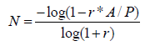
Where A is the initial amount of the loan, r is the interest rate（利息率）, P is the
payment per month, and N is the number of payments it takes.
The total interest paid on the loan is then:
T = N * P - A
1).Create a new MATLAB function file. This function should accept r, A and P as inputs. A and r will be scalars; P will be a vector with different values of payment per month. The function should have two outputs, N and T. N and T will be the same length as P.
2). In the function, for each value of P, calculate the corresponding values of N andT.
3).Test. from the command line, run your function for A=$50,000,r=0.05/12, and P=500:100:5000. Plot T versus P.
5. The shift cipher is not very secure: you can break it by trying keys sequentially and see which result most resembles a sentence. A somewhat more secure code is called the Vigenere cipher. Here, instead of a single shift value, the key now has several values, which are repeated. For example, if the message is “MATLAB” and the key is [1 4 6 3], the encryption would look like this:
M A T L A B
+ 1 4 6 3 1 4
N E Z O B F
1).Create a new MATLAB function that will be a Vigenere encoder. The encoder should take a message and a key as inputs, and output the encoded message.
2).In this function, repeat the key so that it matches the length of the input message. The commands repmat and mod will be useful.
3).Convert the message to its ASCII values using the double command (e.g. double(‘ABC’’=[65 66 67])and add the repeated key.
4).Create a new MATLAB function that will be the decoder. The decoder should take an encrypted message and a key as inputs, and output the decoded message.
5).In this function, decode the message by subtracting a repeated key, and then using the char command to convert from ASCII to text.
6). Test your function with message=’The decoder should take a encrypted message and a key as inputs, and output the decoded message.’, and key=[3,5,7,2,8].
6. 编写一个矩阵相加函数mat_add()，使得该函数能够接受任意多个矩阵，且其调用函数的格式给A=mat_add(A1,A2,A3,…) 。注意写出相应的注释，在调用help 时能够看到对该函数的注解。
三、实验环境
计算机*1
Matlab2013a
四、实验过程与分析
1. The fertility rate (出生率)of a country is defined as the average number of children that a woman has during her reproductive year. In this exercise, you will work with 2009 fertility rates as estimated by the U.S Central Intelligence Agency. The file FertilityRates.xls contains this data for just European and African countries.
1).Create a new MATLAB script. In this script, start by clearing all the variables.
clear
2).load the MAT‐file EuropeFertility.mat. This loads the variable EuropeRates into the workspace.
load EuropeFertility.mat
3).Plot the histogram(柱状图，命令hist)of the European fertility rates. Explaining the meaning of each Column by comments.
Hist(EuropeRates(1:44,1));
4). Add comments to each line of the script.
clear; %清除所有Variable
load EuropeFertility.mat; %读取mat数据
hist(EuropeRates(1:44,1)); %用柱状图表示数据
2. In this exercise, we will add the African fertility data to the European fertility data we visualized in the previous exercise.
1).Create a new script, In this script, start by clearing all the variables and to load the MAT‐file EuropeFertility.mat.
clc;
load EuropeFertility.mat;
2). Load AfricaFertility.mat. this loads a variable called AfricaRates into the workspace.
load AfricaFertility.mat;
3).In the script, concatenate EuropeRates and AfricaRates into a single variable allRates.
allRates=[EuropeRates;AfricaRates];
4).Plot the historgram of allRates with 20bins.
hist (allRates,20);
5).Add comments.
clear; %清空Workspace中的变量
load EuropeFertility.mat; %读取EuropeFertility.mat中的数据
load AfricaFertility.mat; %读取AfricaFertility.mat中的数据
allRates=[EuropeRates;AfricaRates]; %将前二者中读取的数据合并到allRates
hist (allRates,20); %以20列的柱状图绘制allRates
3. You write a function to decode an encrypted(加密) message. The message has been encrypted using a simple shift cipher, which means each character in the original message has had a fixed numeric value added to its ASCII representation.
1).Create a new function file using the MATLAB Editor. Start by creating the function declaration, which should include two inputs and one output. The inputs are the encrypted message and the amount of the shift; the output is the decrypted（解密）message.
function[decrypted] = decode(message, shift)
2). In the function, take each value in the input message and subtract the value of the
shift input.
decrypted=char(message-shift);
3).Test you function by loading in the message from the file message1.mat. The shift
value needed for this message is 5.
function[decrypted] = decode(message, shift)
decrypted=char(message-shift);
end
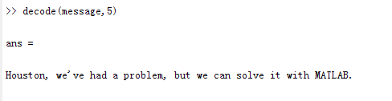
4. The amount of time it takes to pay off a loan （贷款）can be determined by the
following equation:
Where A is the initial amount of the loan, r is the interest rate（利息率）, P is the
payment per month, and N is the number of payments it takes.
The total interest paid on the loan is then:
T = N * P - A
1).Create a new MATLAB function file. This function should accept r, A and P as inputs. A and r will be scalars; P will be a vector with different values of payment per month. The function should have two outputs, N and T. N and T will be the same length as P.
function[N] = interest(r, A, P)
2). In the function, for each value of P, calculate the corresponding values of N andT.
N=-log(1-r*A./P)/log(1+r);
T=N*P-A;
3).Test. from the command line, run your function for A=$50,000,r=0.05/12, and P=500:100:5000. Plot T versus P.
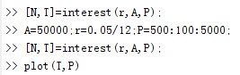
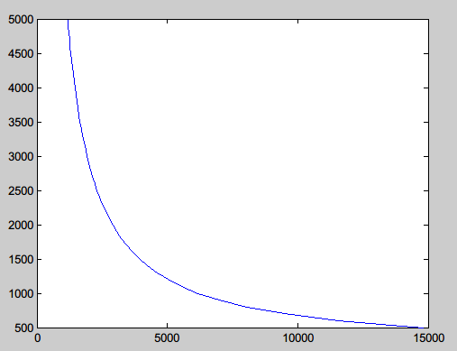
5. The shift cipher is not very secure: you can break it by trying keys sequentially and see which result most resembles a sentence. A somewhat more secure code is called the Vigenere cipher. Here, instead of a single shift value, the key now has several values, which are repeated. For example, if the message is “MATLAB” and the key is [1 4 6 3], the encryption would look like this:
M A T L A B
+ 1 4 6 3 1 4
N E Z O B F
1).Create a new MATLAB function that will be a Vigenere encoder. The encoder should take a message and a key as inputs, and output the encoded message.
function[encoded] = encode(message, key)
2).In this function, repeat the key so that it matches the length of the input message. The commands repmat and mod will be useful.
len1=length(message);
len2=length(key);
tmp=mod(len1,len2);
newkey=repmat(key,1,int32(len2/len1));
newkey=[newkey,key(1,1:tmp)];
3).Convert the message to its ASCII values using the double command (e.g. double(‘ABC’’=[65 66 67])and add the repeated key.
message=double(message);
4).Create a new MATLAB function that will be the decoder. The decoder should take an encrypted message and a key as inputs, and output the decoded message.
function[encoded] = encode(message, key)
5).In this function, decode the message by subtracting a repeated key, and then using the char command to convert from ASCII to text.
encoded=char(message);
6). Test your function with message=’The decoder should take a encrypted message and a key as inputs, and output the decoded message.’, and key=[3,5,7,2,8].
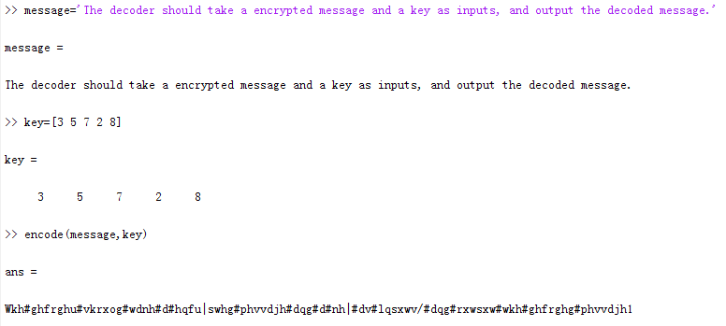
6. 编写一个矩阵相加函数mat_add()，使得该函数能够接受任意多个矩阵，且其调用函数的格式给A=mat_add(A1,A2,A3,…) 。注意写出相应的注释，在调用help 时能够看到对该函数的注解。
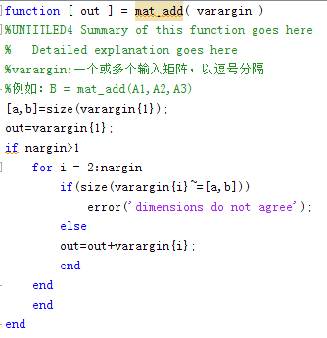
五、实验结果总结
通过本次实验，我掌握了script的基本写法和其意义（批量的Command，方便批量调用减少重复劳动）。除了用plot绘制曲线图以外，还学会了用hist绘制柱状图，其中hist(A,N)第二个参数N用于定义柱状图列数是非常实用的一种写法。另外还有函数的基本写法：
function[输出参数，输出参数…]=函数名(输入参数，输入参数，…)
函数体
end
保存为.m格式的函数名.m文件
当调用函数时，使用函数名(输入参数，输入参数，…)调用，前面可以添加 变量= 以将函数返回值赋值给变量。第四题让我掌握了多个输入/输出变量函数的写法和使用方法，注意须使用.*等操作符进行逐个操作而不是*以防止错误。第6题我学会了不定输入参数数量的函数的写法，varargin表示不定个数的输入参数，nargin用于获取输入参数的数量。此外有varargout表示不定个数的输出参数，此题中未使用但我也已大致了解。此外我也在此题中尝试了对函数进行注解，方便用help进行查看，快速掌握函数的功能。
六、附录

