附录 华东师范大学软件学院实验报告
实验课程：嵌入式系统开发规范与建模 | 年级：2013级 | 实验成绩：
实验名称：Simulink 的基本模块的应用及  建模程序结构的方法 | 姓名：杨一新
实验编号： | 学号：10132510349 | 实验日期：2014.12.15
指导教师：郭建 | 组号： | 实验时间：8:00-9:30

一、实验目的
熟悉Simulink 的工作环境，能够运用基本模块建立模型，并且进行仿真，观察仿真结果；
掌握建模程序结构的两种方法：块图方法和运用Embedded MATLAB function 块图的方法。
二、实验内容与实验步骤
1. A transducer takes position and converts it to speed. The mathematical model for a transducer is an algebraic equation. Use blocks from the simulink library to implement a transducer.
The transducer is modeled with the following equation
y=3u+2
Where u represents position and y represents velocity.
a) Create a Simulink model of the transducer. Use a Ramp block (with the default value of 1 for the Slope) from the Sources library to view the position (u). Use a Display block from the Sinks library to view the value of the velocity (y) signal. The display block shows you only the current value of the signal.
b) Add a Signal Viewer to the velocity signal to see the signal values over the course of the entire simulation.
c) Set up the model to use input data from the MATLAB workspace.
(I) Delete the Ramp block and replace it with an Import block from the Sources library.
(II) Set up the data import parameters such that the following inputs are used.
time position(u)
0.0 0.0
3.0 0.5
7.0 1.0
10.0 0.0
d) Output the velocity signal to the MATLAB workspace and plot it using the plot function.
Hint:
Input: u—Position; Output: y—Velocity

2. In a torque converter system, the impeller torque and turbine torque can be represented with the following equations.
T_{impeller} = (N_{engine} / K)² T_{trubine} = Q_{tq} T_{impeller} SpeedRatio=N_{trubine}/N_{engine}
In the above equations, the variables Q_{tq} and K are known via the following empirical relationships.
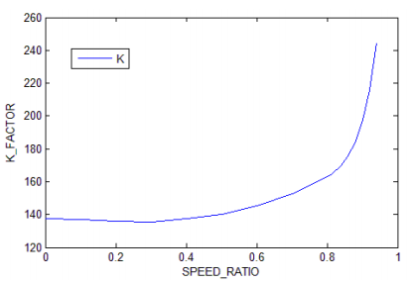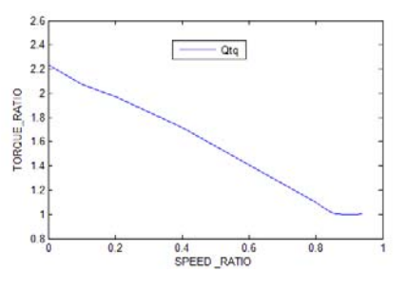
Create the model using the equations and empirical relationships above.
Hint
Inputs: N_{engine}—Engine speed (N_engine) ;
N_{turbine}—Turbine speed (N_turbine)
t—Time(t)
Output: t_{turbine}—turbine torque
Parameters: SpeedRatio—Speed ratio reference for lookup table (SPEED_RATIO)
K—K factor as a function of speed ratio (K_FACTOR)
Q_{tq}—Torque ratio as a function of speed ratio (TORQUE_RATIO)
All the necessary parameters and input signals are loaded automatically into the MATLAB workspace from torque_converter.mat as a model preload function.
3. Diodes are commonly used to allow current to pass in only one direction. You can model the voltage/current relationship of a power diode using a lookup table.
The input (voltage)/output (current) relationship is known to be as follows:
Input Data Map Table Data
(Volts) (Amps)
-5 -0.4
-4 -0.2
-3 -0.1
-2 -0.05
-1 -0.01
0 0.0
1 0.6
2 1.5
3 3.2
4 4.0
5 4.1
Use the data above to define the parameters of the lookup table.
Test your power diode model with a Sine wave input (with amplitude of 5). Attach a single Signal Viewer to both the input and output of the diode so that signals appear on the same display.
Hint:
Input:V—Voltage(sine wave with amplitude 5)
Output: i—Current
Parameter: Input data map (volts) Table data (amps)
4. The Mars Pathfinder was launched outside the atmosphere of Mars with a parachute that opens automatically based on the altitude of the Pathfinder as well as its velocity. The parachute is deployed in the altitude range 6500‐17000m. The mathematical model for the opening of the parachute is a logical equation.
Model the logic of the parachute two ways
a) Using Simulink logical blocks.
b) Using the Embedded MATLAB function block.
The parachute logic is summarized in the following pseudo code:
deploy=0
if(altitude<=17000 m) and (vel<=503.8 m/s)
deploy=1
if (altitude<=6500 m)
deploy=1
Test data for your system inputs, altitude and velocity, is in mars_para_data.mat(load mars_para_data).Use import blocks to pass altitude and velocity into the model(you can use the starter model mars_para_start). Simulate the model using a variable‐step, discrete solver with a Stop time of 200. Determine the time that the parachute was deployed.
Hint: Duplicate Import blocks to avoid crossing lines when sharing input signals.
Inputs:
altitude—Altitude of pathfinder(Alt)
vel—Velocity of pathfinder (Vel)
t—Time(t)
Output: deploy—Boolean indicating that parachute deployed
三、实验环境
计算机*1
Matlab2013a

四、实验过程与分析
1.
a) Create a Simulink model of the transducer. Use a Ramp block (with the default value of 1 for the Slope) from the Sources library to view the position (u). Use a Display block from the Sinks library to view the value of the velocity (y) signal. The display block shows you only the current value of the signal.
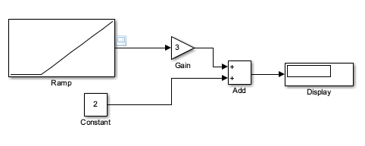
b) Add a Signal Viewer to the velocity signal to see the signal values over the course of the entire simulation.
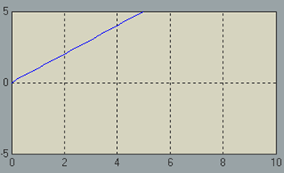
c) Set up the model to use input data from the MATLAB workspace.
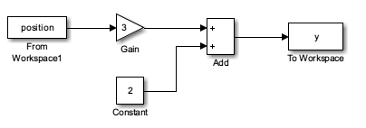
- Delete the Ramp block and replace it with an Import block from the Sources library.
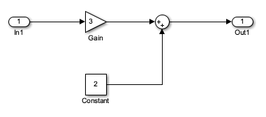
(II) Set up the data import parameters such that the following inputs are used.
time position(u)
0.0 0.0
3.0 0.5
7.0 1.0
10.0 0.0
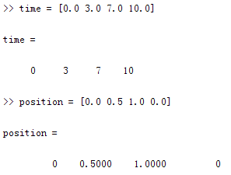
d) Output the velocity signal to the MATLAB workspace and plot it using the plot function.
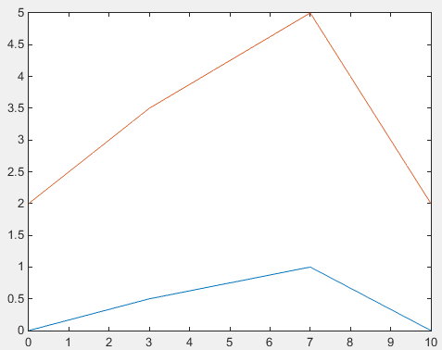plot(t,u,tout,yout)
2. In a torque converter system, the impeller torque and turbine torque can be represented with the following equations.
T_{impeller} = (N_{engine} / K)²
T_{trubine} = Q_{tq} T_{impeller}
SpeedRatio = N_{trubine} / N_{engine}
All the necessary parameters and input signals are loaded automatically into the MATLAB workspace from torque_converter.mat as a model preload function.
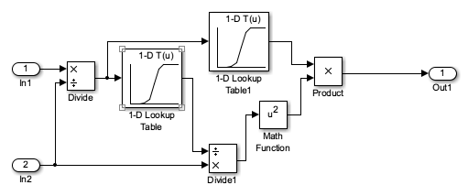
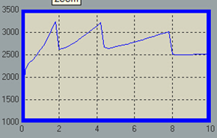 N_engine

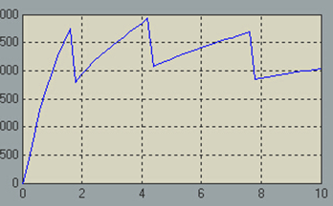 N_turbine

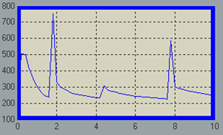 SpeedRatio
3. Diodes are commonly used to allow current to pass in only one direction. You can model the voltage/current relationship of a power diode using a lookup table.
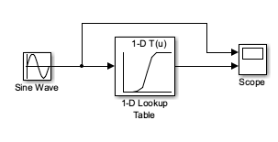
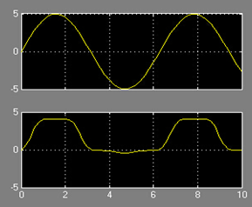
4. The Mars Pathfinder was launched outside the atmosphere of Mars with a parachute that opens automatically based on the altitude of the Pathfinder as well as its velocity. The parachute is deployed in the altitude range 6500‐17000m. The mathematical model for the opening of the parachute is a logical equation.Model the logic of the parachute two ways
- Using Simulink logical blocks
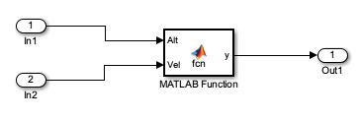
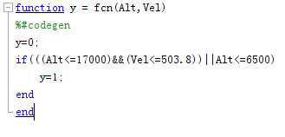
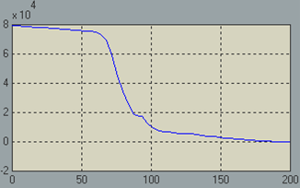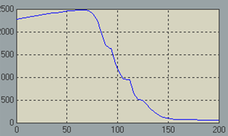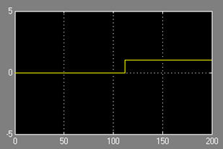
- Using the Embedded MATLAB function block.
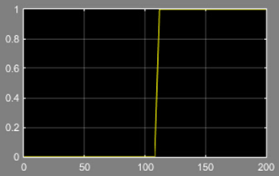
五、实验结果总结
通过本次实验，我掌握了Simulink模块的基本使用方法。比如输入参数和输出参数的in和out模块，将参数叠加的Sum模块和Add模块，放缩的Gain模块，观测输出参数并绘制图形的scope模块，与常数比较得出逻辑结果的Compare To Constant模块，逻辑操作模块Logical Operator模块，引用matlab函数的matlab function模块等。
六、附录

