附录 华东师范大学软件学院实验报告
实验课程：嵌入式系统开发规范与建模 | 年级：2013级 | 实验成绩：
实验名称：Simulink 的对离散系统和连续系统的  建模与仿真 | 姓名：杨一新
实验编号： | 学号：10132510349 | 实验日期：2014.12.22
指导教师：郭建 | 组号： | 实验时间：8:00-9:30

一、实验目的
掌握离散系统和连续系统的建模方法，熟悉分层建模的方法。
二、实验内容与实验步骤
1. This example implements population dynamics based on a nonlinear, discrete model. In the model, the population in a certain year, p(k), depends proportionally on the population of the previous year, p(k‐1), multiplied by the reproduction rate, r. However, the resources are limited to L individuals, thereby creating negative effect on the population. The overall dynamics are given by the difference equation:
p[k]=p[k-1]+r*p[k-1]*(L‐p[-1])
For L=le6 and p(0)=le5, try
r=1.5e-6(system converges to a single value)
r=2.2e-6(system is periodic every 2 years)
r=2.5e-6(system is periodic every 4 years)
r=2.56e-6(system is periodic every 8 years)
a) Start with a Unit Delay block whose input is p(k) and output is p(k-1). Then construct the expression for p(k), which is given in terms of the population. Run the system with a Stop time of 100 to observe the dynamics. Use a sample time of 1.
2. Computing a moving average is a commonly used technique to analyze trends in an otherwise wildly fluctuating(波动) set of time series data (e.g. stock prices or temperature of the atmosphere). The file temp.xls contains temperature data over several years. In this exercise, we will apply a moving average to this data to surmise long‐term trends in the temperature of Earth’s atmosphere.
First, you must load the data into the MATLAB workspace with the following command:
>> data = xlsread(‘temp.xls’);
Then, build a model that computes a 6‐point moving average. The equation is given by
y[k]=( x[k] +x[k-1]+x[k-2]+x[k-3]+x[k-4])/5
Start with a Unit Delay block whose input is x(k) and output is x(k-1). Connect the output with another Unit Delay block to obtain x(k-2), and so on.
Additionally, you must Load the data(data) into the model using a from Workspace block.
Set the start time and stop time to be the first year(data(1,1)) and last year(data(end,1)) of the imported temperature data, respectively.
Set the sample time of the algorithm to 1 for every Unit Delay block, to match the period of the input data.
3. You are going to model a water tank. The equations that model the water level of the tank are
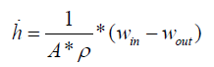
The derivative of the height is a function of the difference of the water flow in and out. h is the water level of the tank. A is the surface area of the bottom of the tank, and  is the density of the water. The flows in and out (w_{in} and w_{out}) are mass flows. The flow out is a function of water level h:
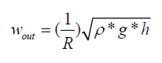
R is the resistance of the exit, and assume the exit is at the bottom of the tank.
a) The combination of these two equations is a continuous nonlinear dynamical model of the water level in a tank. Build this model in Simulink.
b) And create subsystem for this model.
c) If the height of the tank is considered to be 2m, at what time does the tank fill completely?
Tips: outputs h---Height of the water in the tank
w_{out}---water flow out of the tank
Parameters:
A‐‐‐Area of tank(4m²)
ρ‐‐‐Density of water(1000kg/m³)
w_{in}‐‐‐Water flow into the tank(100kg/s)
R‐‐‐Resistance of the exit(5(kg.m) ^{‐1/2})
h₀‐‐‐Initial height of the water in the tank(0 m)
g‐‐‐Gravitational constant(9.81m/s²)
h_{max}‐‐‐Height of tank(2m)
States:
h‐‐‐height of the water in the tank
4. A free‐falling ball is a good example of a system with continuous dynamics. The position of a ball in free fall is governed by Newton’s Second Law:
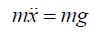
Where m is the ball’s mass, g is the gravitational acceleration, and x is the position. For simplicity air resistance is not considered here, Since m is on both sides of the equation, the cancel out, and the equation simplifies to
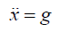
a) Build a Simlink model that emulates the dropping of a ball, Test the model with the
following parameters and initial condition:
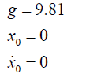
Run the simulation until a stop time of 10 seconds.
b) Save the results into both the Matlab workspace and a MAT‐file(using the to file block in source libary).
三、实验环境
计算机一台
Matlab2013a
四、实验过程与分析
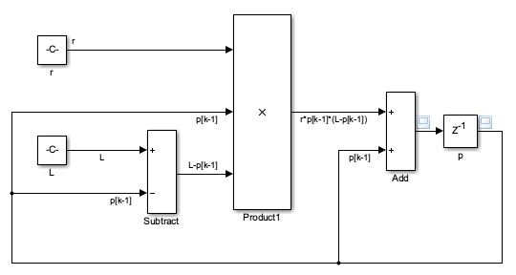
P[k]的图形：
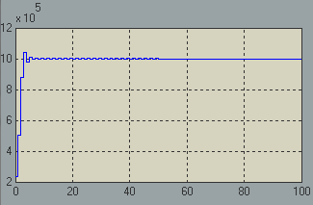

2.
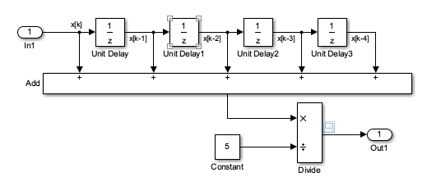
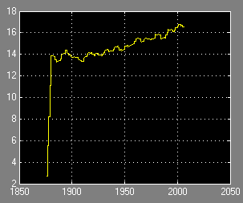

3.
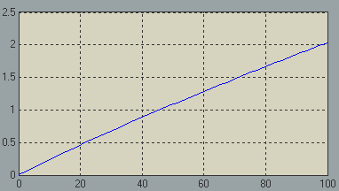
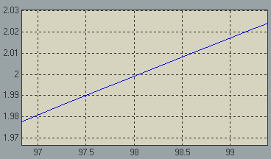
当t=98时，缸满

4.
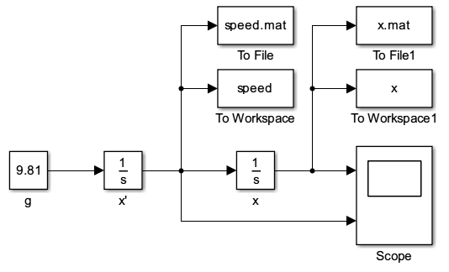
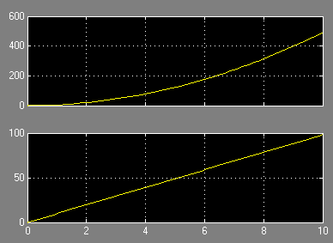

五、实验结果总结
通过本次实验，我掌握了通过unit delay对同一个离散变量的多次引用的方法。也学会了简单的连续动态模型的simulink建模。与理论课教材中的知识结合后印象更加深刻。
六、附录

