附录 华东师范大学软件学院实验报告
实验课程：嵌入式系统开发规范与建模 | 年级：2013级 | 实验成绩：
实验名称：Stateflow 中流程图的建模与仿真 | 姓名：杨一新
实验编号： | 学号：10132510349 | 实验日期：2014.12.30
指导教师：郭建 | 组号： | 实验时间：10:00-11:30

一、实验目的
熟悉如何使用Simulink 中Stateflow Library ，掌握如何为复杂的逻辑结构建立流程图，并对此进行仿真。掌握在Stateflow 中对于状态机建模的初步。熟悉debug 的使用。
二、实验内容与实验步骤
1. In this exercise, you will implement logic for a launch abort system. A launch abort system is designed to abort the launch of a space shuttle if anomalies are detected. The altitude of the space shuttle at the time of the abort determines how the vehicle will return safely to the ground. The possible situations are
(1) If altitude is greater than or equal to 50000m, abort into orbit(ATO), meaning the shuttle is released into orbit.
(2) If altitude is greater than or equal to 10000m, but less than 50000, abort once around(AOA).
(3) If altitude is greater than or equal to 1000m, but less than 10000, abort to a downrange landing(DRL).
(4) If altitude is less than 1000, abort and return to launch site (RTLS) Open the model abort_logic_start and create a Stateflow chart that will model the logic described above. Pseudocode for this logic can be written as follows:
ATO=0
AOA=0
DRL=0
RTLS=0
if Anomaly==1
if Altitude>=50000
ATO=1
else if Altitude>=10000
AOA=1
else if Altitude>=1000
DRL=1
else
RTLS=1
End

2. Open the simplified vehicle model car and study the mechanism that handles the shifting of the automatic transmission. Notice that the shifting control is running at a rate of 0.05. The control logic relies on speed thresholds returned from lookup tables to govern the gear shift. The logic shifts to a higher gear when the vehicle speed exceeds an upshift threshold. Likewise, it shifts to a lower gear when the vehicle speed drop below a downshift threshold. The new gear value is then derived by accumulating the shifting command to the existing
value. Redesign the model by creating a state machine to implement the transmission gears such that the shifter subsystem and the Sum block that maintains the gear value can be eliminated. The state machine should
. Maintain four gears as exclusive states.
. Receive the vehicle speed, upshift threshold, and downshift threshold as inputs.
.Return the gear value as an output.
. Sample at 0.05.

3. In the following model, the chart is currently designed to enable the cooler and heater based on the room temperature and the desired temperature setting. Modify the state machine in the file climateCtr1 such that the chart controls the humidifier(加湿器) as well. The humidifier output is dh, the change in humidity. Model the humidifier control using secondary states in the chart. The new implementation should have the following
behavior:
(1). The humidifier should be enabled when the room humidity drops below the desired setting.
(2). The humidifier can be enabled only if either the cooler or heater is enabled.
(3). the humidifier is disabled when the cooler or heater is initially enabled.
(4). when the humidifier is enabled, the humidifier input to the Room Thermodynamics
subsystem should be set to 1.5, otherwise it should be set to 0.

4. In this exercise, we will use the multiprocessing or parallel, capabilities of the Stateflow software to modify the climate control algorithm. The additions we will make will allow the control strategy to toggle between aggressive and non aggressive.
(1) Open the starting model –temParallelStart.
(2) Modify the chart to contain two parallel start, A and B
State A‐This state should contain all of the current contents of the state chart.
State B‐this state should contain the following logic, implemented using states:
if (aggressive==1)
dT=0.1; //aggressive state
else
dt=2; //nonaggressive state
(3) Set the execution order of the two parallel states such that state B executes before state A when the chart is updated.

三、实验环境
计算机一台
Matlab R2014a
四、实验过程与分析
1.
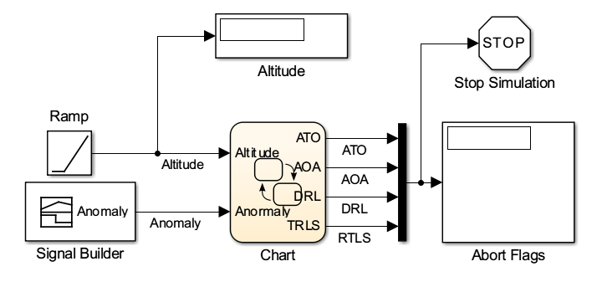
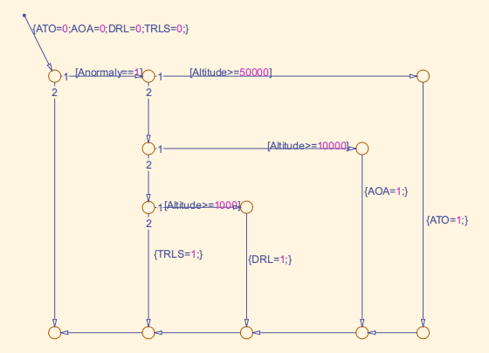
2.
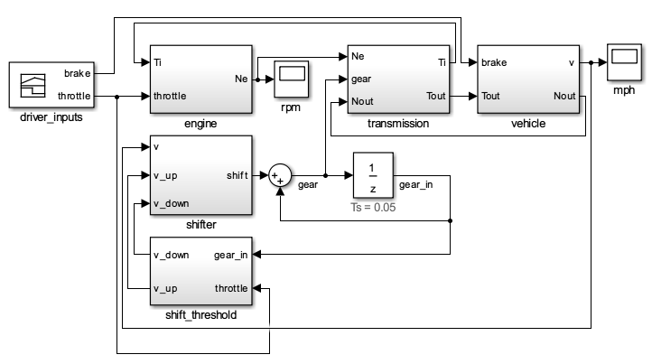
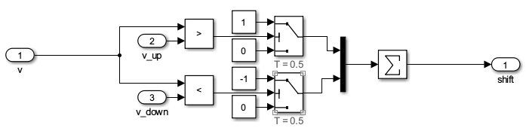
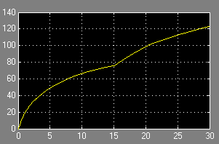
3.
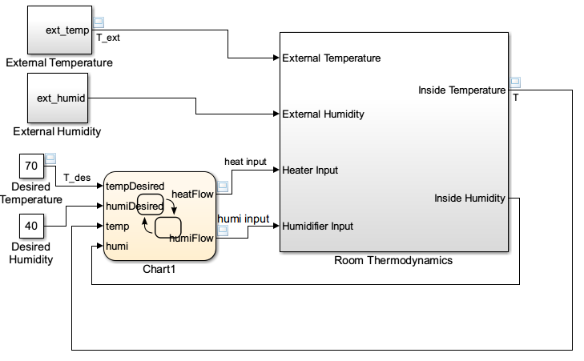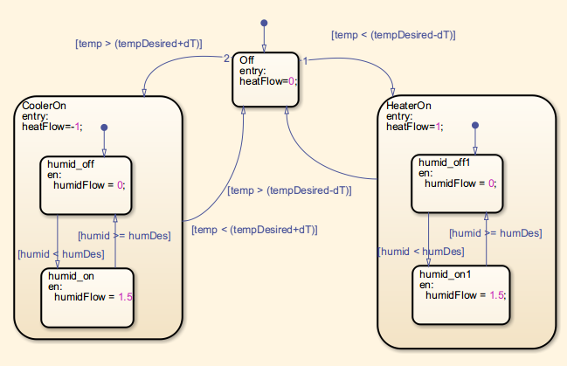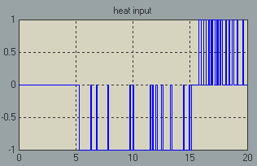

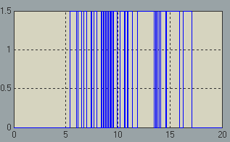

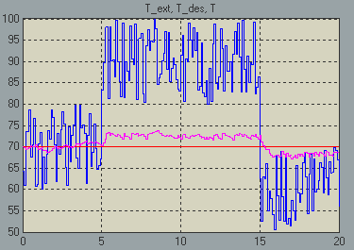
4.
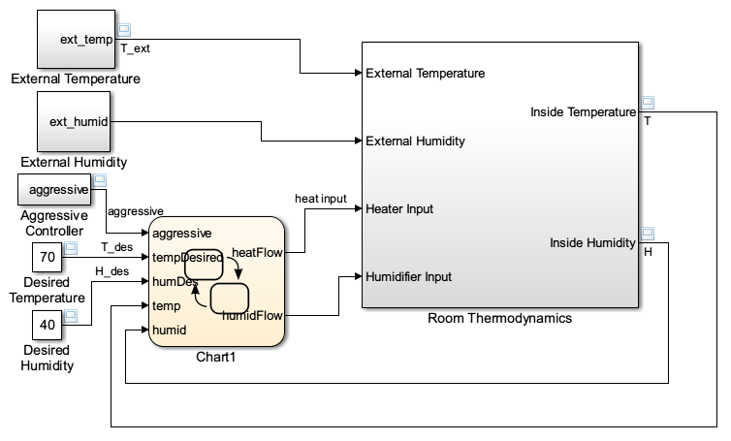
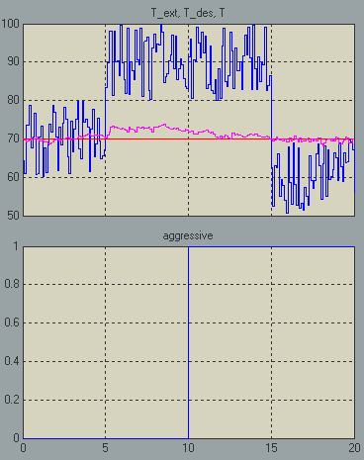
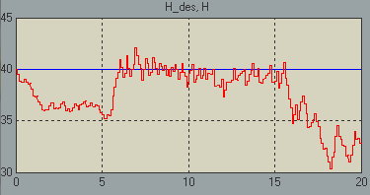
五、实验结果总结
通过本次实验，我掌握了Stateflow Library的基本使用方法。学会了建立流程图并仿真和对状态机建模。
六、附录

