Part 1: Introduction (0:00 - 05:00)
Slide 1: Title
English: "Good morning everyone. Today I am presenting a detailed analysis of the paper 'Measuring the Consistency Between Data and Control Plane in SDN', or 2MVeri. This work addresses a fundamental reliability issue in Software Defined Networking."
中文: "大家早上好。今天我将详细解读论文《测量SDN中数据平面与控制平面的一致性》，简称 2MVeri。这项工作解决了软件定义网络中一个根本性的可靠性问题。"

Slide 2：Blackground
"Before diving into our specific research, let's briefly review the paradigm of Software Defined Networking (SDN).
The most significant feature of SDN is the decoupling of the Control Plane and the Data Plane.
The Control Plane acts as the logically centralized 'brain,' making intelligent decisions.
The Data Plane consists of forwarding devices, like switches, which simply follow orders.
These orders are sent as 'Flow Rules' via protocols like OpenFlow.
However, precisely because these two planes are separated and communicate asynchronously, a critical problem arises: Inconsistency. The rules stored in the controller might not match the rules actually installed in the switches. This gap is exactly what our paper, 2MVeri, aims to measure and solve."
中文讲稿:
"在深入研究具体内容之前，让我们简要回顾一下软件定义网络 (SDN) 的范式。
SDN 最显著的特点是实现了控制平面与数据平面的解耦。
控制平面充当逻辑上集中的“大脑”，负责制定智能决策。
数据平面由交换机等转发设备组成，它们只是简单地执行命令。
这些命令通过像 OpenFlow 这样的协议以**‘流规则’**的形式下发。
然而，正是因为这两个平面是分离的且进行异步通信，这就引发了一个关键问题：不一致性。控制器中存储的规则可能与交换机中实际安装的规则不匹配。这种差距正是我们的论文 2MVeri 旨在测量和解决的问题。"

English: "Why is this a problem? If packets take unexpected paths, it can bypass firewalls (security risks), cause forwarding loops (performance degradation), or lead to black holes (packet loss). Therefore, measuring this consistency is crucial."
中文: "为什么这是个问题？如果数据包走了非预期的路径，可能会绕过防火墙（安全风险），导致转发环路（性能下降），或导致黑洞（丢包）。因此，测量这种一致性至关重要。"

Slide 3: Root Causes
English: "The paper highlights four main causes for this inconsistency:
Lack of Acknowledgement: OpenFlow switches don't confirm every single rule installation.
Switch Failures: Software bugs or hardware faults may cause a switch to ignore priority levels.
External Modifications: Attackers or 3rd-party tools (like ONIE) might tamper with rules directly.
Network Updates: Asynchronous updates lead to transient inconsistencies."
中文: "论文强调了导致不一致的四个主要原因：1. 缺乏确认机制（OpenFlow不确认每条规则）；2. 交换机故障（软硬件错误导致忽略优先级）；3. 外部修改（攻击者或第三方工具篡改规则）；4. 网络更新（异步更新导致的瞬时不一致）。"

Part 2: Related Work (05:00 - 10:00)
Slide 4: Critique
English: "Existing solutions are categorized into Out-of-band (using probe packets) and In-band (using tags in real traffic)."
中文: "现有方案分为带外（使用探测包）和带内（在真实流量中使用标签）两类。"
English: "However, they have limitations.
Out-of-band tools like ATPG or RuleScope are slow. Generating probes for thousands of rules takes minutes, making them unsuitable for dynamic networks.
In-band tools like VeriDP inject tags, but they suffer from high storage overhead because they store expected paths hop-by-hop. Also, many cannot pinpoint which switch failed.
2MVeri aims to be In-band, low overhead, and capable of precise fault localization."
中文: "然而，它们都有局限性。带外工具（如ATPG）太慢，生成探测包需要几分钟，不适合动态网络。带内工具（如VeriDP）虽然嵌入标签，但存储开销大，因为需要逐跳存储路径。此外，许多工具无法定位具体是哪个交换机出了故障。2MVeri 的目标是实现带内、低开销且能精确故障定位。"

Part 3: System Design (10:00 - 20:00)
Slide 5: Framework Overview
English: "2MVeri consists of three subsystems:
Packet Processing: Carried out on switches to update tags.
Verification: Carried out on the controller to check consistency.
Localization: Triggered only when verification fails."
中文: "2MVeri 由三个子系统组成：1. 数据包处理（在交换机上更新标签）；2. 验证（在控制器上检查一致性）；3. 定位（仅在验证失败时触发）。"

Slide 6:Tag
- English: "The design relies on a Tag inserted into packet headers (MPLS/VLAN fields). It has three parts:
  - A 16-bit Bloom Filter: Records switch IDs.
  - A 2D Vector: Captures path state.
  - A Modulus: Prevents overflow.
Each switch holds a unique 2x2 Characteristic Matrix assigned by the controller."
- 中文: "该设计依赖于插入数据包头的标签。它包含三部分：1. 16位布隆过滤器（记录交换机ID）；2. 二维向量（捕获路径状态）；3. 模数（防止溢出）。每个交换机都有一个由控制器分配的唯一 2x2 特征矩阵。"
- English: "Where do we store this information? We don't want to increase the packet size.
2MVeri cleverly reuses existing header fields.
  - The 16-bit Bloom Filter goes into the VLAN tag.
  - The Two-dimensional Vector and Modulus are split into MPLS labels.
This design ensures that 2MVeri is compatible with existing hardware and doesn't introduce fragmentation."
- 中文: "这些信息存哪儿？我们不想增加包大小。2MVeri 巧妙复用了现有头部字段。16位布隆过滤器放入 VLAN 标签；二维向量和模数拆分放入 MPLS 标签。这种设计确保了 2MVeri 兼容现有硬件且不引入分片。"

Slide 7:Packet Processing Logic
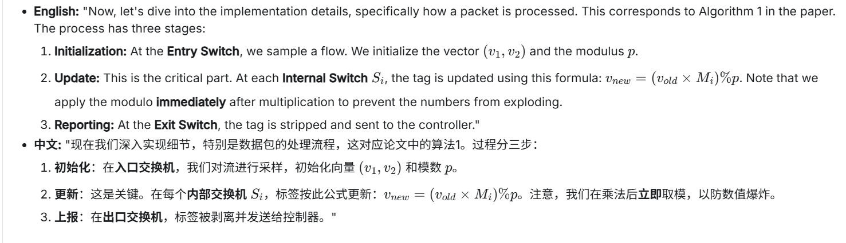
- English: "Now, let's dive into the implementation details, specifically how a packet is processed. This corresponds to Algorithm 1 in the paper.
The process has three stages:
  - Initialization: At the Entry Switch, we sample a flow. We initialize the vector $(v_{1},v_{2})$ and the modulus $p$
  - Update: This is the critical part. At each Internal Switch $S_{i}$, the tag is updated using this formula: $v_{new}=(v_{old}×M_{i})\%p$. Note that we apply the modulo immediately after multiplication to prevent the numbers from exploding.
  - Reporting: At the Exit Switch, the tag is stripped and sent to the controller."
- 中文: "现在我们深入实现细节，特别是数据包的处理流程，这对应论文中的算法1。过程分三步：
  - 初始化：在入口交换机，我们对流进行采样，初始化向量 $(v_{1},v_{2})$ 和模数 $p$。
  - 更新：这是关键。在每个内部交换机$S_{i}$，标签按此公式更新：$v_{new}=(v_{old}×M_{i})\%p$。注意，我们在乘法后立即取模，以防数值爆炸。
  - 上报：在出口交换机，标签被剥离并发送给控制器。"
此处应有图
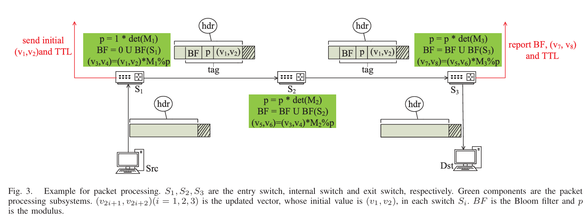

Slide 8: Dynamic Tag Update Mechanism
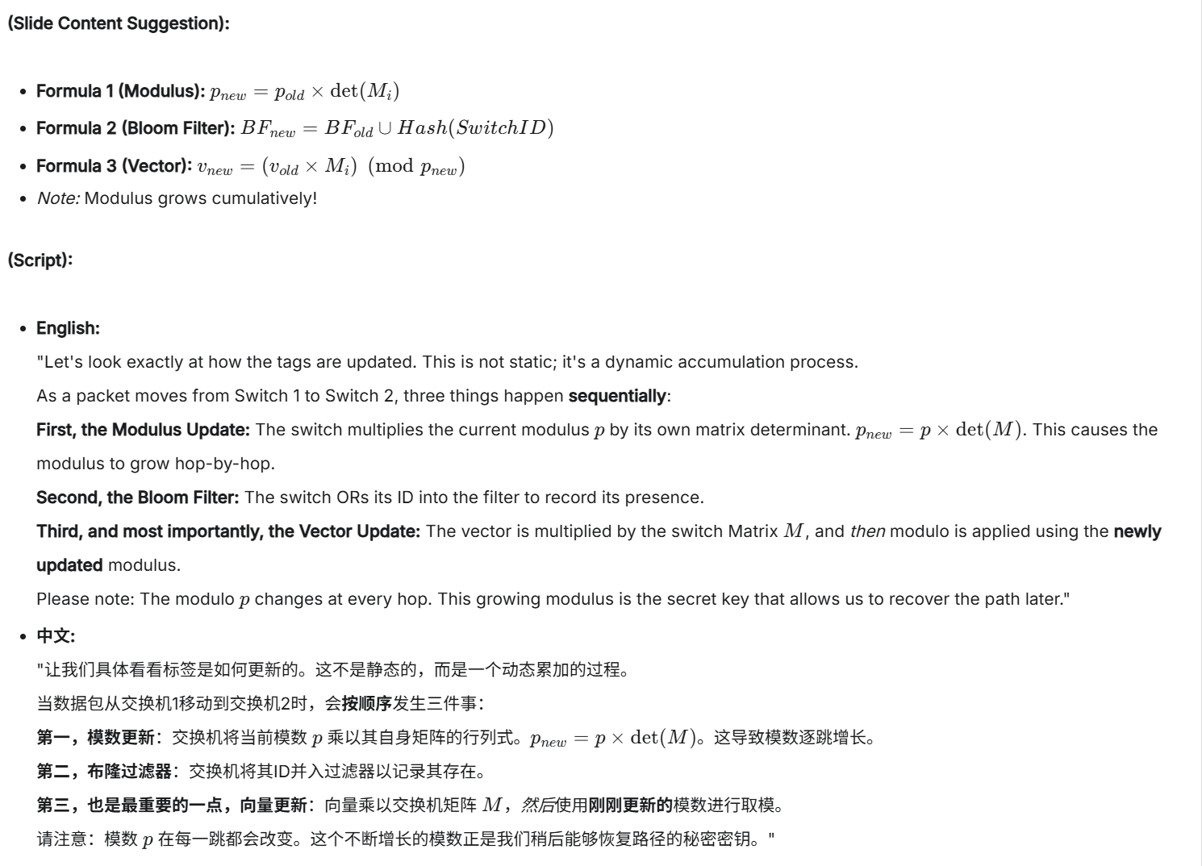
Slide 8: Dynamic Tag Update Mechanism
(Slide Content Suggestion):
- Formula 1 (Modulus):
$$p_{new}=p_{old}×det⁡(M_{i})$$
- Formula 2 (Bloom Filter):
$$BF_{new}=BF_{old}∪Hash(SwitchID)$$
- Formula 3 (Vector):
$$v_{new}=(v_{old}×M_{i})(modp_{new})$$
- Note: Modulus grows cumulatively!
(Script):
- English:
"Let's look exactly at how the tags are updated. This is not static; it's a dynamic accumulation process.
As a packet moves from Switch 1 to Switch 2, three things happen sequentially:
First, the Modulus Update: The switch multiplies the current modulus $p$ by its own matrix determinant. $p_{new}=p×det⁡(M)$. This causes the modulus to grow hop-by-hop.
Second, the Bloom Filter: The switch ORs its ID into the filter to record its presence.
Third, and most importantly, the Vector Update: The vector is multiplied by the switch Matrix $M$, and then modulo is applied using the newly updated modulus.
Please note: The modulo $p$changes at every hop. This growing modulus is the secret key that allows us to recover the path later."
- 中文:
"让我们具体看看标签是如何更新的。这不是静态的，而是一个动态累加的过程。
当数据包从交换机1移动到交换机2时，会按顺序发生三件事：
第一，模数更新：交换机将当前模数 $p$乘以其自身矩阵的行列式。$p_{new}=p×det⁡(M)$。这导致模数逐跳增长。
第二，布隆过滤器：交换机将其ID并入过滤器以记录其存在。
第三，也是最重要的一点，向量更新：向量乘以交换机矩阵 $M$，然后使用刚刚更新的模数进行取模。
请注意：模数 $p$在每一跳都会改变。这个不断增长的模数正是我们稍后能够恢复路径的秘密密钥。"

Slide 9: Verification Logic
(Slide Content Suggestion):
- Controller: Contains global topology & path expectations.
- Process:
  - Look up Expected Path for Flow $F$
  - Compute $Tag_{correct}$ using matrices of expected switches.
  - Receive $Tag_{reported}$from Exit Switch.
  - Compare: if (Tag_rep == Tag_corr) return Consistent;
(Script):
- English:
"Once the packet reaches the exit, verification is straightforward.
The Controller already knows the Expected Path. It runs the exact same calculation logic I just described—in software—to generate a 'Correct Tag'.
It then compares this locally computed tag with the 'Reported Tag' from the packet.
If the Bloom Filter, Vector, and Modulus all match, the path is verified. If there is any mismatch, we immediately trigger the Localization Algorithm."
- 中文:
"一旦数据包到达出口，验证过程就很直接了。
控制器已经知道预期路径。它在软件中运行我刚才描述的完全相同的计算逻辑，生成一个**‘正确标签’。
然后，它将这个本地计算的标签与数据包中的‘报告标签’**进行比较。
如果布隆过滤器、向量和模数都匹配，则路径验证通过。如果存在任何不匹配，我们立即触发定位算法。"

Slide 10: Fault Localization: The Reverse Search Strategy
(Slide Content Suggestion):
- Visual: A tree structure rooted at the Exit Switch.
- Goal: Find path back to Entry Switch.
- Core Idea: Use Inverse Matrix ($M^{-1}$) to "undo" the multiplication.
- Stop Condition: Path Length == TTL Difference.
(Script):
- English:
"Now, the most complex part: How do we localize the fault?
Imagine walking backwards from the Exit Switch to find the Entry Switch.
We use a Depth-First Search (DFS) algorithm. We know the total number of hops from the IP TTL field.
The algorithm asks a simple question to every upstream neighbor: 'Could the packet have come from you?'
To answer this, we try to reverse the matrix operation. We multiply the reported vector by the Inverse Matrix ($M^{-1}$) of the neighbor we are testing."
- 中文:
"现在是最复杂的部分：我们如何定位故障？
想象一下从出口交换机倒着往回走，去寻找入口交换机。
我们使用深度优先搜索 (DFS) 算法。我们通过 IP TTL 字段知道总跳数。
算法向每个上游邻居问一个简单的问题：‘数据包可能是从你这里发过来的吗？’
为了回答这个问题，我们尝试逆转矩阵操作。我们将报告的向量乘以我们正在测试的邻居的逆矩阵 ($M^{-1}$)。"

Slide 11: Fault Localization: Implementation Details
(Slide Content Suggestion):
- Pseudocode Logic:
- 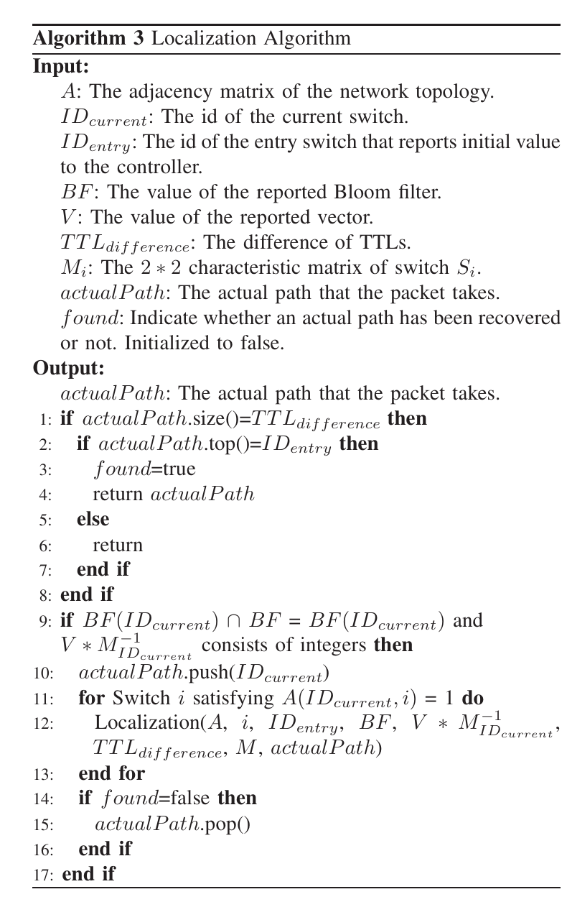
- Highlight: The "Integer vs Fraction" distinction.
(Script):
- English:
"Here is the specific implementation logic, corresponding to Algorithm 3 in the paper.
For a neighbor switch to be valid, it must pass two strict checks:
Check 1: The Bloom Filter. Is the neighbor's ID present in the reported Bloom Filter? This is a fast filter.
Check 2: The Integer Property. This is the mathematical guarantee. We calculate $V×M^{-1}$.
  - If the switch is correct, the result will be a clean Integer Vector.
  - If the switch is incorrect, the result will essentially be fractions (due to the modulo design).
If both checks pass, we push this switch to our path stack and recurse deeper with the new vector state. If we hit a dead end, we backtrack and try another neighbor."
- 中文:
"这是具体的实现逻辑，对应论文中的算法 3。
一个邻居交换机要被认定为有效，必须通过两个严格的检查：
检查 1：布隆过滤器。 邻居的 ID 是否存在于报告的布隆过滤器中？这是一个快速过滤器。
检查 2：整数性质。 这是数学上的保证。我们计算 $V×M^{-1}$。
  - 如果交换机是正确的，结果将是一个干净的整数向量。
  - 如果交换机是错误的，结果本质上将是分数（归因于模数的设计）。(加一句：we will talk about this next part)
如果两个检查都通过，我们将此交换机推入路径栈，并使用新的向量状态进行递归。如果我们走进死胡同，我们就回溯并尝试另一个邻居。"

Part 4: Theoretical Rationale (20:00 - 30:00)
- English: "Now, we must address a theoretical challenge. Why do we need Modulo? To avoid overflow. But modulo causes information loss—we lose the quotients.
Normally, without quotients, you cannot uniquely recover the path using inverse matrices. This creates ambiguity."
- 中文: "现在我们必须解决一个理论挑战。为什么需要模运算？为了避免溢出。但模运算导致信息丢失——我们丢失了商。通常情况下，没有商就无法通过逆矩阵唯一恢复路径，这造成了歧义。"
Slide 13: The Math Proof
- English: "The authors solved this with Lemma 1 and Proposition 1.
  - The Idea: If we set the Modulus $p$ to be a multiple of the determinants of the matrices along the path.
  - The Proof: They proved that $D_{new}=D_{old}*A^{-1}$ will always result in integers if the modulus encompasses the determinant.
  - This mathematically guarantees that we can perform fault localization even with incomplete information (missing quotients)."
- 中文: "作者通过引理1和命题1解决了这个问题。思路：如果我们将模数 $p$设置为路径上矩阵行列式的倍数。**证明：**他们证明了，如果模数包含行列式，逆运算的结果总是整数。这在数学上保证了即使信息不完整（缺少商），我们也能进行故障定位。"
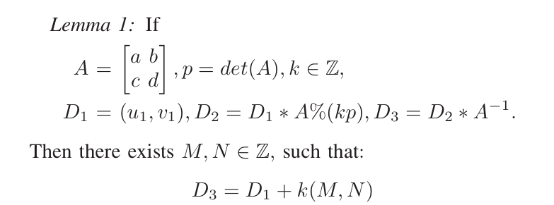
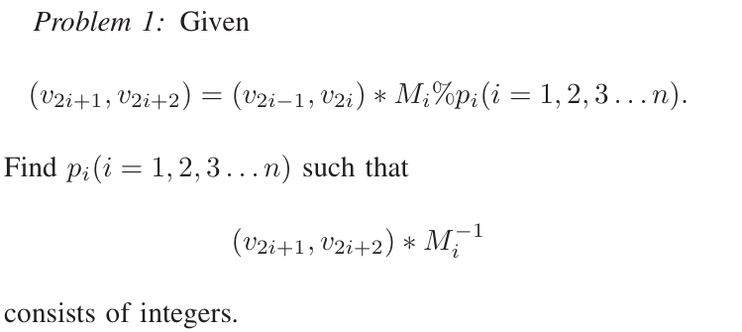
Slide 14: Matrix Design
- English: "To make this work, the matrices must follow constraints:
  - Column vectors cannot be multiples of each other (to ensure invertibility).
  - Determinants should be small integers (like 3 or 4) to keep the modulus from growing too fast, yet strictly $>2$ to avoid high false negatives."
- 中文: "为了使其有效，矩阵必须遵循约束：1. 列向量不能成倍数关系（确保可逆）；2. 行列式应为小整数（如3或4）以防止模数增长过快，但必须大于2以避免高假阴性率。"

Part 5: Evaluation (30:00 - 37:00)
Slide 15: Experimental Setup
- English:
"To rigorously evaluate 2MVeri, we built a comprehensive simulation environment.
We used Mininet to emulate the network and Floodlight as the SDN controller. The data plane consists of Open vSwitch (OVS) instances running our modified packet processing logic.
For topologies, we didn't just use simple networks. We tested on:
  - Fat Tree topologies (k=4 and k=6): Representing standard data center architectures.
  - Stanford Backbone: A real-world wide area network topology to ensure our solution works in complex, non-regular environments.
We generated UDP traffic to populate flow tables and then deliberately injected faults to test the system."
- 中文:
"为了严格评估 2MVeri，我们搭建了一个全面的仿真环境。
我们使用 Mininet 模拟网络，使用 Floodlight 作为 SDN 控制器。数据平面由运行我们修改后的数据包处理逻辑的 Open vSwitch (OVS) 实例组成。
在拓扑结构方面，我们不仅使用了简单的网络，还测试了：
  - 胖树拓扑（k=4 和 k=6）：代表标准的数据中心架构。
  - 斯坦福骨干网：这是一个真实的广域网拓扑，以确保我们的方案在复杂的非规则环境中也能工作。
我们生成 UDP 流量来填充流表，然后故意注入故障来测试系统。"
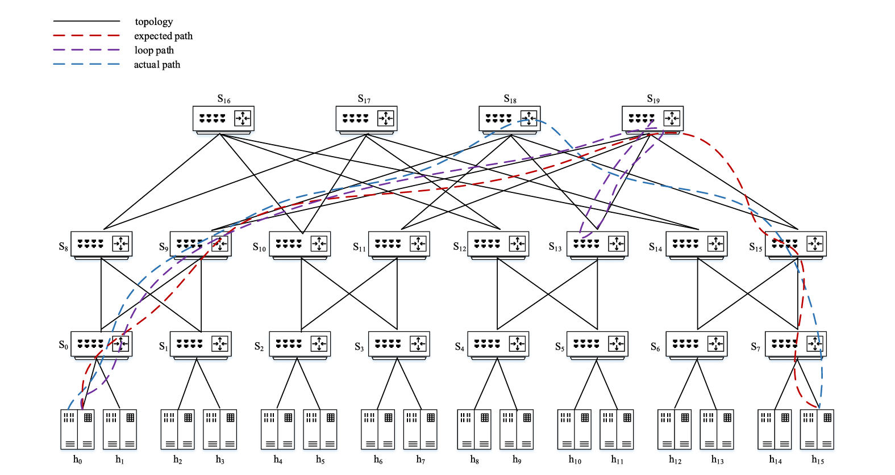
Slide 16: Functional Tests
- English:
"First, we conducted functional tests to verify if 2MVeri can detect specific types of network failures. We simulated three classic scenarios:
Scenario 1: Black Hole. We modified a switch rule to drop packets. 2MVeri detected the missing tags immediately.
Scenario 2: Path Deviation. We forced a switch to forward packets to a wrong port. The verification failed because the matrix multiplication result didn't match the expected value. 2MVeri successfully recovered the actual path and located the deviating switch.
Scenario 3: Forwarding Loop. We created a loop between two switches. The reported tag became inconsistent due to repeated multiplications.
The Result: In all these cases, 2MVeri achieved 100% detection success, proving its functional correctness."
- 中文:
"首先，我们进行了功能测试，以验证 2MVeri 是否能检测特定类型的网络故障。我们模拟了三种经典场景：
场景 1：黑洞。 我们修改了交换机规则以丢弃数据包。2MVeri 立即检测到了标签缺失。
场景 2：路径偏离。 我们强制交换机将数据包转发到错误的端口。由于矩阵乘法结果与预期值不匹配，验证失败。2MVeri 成功恢复了实际路径并定位了发生偏离的交换机。
场景 3：转发环路。 我们在两个交换机之间制造了一个环路。由于重复的乘法运算，报告的标签变得不一致。
结果： 在所有这些案例中，2MVeri 都实现了 100% 的检测成功率，证明了其功能上的正确性。"
Slide 17: Performance Analysis
- English:
"Now, let's look at the quantitative data. This is crucial. We analyzed how the Matrix Determinant affects accuracy.
Please look at the graph. The X-axis is the Bloom Filter size, and the Y-axis is the False Negative Rate.
Observation: When the determinant is set to 2, the error rate is relatively high.
Why? Because a small determinant means the Modulus $p$ grows slowly. A smaller modulus leads to more hash collisions—where a wrong path accidentally produces the same tag as the correct path.
The Fix: However, as soon as we increase the determinant to 3, 4, or 5, the False Negative Rate drops to zero.
Conclusion: With a determinant $≥3$, 2MVeri achieves 100% Verification Accuracy and 99.8% Localization Accuracy. This empirically proves our theoretical choice of using cumulative determinants."
- 中文:
"现在，让我们来看定量数据。这部分至关重要。我们分析了矩阵行列式如何影响准确率。
请看这张图。X轴是布隆过滤器大小，Y轴是假阴性率（漏报率）。
观察： 当行列式设置为 2 时，错误率相对较高。
原因： 因为较小的行列式意味着模数 $p$ 增长缓慢。较小的模数会导致更多的哈希碰撞——即错误的路径意外地产生了与正确路径相同的标签。
修正： 然而，一旦我们将行列式增加到 3、4 或 5，假阴性率立即降至 零。
结论： 当行列式 $≥3$ 时，2MVeri 实现了 100% 的验证准确率和 99.8% 的定位准确率。这从经验上验证了我们使用累积行列式的理论选择是正确的。"
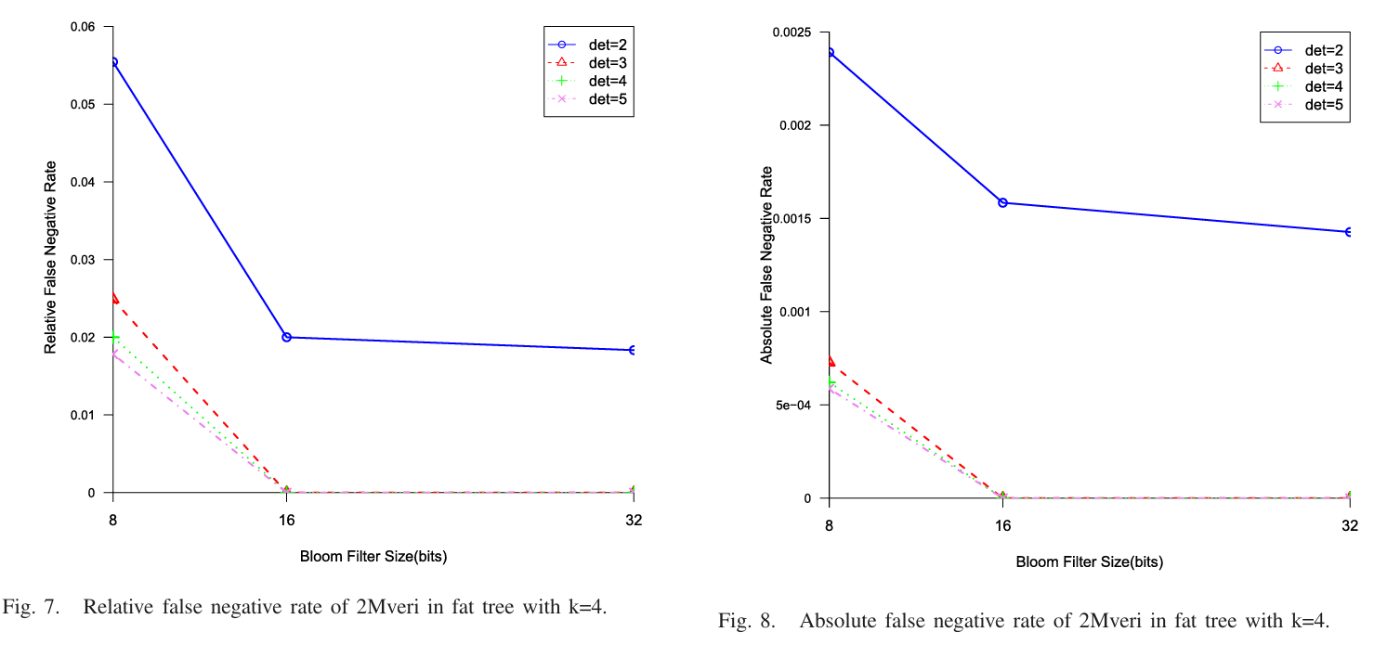

Slide 18: Overhead Comparison (vs. VeriDP)
- English:
"Finally, is 2MVeri efficient? We compared it against the state-of-the-art solution, VeriDP.
Storage Overhead:
  - VeriDP (Blue Line): Requires storing a path table that grows linearly with the number of flows and path length. This consumes significant memory on the control plane.
  - 2MVeri (Red Line): Our storage overhead is constant ($O(1)$). We only need the matrices, regardless of how many flows or hops exist.
Computation Overhead:
  - In terms of speed, 2MVeri's verification throughput reaches 3.5 to 5.8 $×{10}^{5}$packets per second.
This proves that 2MVeri is not only more accurate but also significantly more scalable for large networks."
- 中文:
"最后，2MVeri 高效吗？我们将它与最先进的方案 VeriDP 进行了对比。
存储开销：
  - VeriDP（蓝线）： 需要存储路径表，其大小随流的数量和路径长度线性增长。这消耗了控制平面大量的内存。
  - 2MVeri（红线）： 我们的存储开销是常数级 ($O(1)$)。无论有多少流或多少跳，我们只需要存储矩阵。
计算开销：
  - 在速度方面，2MVeri 的验证吞吐量达到了 每秒 35 万到 58 万个数据包。
这证明了 2MVeri 不仅更准确，而且对于大型网络来说，扩展性显著更强。"
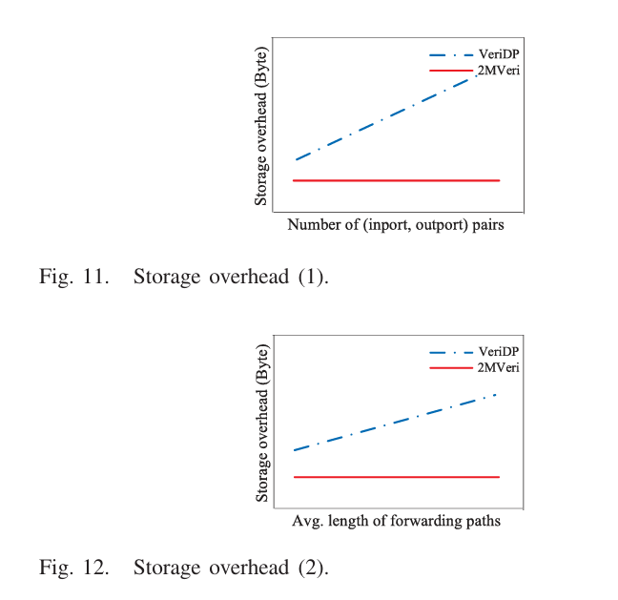
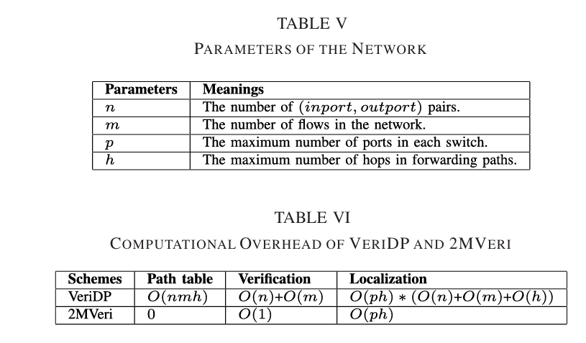

Slide 19: Discussion & Future Directions
- English:
"Before we conclude, let's discuss the road ahead. While 2MVeri has shown excellent performance, there are exciting avenues for future research.
First, Protocol Independence: Currently, our implementation is tailored for the IPv4 scenario. We plan to extend 2MVeri to scenarios where multiple protocols coexist.
Second, P4 Implementation: We are looking to migrate the framework from Open vSwitch to P4 programmable switches. P4 offers greater flexibility and programmability, which would allow 2MVeri to run entirely in the data plane hardware, further reducing latency.
Third, Edge Cases: The paper notes a specific challenge: what if the actual path is the same as the expected path, but the rules matched on the switches are different? We plan to conduct further research to detect this subtle form of inconsistency."
- 中文:
"在结束之前，让我们探讨一下未来的方向。虽然 2MVeri 表现出色，但仍有令人兴奋的研究空间。
第一，协议无关性： 目前我们的实现是针对 IPv4 场景定制的。我们计划将 2MVeri 扩展到多协议共存的场景中。
第二，P4 实现： 我们正计划将框架从 Open vSwitch 迁移到 P4 可编程交换机上。P4 提供了更高的灵活性和可编程性，这将允许 2MVeri 完全在数据平面硬件中运行，进一步降低延迟。
第三，边缘情况： 论文提到了一个特定的挑战：如果实际路径与预期路径相同，但交换机上匹配的规则不同怎么办？我们计划进行进一步研究，以检测这种微妙的不一致形式。"

Slide 20: Conclusion
- English:
"To summarize, this paper presents 2MVeri, a groundbreaking framework for measuring SDN consistency.
We have three key takeaways for you today:
  - Innovative Design: It is the first framework to exploit Matrix Multiplication combined with Modular Arithmetic for in-band path verification. This theoretically solves the overflow problem while preserving path information.
  - High Accuracy: Through rigorous math proofs and experiments, we achieved 100% verification accuracy and 99.8% fault localization accuracy, outperforming existing solutions.
  - Low Overhead: By reusing existing header fields and requiring only constant control plane storage, 2MVeri is highly efficient and scalable for large networks.
It effectively bridges the gap between the control plane's intent and the data plane's reality."
- 中文:
"总结一下，本文提出了 2MVeri，这是一个用于测量 SDN 一致性的开创性框架。
今天我们有三个核心结论：
  - 创新设计： 它是第一个结合矩阵乘法和模运算进行带内路径验证的框架。这在理论上解决了溢出问题，同时保留了路径信息。
  - 高准确率： 通过严谨的数学证明和实验，我们实现了 100% 的验证准确率和 99.8% 的故障定位准确率，优于现有方案。
  - 低开销： 通过复用现有头部字段且仅需常量的控制平面存储，2MVeri 非常高效，具备在大型网络中扩展的能力。
它有效地弥合了控制平面的意图与数据平面的现实之间的差距。"

