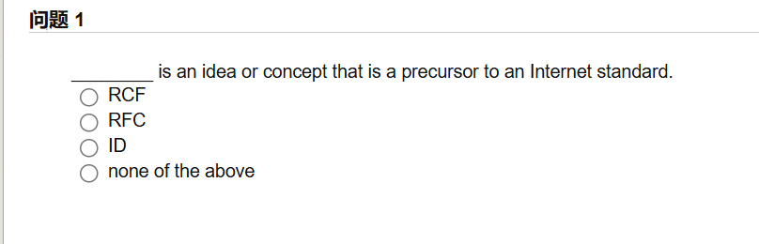

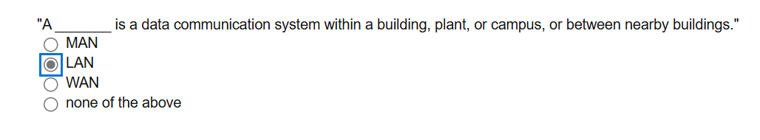

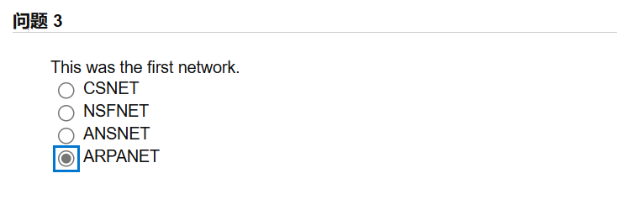

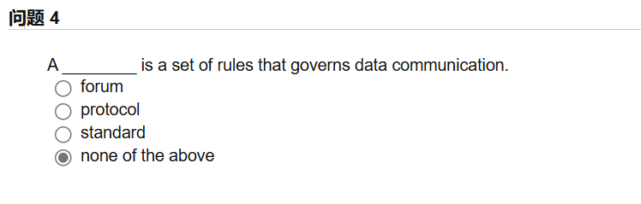

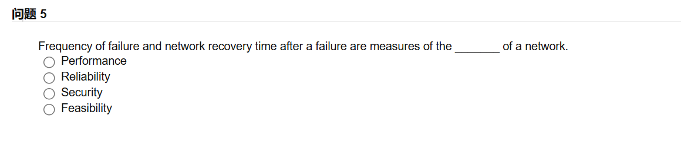

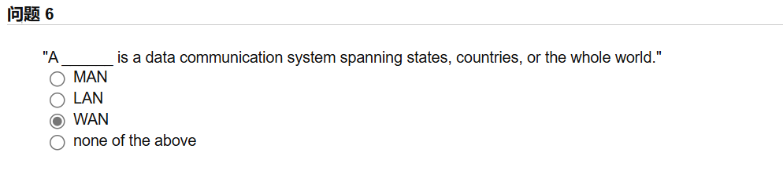

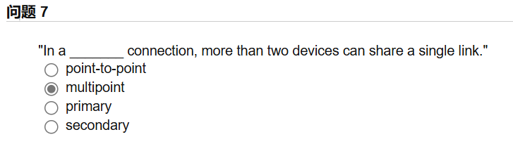

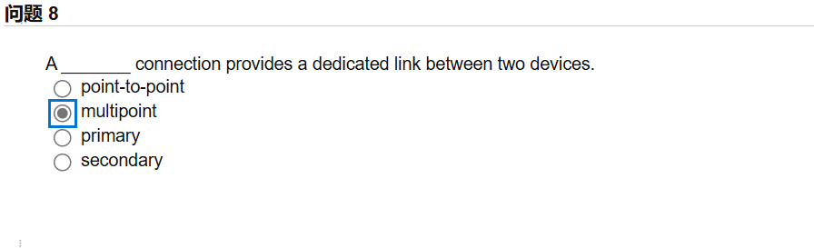

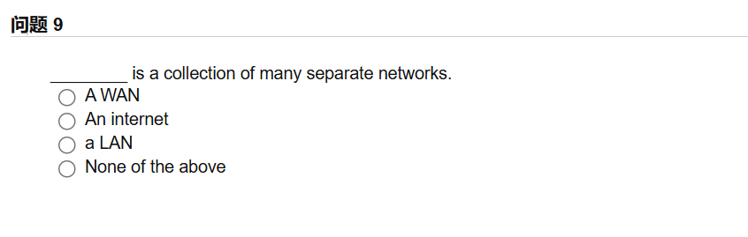

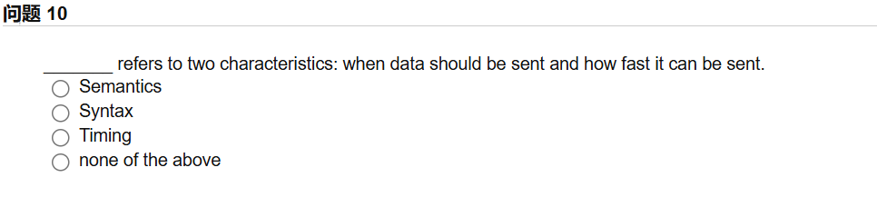

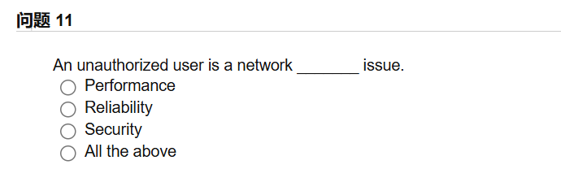

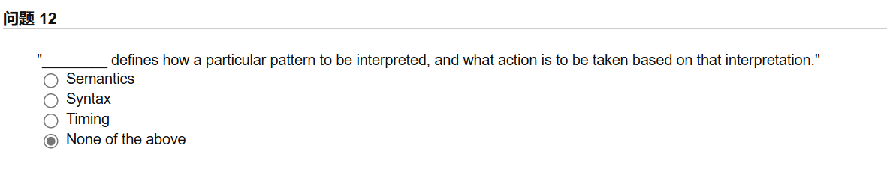

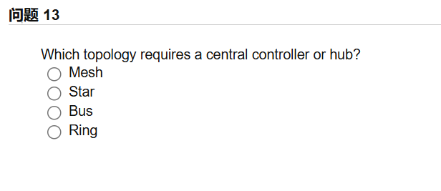

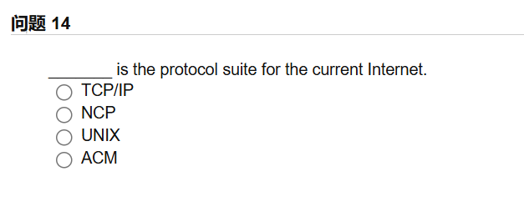

问题15：

____refers to the structure or format of the data, meaning the order in which they are presented.

1. Semantics
2. Syntax
3. Timing
4. None of the above

答案：

Bbdbb

Cbabc

Cabab