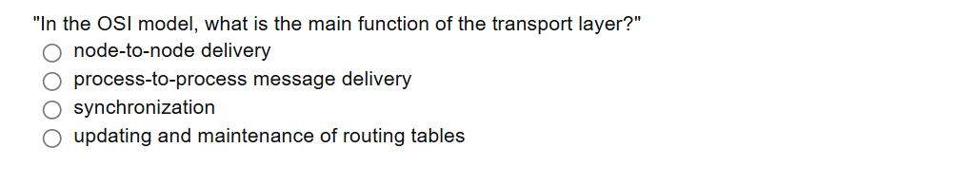

The OSI model consists of _______ layers.

a.7

b.6

c.5

d.4

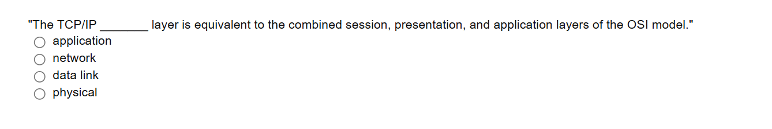

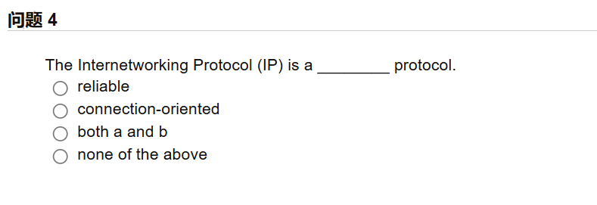

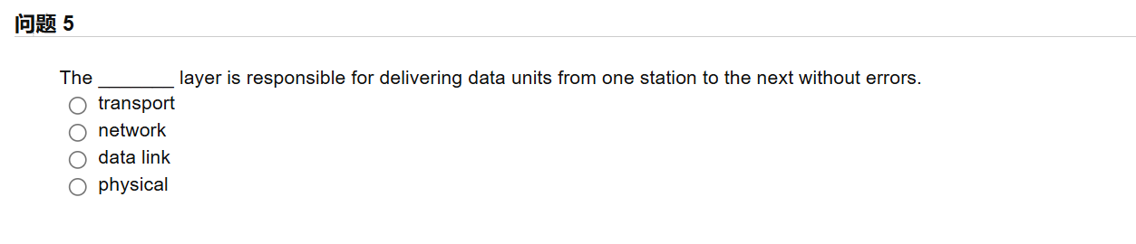

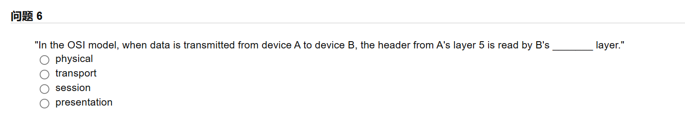

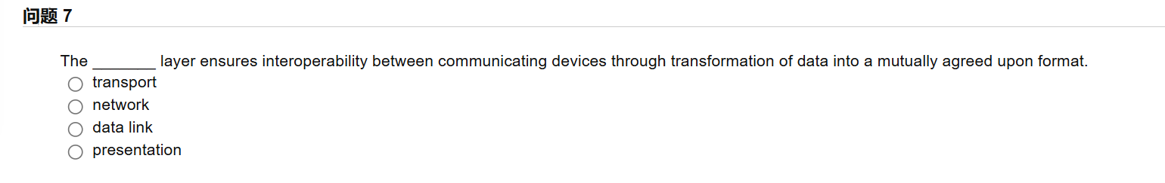

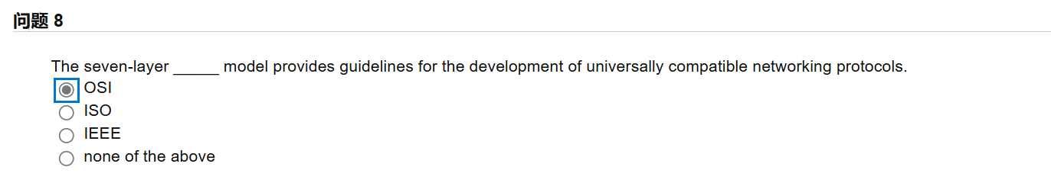

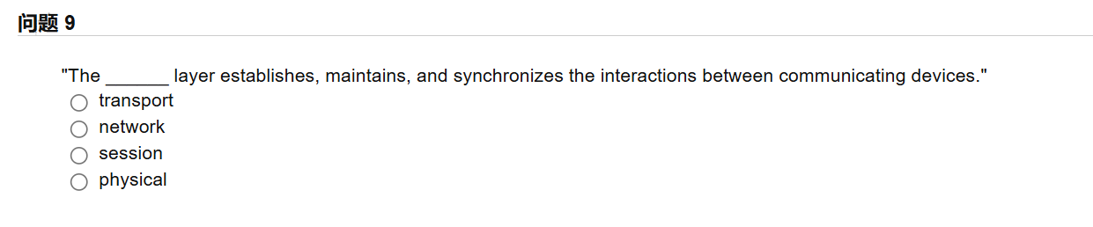

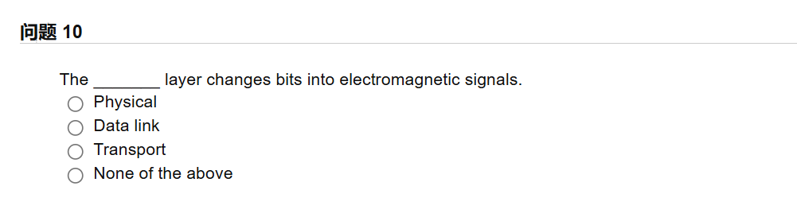

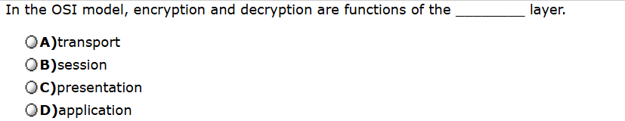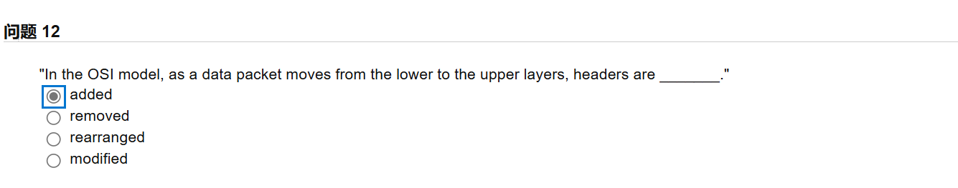

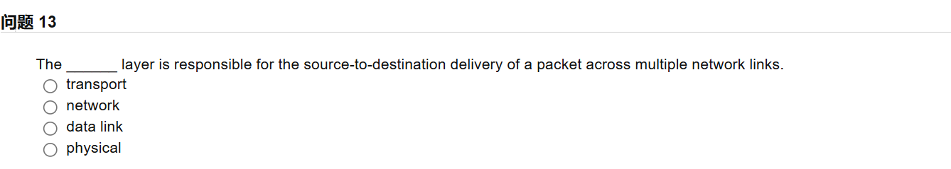

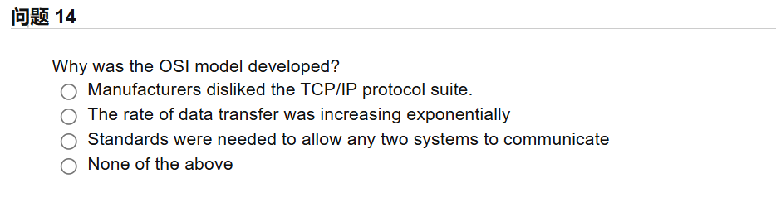

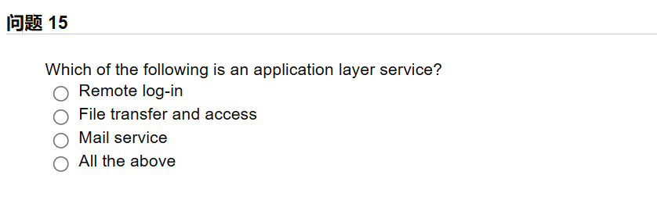

答案：b a a d c

C d a c a

C b b c d