3-1. Answer the following questions:

1. The following data fragment occurs in the middle of a data stream for which the byte-stuffing algorithm described in the text is used: A B ESC C ESC FLAG FLAG D. What is the output after stuffing?

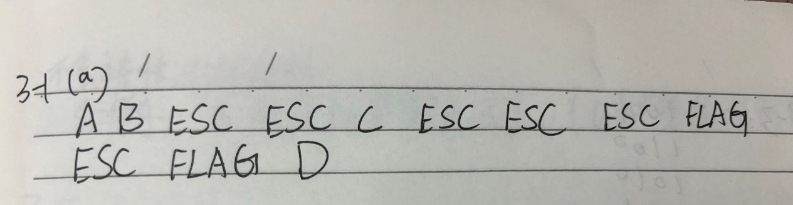

1. You receive the following data fragment: 0110 0111 1100 1111 0111 1101. You know that the protocol uses bit stuffing. Show the data after destuffing.

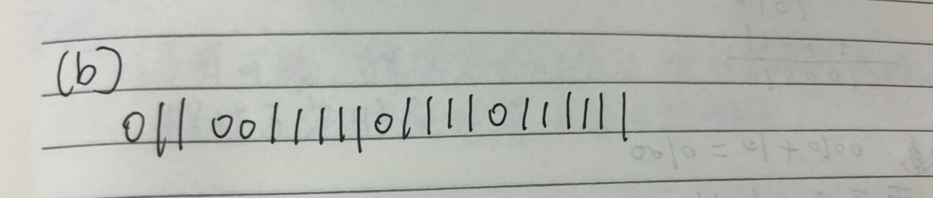

3-2. A 12-bit Hamming code whose hexadecimal value is 0xE4F arrives at a receiver. What was the original value in hexadecimal? Assume that not more than 1 bit is in error. (p.s.: number the bits from left to right starting at bit 1)

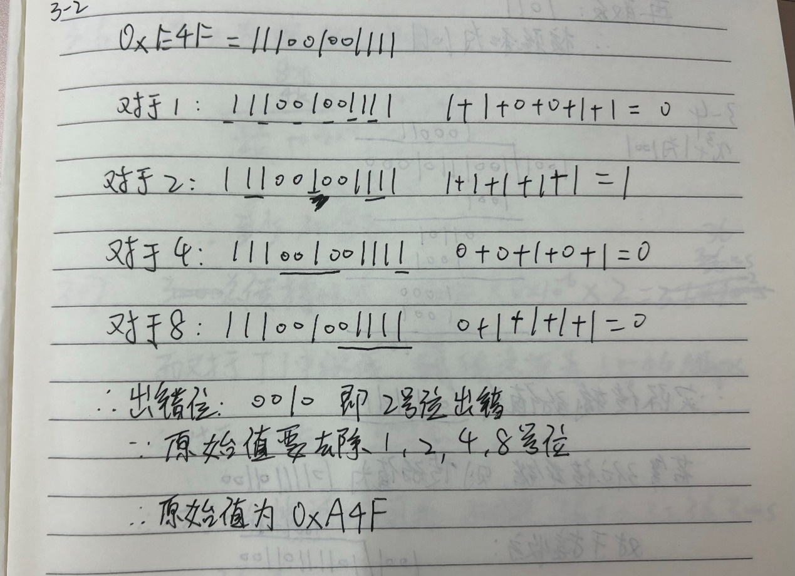

3-3. Suppose that a message 1001 1100 1010 0011 is transmitted using the Internet Checksum (4-bit word). What is the value of the checksum?

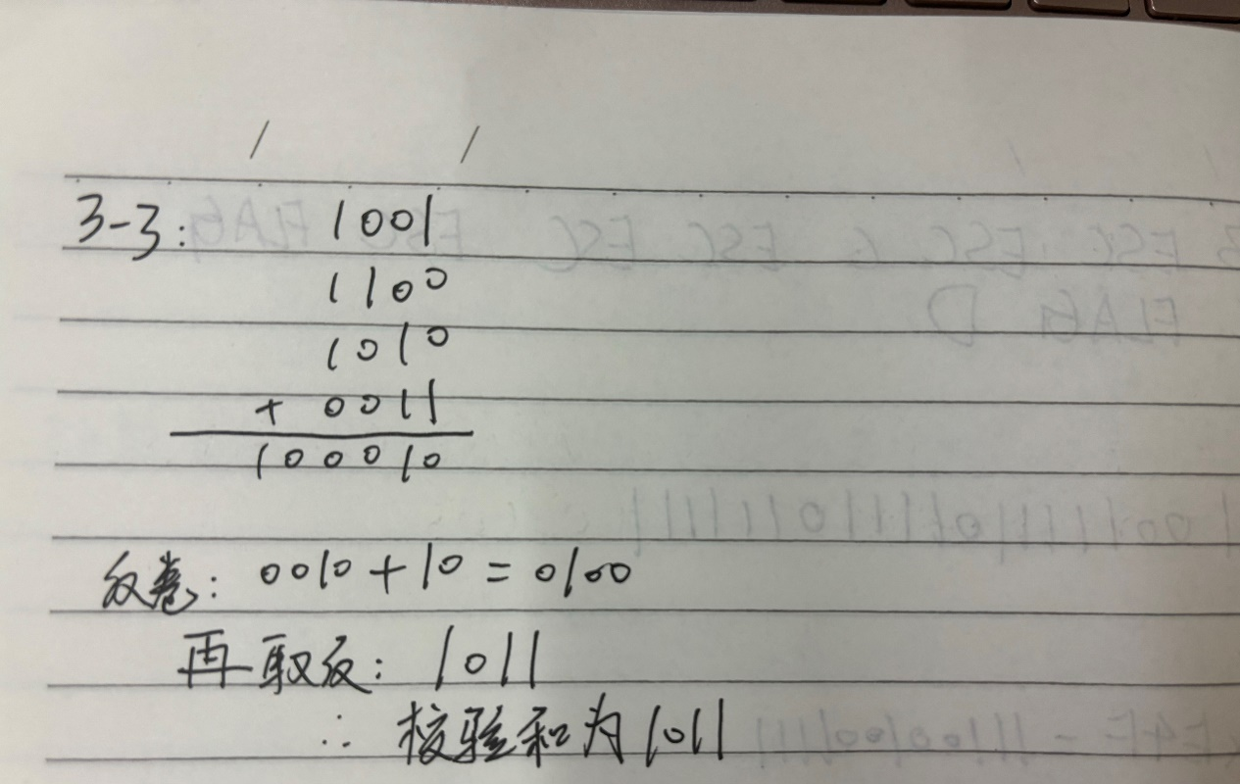

3-4. A bit stream 10011101 is transmitted using the standard CRC method described in the text. The generator polynomial is x3 + 1. Show the actual bit string transmitted. Sup pose that the third bit from the left is inverted during transmission. Show that this error is detected at the receiver’s end. Give an example of bit errors in the bit string trans mitted that will not be detected by the receiver.

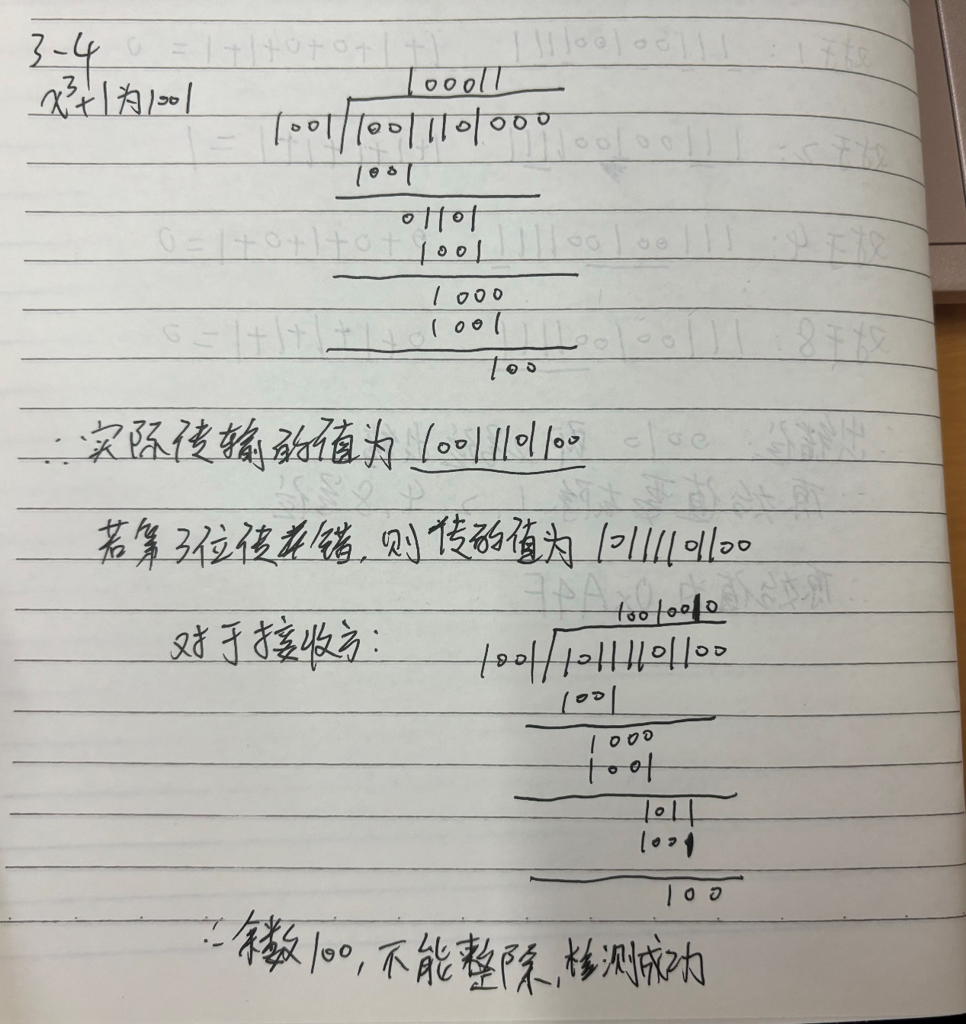

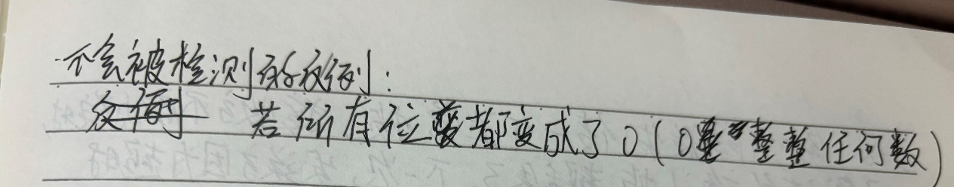

3-5. In the discussion of ARQ protocol in Section 3.3.3, a scenario was outlined that resulted in the receiver accepting two copies of the same frame due to a loss of acknowledgement frame. Is it possible that a receiver may accept multiple copies of the same frame when none of the frames (message or acknowledgement) are lost?

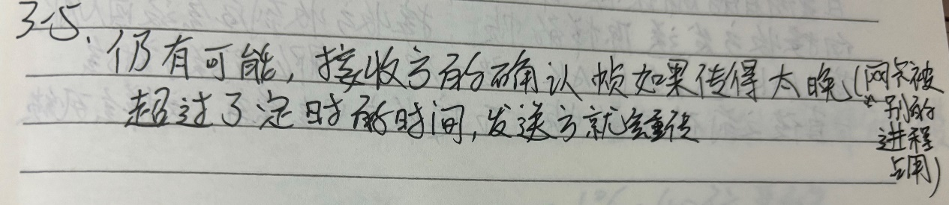

3-6. A channel has a bit rate of 4 kbps and a propagation delay of 20 msec. For what range of frame sizes does stop-and-wait give an efficiency of at least 50%?

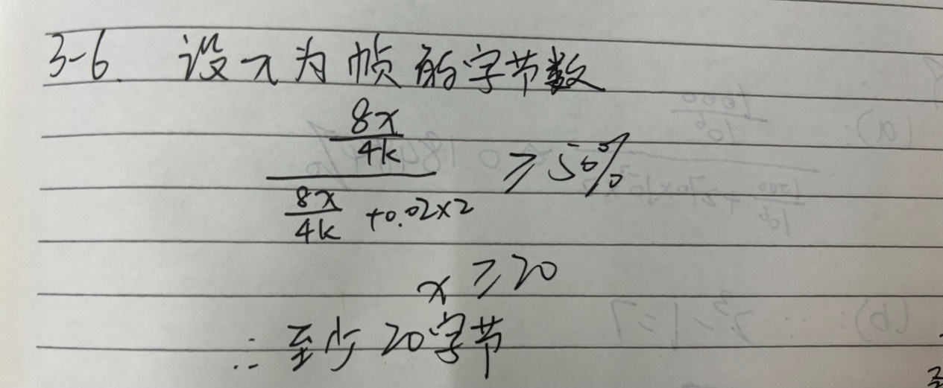

3-7. A 3000-km-long T1 trunk is used to transmit 64-byte frames using protocol 5. If the propagation speed is 6 µsec / km, how many bits should the sequence numbers be?

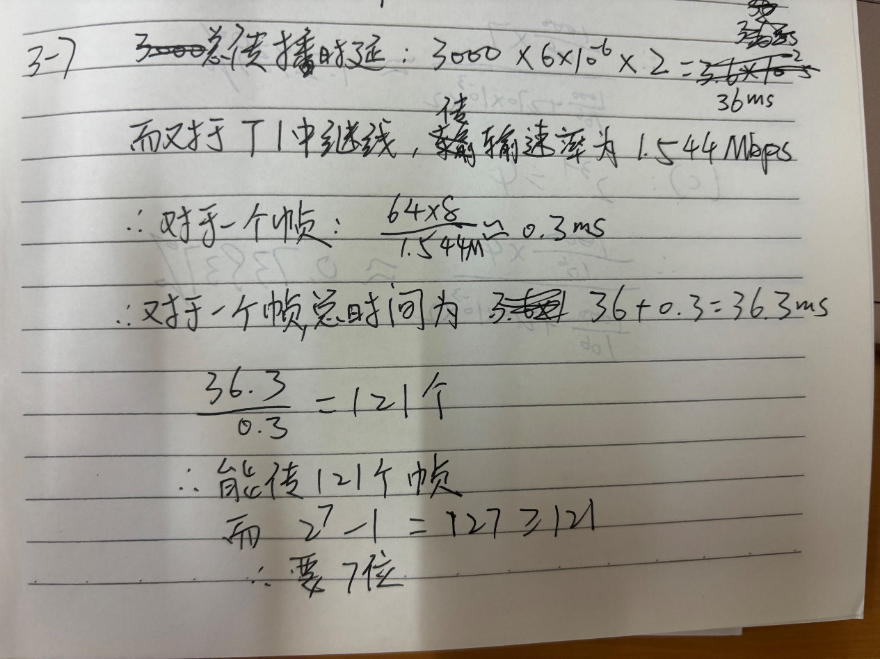

3-8. In protocol 6, when a data frame arrives, a check is made to see if the sequence number differs from the one expected and no_nak is true. If both conditions hold, a NAK is sent. Otherwise, the auxiliary timer is started. Suppose that the else clause were omitted. Would this change affect the protocol’s correctness?

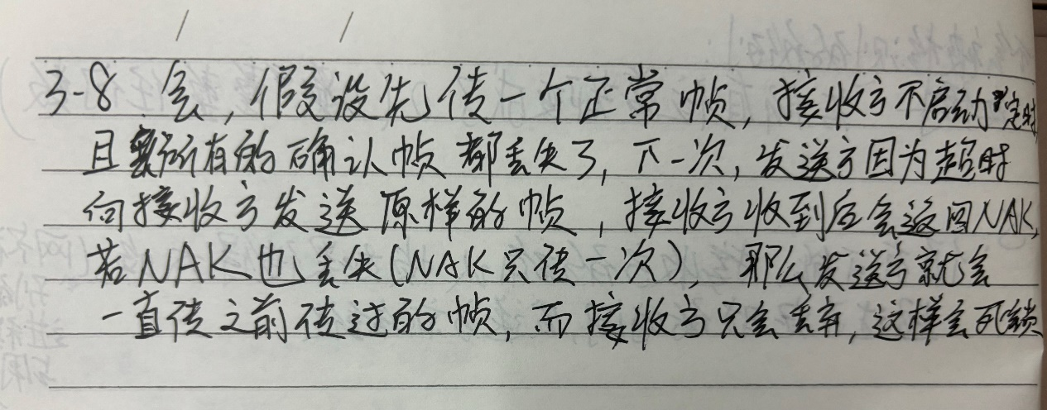

3-9. Frames of 1000 bits are sent over a 1-Mbps channel using a geostationary satellite whose propagation time from the earth is 270 msec. Acknowledgements are always piggybacked onto data frames. The headers are very short. Three-bit sequence numbers are used. What is the maximum achievable channel utilization for

1. Stop-and-wait?
2. Protocol 5?
3. Protocol 6?

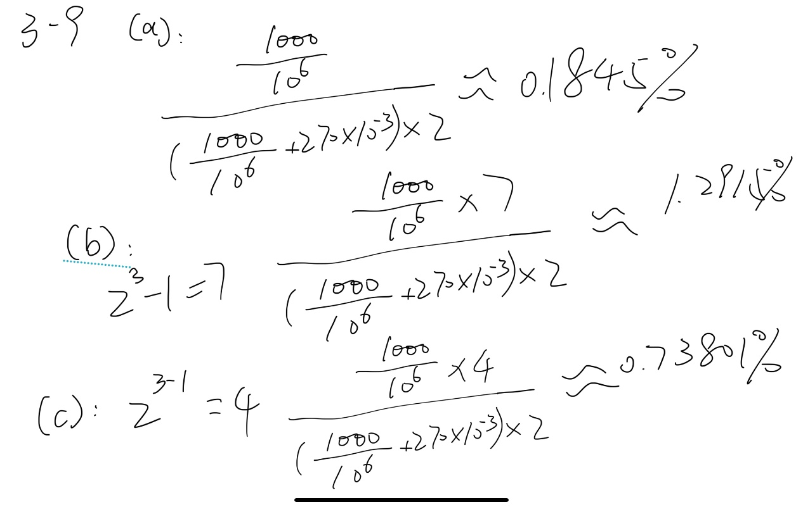

3-10. Compute the fraction of the bandwidth that is wasted on overhead (headers and retransmissions) for protocol 6 on a heavily loaded 50-kbps satellite channel with data frames consisting of 40 header and 3960 data bits. Assume that the signal propagation time from the earth to the satellite is 270 msec. ACK frames never occur. NAK frames are 40 bits. The error rate for data frames is 1%, and the error rate for NAK frames is negligible. The sequence numbers are 8 bits.

