5-1. Give three examples of protocol parameters that might be negotiated when a connection is set up.

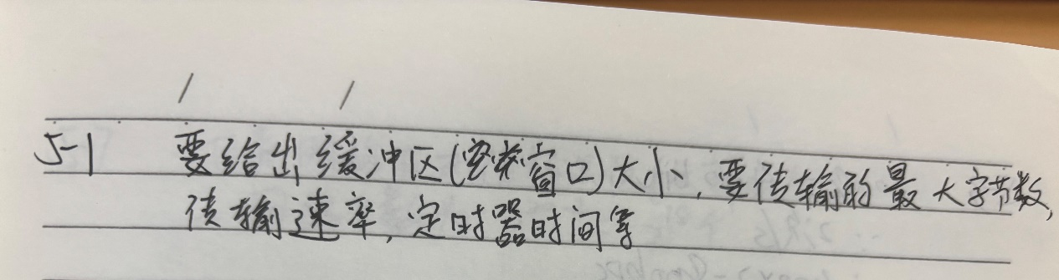

5-2. Consider the network of Fig. 5-12(a). Distance vector routing is used, and the following link state packets have just come in at router D: from A: (B: 5, E: 4); from B: (A: 4, C: 1, F: 5); from C: (B: 3, D: 4, E: 3); from E: (A: 2, C: 2, F: 2); from F: (B: 1, D: 2, E: 3). The cost of the links from D to C and F are 3 and 4 respectively. What is D’s new routing table? Give both the outgoing line to use and the cost.

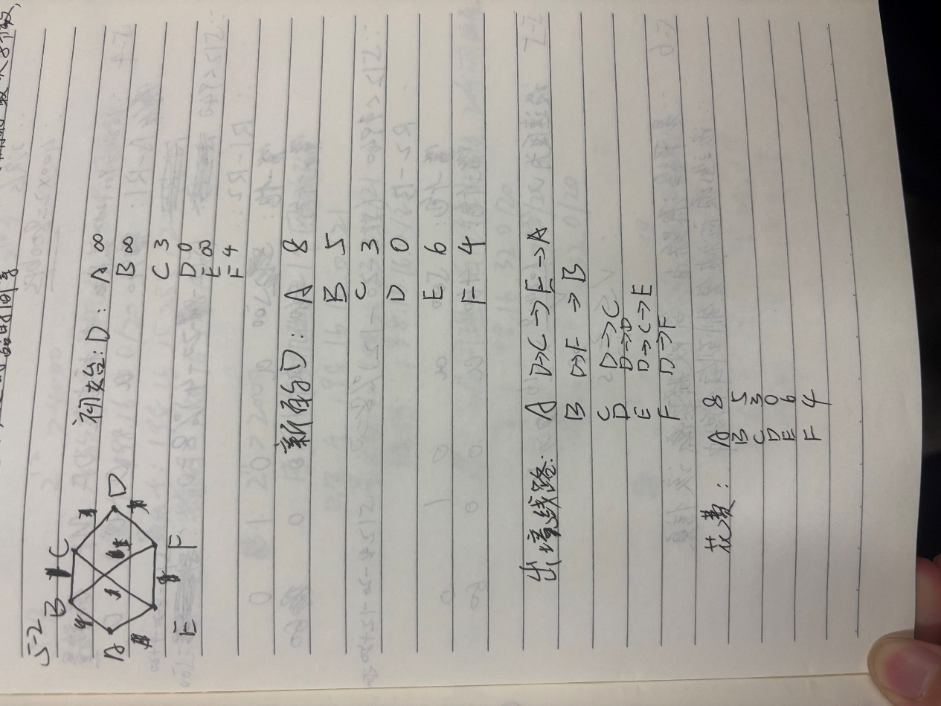

5-3. If costs are recorded as 8-bit numbers in a 50-router network, and distance vectors are exchanged twice a second, how much bandwidth per (full-duplex) line is chewed up by the distributed routing algorithm? Assume that each router has three lines to other routers.

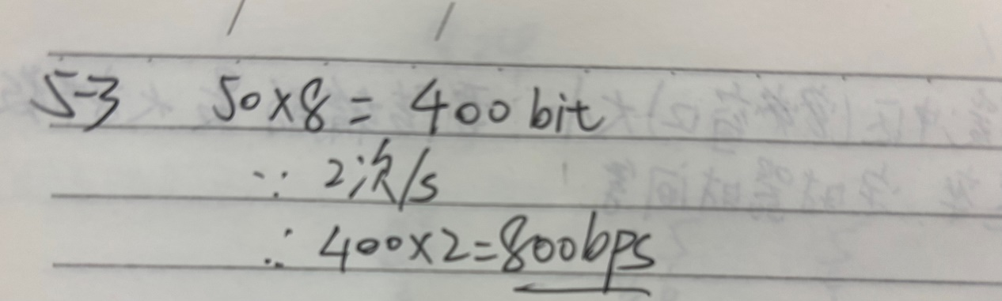

5-4. Suppose that host A is connected to a router R 1, R 1 is connected to another router, R 2, and R 2 is connected to host B. Suppose that a TCP message that contains 900 bytes of data and 20 bytes of TCP header is passed to the IP code at host A for delivery to B. Show the Total length, Identification, DF, MF, and Fragment offset fields of the IP header in each packet transmitted over the three links. Assume that link A-R1 can support a maximum frame size of 1024 bytes including a 14-byte frame header, link R1-R2 can support a maximum frame size of 512 bytes, including an 8-byte frame header, and link R2-B can support a maximum frame size of 512 bytes including a 12-byte frame header.

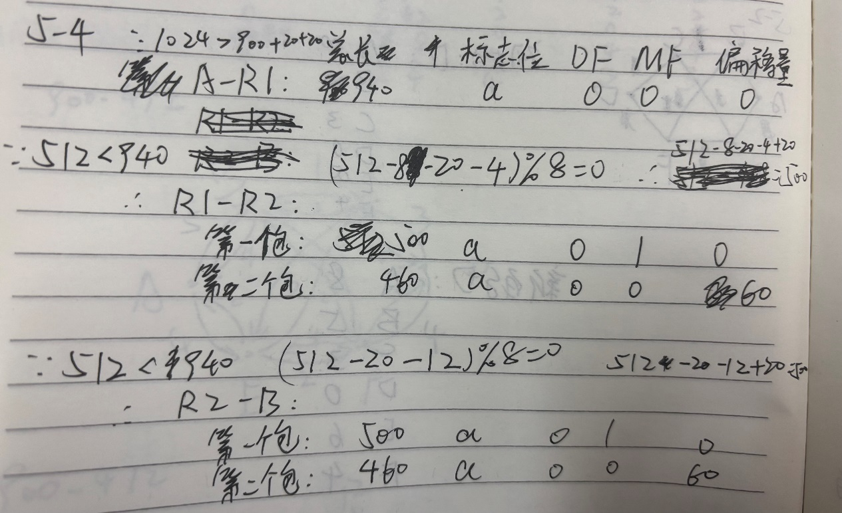

5-5. A router is blasting out IP packets whose total length (data plus header) is 1024 bytes. Assuming that packets live for 10 sec, what is the maximum line speed the router can operate at without danger of cycling through the IP datagram ID number space?

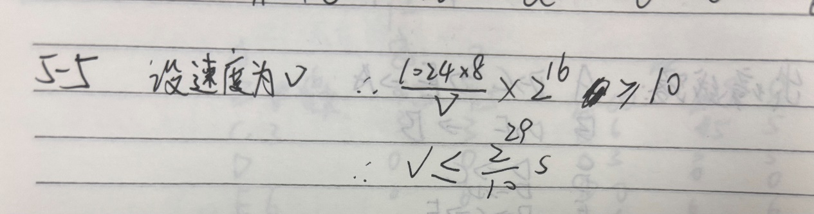

5-6. An IP datagram using the Strict source routing option has to be fragmented. Do you think the option is copied into each fragment, or is it sufficient to just put it in the first fragment? Explain your answer.

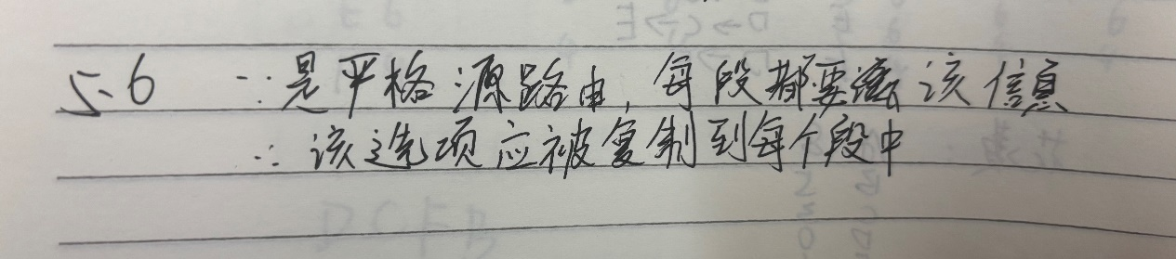

5-7. Suppose that instead of using 16 bits for the network part of a class B address originally, 20 bits had been used. How many class B networks would there have been?

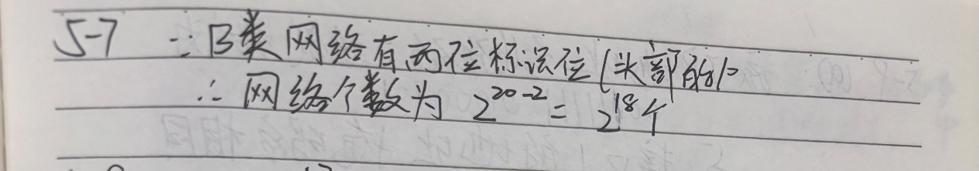

5-8. A large number of consecutive IP addresses are available starting at 198.16.0.0. Suppose that four organizations, A, B, C, and D, request 4000, 2000, 4000, and 8000 addresses, respectively, and in that order. For each of these, give the first IP address assigned, the last IP address assigned, and the mask in the w.x.y.z/s notation.

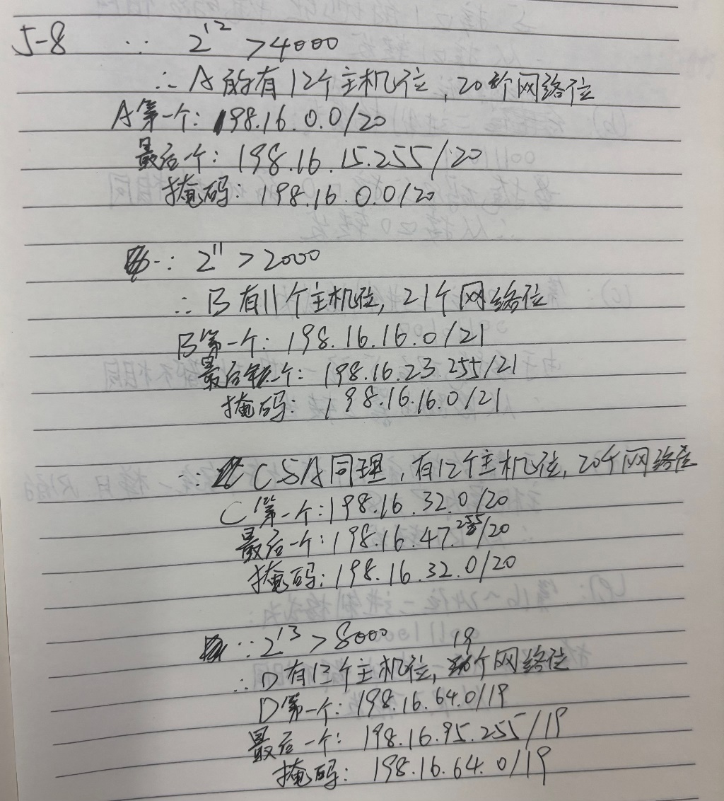

5-9. A router has the following (CIDR) entries in its routing table:

|  |  |
| --- | --- |
| Address/mask | Next hop |
| 135.46.56.0/22 | Interface 0 |
| 135.46.60.0/22 | Interface 1 |
| 192.53.40.0/23 | Router 1 |
| default | Router 2 |

For each of the following IP addresses, what does the router do if a packet with that  
address arrives?  
(a) 135.46.63.10  
(b) 135.46.57.14  
(c) 135.46.52.2  
(d) 192.53.40.7  
(e) 192.53.56.7

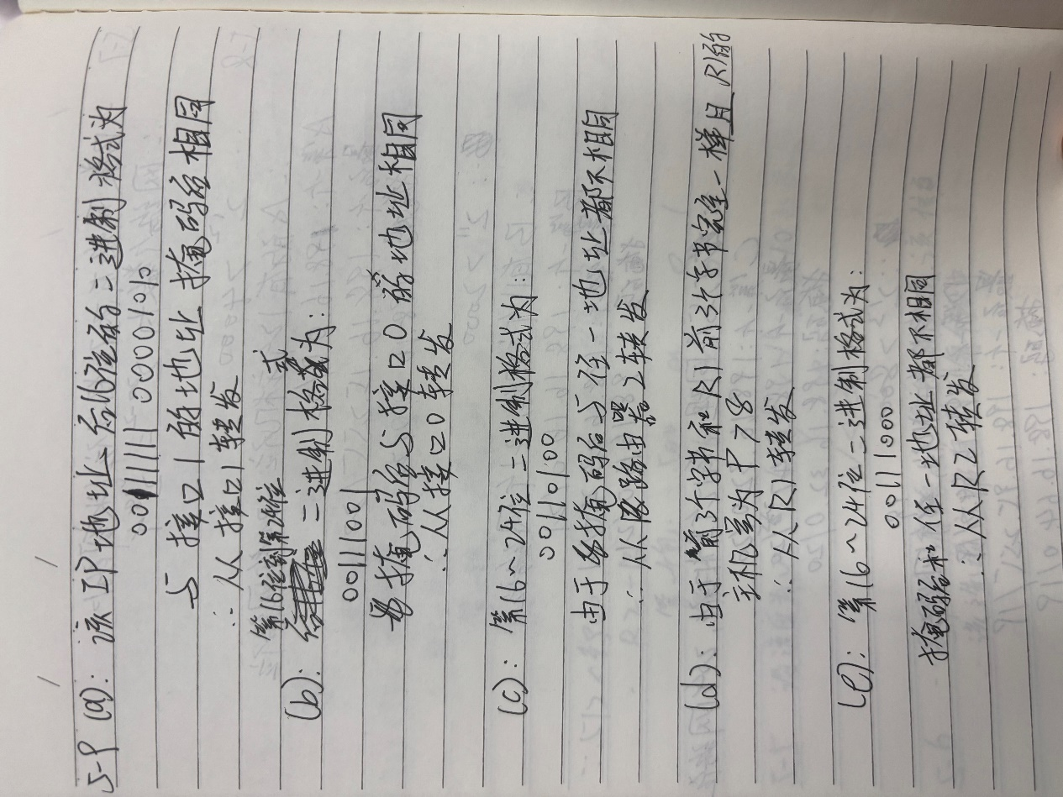

5-10. Two machines on the same network try to use the same port number to communicate with a server on another network. Is this possible? Explain why (not). What changes if these machines are separated from other networks by a NAT box?

