6-1. In both parts of Fig. 6-6, there is a comment that the value of SERVER PORT must be the same in both client and server. Why is this so important?

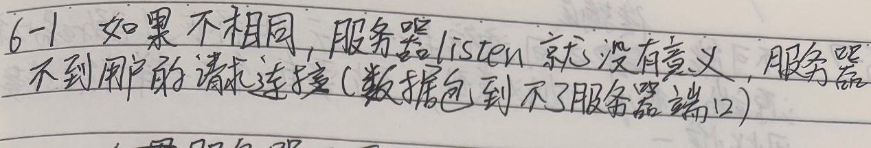

6-2. In the Internet File Server example (Figure 6-6), can the connect( ) system call on the client fail for any reason other than listen queue being full on the server? Assume that the network is perfect.

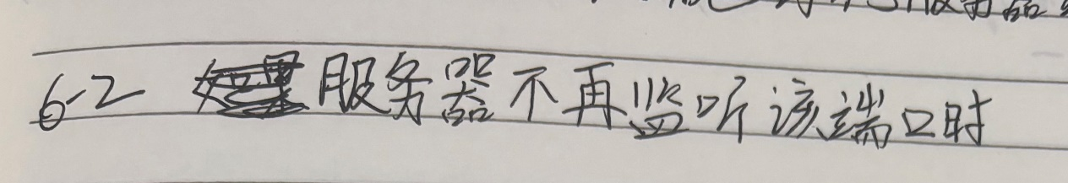

6-3. One criteria for deciding whether to have a server active all the time or have it start on demand using a process server is how frequently the service provided is used. Can you think of any other criteria for making this decision?

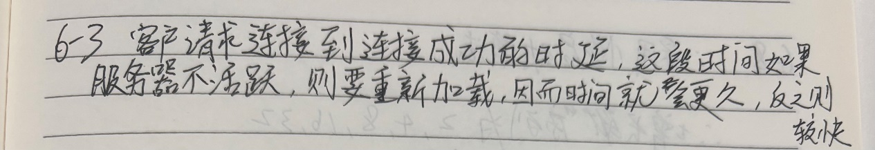

6-4. Why does the maximum packet lifetime, T, have to be large enough to ensure that not only the packet but also its acknowledgements have vanished?

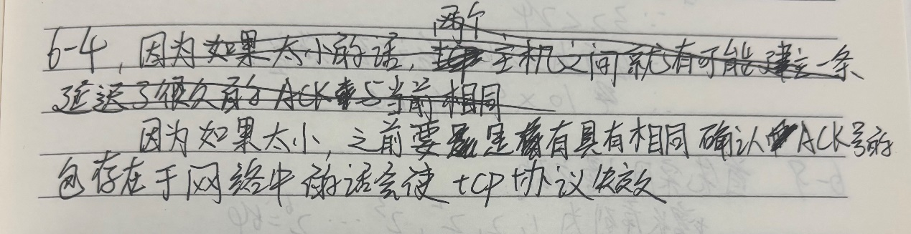

6-5. Discuss the advantages and disadvantages of credits versus sliding window protocols .

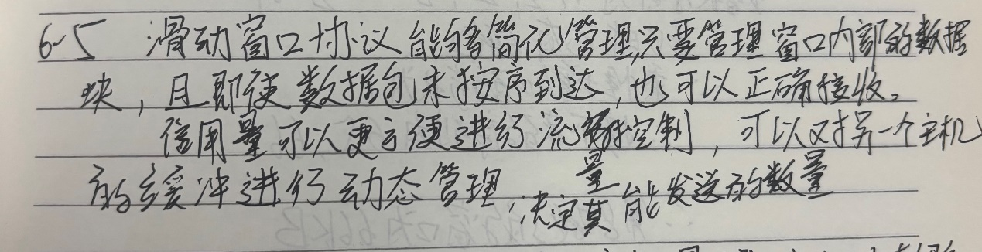

6-6. Why does UDP exist? Would it not have been enough to just let user processes send raw IP packets?

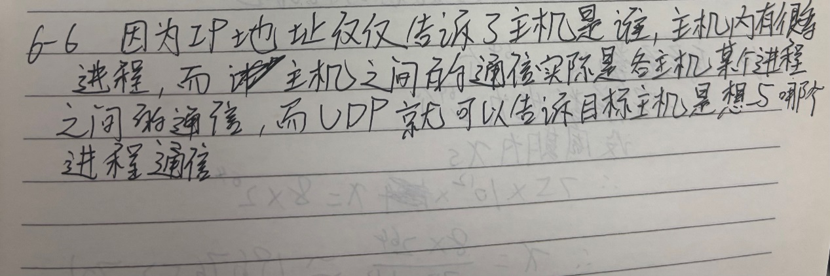

6-7. A process on host 1 has been assigned port p, and a process on host 2 has been assigned port q. Is it possible for there to be two or more TCP connections between these two ports at the same time?

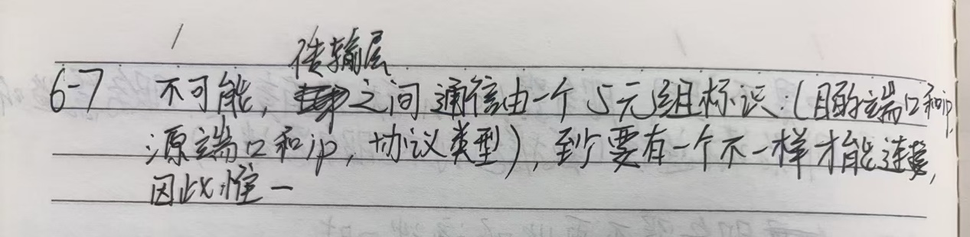

6-8. Consider the effect of using slow start on a line with a 10-msec round-trip time and no congestion. The receive window is 24 KB and the maximum segment size is 2 KB. How long does it take before the first full window can be sent?

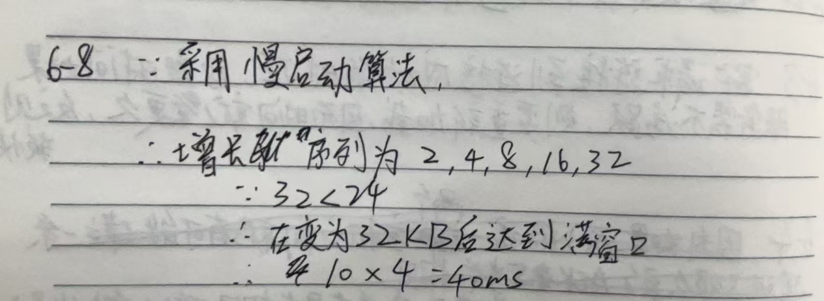

6-9. Consider a connection that uses TCP Reno. The connection has an initial congestion window size of 1 KB, and an initial threshold of 64. Assume that additive increase uses a step-size of 1 KB. What is the size of the congestion window in transmission round 8, if the first transmission round is number 0?

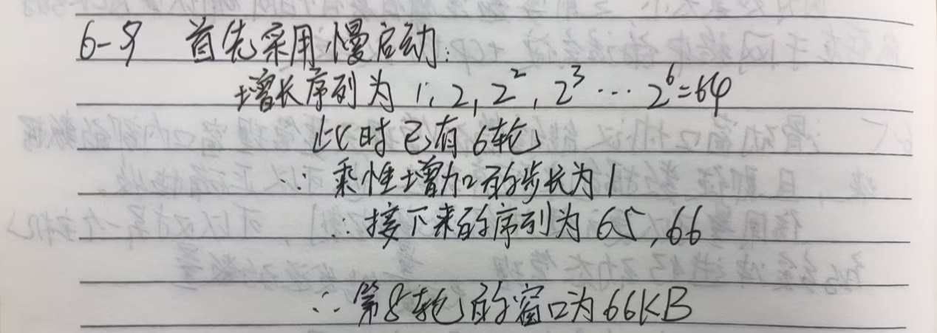

6-10. To get around the problem of sequence numbers wrapping around while old packets still exist, one could use 64-bit sequence numbers. However, theoretically, an optical fiber can run at 75 Tbps. What maximum packet lifetime is required to make sure that future 75-Tbps networks do not have wraparound problems even with 64-bit sequence numbers? Assume that each byte has its own sequence number, as TCP does.

