4-1. A group of N stations share a 56-kbps pure ALOHA channel. Each station outputs a 1000-bit frame on average once every 100 sec, even if the previous one has not yet been sent (e.g., the stations can buffer outgoing frames). What is the maximum value of N?

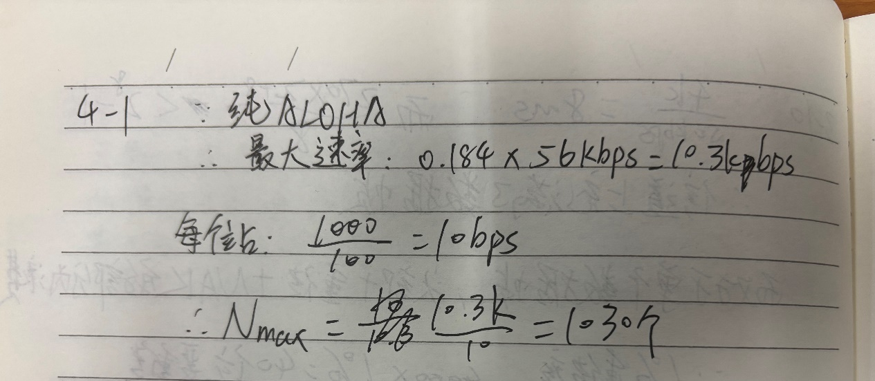

4-2. A large population of ALOHA users manages to generate 50 requests/sec, including both originals and retransmissions. Time is slotted in units of 40 msec.

(a) What is the chance of success on the first attempt?

(b) What is the probability of exactly k collisions and then a success?

(c) What is the expected number of transmission attempts needed?

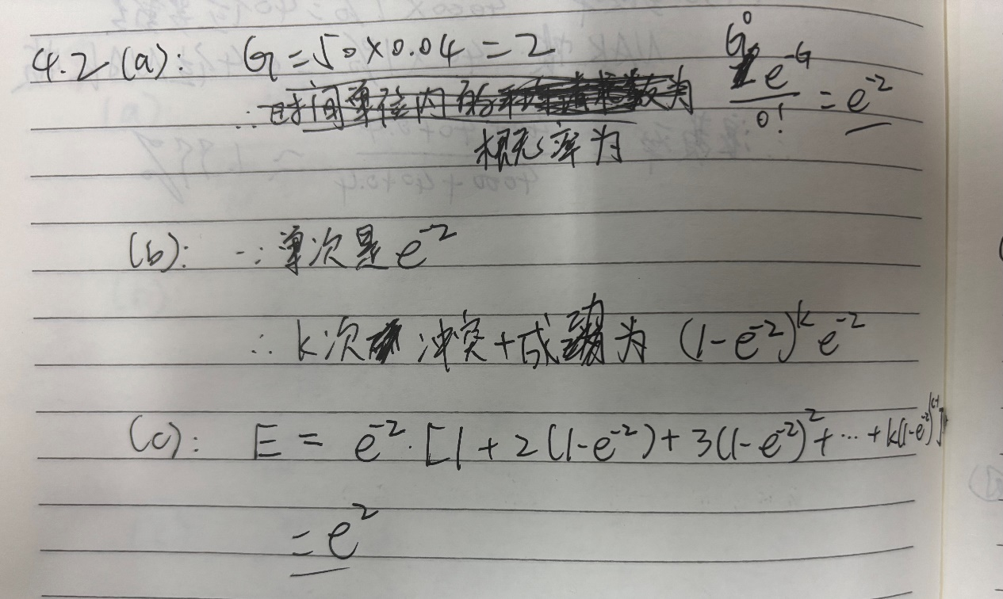

4-3. What is the length of a contention slot in CSMA/CD for

(a) a 2-km twin-lead cable(signal propagation speed is 82% of the signal propagation speed in vacuum)?, and

(b) a 40-km multimode fiber optic cable (signal propagation speed is 65% of the signal propagation speed in vacuum)?

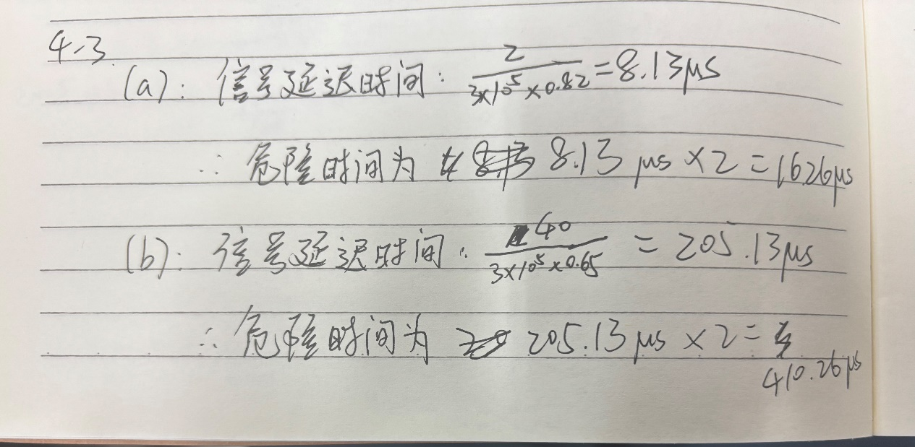

4-4. Consider five wireless stations, A, B, C, D, and E. Station A can communicate with all other stations. B can communicate with A, C and E. C can communicate with A, B and D. D can communicate with A, C and E. E can communicate A, D and B.

(a) When A is sending to B, what other communications are possible?

(b) When B is sending to A, what other communications are possible?

(c) When B is sending to C, what other communications are possible?

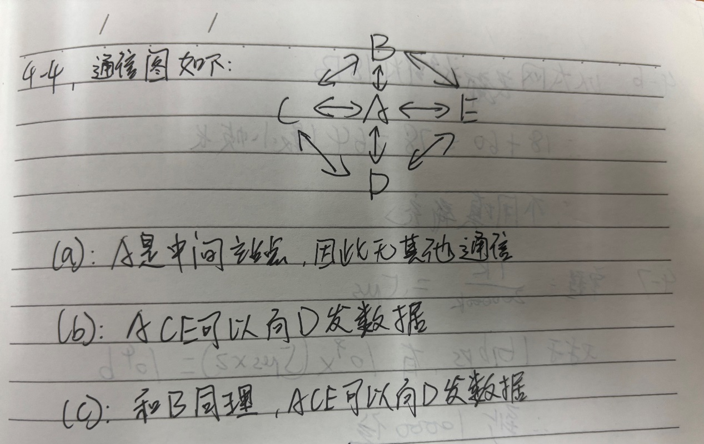

4-5. A 1-km-long, 10-Mbps CSMA/CD LAN (not 802.3) has a propagation speed of

200 m/μsec. Repeaters are not allowed in this system. Data frames are 256 bits long, including 32 bits of header, checksum, and other overhead. The first bit slot after a successful transmission is reserved for the receiver to capture the channel in order to send a 32-bit acknowledgement frame. What is the effective data rate, excluding overhead, assuming that there are no collisions?

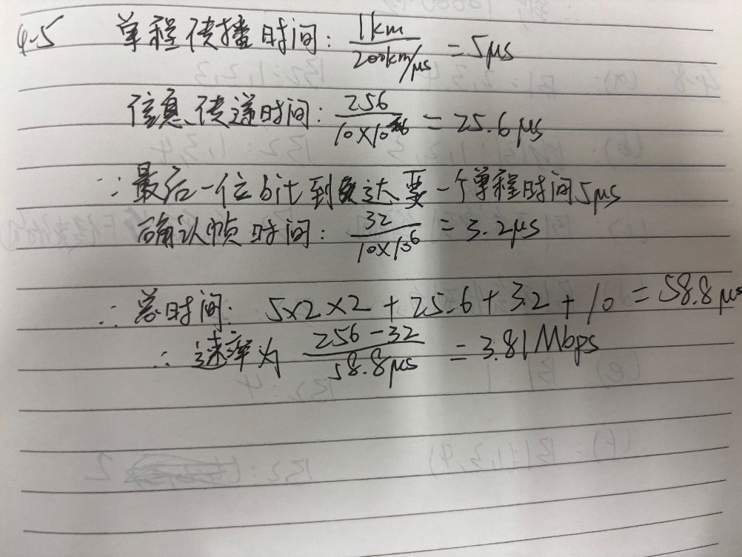

4-6. An IP packet to be transmitted by Ethernet is 60 bytes long, including all its headers. If LLC is not in use, is padding needed in the Ethernet frame, and if so, how many bytes?

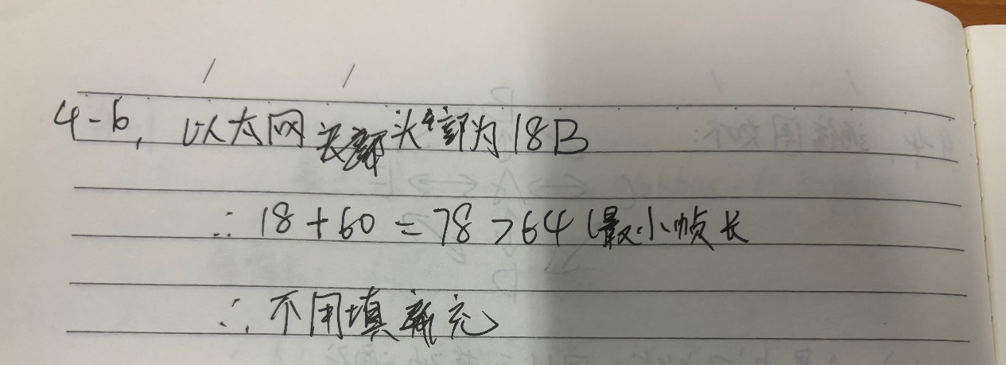

4-7. Consider building a CSMA/CD network running at 1 Gbps over a 1-km cable with no repeaters. The signal speed in the cable is 200,000 km/sec. What is the minimum frame size?

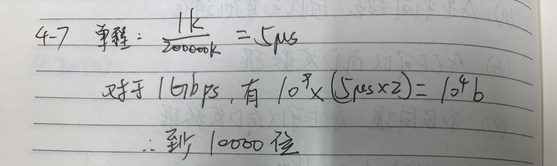

4-8. Consider the extended LAN connected using bridges B1 and B2 in Fig. 4-33(b). Suppose the hash tables in the two bridges are empty. List all ports on which a packet will be forwarded for the following sequence of data transmissions:

(a) A sends a packet to C.

(b) E sends a packet to F.

(c) F sends a packet to E.

(d) G sends a packet to E.

(e) D sends a packet to A.

(f) B sends a packet to F.

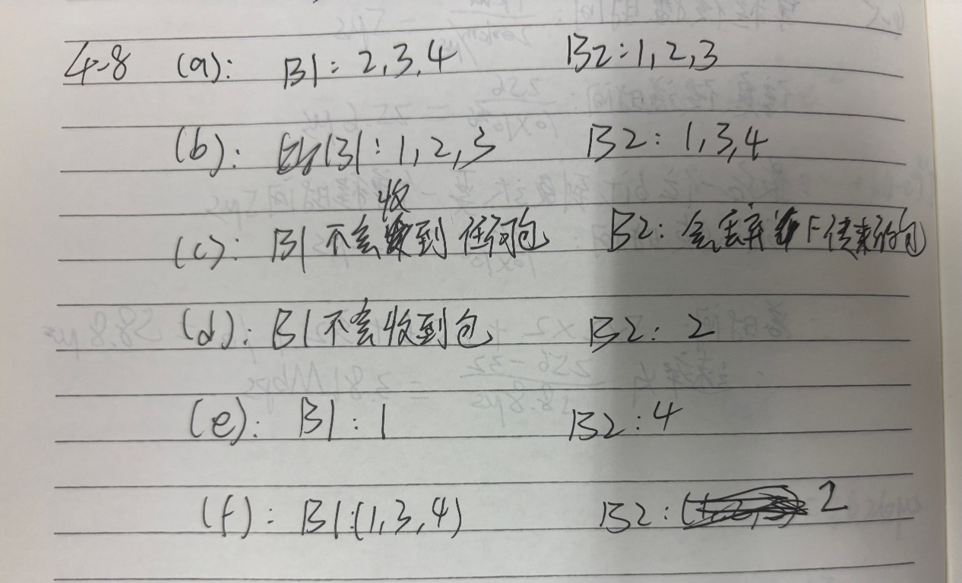

4-9. Store-and-forward switches have an advantage over cut-through switches with respect to damaged frames. Explain what it is.

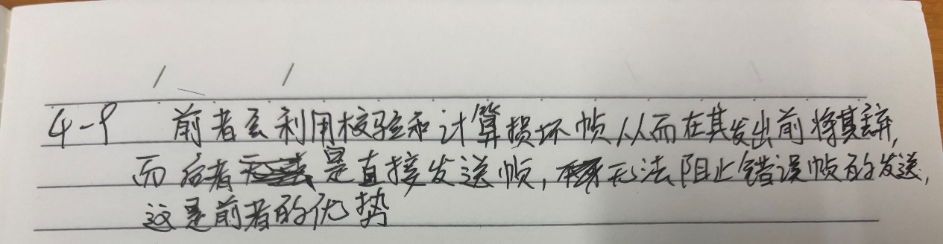

4-10. It is mentioned in Section 4.7.3 that some bridges may not even be present in the spanning tree. Outline a scenario where a bridge may not be present in the spanning tree.

