AURA
Permission-Based Personal AI Agent
Project Specification, Architecture, Implementation Plan & Evaluation
Technology baseline: Python + Django REST Framework · React · Neon PostgreSQL
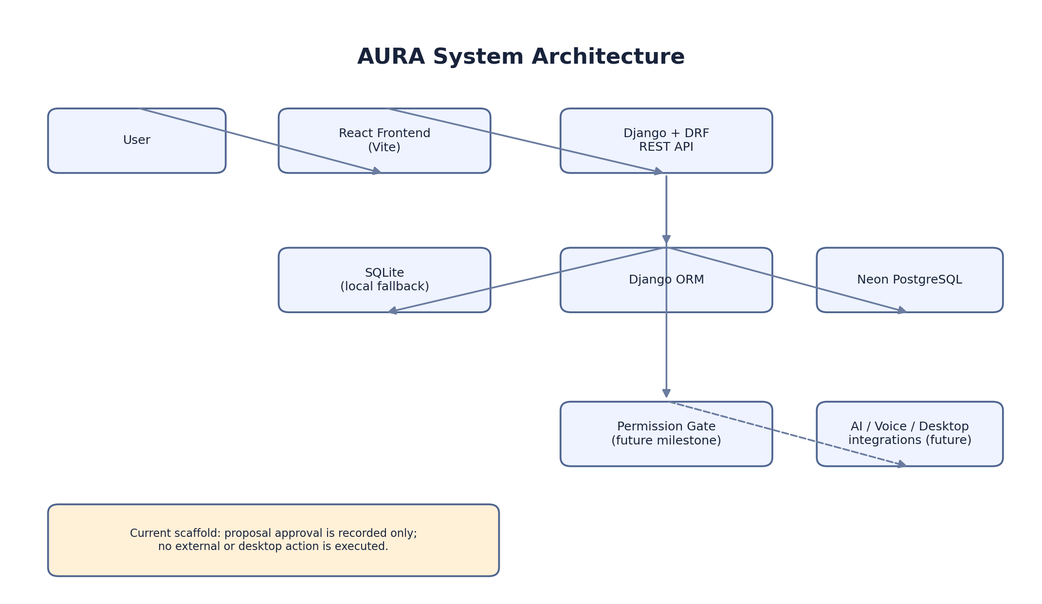
Project status: starter scaffold. AI reasoning, desktop monitoring, voice, phone connectivity, and messaging integrations remain future work.

1. Project Overview
AURA is a personal AI agent concept intended to help a user remember context, understand work activity, prepare suggestions, and perform approved tasks. Its defining principle is user control: it should never silently take consequential action.

2. Problem Statement
People work across browsers, desktop applications, email, messaging, and personal tasks. Frequent context switching can cause forgotten follow-ups and delayed responses. AURA aims to reduce this burden by capturing selected context, organizing it, and presenting useful next-step suggestions.

3. Goals
- Create a React dashboard connected to a Django REST API.
- Persist activity notes and action proposals in a database, with Neon PostgreSQL supported through DATABASE_URL.
- Build toward optional voice control, contextual assistance, and approved desktop actions.
- Keep permission checks explicit, visible, auditable, and deny-by-default.
- Produce a measurable portfolio project with honest evaluation and documented limitations.

4. Non-Goals of the Starter
- It does not currently monitor the screen or record desktop activity.
- It does not include an AI/ML model or claim model accuracy.
- It does not read or send Gmail, WhatsApp, or Messenger messages.
- It does not place calls or execute operating-system commands.
- The approval endpoint records approval state only; it does not execute a proposal.

5. Technology Stack
Layer | Technology | Purpose
Backend | Python, Django, Django REST Framework | API, data models, validation, business logic
Frontend | React, JavaScript, Vite, CSS | Dashboard and user interaction
Database | Neon PostgreSQL | Cloud relational persistence
Local fallback | SQLite | Easy first run without Neon credentials
API | REST / JSON | Communication between React and Django
Future AI/desktop | Python modules | Speech, model inference, controlled automation
Version control | Git + GitHub | History, collaboration, portfolio

6. Architecture
React communicates with Django REST Framework over HTTP. Django validates requests and uses the ORM to store activity notes and action proposals. When DATABASE_URL is configured, the backend uses Neon PostgreSQL; otherwise it uses SQLite locally. A permission gate and AI/desktop integrations are future components and are not active in this starter.

7. Current API
Method | Endpoint | Purpose
GET | /api/health/ | Health status
GET, POST | /api/activity-notes/ | List or create a note
GET, POST | /api/proposals/ | List or create an action proposal
POST | /api/proposals/<id>/approve/ | Record approval without executing action

8. Database Design
ActivityNote: id, title, note, created_at. ActionProposal: id, title, description, status, created_at. Proposal status is pending, approved_not_executed, or rejected. These are starter entities; add user ownership and audit history before multi-user or production use.

9. Setup Summary (Windows CMD)
- cd backend
- py -3.11 -m venv .venv
- .venv\Scripts\activate
- pip install -r requirements.txt
- copy .env.example .env
- python manage.py migrate
- python manage.py runserver
- Open a second CMD: cd frontend
- npm install
- npm run dev
Configure Neon by copying the connection string from the Neon dashboard into backend/.env as DATABASE_URL. Never commit credentials. Full steps are in README.md.

10. Permission and Safety Model
- Deny by default: do not expose tools/actions unless deliberately implemented.
- Require a fresh confirmation before sending messages, placing calls, deleting files, or making external changes.
- Show a visible monitoring indicator and provide immediate pause/stop controls before any screen observation is implemented.
- Use official integrations and respect provider permissions, quotas, and terms.
- Store only necessary information; define retention and deletion controls.
- Never treat text found on a webpage or in a message as permission to execute a tool.

11. Methodology
- Capture: begin with user-entered notes; introduce voice and desktop capture only after opt-in controls exist.
- Represent: store notes and proposals with Django models.
- Interpret: add separately tested AI components for intent, summarization, and drafting.
- Recommend: show a proposal and explain its purpose before any action.
- Authorize: require explicit confirmation for each consequential operation.
- Execute: implement one integration at a time behind server-side permission checks.
- Audit: record authorization decisions and errors while minimizing sensitive data.

12. AI/ML Effectiveness and Evaluation
No AI/ML model is bundled in this starter. Therefore, no measured accuracy or benchmark score can honestly be reported yet. Future evaluation should use a documented test set and include:
- Intent classification: precision, recall, F1 score, and confusion matrix.
- Bangla/English speech recognition: Word Error Rate under specified noise, accent, and code-switching conditions.
- Suggestion usefulness: user ratings, task completion rate, and rate of irrelevant or unsafe suggestions.
- Latency: median and 95th percentile response time.
- Permission safety: zero unapproved external actions in the test suite.
- Privacy: retention/deletion tests and checks for secrets in logs.

13. Limitations and Risks
- Starter endpoints do not implement authentication or per-user data access controls; keep the application local.
- Language models can hallucinate, misunderstand intent, or generate unsafe recommendations.
- Speech recognition can be affected by noise, accent, and mixed Bangla-English speech.
- Desktop screens and messages may contain highly sensitive personal information.
- Third-party integrations may have API restrictions, quotas, cost, and account-specific permission limits.
- Cloud database use depends on network availability and correct secret configuration.

14. Roadmap
- Phase 1 — verify Django API, React UI, SQLite fallback, and Neon configuration.
- Phase 2 — add automated tests, authentication, per-user permissions, and audit history.
- Phase 3 — add opt-in voice input/output and evaluate Bangla/English performance.
- Phase 4 — add one official integration with narrowly scoped permissions.
- Phase 5 — add desktop capture with visible controls and emergency pause.
- Phase 6 — conduct model evaluation, threat testing, usability study, and publish results.

15. Expected Outcomes and Portfolio Value
The starter is expected to demonstrate a full-stack foundation, REST API design, ORM/database configuration, frontend integration, and safety-first action proposal workflow. These are expected outcomes, not a claim that all tests have already been run. Record real test results and measured performance before publishing claims.

16. Conclusion
AURA is a staged personal AI agent project. The updated stack is Django REST Framework, React, and Neon PostgreSQL. The package supplies a runnable starter foundation; advanced AI and automation remain future milestones and must be added with explicit permission, testing, and privacy controls.

