Automatic Night Light Control by Using Arduino UNO

**Project Proposal**

**Supervisor**

**Khandaker Iftakher Ahmed**

Lecturer C.C. of CSE

European University of Bangladesh

**Submitted By**

[**230122006, 230122007, 230122035,**

**230122045, 230122054**]

Students of CSE

European University of Bangladesh

[January 2025]

**Department of Computer Science & Engineering**

European University of Bangladesh.

**Automatic Night Light Control by Using Arduino UNO**

*Faculty of Computer Science & Engineering, European University of Bangladesh.*

***A****bstract*— Our main goal is to develop an ultramodern and reliable automatic night light control by using arduino uno. Which is used in almost every field in our daily life. For example in house lights, office lights, billboards, street lights, etc. To develop this system, we used an Arduino UNO as the main processor, an LDR sensor, a buzzer, LEDs, resistors, jumper wires, a 9V battery, and other components.

# **Introduction**

This project is to design and implement a cost-effective, energy-efficient system, that can without humans automatically operate LDR based on ambient light levels. LDR is a light dependent resistor. When we keep lights on all night at home or office, then the performance and life of that light is reduced. In case we have to face financial problems especially in the electrical sector. For example in loss of conductors, lights, and electricity etc.

# **Problem Description**

The main goal of this project is, how to easily fix every problem by using ultramodern intelligence in a short time to reduce. So by using LDR and Arduino UNO as a main processor, we can automatically turn on the light as soon as it gets dark. And we can automatically turn off the light as the light approaches. By using LDR and Arduino UNO, there is no need to use and operate any type of switch. It will work in a fully automatic system all the time.

# **Methodology**

**Equipments:**

* Arduino UNO
* BreadBoard
* Buzzer
* LDR (Light Dependent Sensor)
* LED (Light-Emitting Diode)
* Resistors
* Jumper Wires
* 9V Battery

**Circuit Diagram:** To develop this system, we used an Arduino UNO as the main processor, an LDR sensor, a buzzer, LEDs, resistors, jumper wires, a 9V battery, and other components.

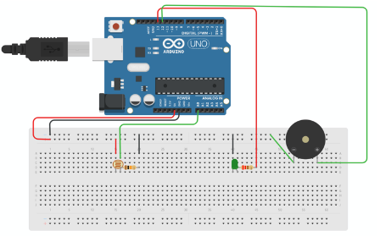

Fig. Circuit Diagram

# **Project Scope**

# **Advantages**

# **Energy Efficiency**: The light only turns on when it's dark, saving electricity.

# **Convenience**: No need to manually switch the light on and off.

# **Cost-Effective**: Using an Arduino and basic components is relatively inexpensive.

1. **Customization**: You can adjust the sensitivity of the light sensor and the threshold for turning the light on or off.
2. **Limitations**
3. **Limited Range**: The light sensor's range might be limited, affecting the system's responsiveness in larger areas.
4. **Environmental Factors**: Dust, dirt, or other environmental factors can affect the sensor's accuracy.
5. **Power Dependency**: The system requires a constant power supply, which might not be feasible in all locations.
6. **Complexity for Beginners**: For those new to electronics and programming, setting up and troubleshooting the system can be challenging.
7. **Enhancements**
8. **Microcontroller Integration:** Use Arduino or Raspberry Pi for better control and advanced features.
9. **IoT Connectivity:** Add Wi-Fi or Bluetooth modules for remote monitoring.
10. **Motion Sensing:** Integrate PIR sensors to operate lights only when motion is detected.
11. **Battery Backup**: Include a battery backup to ensure the system works during power outages.

**Feasibility Study**

# **Technical Feasibility**

# **Components:** LDR, Arduino UNO, LEDs, Ohm's, conductors & power supply etc.

# **Design:** LDR should be designed using an Arduino UNO.

1. **Economic Feasibility**

# **Cost of Components:** The components required for the system are inexpensive and widely available.

# **Energy Savings:** By automating the lighting, the system can significantly reduce energy consumption, leading to cost savings over time.

1. **Operational Feasibility**

# **Ease of Use:** The system is user-friendly, with automatic operation eliminating the need for manual intervention.

# **Reliability:** The system is designed to operate reliably under various environmental conditions, provided it is properly installed and protected.

# **Solution Application Areas**

1. **Residential Lighting**
2. **Outdoor Lighting:** Automatically turns on porch, garden, and pathway lights at dusk and off at dawn.
3. **Indoor Lighting:** Useful for hallways, staircases, and children’s rooms to provide safety and comfort during the night.
4. **Public Infrastructure**
5. **Street Lighting:** Automates street lights to improve visibility and safety on roads and sidewalks.
6. **Parks and Recreational Areas:** Provides lighting in public parks and playgrounds, enhancing safety for evening visitors.
7. **Educational Institutions**
8. **University Campuses:** Automates lighting for pathways, parking lots, and building exteriors, ensuring safety for students and staff.
9. **Libraries and Study Areas:** Provides lighting in study areas during evening hours, promoting a conducive learning environment.

# **Tools/Technology**

**Hardware:**

* Arduino UNO
* BreadBoard
* Buzzer
* LDR (Light Dependent Sensor)
* LED (Light-Emitting Diode)
* Resistors
* Jumper Wires
* 9V Battery

**Software:**

* Not applicable (if built as a hardware-based project).
* For microcontroller-based systems, software like Arduino UNO IDE may be used.
* TinkerCad circuit simulation software.

# **Expertise of the Team Members**

We present the significance of our project with the overall cooperation of the team members:

1. **Energy Efficiency:** The system should automatically turn on lights only when needed, reducing unnecessary energy consumption.
2. **Convenience:** By automating the lighting process, the system eliminates the need for manual operation, providing ease of use for the users.
3. **Cost-Effectiveness:** Utilizing components like Light Dependent Resistors (LDRs) and Arduino UNO, the project should be affordable and easy to implement.
4. **Enhanced Safety:** Automatic lighting can improve safety by ensuring that areas are well-lit during low-light conditions, reducing the risk of accidents.
5. **Scalability:** The system should be adaptable for various environments, from small residential setups to larger commercial applications.
6. **Sustainability:** By reducing energy usage, the project contributes to environmental sustainability.

# **Milestones**

* **Cost:**

| **SN** | **Hardware** | **Cost** |
| --- | --- | --- |
| 1 | Arduino UNO | 580 |
| 2 | BreadBoard | 70 |
| 3 | Buzzer | 20 |
| 4 | LDR (Light Dependent Sensor) | 20 |
| 5 | LED (Light-Emitting Diode) | 20 |
| 6 | Resistors | 20 |
| 7 | Jumper Wires | 70 |
| 8 | 9V Battery | 80 |

* **Flowchart:**

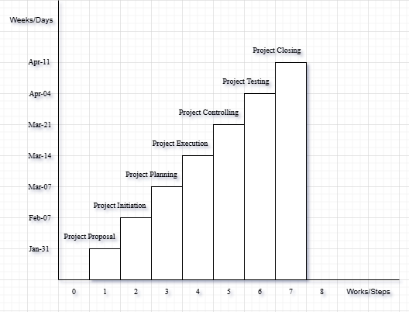

**References**

We mentioned all the literature or web references, etc here-

* Internet web page & resources: [ResearchGate](https://www.researchgate.net/profile/Md-Abu-Sayed-24), Gemini, etc.

End!