Automatic Railway Gate by Using Arduino UNO

**Project Proposal**

**Supervisor**

**Khandaker Iftakher Ahmed**

Lecturer C.C. of CSE

European University of Bangladesh

**Submitted By**

[**230122011, 230122010, 230122026,**

**230122036, 230122049, 220322052**]

Students of CSE

European University of Bangladesh

[January 2025]

**Department of Computer Science & Engineering**

European University of Bangladesh.

**Automatic Railway Gate by Using Arduino UNO**

*Faculty of Computer Science & Engineering, European University of Bangladesh.*

***A****bstract*— Our main goal is to develop an ultramodern and reliable automatic railway gate by using arduino uno. Which is faced in almost every field in our daily life. For example road crossing, urban railway crossing, residential zones, school zones, etc. To develop this system, we used an Arduino UNO as the main processor, an ultrasonic sensor, two servo motors, resistors, jumper wires, a 9V battery, and other components.

# **Introduction**

The main aim of this project is to reduce the wastage of people's precious time, and to ensure the safety of all while crossing the road, as well as to develop a smooth management. Working to reduce the wastage of valuable time in daily life and avoid various unwanted road accidents. So in this project we can create an orderly automatic railway gate by using Arduino UNO. Which will play an important role in the welfare of our country and nation.

# **Problem Description**

Arduino UNO must be used properly in making this project. And how to complete the project using Arduino UNO must be noted. In automatic railway gate management, state-of-the-art creativity, intelligence and future possibilities must be exploited. Also, to solve the traffic crisis in the near future, modern technology must be used. And new techniques and technologies have to be developed to avoid unwanted road accidents. At the same time, modern technology should be used in such a way that everyone obeys the traffic laws.

**Methodology**

**Equipments:**

* Arduino UNO
* BreadBoard
* Servo Motor
* Ultrasonic Sensor
* Resistors
* Jumper Wires
* 9V Battery

**Circuit Diagram:** To develop this system, we used an Arduino UNO as the main processor, an ultrasonic sensor, two servo motors, resistors, jumper wires, a 9V battery, and other components.

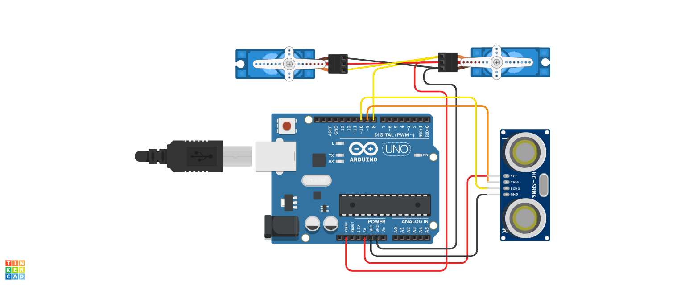

Fig. Circuit Diagram

# **Project Scope**

# **Advantages**

# **Safety**: Reduces human error and accidents at railway crossings.

# **Cost-Effective**: Utilizes affordable Arduino technology.

# **Reliability**: Provides consistent performance without fatigue.

1. **Scalability**: Easy to integrate with other sensor and control systems.
2. **Limitations**
3. **Sensor Accuracy**: Potential for false readings.
4. **Regular Maintenance**: Needs ongoing upkeep.
5. **Weather Impact**: Affected by harsh weather.
6. **Complex Setup**: Initial installation is time-consuming.
7. **Enhancements**
8. **Advanced Sensors**: Use LIDAR or RADAR for higher accuracy.
9. **Backup Power**: Include battery or solar backup.
10. **Weatherproofing**: Protect sensors from extreme conditions.
11. **Remote Monitoring**: Integrate IoT for remote control and monitoring.

# **Feasibility Study**

# **Technical Feasibility**

# **Component Availability**: Easily accessible sensors, servos, and Arduinos.

# **Cost**: Relatively low compared to commercial systems.

1. **Installation**: Requires technical know-how but manageable with guides.
2. **Scalability**: Arduino's modular nature allows easy upgrades.
3. **Economic Feasibility**
4. **Low Initial Investment**: Affordable components keep startup costs low.

# **Energy Efficiency**: Low power consumption leads to lower operational costs.

# **Maintenance**: Minimal cost due to simple system structure.

1. **Scalability**: Economical to scale up due to modular design.
2. **Operational Feasibility**

# **Ease of Deployment**: User-friendly setup with clear guides available.

1. **Maintenance**: Regular upkeep is straightforward with basic technical skills.

# **Reliability**: Consistent performance under standard conditions.

1. **Integration**: Can be seamlessly integrated with existing infrastructure.

# **Solution Application Areas**

1. **Urban Railway Crossings**
2. **Safety**: Reduces accidents and ensures pedestrians' and vehicles' safety.
3. **Traffic Management**: Helps in smooth flow of urban traffic.
4. **User Convenience**: Provides a reliable and automated solution in busy areas.
5. **Scalability**: Easily integrates with existing city infrastructure.
6. **Industrial Zones**
7. **Safety**: Reduces risks of accidents involving heavy machinery and trains.
8. **Productivity**: Minimizes downtime by ensuring seamless operations.
9. **Automation**: Reduces the need for manual oversight.
10. **Compatibility**: Integrates with industrial automation systems.
11. **School Zones**
12. **Child Safety**: Ensures the safety of children crossing near railways.
13. **Automated Alerts**: Provides timely alerts to keep students and staff informed.
14. **Traffic Control**: Helps manage school traffic efficiently.
15. **Peace of Mind**: Offers parents and staff reassurance with automated safety measures.

.

# **Tools/Technology**

**Hardware:**

* Arduino UNO
* BreadBoard
* Servo Motor
* Ultrasonic Sensor
* Resistors
* Jumper Wires
* 9V Battery

**Software:**

* Not applicable (if built as a hardware-based project).
* For microcontroller-based systems, software like Arduino UNO IDE may be used.
* TinkerCad circuit simulation software.

# **Expertise of the Team Members**

We present the significance of our project with the overall cooperation of the team members:

1. **Enhanced Safety**: Automatic operation reduces the risk of accidents and ensures the safety of pedestrians and vehicles.
2. **Efficiency**: Automates gate operations, leading to timely and efficient management of railway crossings.
3. **Cost-Effective**: Utilizes affordable, readily available Arduino components, making it a budget-friendly solution.
4. **Reliability**: Automated systems provide consistent performance without fatigue or errors typical in manual operations.
5. **Ease of Integration**: Can be easily integrated with other smart traffic management systems for better overall control.
6. **Scalability**: Modular design allows for easy upgrades and expansion to accommodate additional features or broader applications.

# **Milestones**

* **Cost:**

| **SN** | **Hardware** | **Cost** |
| --- | --- | --- |
| 1 | Arduino UNO | 580 |
| 2 | BreadBoard | 70 |
| 3 | Servo Motor | 120 |
| 4 | Ultrasonic Sensor | 80 |
| 5 | Resistors | 20 |
| 6 | Jumper Wires | 70 |
| 7 | 9V Battery | 80 |

* **Flowchart:**

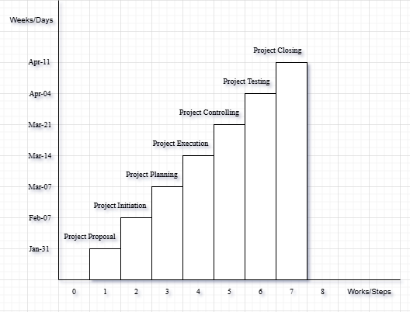

**References**

We mentioned all the literature or web references, etc here-

* Internet web page & resources: [ResearchGate](https://www.researchgate.net/profile/Md-Abu-Sayed-24), Gemini, etc.

End!