Traffic Control by Using Arduino UNO

**Project Proposal**

**Supervisor**

**Khandaker Iftakher Ahmed**

Lecturer C.C. of CSE

European University of Bangladesh

**Submitted By**

[**230122003, 230122004, 230122015,**

**230122031, 230122077**]

Students of CSE

European University of Bangladesh

[January 2025]

**Department of Computer Science & Engineering**

European University of Bangladesh.

**Traffic Control by Using Arduino UNO**

*Faculty of Computer Science & Engineering, European University of Bangladesh.*

***A****bstract*— Our main goal is to develop an ultramodern and reliable traffic control by using arduino uno. Which is faced in almost every field in our daily life. For example road crossing, human, car, bus, motor-cycle, three-wheelers, etc. To develop this system, we used an Arduino UNO as the main processor, LEDs, servo motors, buzzers, resistors, jumper wires, a 9V battery, and other components.

# **Introduction**

The main aim of this project is to reduce the wastage of people's precious time, and to ensure the safety of all while crossing the road, as well as to develop a smooth management. Working to reduce the wastage of valuable time in daily life and avoid various unwanted road accidents. So in this project we can create an orderly traffic control system by using Arduino UNO. Which will play an important role in the welfare of our country and nation.

# **Problem Description**

Arduino UNO must be used properly in making this project. And how to complete the project using Arduino UNO must be noted. In traffic control management, state-of-the-art creativity, intelligence and future possibilities must be exploited. Also, to solve the traffic crisis in the near future, modern technology must be used. And new techniques and technologies have to be developed to avoid unwanted road accidents. At the same time, modern technology should be used in such a way that everyone obeys the traffic laws.

**Methodology**

**Equipments:**

* Arduino UNO
* BreadBoard
* Buzzer
* Servo Motor
* IC7400 (NAND)
* LDR (Light Dependent Sensor)
* LEDs (Red, Yellow, Green)
* Resistors
* Jumper Wires
* 9V Battery

*To enhance the project's quality, we can modify the materials as needed. The selection of materials will depend on the tasks that can be completed within the project's limited timeframe.

**Circuit Diagram:** To develop this system, we used an Arduino UNO as the main processor, LEDs, servo motors, buzzers, resistors, jumper wires, a 9V battery, and other components.

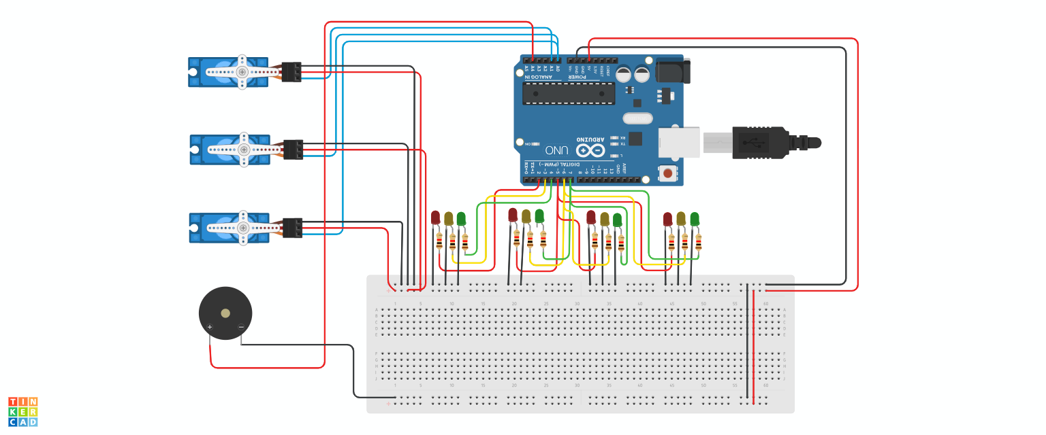

Fig. Circuit Diagram

# **Project Scope**

# **Advantages**

# **Cost-Effective:** Affordable microcontroller.

# **Educational Value:** Hands-on learning experience.

# **Customization:** Easily modifiable and expandable.

1. **Real-World Application:** Practical solution for traffic management.
2. **Limitations**
3. **Limited Processing Power:** May restrict complex algorithms.
4. **Reliability:** Affected by power supply, environment, and component quality.
5. **Sensor Integration:** Requires additional components and complex programming.
6. **Limited Connectivity:** Challenging to integrate with other systems.
7. **Enhancements**
8. **Energy Efficiency:** Use energy-efficient components and solar power.
9. **Vehicle Detection:** Use sensors to detect vehicles and adjust light timings.
10. **Remote Monitoring:** Integrate with IoT for remote monitoring and control.
11. **Adaptive Traffic Control:** Implement algorithms to adapt to real-time traffic conditions.

# **Feasibility Study**

1. **Technical Feasibility**
2. **Hardware**: Limited processing power and memory.
3. **Real-Time**: Challenges with multiple inputs/outputs.
4. **Sensors**: Requires extra components and complex programming.
5. **Scalability**: Managing intersections needs advanced hardware.
6. **Economic Feasibility**
7. **Low Cost:** Affordable components and development.
8. **Energy Efficiency**: Low power consumption reduces operational costs.
9. **Open-Source**: Access to free resources and community support.
10. **Scalability**: Cost-effective for small-scale implementations.
11. **Operational Feasibility**
12. **Ease of Implementation**: Simple setup and programming.
13. **Maintenance**: Low maintenance requirements.
14. **Reliability**: Dependent on component quality and environmental conditions.
15. **Scalability**: Suitable for small-scale implementations.

**Solution Application Areas**

1. **Urban Intersections**
2. **Traffic Flow Management:** Efficiently manage traffic at busy intersections.
3. **Pedestrian Safety**: Ensure safe crossing for pedestrians.
4. **Emergency Vehicle Priority**: Allow emergency vehicles to pass quickly.
5. **Adaptive Control**: Adjust light timings based on real-time traffic conditions.
6. **Pedestrian Crossings**
7. **Safety**: Ensure safe crossing for pedestrians.
8. **Button Integration**: Use a button to trigger pedestrian crossing signals.
9. **Timed Signals**: Implement timed signals for pedestrian crossing.
10. **Visual and Audible Alerts**: Provide visual and audible alerts for pedestrians.
11. **Emergency Routes**
12. **Priority Control**: Allow emergency vehicles to pass quickly.
13. **Real-Time Detection**: Use sensors to detect emergency vehicles.
14. **Override Function**: Implement an override function to change traffic signals.
15. **Communication**: Integrate with emergency services for real-time updates.

.

# **Tools/Technology**

**Hardware:**

* Arduino UNO
* BreadBoard
* Buzzer
* Servo Motor
* IC7400 (NAND)
* LDR (Light Dependent Sensor)
* LEDs (Red, Yellow, Green)
* Resistors
* Jumper Wires
* 9V Battery

**Software:**

* Not applicable (if built as a hardware-based project).
* For microcontroller-based systems, software like Arduino UNO IDE may be used.
* TinkerCad circuit simulation software.

# **Expertise of the Team Members**

We present the significance of our project with the overall cooperation of the team members:

1. **Cost-Effective**: Arduino UNO and its components are affordable, making it a budget-friendly option for developing traffic control systems.
2. **Educational Value**: Working with Arduino UNO provides a hands-on learning experience, making it an excellent educational tool for students and hobbyists.
3. **Customization**: Arduino UNO is easily modifiable and expandable, allowing you to tailor the system to specific traffic control needs.
4. **Scalability**: The system can be scaled up to manage larger and more complex traffic networks.
5. **Open-Source Community**: The extensive open-source community offers a wealth of shared resources, support, and project ideas.
6. **Real-World Application**: Arduino UNO provides a practical solution for traffic management, enabling real-time monitoring and control of traffic signals.

# **Milestones**

* **Cost:**

| **SN** | **Hardware** | **Cost** |
| --- | --- | --- |
| 1 | Arduino UNO | 580 |
| 2 | BreadBoard | 70 |
| 3 | Buzzer | 20 |
| 4 | Servo Motor | 120 |
| 5 | IC7400 (NAND) | 20 |
| 6 | LDR (Light Dependent Sensor) | 20 |
| 7 | LEDs (Red, Yellow, Green) | 20 |
| 8 | Resistors | 20 |
| 9 | Jumper Wires | 70 |
| 10 | 9V Battery | 80 |

* **Flowchart:**

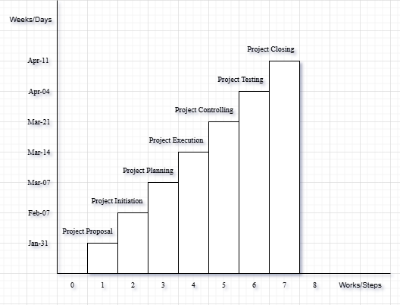

**References**

We mentioned all the literature or web references, etc here-

* Internet web page & resources: [ResearchGate](https://www.researchgate.net/profile/Md-Abu-Sayed-24), Gemini, etc.

End!