Circuit Diagram

Time: 10.50am Date: 08-11-2024

Circuit Diagram: To develop this circuit, we used an LDR sensor, an BC547 transistor, some LEDs, some resistors and some conductors and AC/DC voltages supply etc.

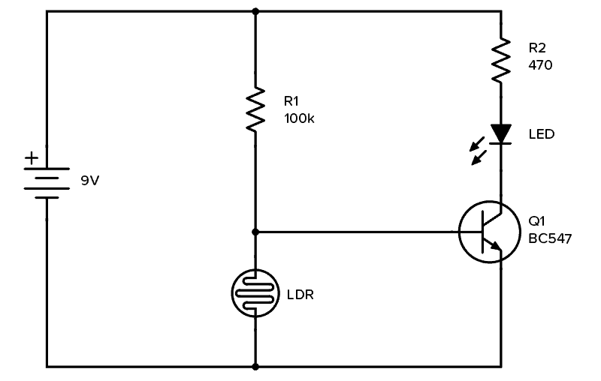
Fig. Automatic Night System

Equipments:
- 9V Battery
- Photoresistor (around 5kΩ in light, 200kΩ or more in dark)
- Transistor BC547
- Resistor 100 kΩ & 470 Ω
- Light-Emitting Diode (LED)

Comments:

