Automatic Night Light System


Project Report

Supervisor

Ariful Islam Arif
Lecturer of CSE
European University of Bangladesh

Submitted By

Team “EUB_Binary”
Students of CSE
European University of Bangladesh

[September 2024]

Department of Computer Science & Engineering
European University of Bangladesh.
Automatic Night Light System
Faculty of Computer Science & Engineering, European University of Bangladesh.

Abstract— Our main goal is to develop an ultramodern and a reliable automatic night light system. Which is used in almost every field in our daily life. For example in house lights, office lights, billboards, street lights etc. To develop this system, we used an LDR sensor, an BC547 transistor, some LEDs, some resistors and some conductors and AC/DC power supply etc.

Introduction
This project is to design and implement a cost-effective, energy-efficient system, that can without humans automatically operate LDR based on ambient light levels. LDR is a light dependent resistor. When we keep lights on all night at home or office, then the performance and life of that light is reduced. In case we have to face financial problems especially in the electrical sector. For example in loss of conductors, lights, and electricity etc.

Problem Description
The main goal of this project is, how to easily fix every problem by using ultramodern intelligence in a short time to reduce. So by using LDR, we can automatically turn on the light as soon as it gets dark. And we can automatically turn off the light as the light approaches. By using LDR, there is no need to use and operate any type of switch. It will work in a fully automatic system all the time.

We can design this project in two ways. (i) To develop this system, we used an LDR sensor, an BC547 transistor, some LEDs, some resistors and some conductors and AC/DC voltages supply etc. (ii) To develop this system more precisely. We used a breadboard, an IC7400, an LDR sensor, some resistors and some conductors and some DC 6v batteries etc.

Methodology

Equipments:
- BreadBoard
- LDR (Light Dependent Sensor)
- LEDs (Red, Yellow, Green)
- BC547 Transistor
- IC7400 (NAND)
- Resistors (10kΩ & 100kΩ)
- Jumper Wires
- 9V Battery
Circuit Diagram: To develop this system, we used an LDR sensor, an BC547 transistor, some LEDs, some resistors and some conductors and AC/DC voltages supply etc.

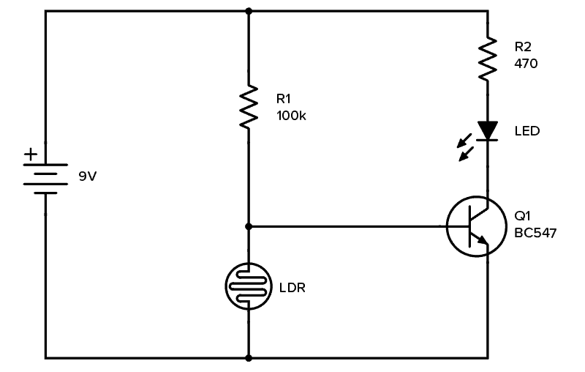

NAND Gate: A NAND gate, short for “NOT-AND” gate, is a fundamental building block in digital electronics. It performs a logical operation that outputs a low signal (0) only when all its inputs are high (1). In all other cases, it outputs a high signal (1). Essentially, it is the inverse of an AND gate.
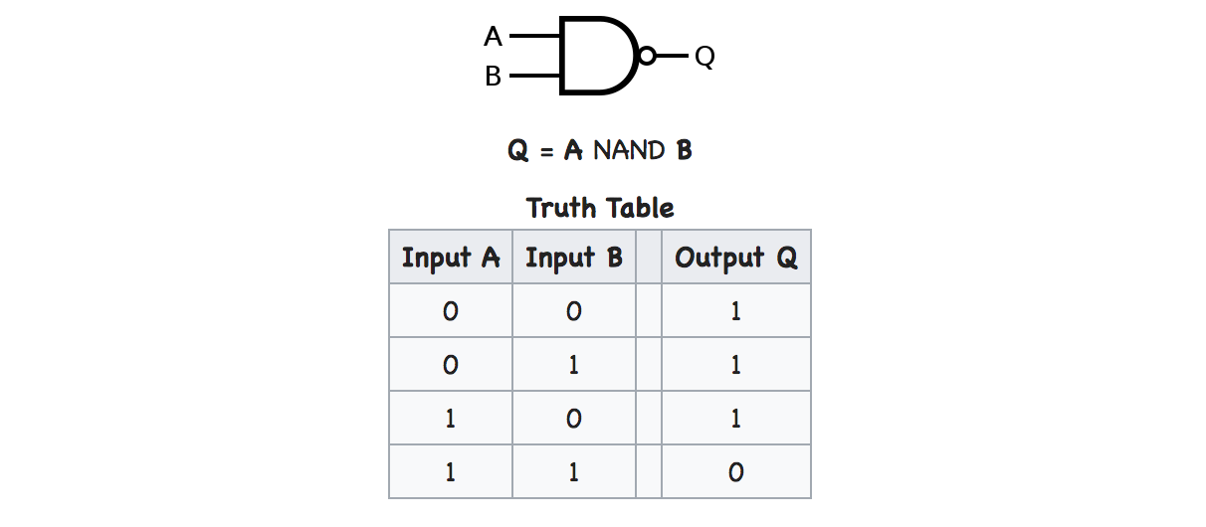

From the truth table it is easy to "implement" in Python:

def nand(a, b):
return 1 if (a == 0 or b == 0) else 0
print("A B | A NAND B")
print(f"0 0 | {nand(0, 0)}")
print(f"0 1 | {nand(0, 1)}")
print(f"1 0 | {nand(1, 0)}")
print(f"1 1 | {nand(1, 1)}")

Breadboard Testing: To develop this system more precisely. We used a breadboard, an IC7400, an LDR sensor, some resistors and some conductors and some DC 6v batteries etc.

Here, When the resistance is exposed to light, the light flashes off automatically.

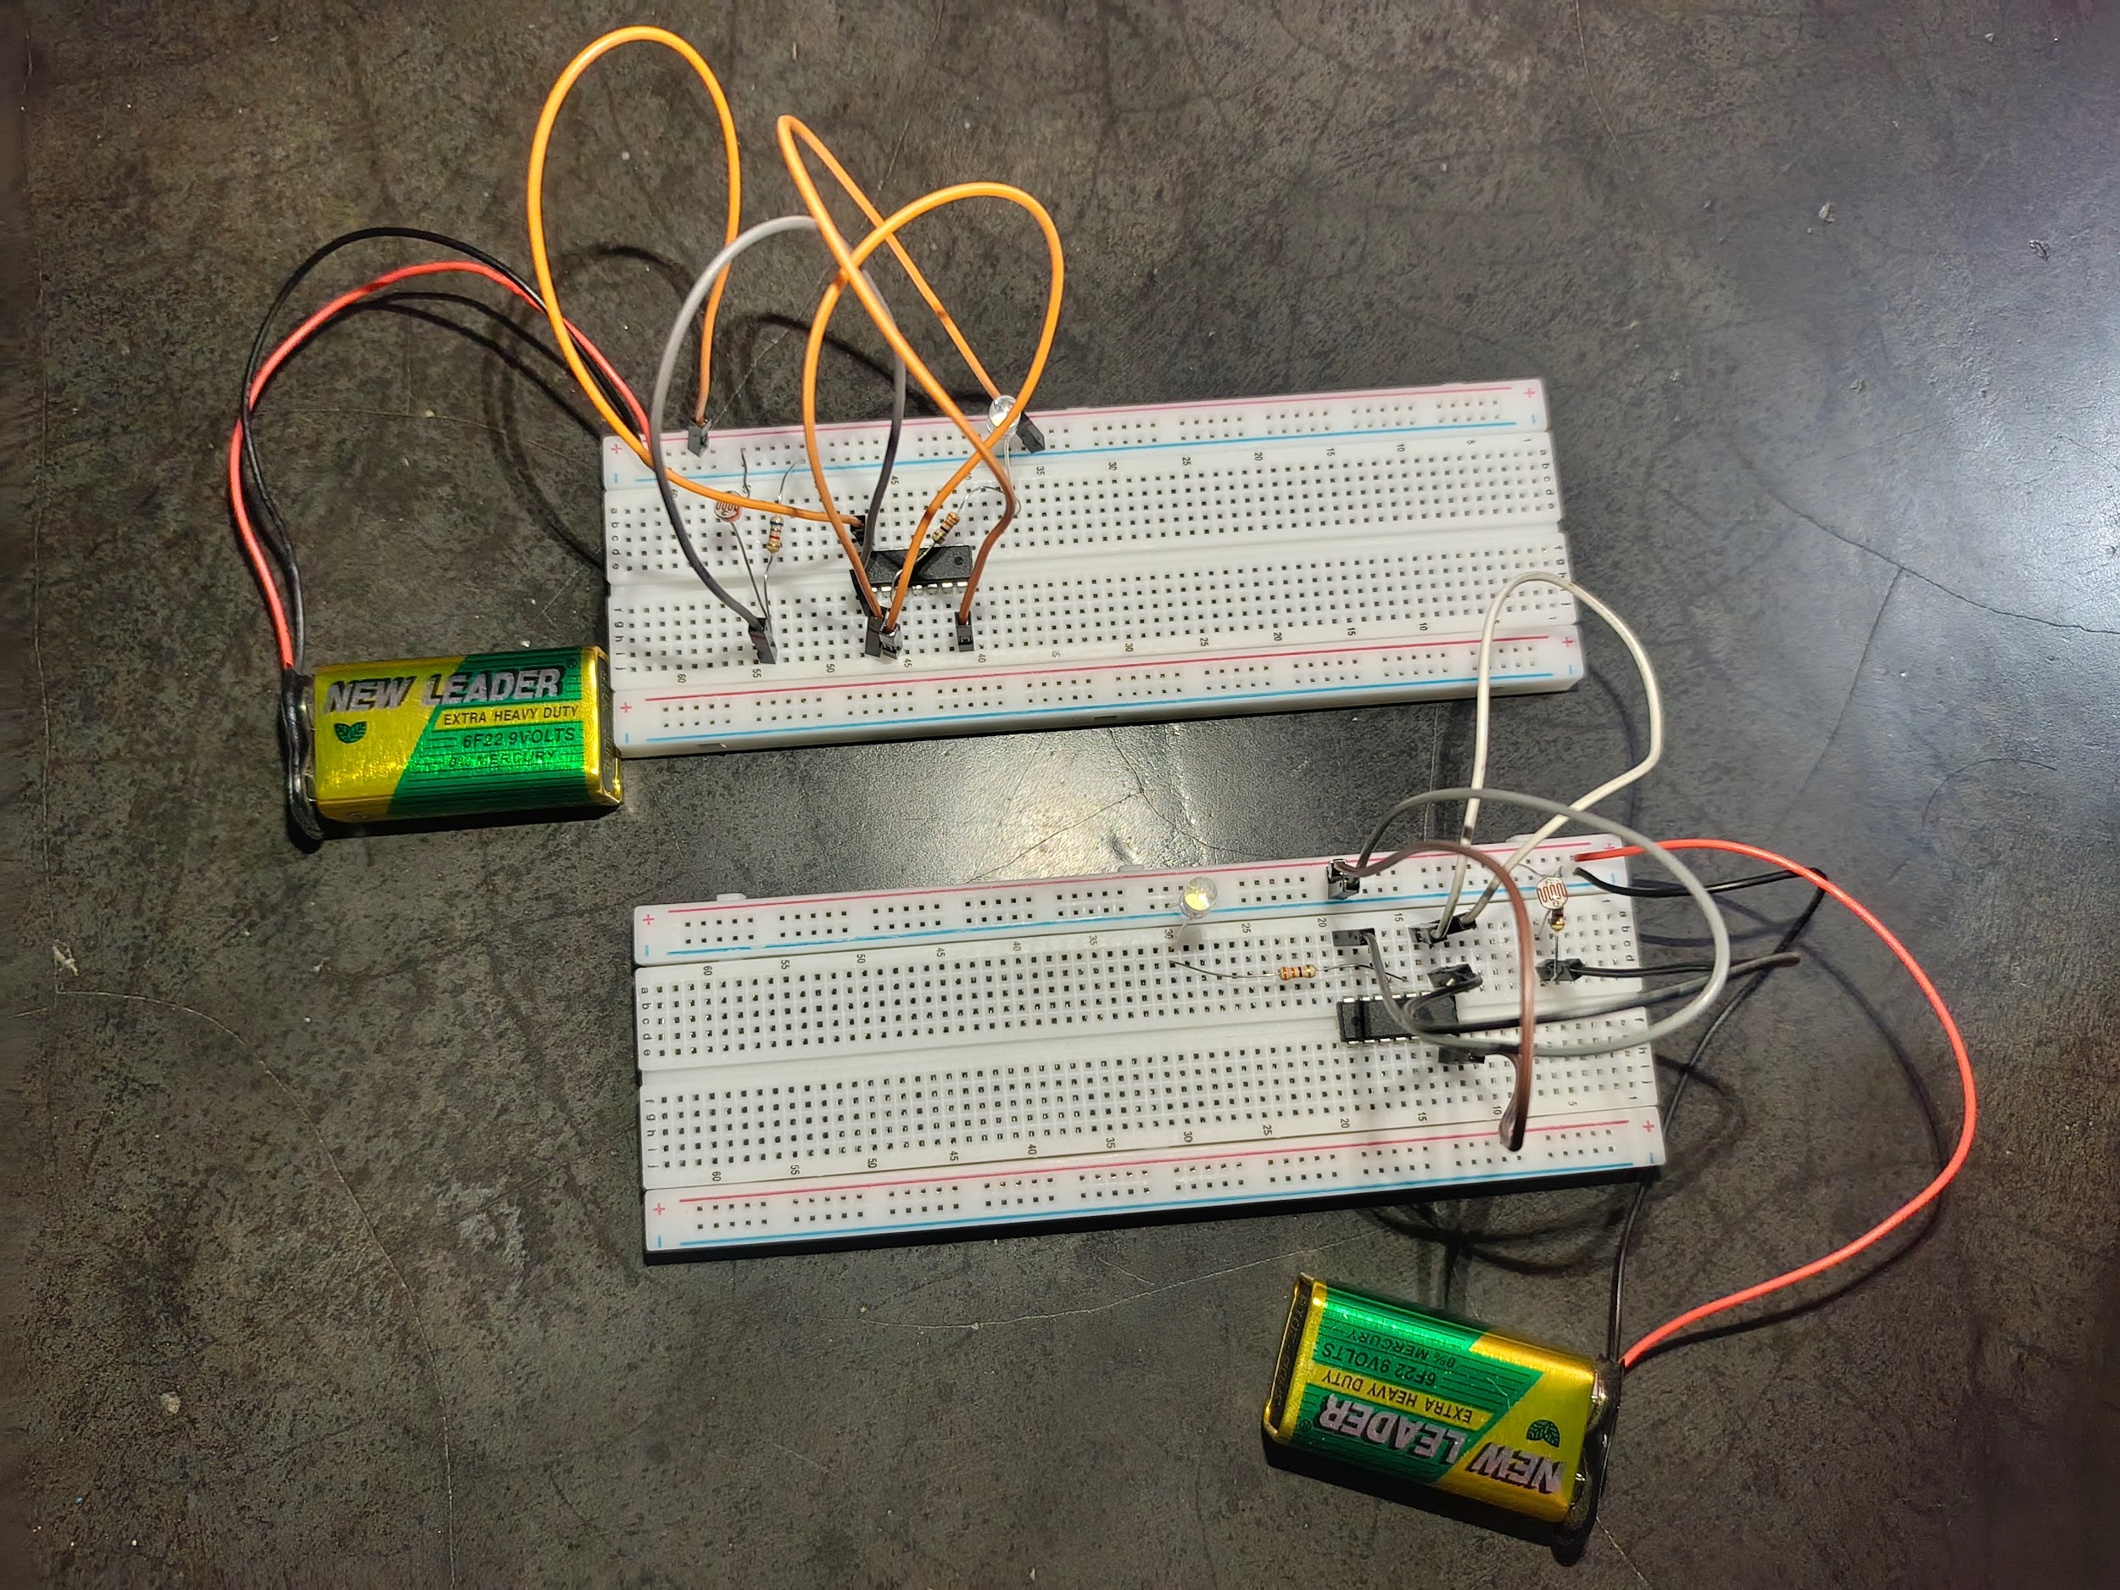

Again, when light is directed away from the resistor, then the light flashes on automatically.

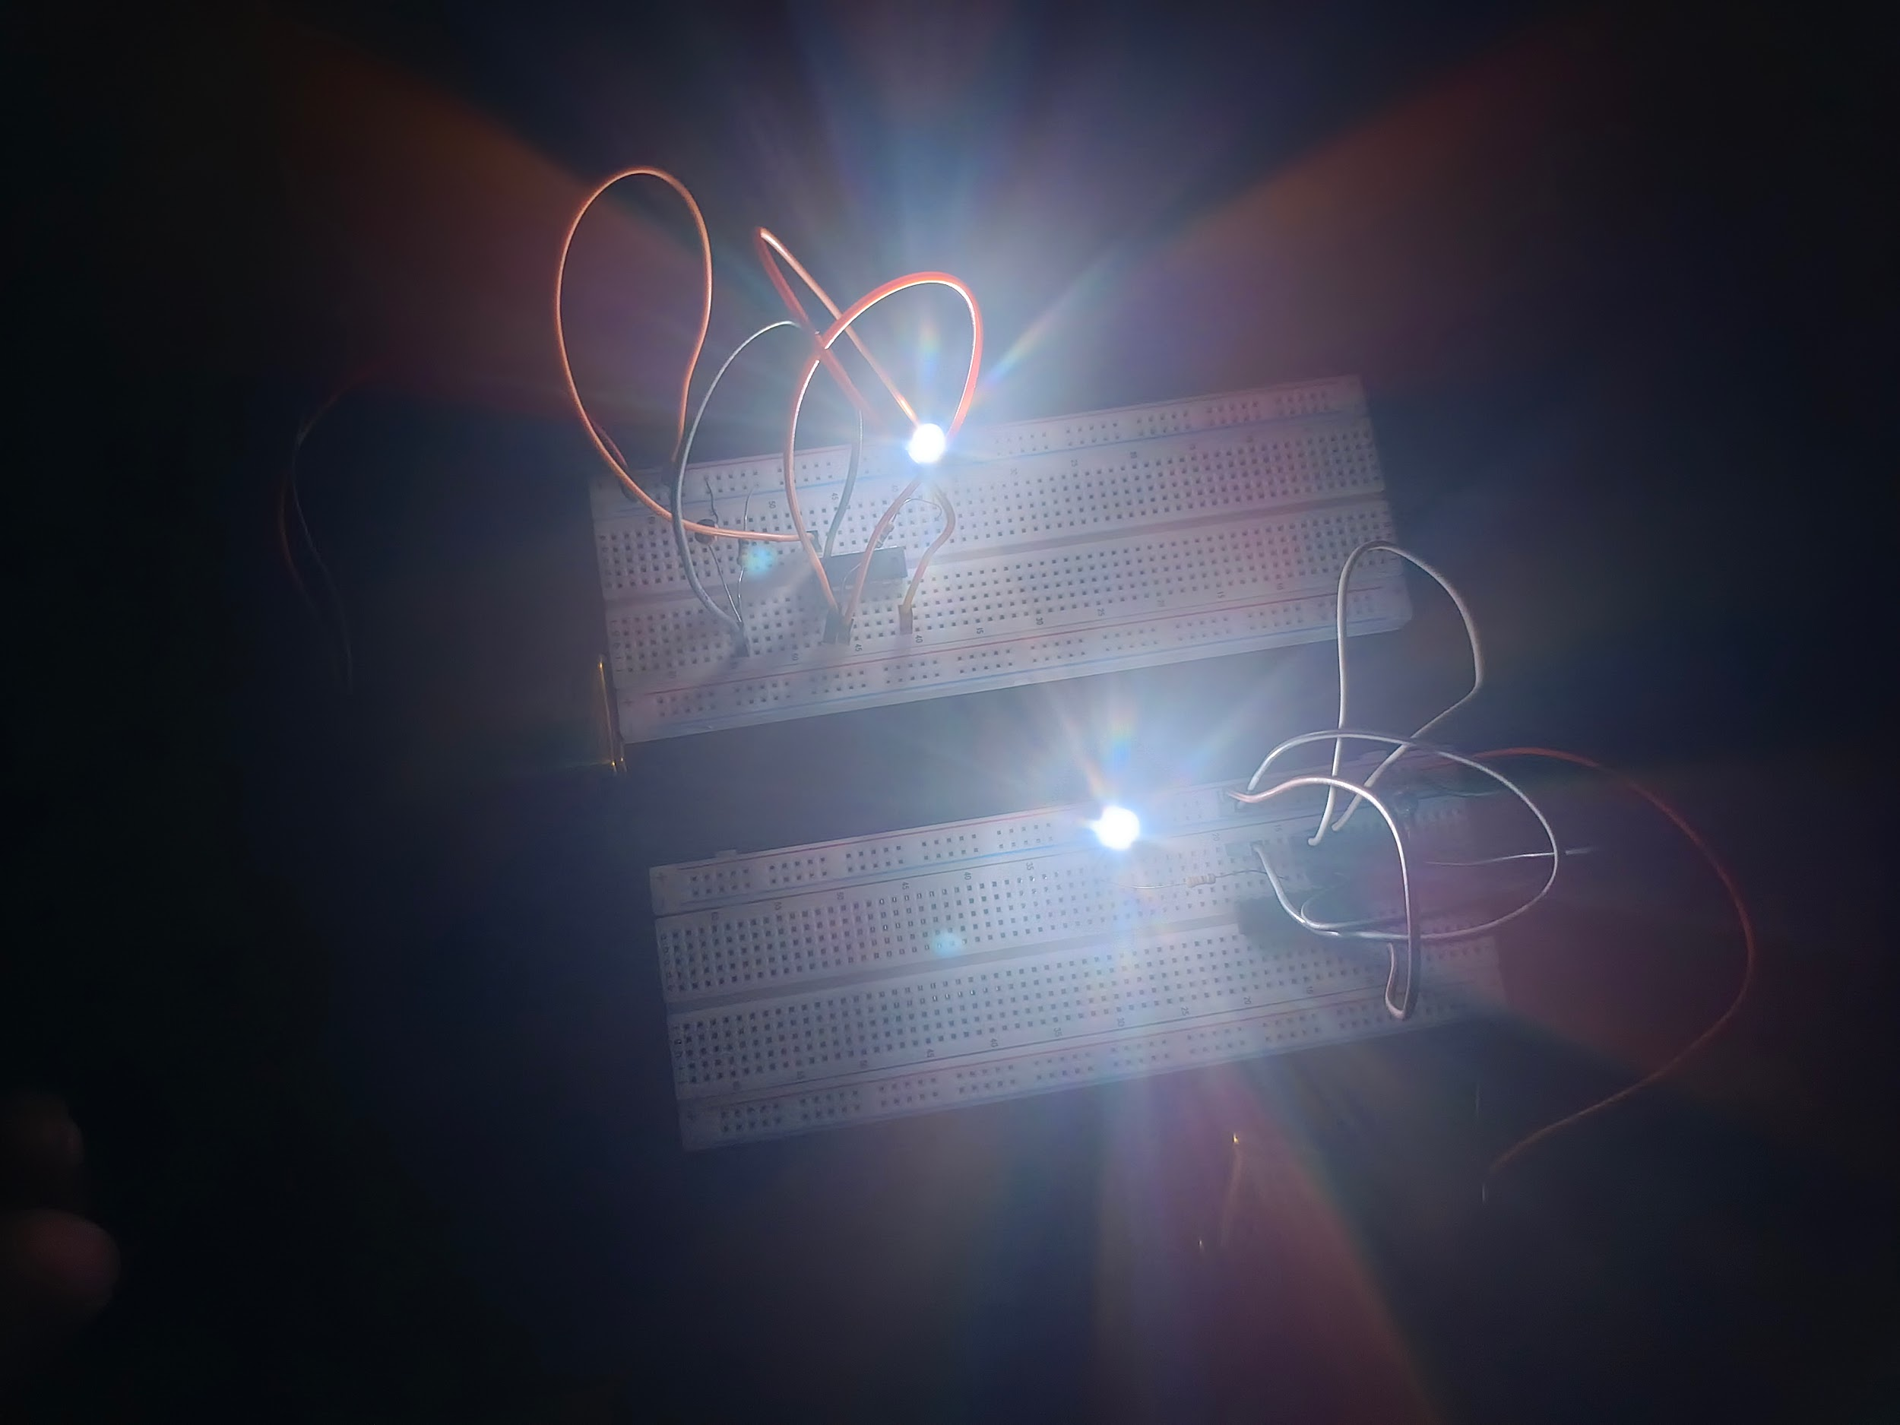

Primary Design: There will be a little two-lane road. And in the middle there will be street lights for both sides. And the street lights will be completely controlled by a circuit. Where LDR will play an important role. If necessary, the part that is in the middle of the road. There we can provide billboards with foot over bridge. And we can do more with more beautiful creativity.

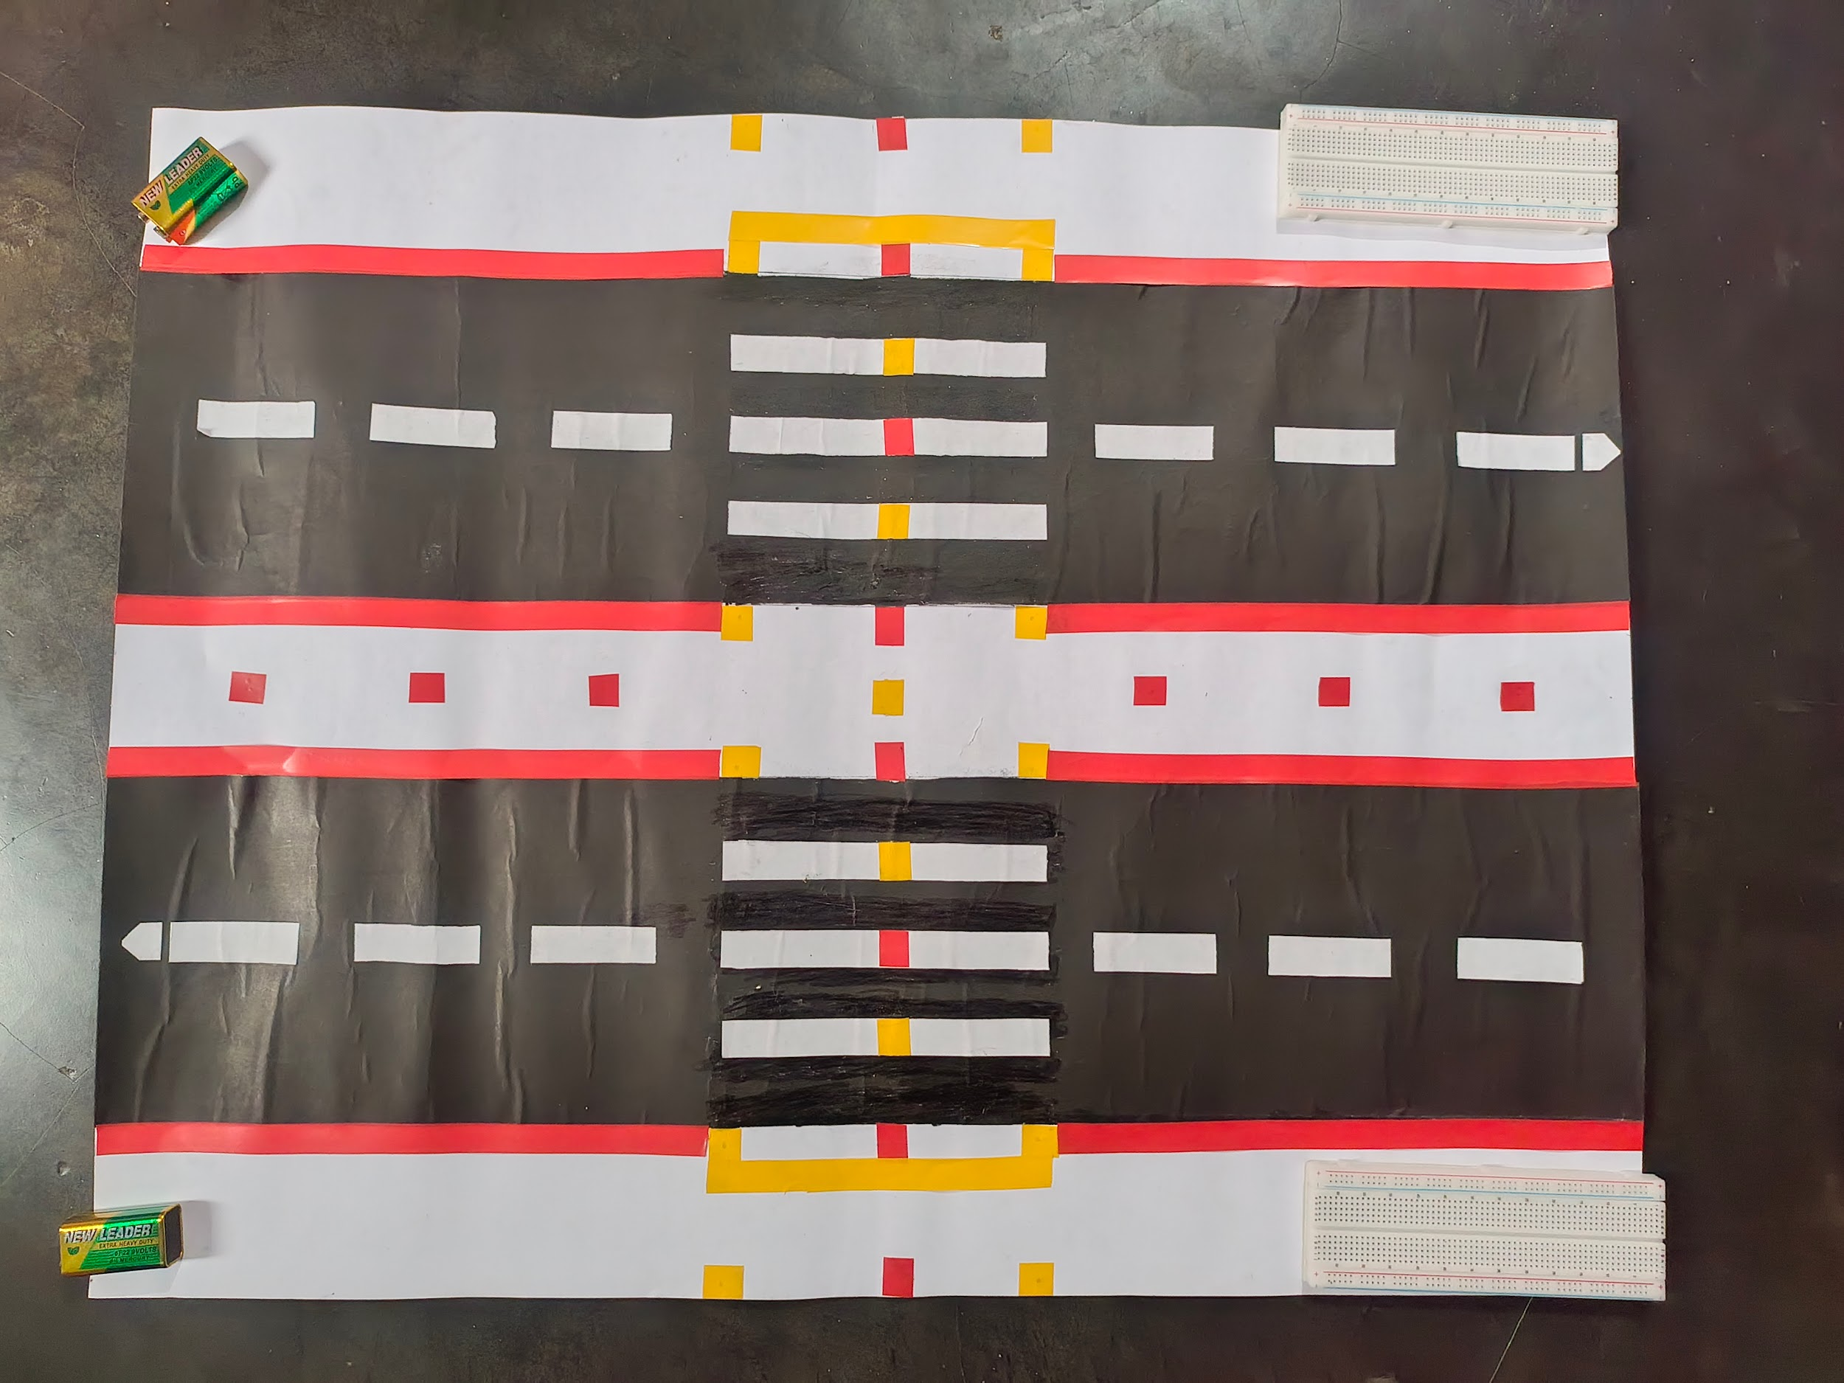

Step-1:

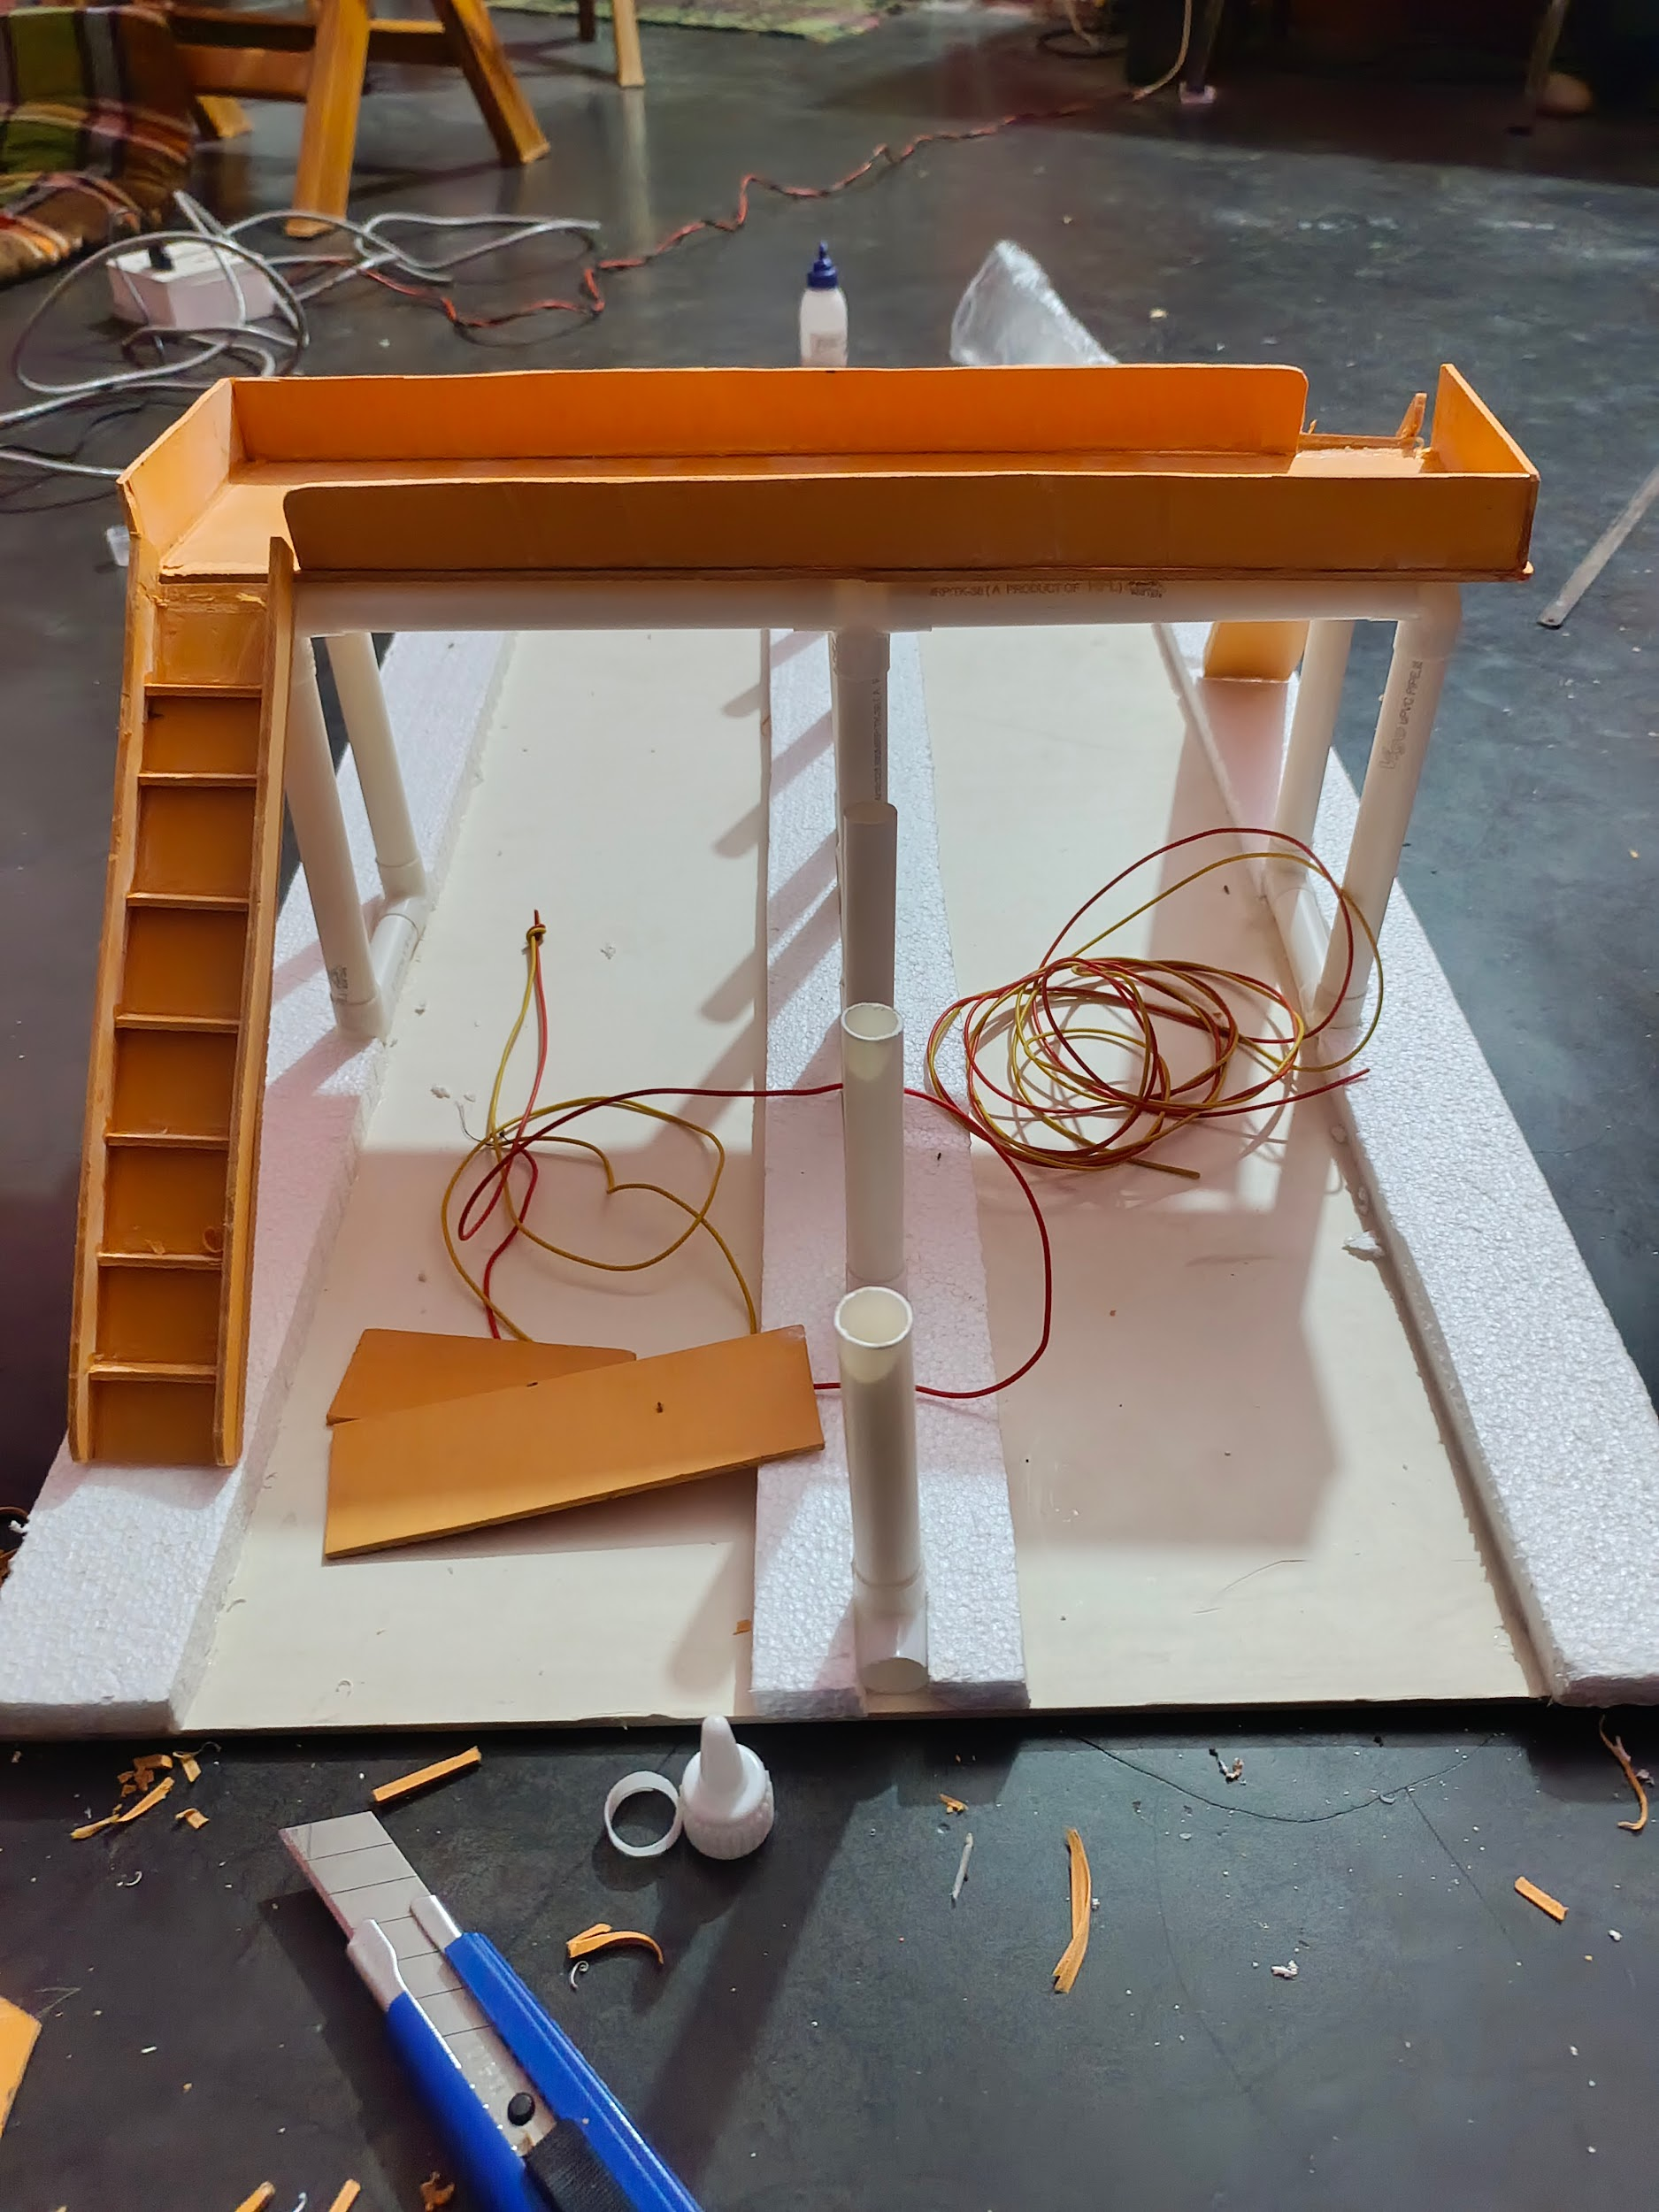

Step-2: When the resistance is exposed to light, the light flashes off automatically.

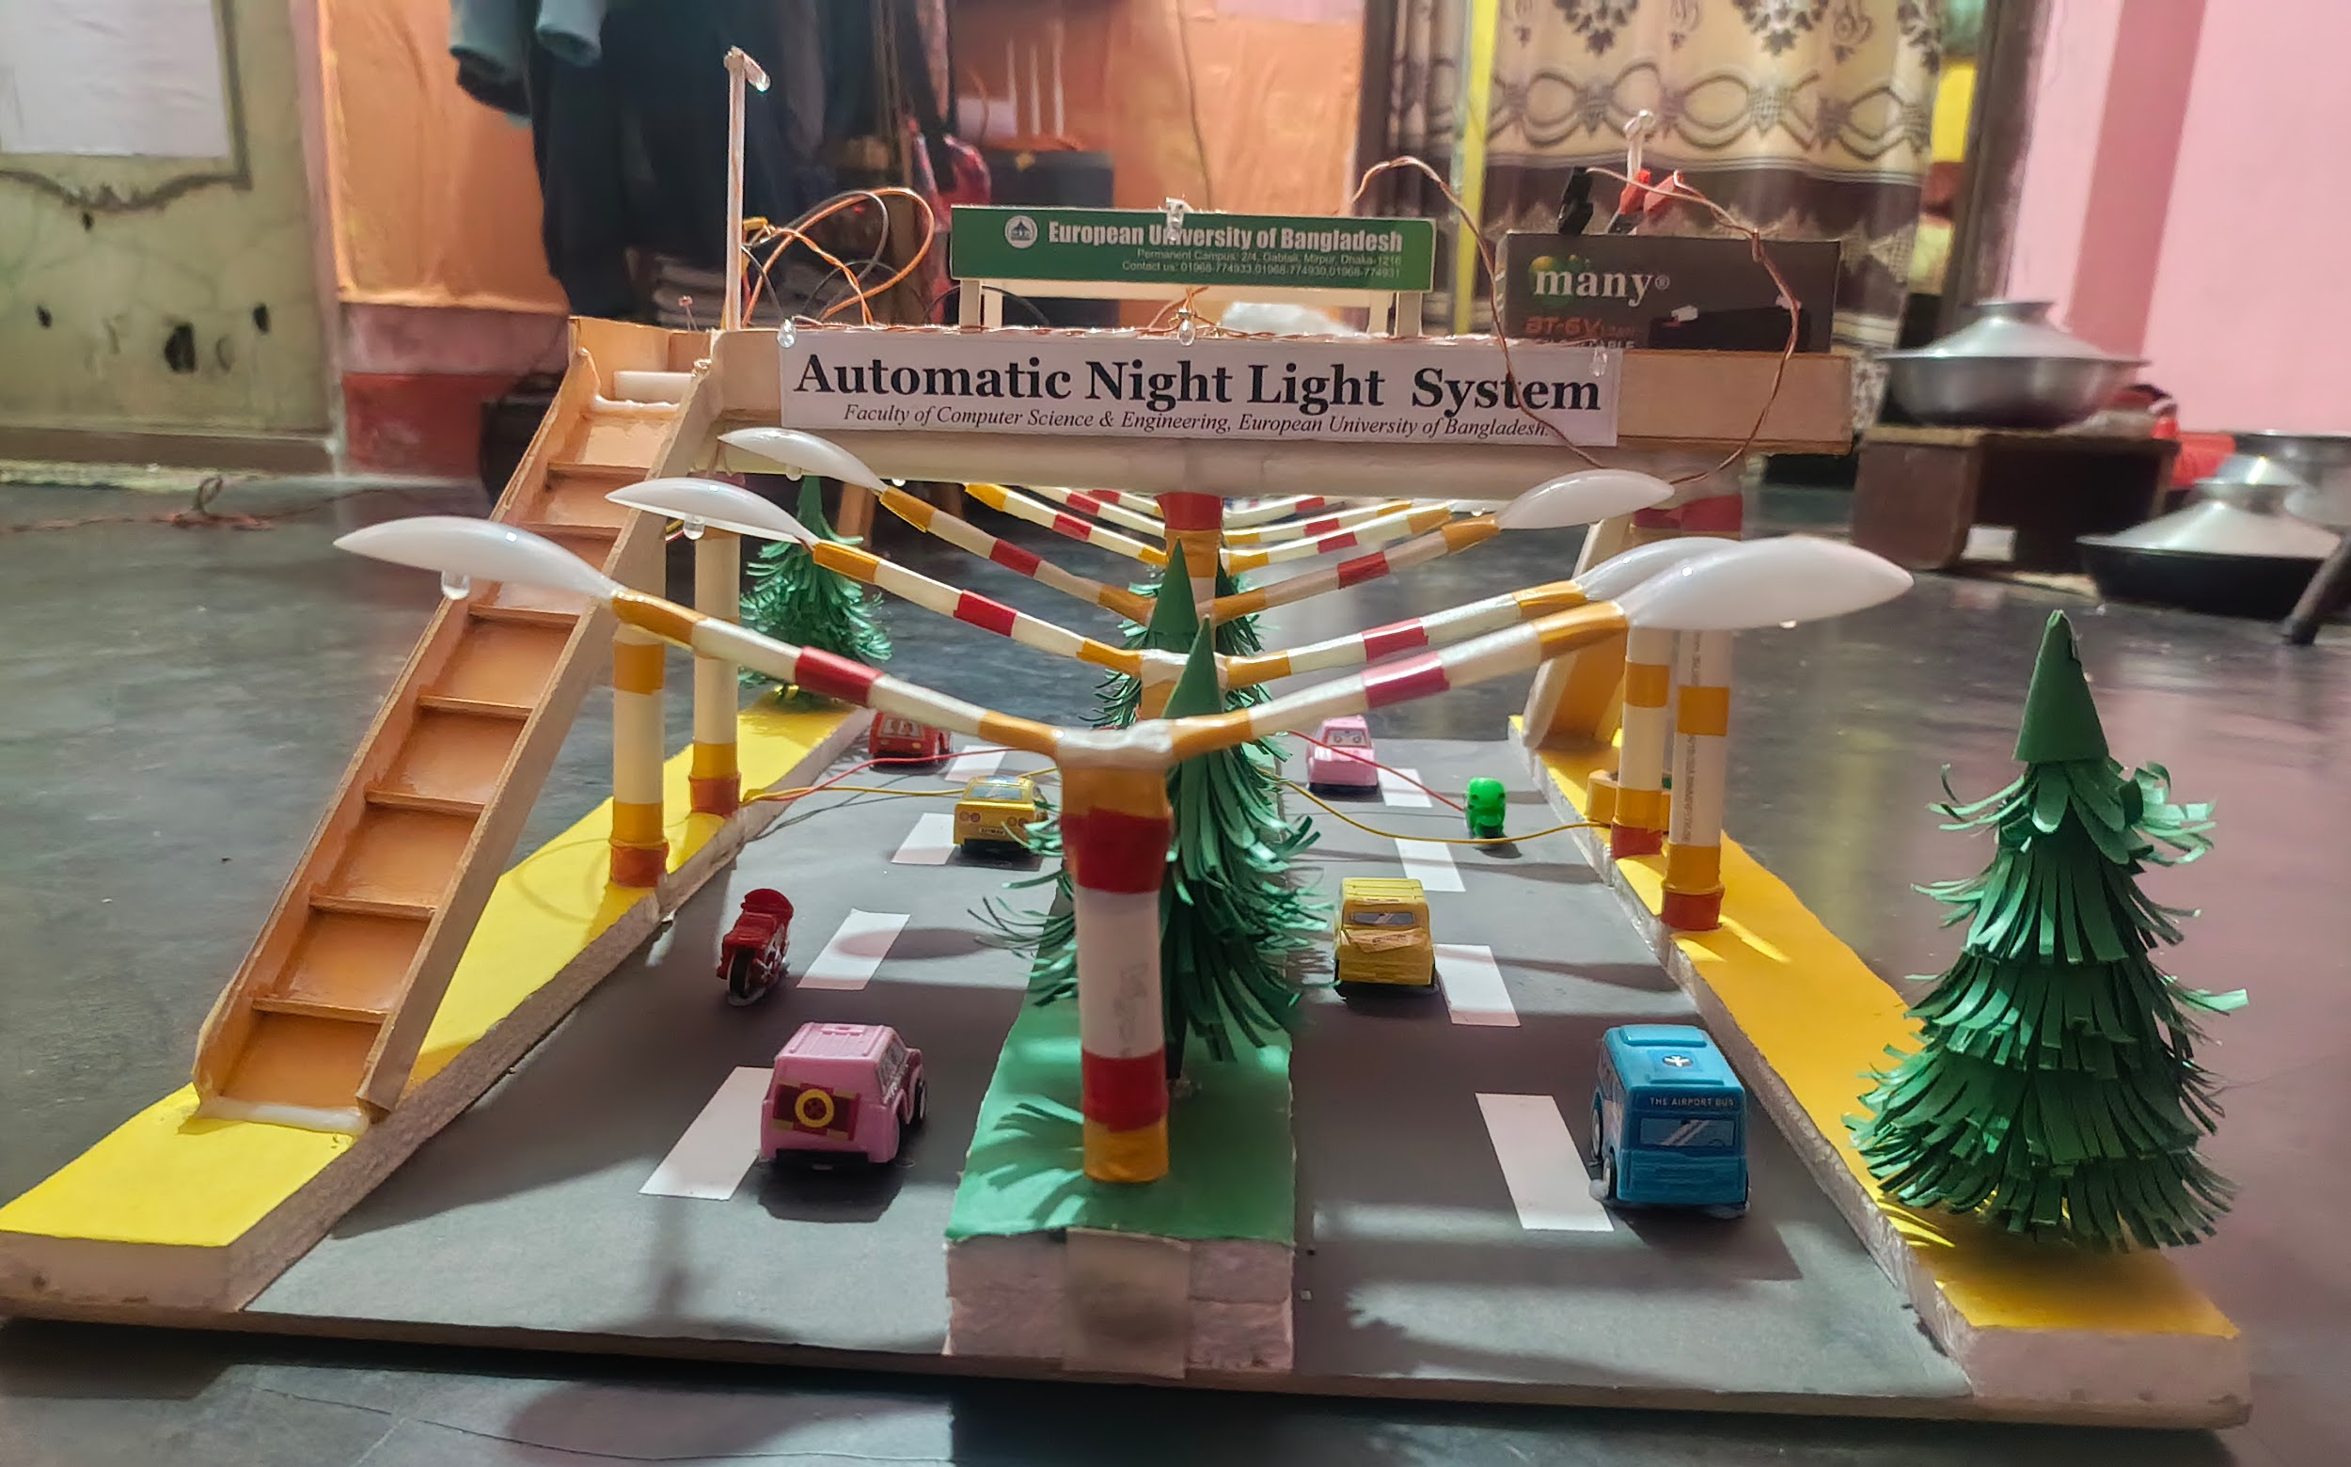

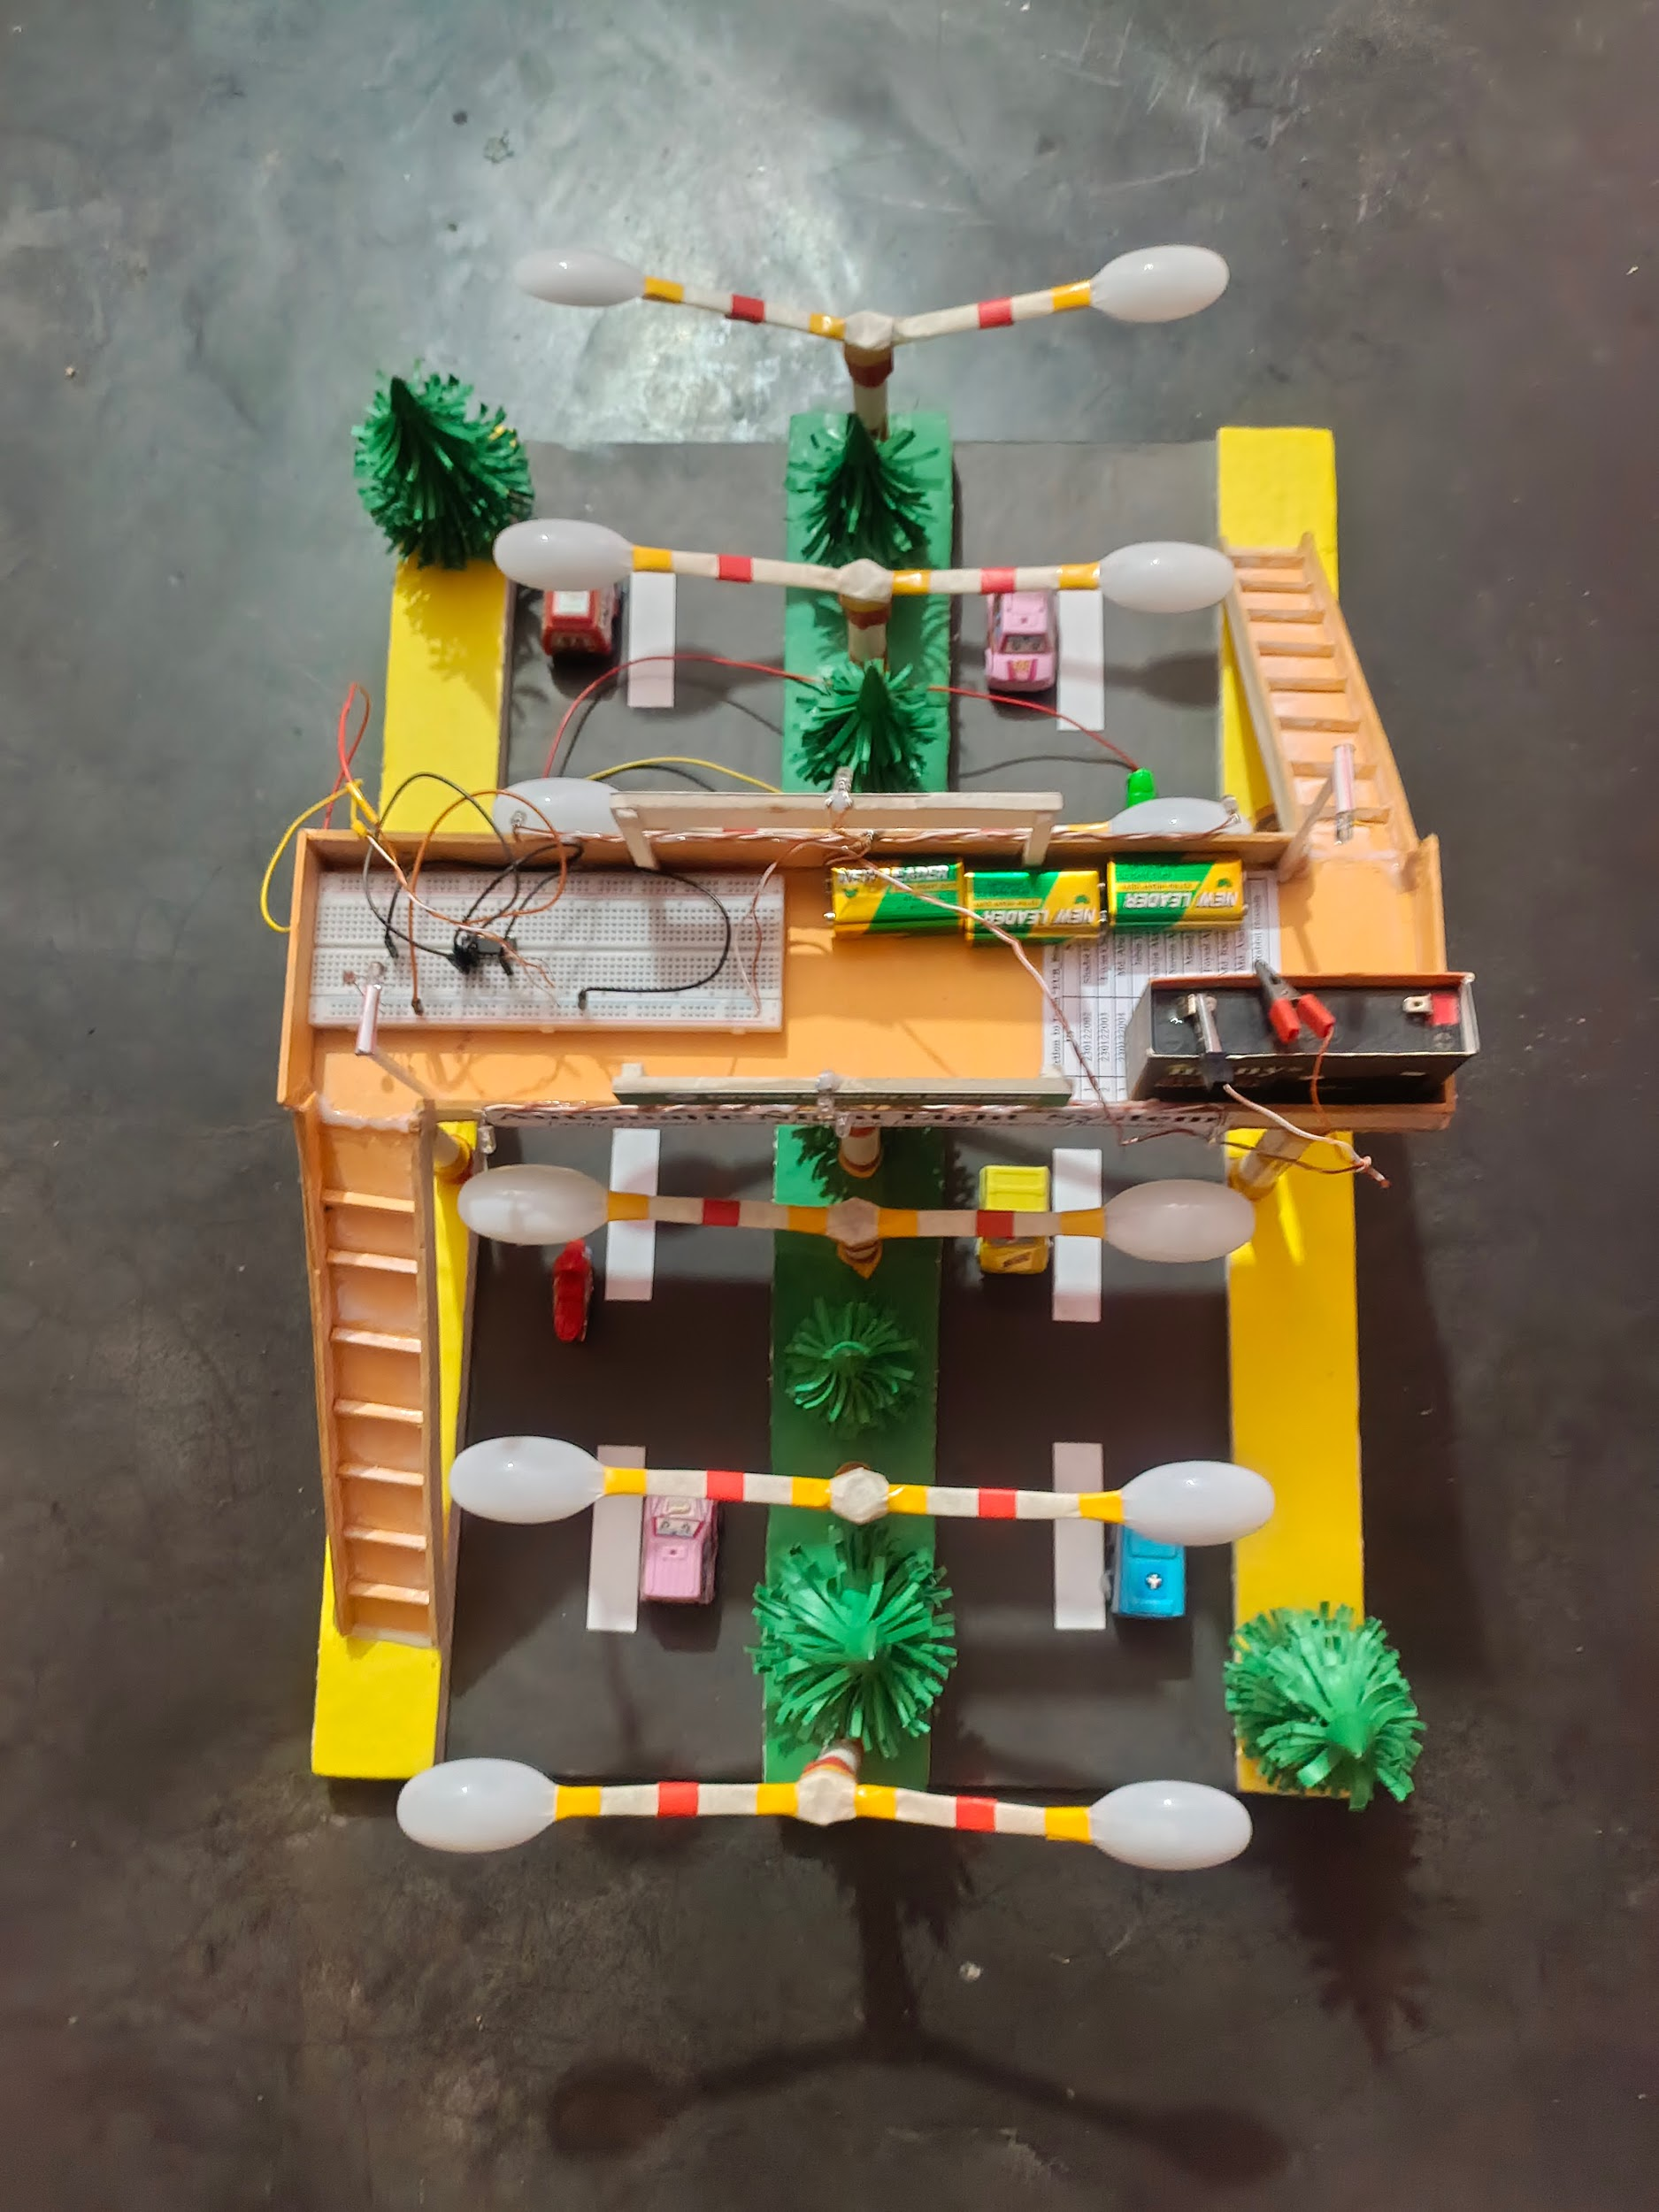

Step-3: When light is directed away from the resistor, then the light flashes on automatically.

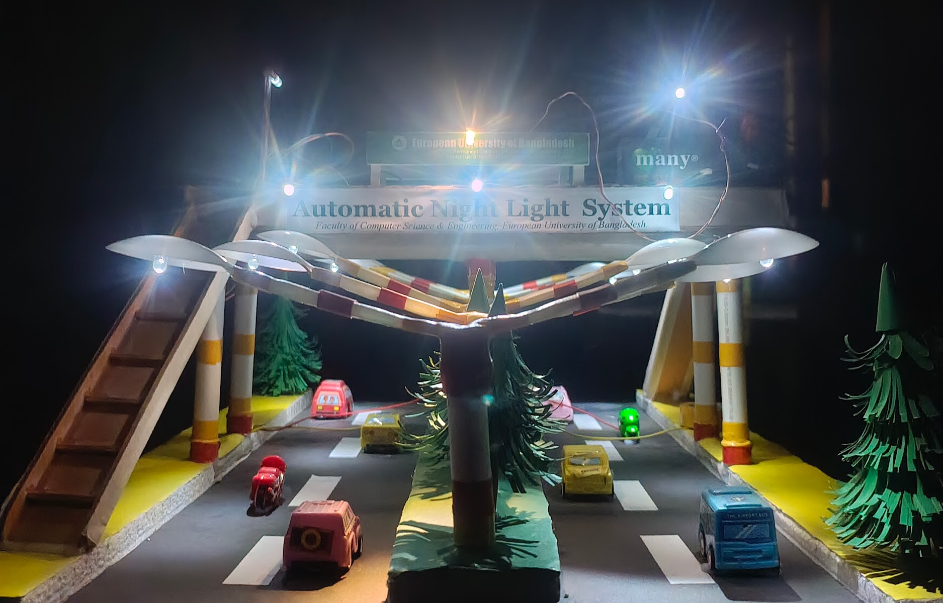

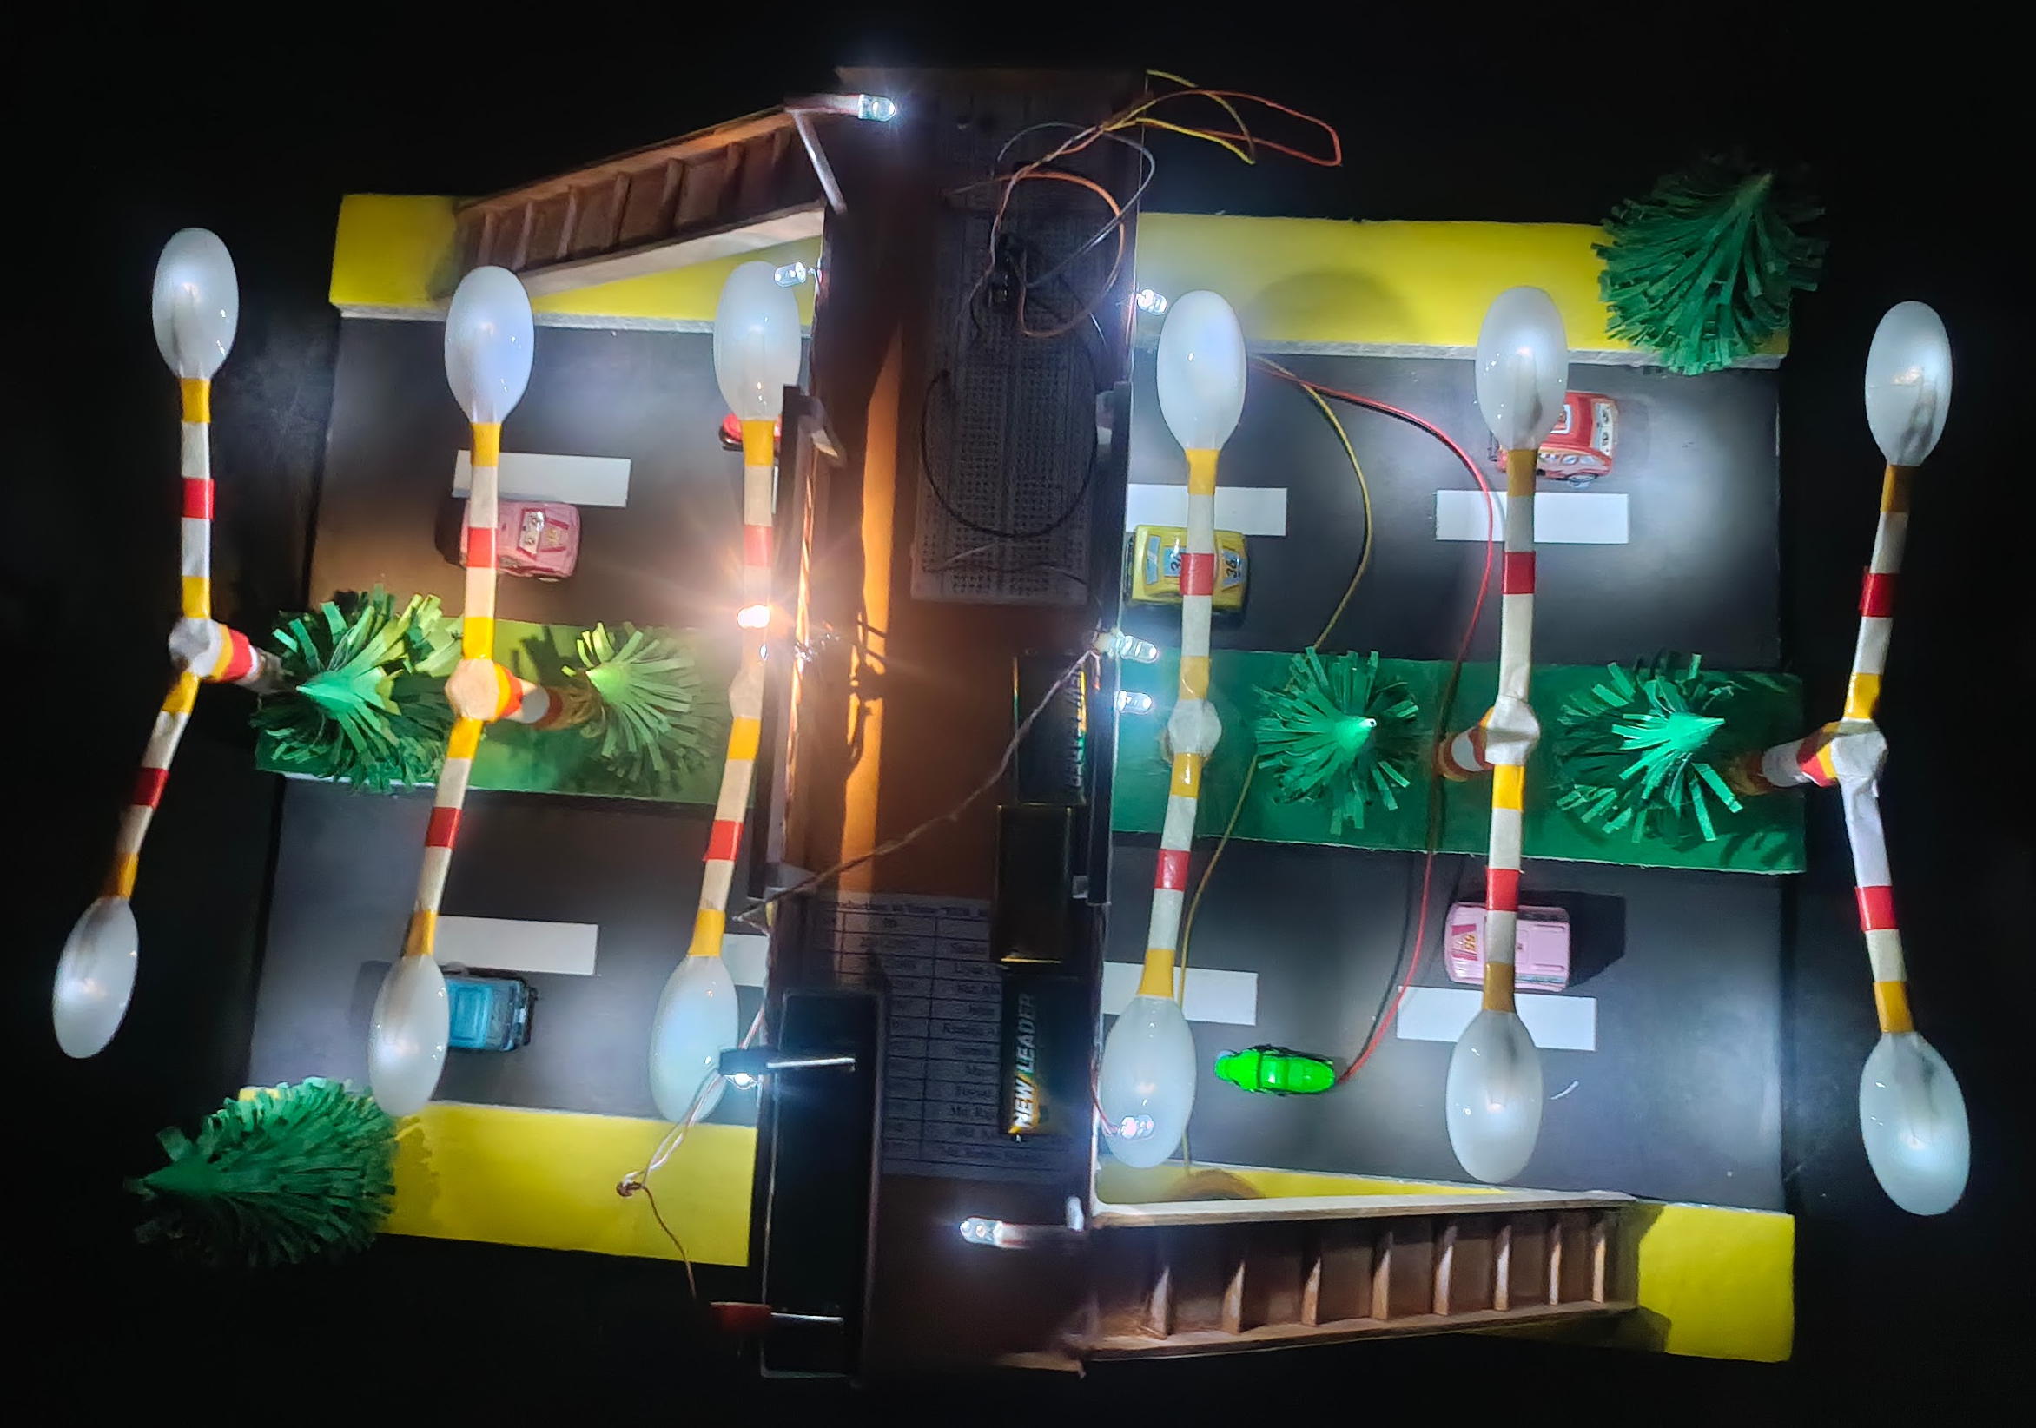

Project Scope

Advantages

Energy Efficiency: Reduces energy consumption by ensuring lights are only on when needed.

Convenience: Eliminates the need for manual switching of lights.

Security: Enhances security by ensuring areas are well-lit during the night.

- Limitations
- Weather Conditions: The system must be robust enough to handle various weather conditions.
- Component Durability: Ensuring the longevity and reliability of components used in the system.
- Fixed Sensitivity: Requires manual adjustment for different light levels.

- Enhancements
- Microcontroller Integration: Use Arduino or Raspberry Pi for better control and advanced features.
- IoT Connectivity: Add WiFi or Bluetooth modules for remote monitoring.
- Motion Sensing: Integrate PIR sensors to operate lights only when motion is detected.

Feasibility Study

Technical Feasibility

Components: LDR, BC547, LEDs, Ohm's, conductors & power supply etc.

Design: LDR should be designed using a BC547 transistor.
- Scalability: Suitable for various applications like street lighting or home automation.

- Economic Feasibility

Cost of Components: The components required for the system are inexpensive and widely available.

Energy Savings: By automating the lighting, the system can significantly reduce energy consumption, leading to cost savings over time.
- Scalability: Cost-effective to implement on a larger scale for applications like street lighting or home automation.

- Operational Feasibility

Ease of Use: The system is user-friendly, with automatic operation eliminating the need for manual intervention.
- Ease of Repair: Designing the system in a way that components can be easily replaced if they fail.

Reliability: The system is designed to operate reliably under various environmental conditions, provided it is properly installed and protected.

Solution Application Areas

- Residential Lighting
- Outdoor Lighting: Automatically turns on porch, garden, and pathway lights at dusk and off at dawn.
- Indoor Lighting: Useful for hallways, staircases, and children’s rooms to provide safety and comfort during the night.
- Bedrooms: To provide gentle lighting when someone gets out of bed at night.

- Public Infrastructure
- Street Lighting: Automates street lights to improve visibility and safety on roads and sidewalks.
- Public Restrooms: Offer safe and convenient lighting in restroom facilities without excessive energy consumption.
- Parks and Recreational Areas: Provides lighting in public parks and playgrounds, enhancing safety for evening visitors.

- Educational Institutions
- University Campuses: Automates lighting for pathways, parking lots, and building exteriors, ensuring safety for students and staff.
- Libraries and Study Areas: Provides lighting in study areas during evening hours, promoting a conducive learning environment.
- Common Areas: Enhance safety and accessibility in common areas such as courtyards, gardens, and seating areas.

Tools/Technology

Hardware:

- BreadBoard
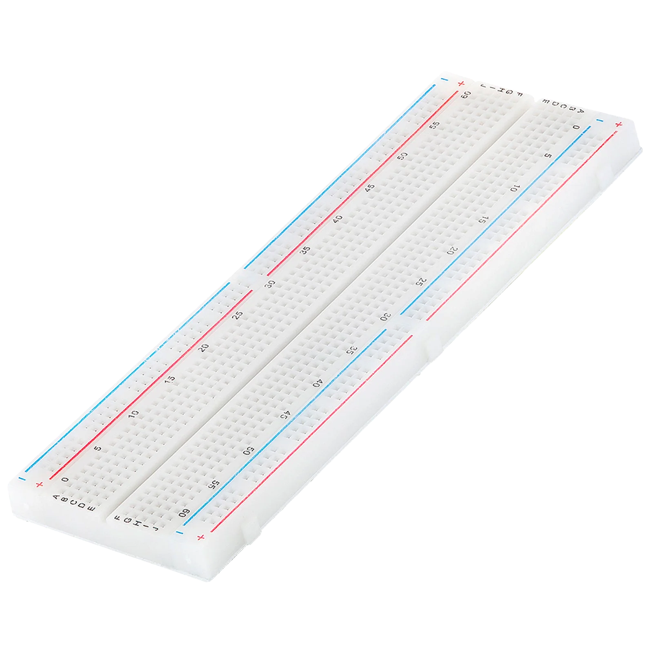
The breadboard is the basic component of any circuit building process. All components, be it input sensors or output display devices are connected to the power supply, microcontroller using wired connections through a breadboard. The holes in the breadboard are in series. There are various sizes like full-sized, half-sized, and mini breadboards.
- LDR (Light Dependent Sensor)
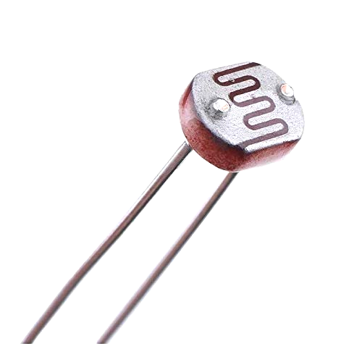
LDR is a photoresistor that works on the principle of photoconductivity. The surface of the LDR is made with a layer of semiconducting material that is responsible for measuring the light intensity. The principle states that when light falls on the surface of the semiconducting material, the electrons receive energy, and movement is caused inside the material.

- LED
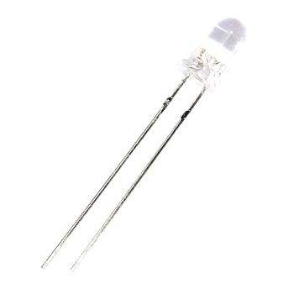
Light Emitting Diode is a commonly used light source. It is a semiconductor that emits light when current flows through it.

- BC547 Transistor
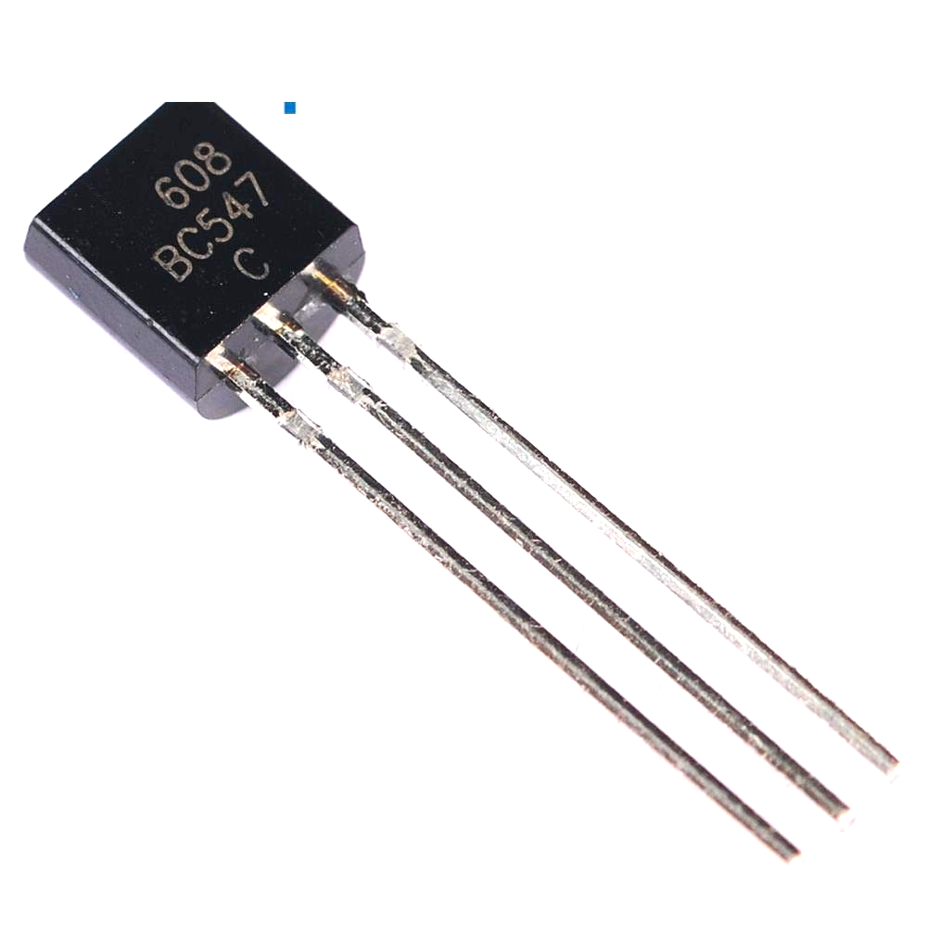
BC547 is usually used for current amplifiers, quick switching and pulse-width modulation (PWM). Therefore, if you need to control the speed of a motor or actuator in some of your projects, you can simply use this transistor to achieve it.
- IC7400 (NAND)
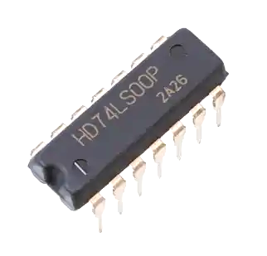
The IC 7400 is a popular integrated circuit that contains four independent 2-input NAND gates. It’s part of the 7400 series of logic chips, which are widely used in digital electronics. The IC comes in a 14-pin package. Each NAND gate has two input pins and one output pin. The remaining pins are for power supply (VCC) and ground (GND).

- Resistors

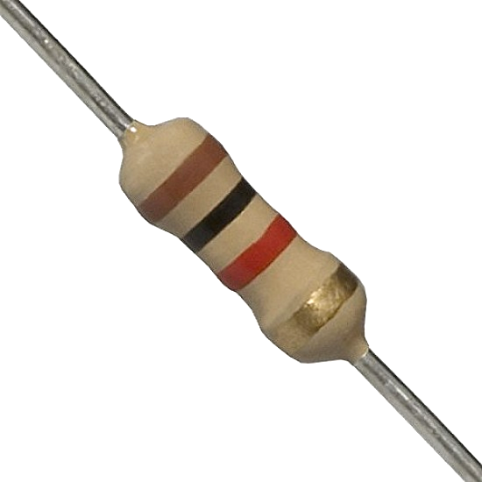
Resistors are passive devices that restrict the flow of current or divide the voltage through the circuit. The input power passes through these resistors and then to the sensors to avoid damage.

- Jumper Wires
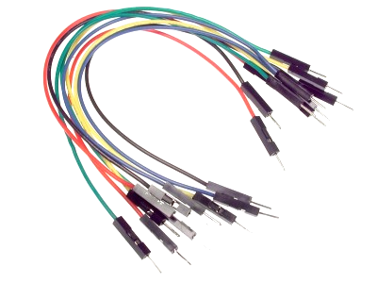
These are the main components that are used to establish the connections between different devices of the circuit.
Software:

- Not applicable (if built as a hardware-based project).

- For microcontroller-based systems, software like Arduino IDE may be used.
TinkerCad circuit simulation software:


Expertise of the Team Members
We present the significance of our project with the overall cooperation of the team members:

- Energy Efficiency: The system should automatically turn on lights only when needed, reducing unnecessary energy consumption.

- Convenience: By automating the lighting process, the system eliminates the need for manual operation, providing ease of use for the users.

- Cost-Effectiveness: Utilizing components like Light Dependent Resistors (LDRs) and transistors, the project should be affordable and easy to implement.

- Enhanced Safety: Automatic lighting can improve safety by ensuring that areas are well-lit during low-light conditions, reducing the risk of accidents.

- Scalability: The system should be adaptable for various environments, from small residential setups to larger commercial applications.

- Sustainability: By reducing energy usage, the project contributes to environmental sustainability.
Milestones

SN | Hardware | Cost
1 | BreadBoard | 130
2 | LDR (Light Dependent Sensor) | 20
3 | LEDs (Red, Yellow, Green) | 20
4 | BC547 Transistor | 20
5 | IC7400 (NAND) | 20
6 | Resistors (10kΩ & 100kΩ) | 20
7 | Jumper Wires | 100
8 | 9V Battery | 80

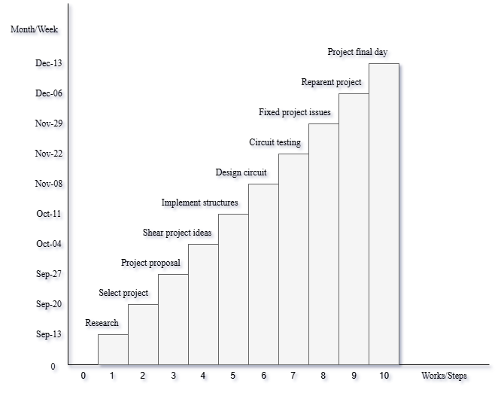

Conclusion
The Automatic Night Light System is a practical and energy-efficient solution for lighting needs. By automating the process of turning lights on and off based on ambient light, this system saves energy, reduces manual effort, and provides a safer environment.

References
We mentioned all the literature or web references, etc here:

- Internet Web page: ResearchGate. “Automatic Night Light Control by Using Arduino UNO”.

