Parking System by Using Arduino UNO


Project Proposal

Supervisor

Khandaker Iftakher Ahmed
Lecturer C.C. of CSE
European University of Bangladesh

Submitted By

[230122002, 230122029, 230122039,
230122048, 230122069]
Students of CSE
European University of Bangladesh

[January 2025]

Department of Computer Science & Engineering
European University of Bangladesh.
Parking System by Using Arduino UNO
Faculty of Computer Science & Engineering, European University of Bangladesh.

Abstract— Our main goal is to develop an ultramodern and reliable parking system by using arduino uno. Which is faced in almost every field in our daily life. For example shopping centers, residential complexes, public parking lots, etc. To develop this system, we used an Arduino UNO as the main processor, a display for the UNO, a servo motor, two IR sensors, resistors, jumper wires, a 9V battery, and other components.

Introduction
The main aim of this project is to reduce the wastage of people's precious time, and to ensure the safety of all while parking, as well as to develop a smooth management. Working to reduce the wastage of valuable time in daily life and avoid various unwanted road accidents. So in this project we can create an orderly parking system by using Arduino UNO. Which will play an important role in the welfare of our country and nation.

Problem Description
Arduino UNO must be used properly in making this project. And how to complete the project using Arduino UNO must be noted. In parking system management, state-of-the-art creativity, intelligence and future possibilities must be exploited. Also, to solve the traffic crisis in the near future, modern technology must be used. And new techniques and technologies have to be developed to avoid unwanted road accidents. At the same time, modern technology should be used in such a way that everyone obeys the traffic laws.

Methodology

Equipments:
- Arduino UNO
- BreadBoard
- Servo Motor
- Display for UNO
- IR Sensor
- Resistors
- Jumper Wires
- 9V Battery
Circuit Diagram: To develop this system, we used an Arduino UNO as the main processor, a display for the UNO, a servo motor, two IR sensors, resistors, jumper wires, a 9V battery, and other components.

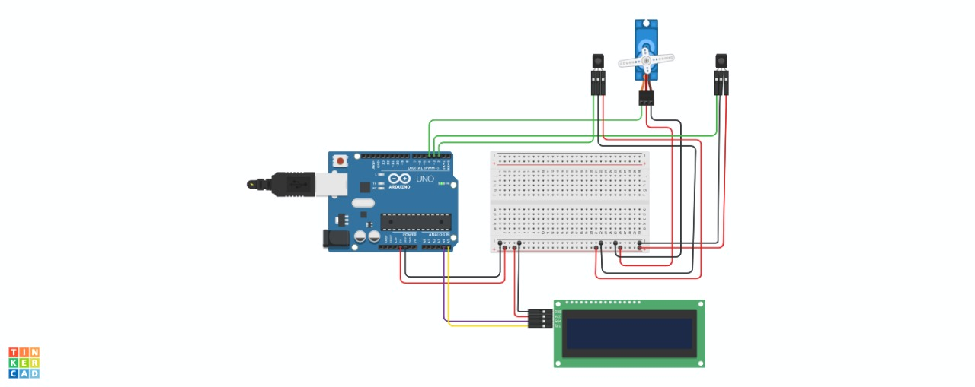
Fig. Circuit Diagram

Project Scope
- Advantages
- Cost-Effective: Affordable components.
- Customizable: Tailor to specific needs.
- Educational: Learn sensors, coding, electronics.
- Real-Time Monitoring: Instant updates on availability.

- Limitations
- Range: Limited sensing distance.
- Accuracy: Potential inaccuracies in detection.
- Integration: Requires effort for advanced integration (e.g., IoT).
- Maintenance: Potential for frequent manual intervention.

- Enhancements
- Multiple Sensors: Cover more parking spaces.
- LCD Display: Show real-time parking status.
- Mobile App Integration: Remote monitoring.
- IoT Capabilities: Connect to the internet for data access.

Feasibility Study

Technical Feasibility

Component Compatibility: Arduino UNO is compatible with a range of sensors and peripheral devices.

Simplicity: Arduino’s user-friendly interface simplifies programming and debugging.
- Power Supply: Standard power requirements are easily met.
- Software Support: Abundant libraries and community support for sensors and displays.

- Economic Feasibility
- Low Initial Investment: Affordable components (Arduino, sensors, and LEDs).

Low Operating Costs: Minimal power consumption and maintenance.

Scalability: Can start small and expand gradually.
- Cost-Effectiveness: High value for the cost, especially in education and DIY environments.

- Operational Feasibility

Ease of Use: User-friendly setup and operation.
- Reliability: Consistent performance with proper calibration.

Scalability: Expandable with additional sensors and features.
- Integration: Can integrate into larger systems with additional work.

Solution Application Areas

- Shopping Centers
- Customer Convenience: Real-time parking info for visitors.
- Traffic Flow Management: Efficiently guide vehicles to available spots.
- Enhanced Security: Improved monitoring of parking areas.
- Reduced Search Time: Quicker parking, leading to better customer satisfaction.

- Residential Complexes
- Resident Convenience: Real-time parking information for residents.
- Space Utilization: Efficient use of limited parking spaces.
- Security: Improved monitoring and safety for parked vehicles.
- Visitor Parking: Navigate and manage guest parking more effectively.

- Public Parking Lots
- Real-Time Information: Display available spaces to drivers.
- Traffic Reduction: Minimize the search time for parking.
- Revenue Management: Track and manage parking fees.
- Enhanced Security: Monitor and secure parking areas.

Tools/Technology

Hardware:
- Arduino UNO
- BreadBoard
- Servo Motor
- Display for UNO
- IR Sensor
- Resistors
- Jumper Wires
- 9V Battery

Software:
- Not applicable (if built as a hardware-based project).
- For microcontroller-based systems, software like Arduino UNO IDE may be used.
- TinkerCad circuit simulation software.

Expertise of the Team Members
We present the significance of our project with the overall cooperation of the team members:

- Cost-Effective: The components required (Arduino, sensors, LEDs) are affordable, making it a budget-friendly project.

- Real-Time Monitoring: Provides instant updates on parking space availability, enhancing convenience for drivers.

- Customizable: The system can be tailored to fit specific needs, such as the number of parking spots or additional functionalities like mobile app integration.

- Energy Efficient: Low power consumption ensures minimal operational costs and environmental impact.

- User-Friendly: Easy to set up and use, with plenty of resources and community support available for troubleshooting and enhancements.

- Educational: Offers a hands-on learning opportunity in electronics, programming, and system integration, making it a valuable educational project.

Milestones

- Cost:

SN | Hardware | Cost
1 | Arduino UNO | 580
2 | BreadBoard | 70
3 | Servo Motor | 120
4 | Display for UNO | 340
5 | IR Sensor | 40
6 | Resistors | 20
7 | Jumper Wires | 70
8 | 9V Battery | 80

- Flowchart:

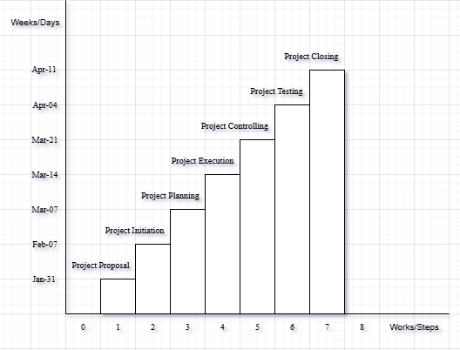

References
We mentioned all the literature or web references, etc here-

- Internet web page & resources: ResearchGate, Gemini, etc.

End!

