Parking System by Using Arduino UNO


Project Report

Supervisor

Khandaker Iftakher Ahmed
Lecturer C.C. of CSE
European University of Bangladesh

Submitted By

[230122002, 230122029, 230122039,
230122048, 230122069]
Students of CSE
European University of Bangladesh

[January 2025]

Department of Computer Science & Engineering
European University of Bangladesh.
Parking System by Using Arduino UNO
Faculty of Computer Science & Engineering, European University of Bangladesh.

Abstract— Our main goal is to develop an ultramodern and reliable parking system by using arduino uno. Which is faced in almost every field in our daily life. For example shopping centers, residential complexes, public parking lots, etc. To develop this system, we used an Arduino UNO as the main processor, a display for the UNO, a servo motor, two IR sensors, resistors, jumper wires, a 9V battery, and other components.

Introduction
The main aim of this project is to reduce the wastage of people's precious time, and to ensure the safety of all while parking, as well as to develop a smooth management. Working to reduce the wastage of valuable time in daily life and avoid various unwanted road accidents. So in this project we can create an orderly parking system by using Arduino UNO. Which will play an important role in the welfare of our country and nation.

Problem Description
Arduino UNO must be used properly in making this project. And how to complete the project using Arduino UNO must be noted. In parking system management, state-of-the-art creativity, intelligence and future possibilities must be exploited. Also, to solve the traffic crisis in the near future, modern technology must be used. And new techniques and technologies have to be developed to avoid unwanted road accidents. At the same time, modern technology should be used in such a way that everyone obeys the traffic laws.

Methodology

Equipments:
- Arduino UNO
- BreadBoard
- Servo Motor
- Display for UNO
- IR Sensor
- Resistors
- Jumper Wires
- 9V Battery
Use Case Diagram: A use case diagram, a type of Unified Modeling Language (UML) diagram, visually represents the interactions between users (actors) and a system, outlining the different ways a user can interact with and achieve goals within the system.

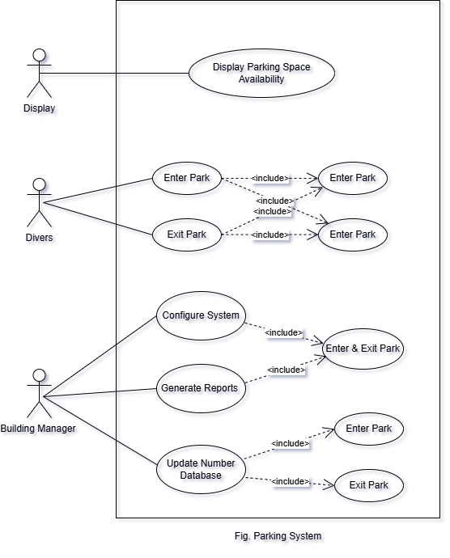
Circuit Diagram: To develop this system, we used an Arduino UNO as the main processor, a display for the UNO, a servo motor, two IR sensors, resistors, jumper wires, a 9V battery, and other components.

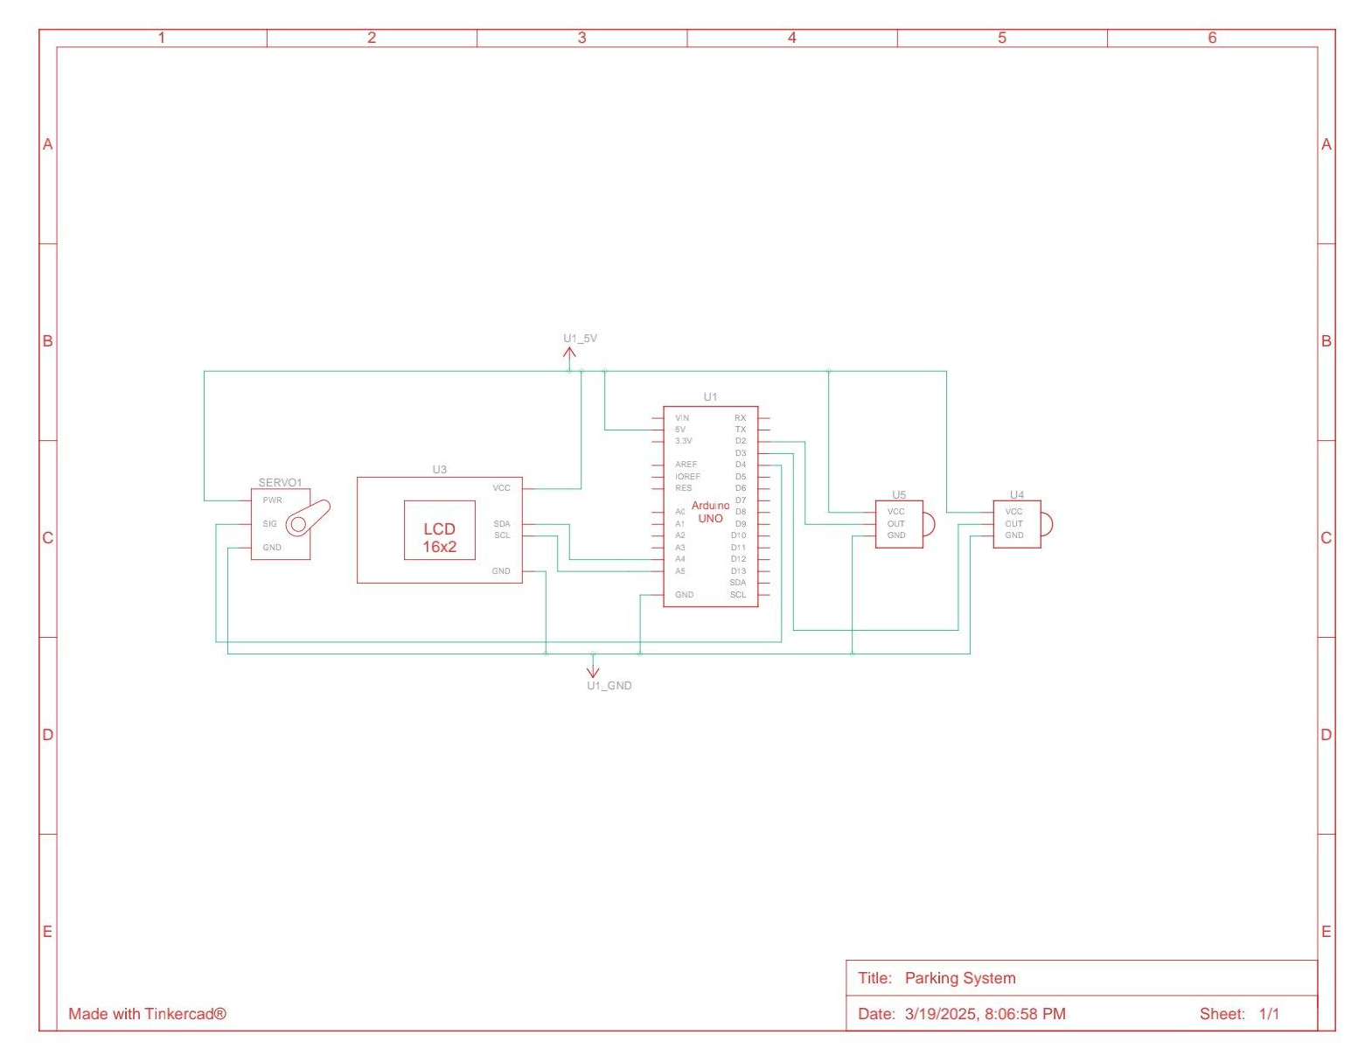
Fig. Circuit Diagram

Connection Diagram: A connection diagram, also known as a wiring diagram, is a visual representation that shows how electrical components are connected, including their relative positions and the connections between them, often using standardized symbols and lines.

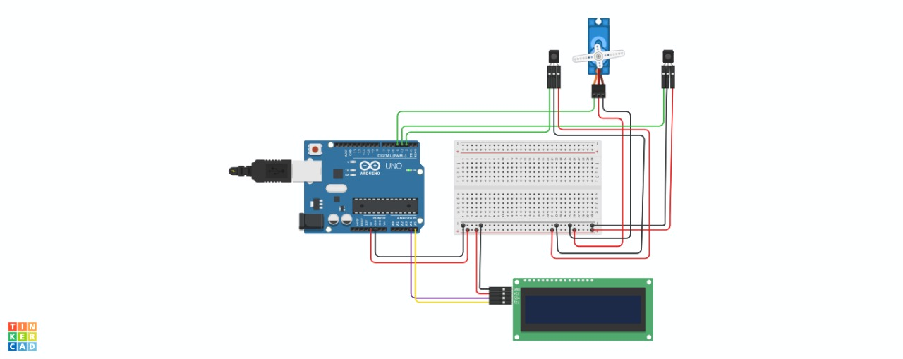

Fig. Connection Diagram
Arduino UNO Code:

#include <Wire.h>
#include <LiquidCrystal_I2C.h>
#include <Servo.h>
// Initialize LCD (I2C address 0x27, 16x2 display)
LiquidCrystal_I2C lcd(0x27, 16, 2);
// Define pins
#define IR_SENSOR_IN 2 // IR sensor 1 (entry)
#define IR_SENSOR_OUT 3 // IR sensor 2 (exit)
#define SERVO_PIN 9 // Servo motor pin
// Parking lot details
int totalSlots = 5; // Total parking slots
int availableSlots = 5; // Slots initially available
// Servo object
Servo gate;
// State tracking
bool gateOpen = false; // Tracks if the gate is open
unsigned long debounceDelay = 2000; // Debounce time (ms)
unsigned long lastSensorTrigger = 0;
bool sensor1State = false; // Track Sensor 1 state
bool sensor2State = false; // Track Sensor 2 state
void setup() {
// Initialize LCD
lcd.init();
lcd.backlight();
lcd.setCursor(0, 0);
lcd.print("Parking System");
delay(2000);
// Setup pins
pinMode(IR_SENSOR_IN, INPUT);
pinMode(IR_SENSOR_OUT, INPUT);
gate.attach(SERVO_PIN);
// Initialize servo to closed position
closeGate();
// Display initial parking slots
updateDisplay();
}
void loop() {
// Read the state of the sensors with debouncing
bool sensor1 = digitalRead(IR_SENSOR_IN) == LOW;
bool sensor2 = digitalRead(IR_SENSOR_OUT) == LOW;
// If Sensor 1 (entry) detects car and debounce delay is passed
if (sensor1 && !sensor1State && (millis() - lastSensorTrigger > debounceDelay)) {
if (availableSlots > 0) { // Check if parking slots are available
openGate(); // Open the gate
lastSensorTrigger = millis(); // Reset debounce timer
sensor1State = true; // Set sensor1 state to true (car detected)
// Wait until the car reaches Sensor 2
while (digitalRead(IR_SENSOR_OUT) == HIGH) {
delay(10); // Keep the gate open while waiting for Sensor 2
}
// Once Sensor 2 detects the car, update count and close the gate
availableSlots--; // Decrease available slots
updateDisplay();
closeGate();
} else {
lcd.setCursor(0, 1);
lcd.print("Parking Full "); // Show parking full message
}
}
// If Sensor 1 state was true and it no longer detects the car
if (!sensor1 && sensor1State) {
sensor1State = false; // Reset sensor1 state when the car has passed
}
// Detect car exiting (Sensor 2 → Sensor 1)
if (sensor2 && !sensor2State && (millis() - lastSensorTrigger > debounceDelay)) {
openGate(); // Open the gate
lastSensorTrigger = millis(); // Reset debounce timer
sensor2State = true; // Set sensor2 state to true (car detected)
// Wait until the car reaches Sensor 1
while (digitalRead(IR_SENSOR_IN) == HIGH) {
delay(10); // Keep the gate open while waiting for Sensor 1
}
// Once Sensor 1 detects the car, update count and close the gate
if (availableSlots < totalSlots) {
availableSlots++; // Increase available slots
updateDisplay();
}
closeGate();
}
// If Sensor 2 state was true and it no longer detects the car
if (!sensor2 && sensor2State) {
sensor2State = false; // Reset sensor2 state when the car has passed
}
}
// Function to update the LCD display
void updateDisplay() {
lcd.clear();
lcd.setCursor(0, 0);
lcd.print("Slots Left:");
lcd.setCursor(0, 1);
lcd.print(availableSlots);
lcd.print("/");
lcd.print(totalSlots);
// Display "Parking Full" if no slots are available
if (availableSlots == 0) {
lcd.setCursor(0, 1);
lcd.print("Parking Full ");
}
}
// Function to open the gate
void openGate() {
gate.write(0); // Open position
gateOpen = true; // Mark gate as open
}
// Function to close the gate
void closeGate() {
gate.write(90); // Closed position
gateOpen = false; // Mark gate as closed
}

Project Controlling: Project controlling, a crucial element of project management, involves monitoring and managing a project's progress to ensure it stays on track, achieves goals, and stays within budget and timeline, by comparing actual performance against planned objectives and taking corrective actions when necessary.

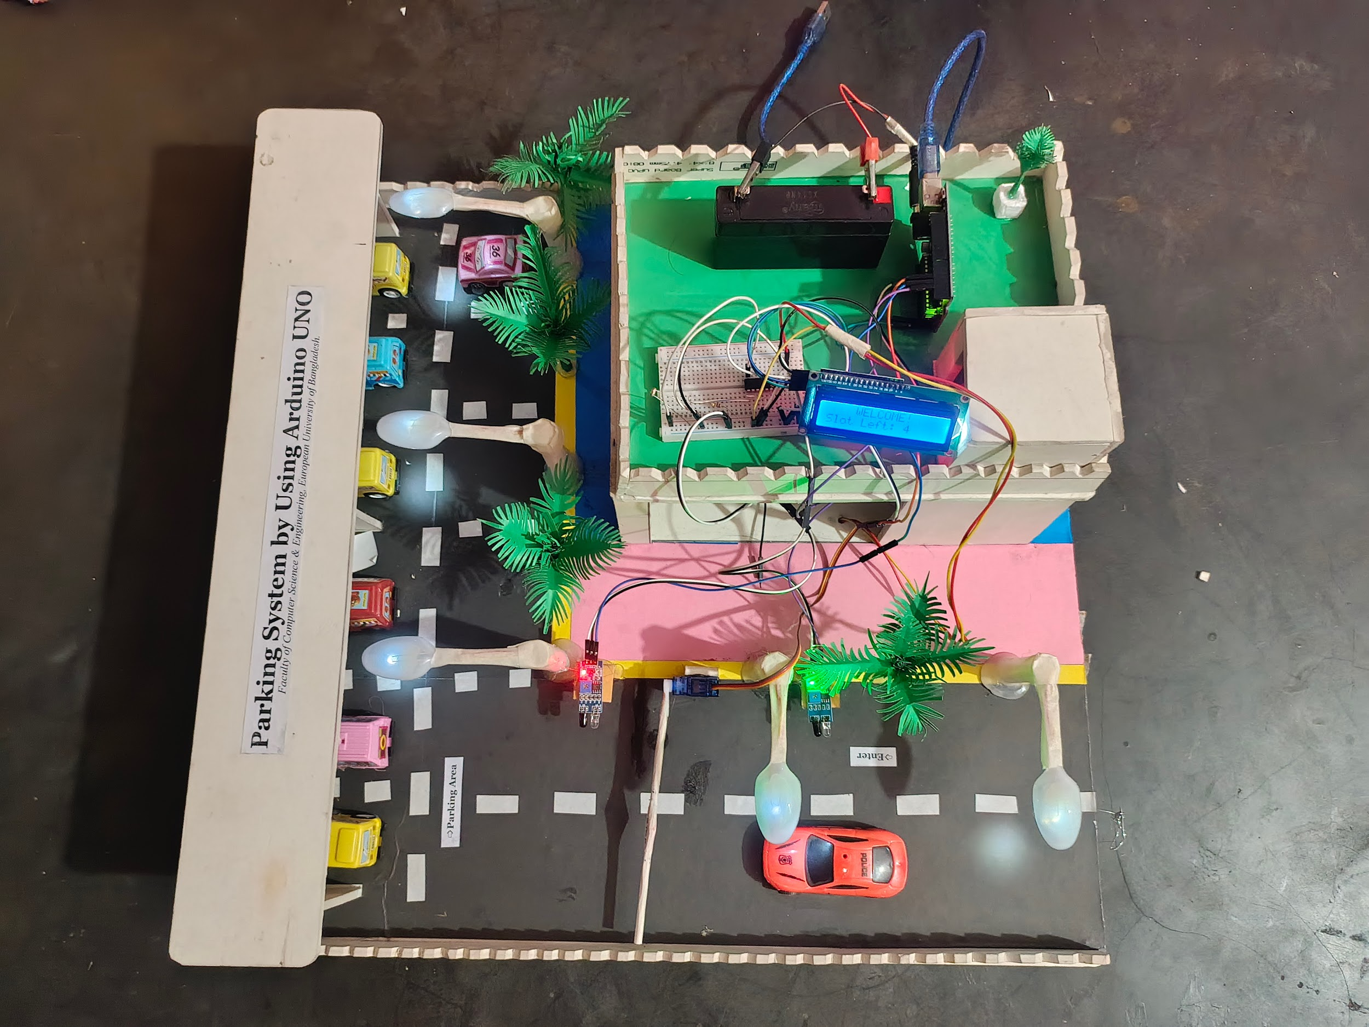

Project Scope

- Advantages
- Cost-Effective: Affordable components.
- Customizable: Tailor to specific needs.
- Educational: Learn sensors, coding, electronics.
- Real-Time Monitoring: Instant updates on availability.

- Limitations
- Range: Limited sensing distance.
- Accuracy: Potential inaccuracies in detection.
- Integration: Requires effort for advanced integration (e.g., IoT).
- Maintenance: Potential for frequent manual intervention.

- Enhancements
- Multiple Sensors: Cover more parking spaces.
- LCD Display: Show real-time parking status.
- Mobile App Integration: Remote monitoring.
- IoT Capabilities: Connect to the internet for data access.

Feasibility Study

Technical Feasibility

Component Compatibility: Arduino UNO is compatible with a range of sensors and peripheral devices.

Simplicity: Arduino’s user-friendly interface simplifies programming and debugging.
- Power Supply: Standard power requirements are easily met.
- Software Support: Abundant libraries and community support for sensors and displays.

- Economic Feasibility
- Low Initial Investment: Affordable components (Arduino, sensors, and LEDs).

Low Operating Costs: Minimal power consumption and maintenance.

Scalability: Can start small and expand gradually.
- Cost-Effectiveness: High value for the cost, especially in education and DIY environments.

- Operational Feasibility

Ease of Use: User-friendly setup and operation.
- Reliability: Consistent performance with proper calibration.

Scalability: Expandable with additional sensors and features.
- Integration: Can integrate into larger systems with additional work.

Solution Application Areas

- Shopping Centers
- Customer Convenience: Real-time parking info for visitors.
- Traffic Flow Management: Efficiently guide vehicles to available spots.
- Enhanced Security: Improved monitoring of parking areas.
- Reduced Search Time: Quicker parking, leading to better customer satisfaction.

- Residential Complexes
- Resident Convenience: Real-time parking information for residents.
- Space Utilization: Efficient use of limited parking spaces.
- Security: Improved monitoring and safety for parked vehicles.
- Visitor Parking: Navigate and manage guest parking more effectively.

- Public Parking Lots
- Real-Time Information: Display available spaces to drivers.
- Traffic Reduction: Minimize the search time for parking.
- Revenue Management: Track and manage parking fees.
- Enhanced Security: Monitor and secure parking areas.

Tools/Technology

Hardware:

- Arduino UNO

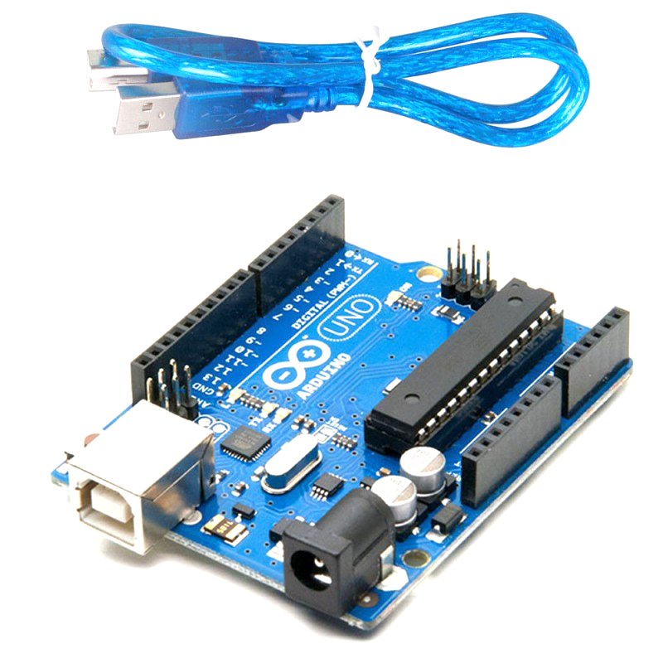
The Arduino Uno is a popular, open-source microcontroller board based on the ATmega328P, designed for creating interactive and electronic projects, and is known for its ease of use and programming, making it a great tool for both beginners and experienced users.

- BreadBoard
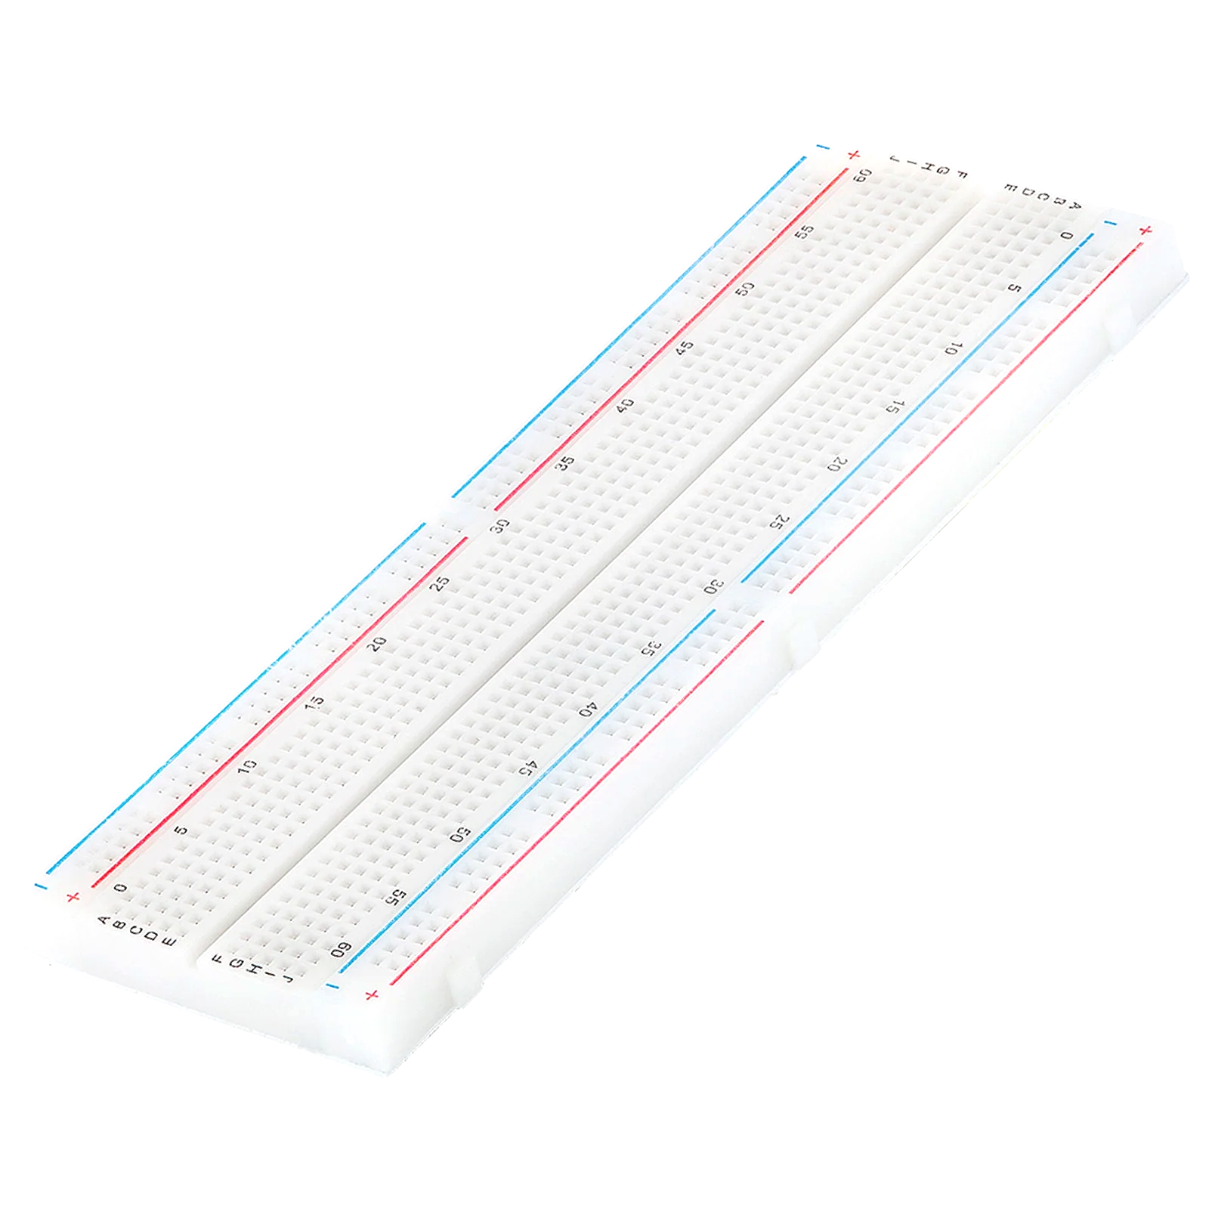
The breadboard is the basic component of any circuit building process. All components, be it input sensors or output display devices are connected to the power supply, microcontroller using wired connections through a breadboard.

- Servo Motor
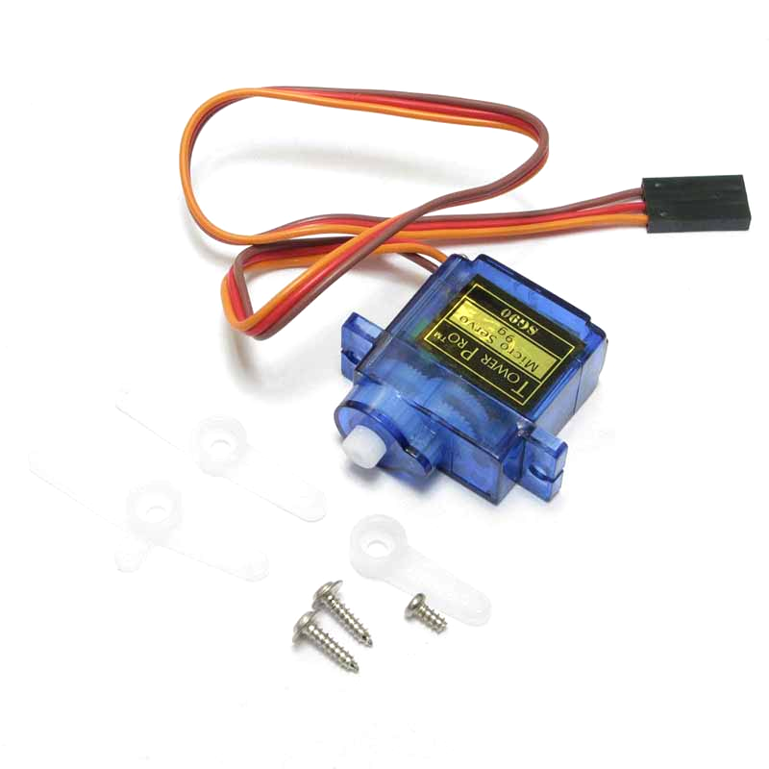
A servomotor is a closed-loop servomechanism that uses position feedback (either linear or rotational position) to control its motion and final position.

- Display for UNO

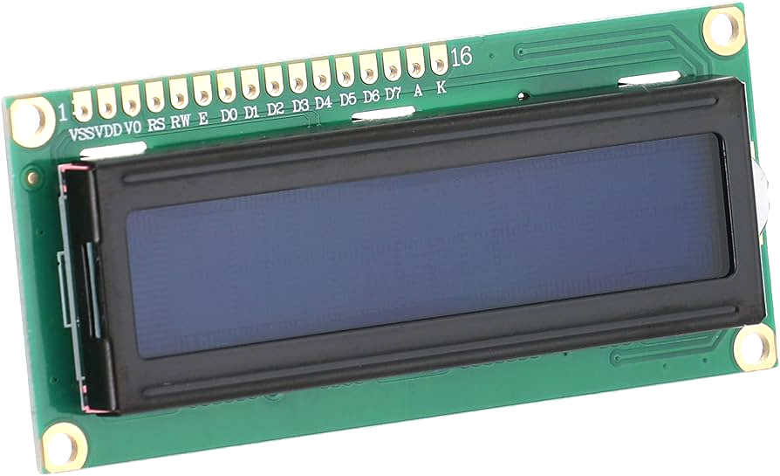

LCDs (Liquid Crystal Displays) are used in embedded system applications for displaying various parameters and status of the system.
- IR Sensor
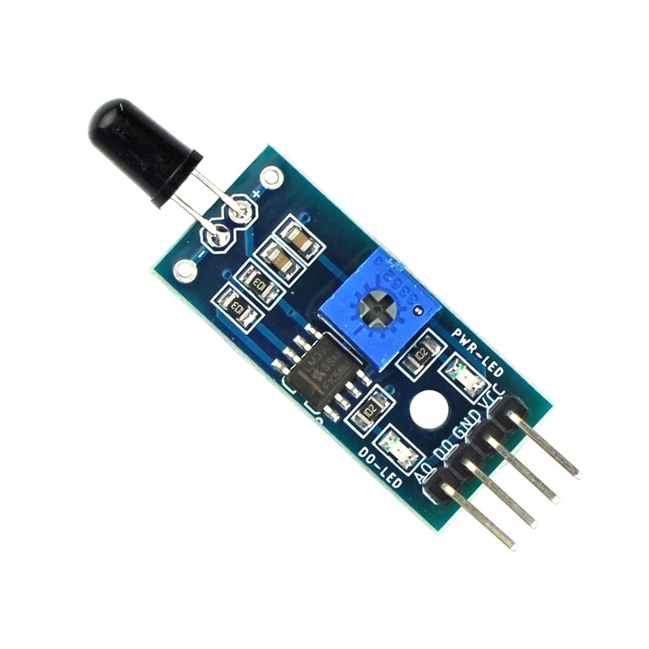
An infrared (IR) sensor is an electronic device that detects and measures infrared radiation, which is invisible to the human eye and has wavelengths longer than visible light.

- Resistors

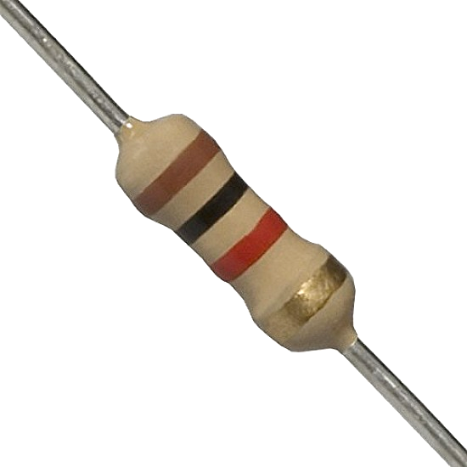
Resistors are passive devices that restrict the flow of current or divide the voltage through the circuit. The input power passes through these resistors and then to the sensors to avoid damage.

- Jumper Wires
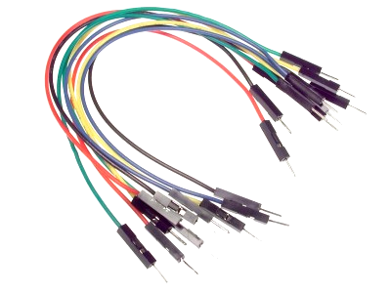
These are the main components that are used to establish the connections between different devices of the circuit.
- 9V Battery

A 9V battery is a compact, rectangular-shaped battery that provides a nominal voltage of 9 volts, commonly used in devices like smoke detectors, clocks, and remote controls, etc.

Software:

- Not applicable (if built as a hardware-based project).

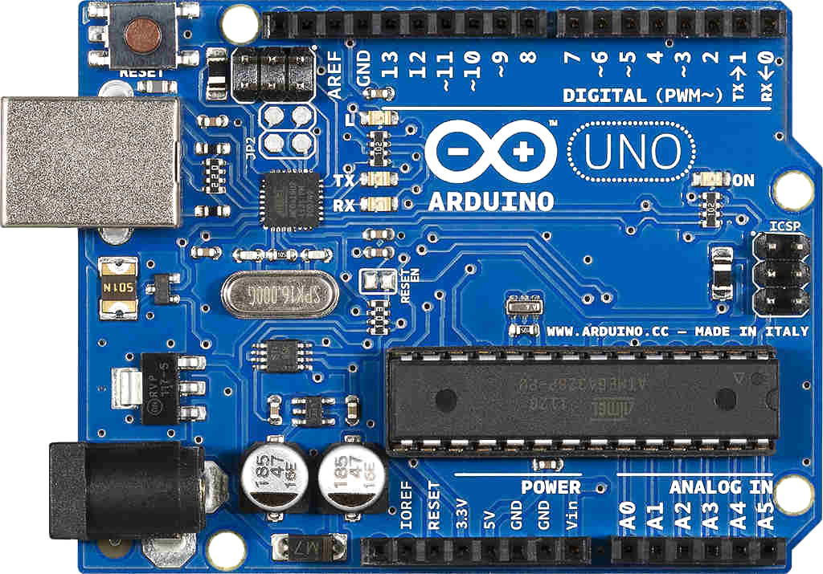

- For microcontroller-based systems, software like Arduino UNO IDE may be used.



- TinkerCad circuit simulation software.



Expertise of the Team Members
We present the significance of our project with the overall cooperation of the team members:

- Cost-Effective: The components required (Arduino, sensors, LEDs) are affordable, making it a budget-friendly project.

- Real-Time Monitoring: Provides instant updates on parking space availability, enhancing convenience for drivers.

- Customizable: The system can be tailored to fit specific needs, such as the number of parking spots or additional functionalities like mobile app integration.

- Energy Efficient: Low power consumption ensures minimal operational costs and environmental impact.

- User-Friendly: Easy to set up and use, with plenty of resources and community support available for troubleshooting and enhancements.

- Educational: Offers a hands-on learning opportunity in electronics, programming, and system integration, making it a valuable educational project.

Milestones

- Cost:

SN | Hardware | Cost
1 | Arduino UNO | 580
2 | BreadBoard | 70
3 | Servo Motor | 120
4 | Display for UNO | 340
5 | IR Sensor | 40
6 | Resistors | 20
7 | Jumper Wires | 70
8 | 9V Battery | 80

- Flowchart:

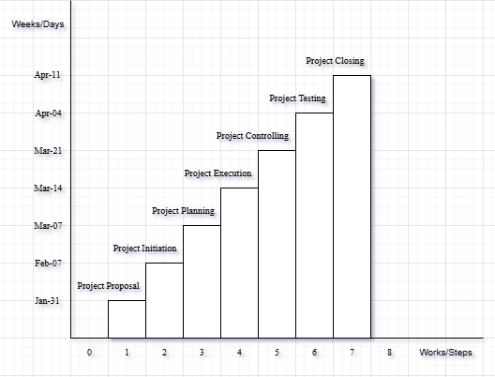

Conclusions
The “Parking System Using Arduino UNO” project efficiently automates parking space management. By integrating the Arduino UNO, IR sensors, servo motor, and display, the system ensures accurate detection of available spaces and seamless parking operations, improving space utilization and convenience. This project highlights the potential of microcontroller-based solutions for smart parking management.

References
We mentioned all the literature or web references, etc here-

- Internet web page & resources: ResearchGate, Gemini, etc.

End!

